IEEE P802.11
Wireless LANs
TGai Berlin AdHoc Meeting Announcement
Update 2
Date: 2013-05-23
Author(s):
Name | Affiliation | Address | Phone | email
Marc Emmelmann | Fraunhofer FOKUS | Kaiserin-Augusta-Allee 31  10589 Berlin GERMANY | +49 30 34637268 | emmelmann@ieee.org
Abstract
TGai Berlin Ad-Hoc Meeting Announcement and Booking Details

Meeting dates: 10. – 12. July 2013

Meeting Venue: Fraunhofer FOKUS;
Kaiserin-Augusta-Allee 31
10589 Berlin
Germany

Registration: Registration required via E-Poll
https://mentor.ieee.org/802.11/poll-vote?p=9400008&t=9400008
Deadline for registration: 28. June 2013

Hotel: Discounted-rate room block available at: Hampton Berlin
Deadline for reservation: 8. June 2013

Changes:
Update 2: Includes instructions on how to reach meeting venue via public transportation
Update 1: Includes link to e-poll for registration
TGai Berlin AdHoc Meeting Announcement

Meeting Date:

TGai will hold an Ad-Hoc Meeting in Berlin, Germany, from 10. – 12. July 2013.

The preliminary meeting agenda is contained in (t.b.a.) Expect the meeting to start at 8.30AM on July 10 and to end at 5.00PM on July 12 (hard deadline).

Registration:

In order to attend the ad-hoc, you are required to register for the ad-hoc meeting using e-poll. You may access the e-poll registration via the following link:
https://mentor.ieee.org/802.11/poll-vote?p=9400008&t=9400008
The deadline for registration is 28. June 2013. There is no registration fee, though, if you have not registered by the deadline, access to the meeting venue might not be granted.

Meeting Venue:

The meeting will take place at the premises of

Fraunhofer FOKUS
Kaiserin-Augusta-Allee 31
10589 Berlin
Germany

How to reach Fraunhofer:

Google Maps: http://goo.gl/maps/xHNQf

Transfer in Berlin to the Venue of the Fraunhofer Institute FOKUS:
http://www.fokus.fraunhofer.de/en/fokus/kontakt/service/anfahrt/anfahrt_berlin/index.html

Hotel information:

A room block at a discounted rate is available at:

Hampton Berlin
Uhlandstrasse 188-189
10623 Berlin
Germany

Dates of availability: July 9 – July 14, 2013

Rate: 119 EURO including tax (single or double occupancy);
Rate includes breakfast and free WiFi

Booking key word: IEEE

Deadline for reservation: June 8, 2013

In order to book a room, please contact:
Ms. Jacqueline Sauter-Israel
Reservation & Sales Coordination
jaqueline.sauter@hamptonbyhilton-berlin.de
phone: +49 30 4050270
fax: +49 30 4050271111

Credit card information has to be provided in order to reserve a room.
Please mention the key word “IEEE” to book under the discounted rate.
If you are a HiltonHonors member, please include your HHonors# in your reservation.

Cancellation: Rooms may be canceled free of charge up to 18.00h at the day of arrival. Cancellation requires written form (e.g. via e-mail). Afterwards, 90% of the entire stay’s price will be charged.

Attention: Please make your hotel arrangements (regardless of the hotel you are staying at) as soon as possible. It’s summer vacation time in Europe and Berlin is a popular destination: prices go up rapidly and hotel rooms at the hotel of your choice might become unavailable.

How to reach Fraunhofer FOKUS from the Hampton Berlin via public transportation (total travel time: 30 minutes):

To use public transportation, you may want to get a single ride ticket (“Einzelfahrausweis Zone A/B”) for 2,40 EUR per trip. Note, that the ticket machines usually do not accept credit cards.

- Walk from the Hamption hotel to U-Bhf Zoologischer Garten (underground station, 550m to walk)
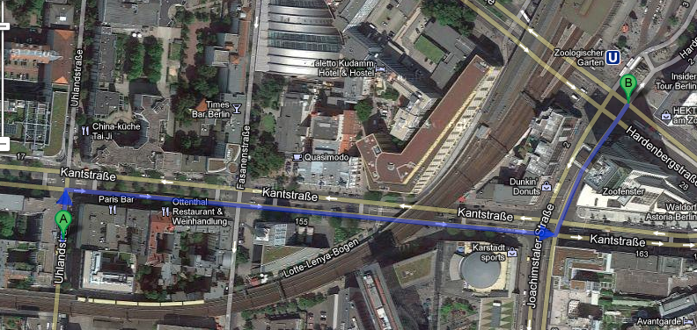
- Take Underground U2 (directions towards Ruhleben)
- Exit at station Bismarkstr. and transfer to underground U7 (directions towards Rathaus Spandau)
- Exit at station Mierendorfplatz
- Walk from Mierendorfplatz to Fraunhofer FOKUS (600 m to walk)
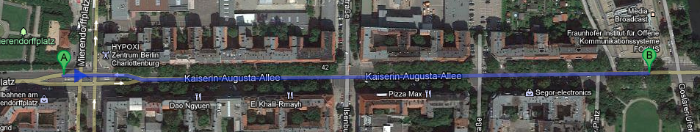

Reverse directions:
- Walk to U-Bhf Mierendorfplatz
- Take U7 (directions towards Rudow)
- Exit at station Bismarkstr. and transfer to U2 (directions towards Pankow)
- Exit at U-Bhf Zoologischer Garten
- Walk to Hampton hotel

Flight information:

It is recommended to book your flight to:

Berlin-Tegel (TXL) airport

There are direct flights to Berlin from, e.g., Newark (EWR, with United) as well as from Los Angeles (LAX, with Air Berlin).

Breakfast, Lunch, Dinner:

Breakfast is included in the hotel rate of the Hampton Berlin. Lunch and dinner will not be provided.

Fraunhofer Fokus has a cafeteria where lunch may be purchased at your own cost. Daily menus always include one vegetarian meal. Prices range from 5 to 10 Euro, cash only.

