IEEE P802.11
Wireless LANs
Comment Resolution for Clause 6.5
Date: 2013-06-20
Author:
Name | Affiliation | Address | Phone | Email
Edward Au | Huawei Technologies | 303 Terry Fox Drive, Suite 400, K2K 3J1 Kanata Ontario |  | edward.au@huawei.com

This submission presents proposed resolution to CIDs 10225, 10224, 10065, and 10226. Changes indicated by a mixture of Word track-changes and instructions.

CID 10225

CID | Clause | Page | Line | Comment | Proposed Change
10225 | 6.5.4.2 | 24 | 26 | This list of exceptions is getting rediculous. Just replace all the "is not used" exceptions with one sentence that not all parameters are used by all PHY types. (Maybe this has to be done by TGmc.) | Replace "The parameter aMPDUDurationFactor is not used by all PHYs defined within this standard. The parameters aSignalExtension, aRIFSTime, aSymbolLength, aSTFOneLength, aSTFTwoLength,  aLTFOneLength, aLTFTwoLength, aPLCPSigTwoLength, aPLCPServiceLength, aPLCPConvolutionalTailLength,  aMPDUDurationFactor, aMPDUMaxLength, aPSDUMaxLength,  aPPDUMaxTime, aIUSTime, aDTT2UTTTime, and aMaxCSIMatricesReportDelay are not used by all PHYs defined within this standard. Not every PHY in this standard uses the parameters aTxPLCPDelay, aRxPLCPDelay, aTxRFDelay, aRxRFDelay, aTxPHYDelay, aRxPHYDelay, aTxPmdTxStartRFDelay, aTxPmdTxStartRMS,  aTxPHYTxStartRFDelay, and aTxPHYTxStartRMS" with "Not all parameters are used by all PHYs defined within this standard."

Discussion:
The following is a snapshot of the paragraph the commenter refers to.

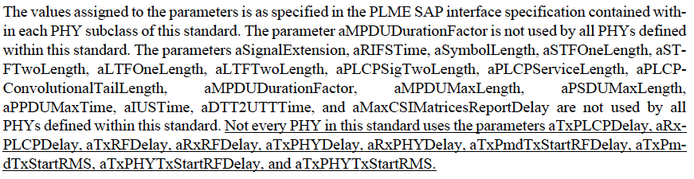

Though I agree that the list of exceptions is getting ridiculous, and these sentences would be combined into one single sentence, the suggested sentence “not all parameters are used by all PHYs defined within this standard” is not sufficient to identify which parameter in the PLME-CHARACTERISTICS.confirm is not used by all PHYs defined within the standards. See the following table:

Parameter Name in  PLME-CHARACTERISTICS.confirm | Parameter not used by all PHYs defined within this standard
aSlotTime | x
aSIFSTime | x
aSignalExtension | ✔
aCCATime | x
aCCAMidTime | x
aPHY-RX-START-Delay | x
aRxTxTurnaroundTime | x
aTXPLCPDelay | ✔
aRXPLCPDelay | ✔
aRxTxSwitchTime | x
aTxRampOnTime | x
aRxRampOnTime | x
aTxRFDelay | ✔
aRxRFDelay | ✔
aAirPropagationTime | x
aMACProcessingDelay | x
aPreambleLength | x
aRIFSTime | ✔
aSymbolLength | ✔
aSTFOneLength | ✔
aSTFTwoLength | ✔
aLTFOneLength | ✔
aLTFTwoLength | ✔
aPLCPHeaderLength | x
aPLCPSigTwoLength | ✔
aPLCPServiceLength | ✔
aPLCPConvolutionalTailLength | ✔
aMPDUDurationFactor | ✔
aMPDUMaxLength | ✔
aPSDUMaxLength | ✔
aPPDUMaxTime | ✔
aIUSTime | ✔
aDTT2UTTTime | ✔
aCWmin | x
aCWmax | x
aMaxCSIMatricesReportDelay | ✔
aMaxTODError | x
aMaxTOAError | x
aTxPmdTxStartRFDelay | ✔
aTxPmdTxStartRMS | ✔
aTxPHYDelay | ✔
aRxPHYDelay | ✔
aTxPHYTxStartRFDelay | ✔
aTxPHYTxStartRMS | ✔

Proposed Resolution:
Counter.

TGac Editor: Please apply the following changes to the paragraph in line 18 of page 24:
The values assigned to the parameters is as specified in the PLME SAP interface specification contained within each PHY subclass of this standard. The parameters aSignalExtension, aRIFSTime, aSymbolLength, aSTFOneLength, aSTFTwoLength, aLTFOneLength, aLTFTwoLength, aPLCPSigTwoLength, aPLCPServiceLength, aPLCPConvolutionalTailLength, aMPDUDurationFactor, aMPDUMaxLength, aPSDUMaxLength, aPPDUMaxTime, aIUSTime, aDTT2UTTTime, aMaxCSIMatricesReportDelay, aTxPLCPDelay, aRxPLCPDelay, aTxRFDelay, aRxRFDelay, aTxPHYDelay, aRxPHYDelay, aTxPmdTxStartRFDelay, aTxPmdTxStartRMS, aTxPHYTxStartRFDelay, and aTxPHYTxStartRMS are not used by all PHYs defined within this standard.

CID 10224

CID | Clause | Page | Line | Comment | Proposed Change
10224 | 6.5.4.2 | 24 | 38 | The antecedent of "otherwise" is not at all clear. | Change this to two sentences, spelling out the "otherwise". I think it is for clause 20, 21 and 22 PHYs?

Discussion:
The following is a snapshot of the paragraph the commenter refers to.

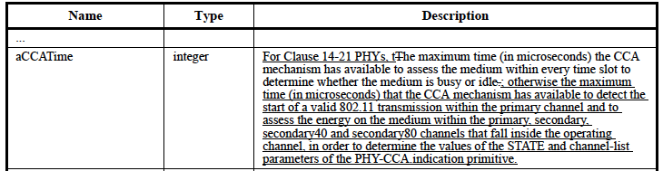

The antecedent of “otherwise” is not required here.

The commenter points out correctly that while the first half of the sentence is for clauses 14-21, the second half is for clause 22.

Proposed Resolution:
Accepted.

TGac Editor: Please apply the following changes to the paragraph in line 38 of page 24:
For Clause 14-21 PHYs, the maximum time (in microseconds) the CCA mechanism has available to assess the medium within every time slot to determine whether the medium is busy or idle. For Clause 22 PHYs, the maximum time (in microseconds) that the CCA mechanism has available to detect the start of a valid 802.11 transmission within the primary channel and to assess the energy on the medium within the primary, secondary, secondary40 and secondary80 channels that fall inside the operating channel, in order to determine the values of the STATE and channel-list parameters of the PHY-CCA.indication primitive.

CID 10065

CID | Clause | Page | Line | Comment | Proposed Change
10065 | 6.5.8.1 | 25 | 57 | Not clear which TXVECTOR is meant | Replace "when the TXVECTOR parameter FORMAT is VHT" with "when the TXVECTOR parameter FORMAT in the corresponding PLME-TXTIME.request is VHT"

Discussion:
The following is a snapshot of the paragraph the commenter refers to.

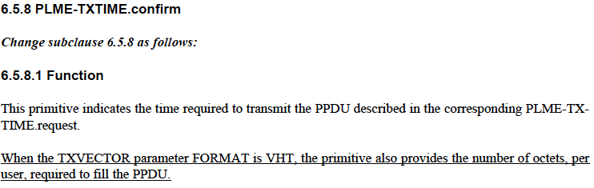

Without referring to the previous clause 6.5.7, it is not clear that the TXVECTOR correspondings to PLME-TXTIME.request primitive.

As per the WG Style Guide, there is a slight modification from the commenter’s suggestion is to replace “PLME-TXTIME.request” with “PLME-TXTIME.request primitive”.

Proposed Resolution:
Counter.

TGac Editor: Please apply the following changes to the paragraph in line 38 of page 24:
When the TXVECTOR parameter FORMAT in the corresponding PLME-TXTIME.request primitive is VHT, the primitive also provides the number of octets per user, required to fill the PPDU.

CID 10226

CID | Clause | Page | Line | Comment | Proposed Change
10226 | 6.5.8.2 | 26 | 7 | PSDU_LENGTH array needs to say it carries integer values. | Change "values" to "integers" at the end of the first sentence in the new paragraph.

Discussion:
The following is a snapshot of the paragraph the commenter refers to.

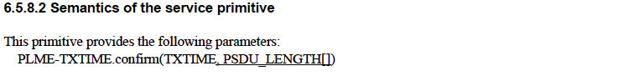
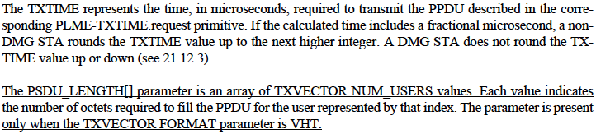

The commenter is correct that the PSDU_Length array carries integer values because the unit of NUM_USERS is integer. As per the WG Style Guide, however, “TXVECTOR” should be replaced by “TXVECTOR parameter”.

Proposed Resolution:
Counter.

TGac Editor: Please apply the following changes to the new paragraph in the clause 6.5.8.2 (i.e., line 7, page 26):
The PSDU_LENGTH[] parameter is an integer array of TXVECTOR parameter NUM_USERS. Each value indicates the number of octets required to fill the PPDU for the user represented by that index. The parameter is present only when the TXVECTOR FORMAT parameter is VHT.

