IEEE P802.11
Wireless LANs
Comment Resolution for Clause 6.3
Date: 2013-06-13
Author:
Name | Affiliation | Address | Phone | Email
Edward Au | Huawei Technologies | 303 Terry Fox Drive, Suite 400, K2K 3J1 Kanata Ontario |  | edward.au@huawei.com

This submission presents proposed resolution to CIDs 10220, 10147, 10221, 10222, 10189, 10223, and 10169. Changes indicated by a mixture of Word track-changes and instructions.

R2 – Proposed resolution for CID 10169 is revised after taking into account a few comments from Menzo Wentink.

CID 10220

CID | Clause | Page | Line | Comment | Proposed Change
10220 | 6.3.3.3.2 | 14 | 21 | The new VHT parameters need to be added to the parameter list, also | Add "VHT Capabilities, VHT Operation" to the parameter list to MLME-SCAN.confirm

Discussion:
As referred to clause 6.3.3.3.2 (Semantics of the service primitives) in IEEE802.11-2012 (c.f., pages 109-114), the parameters (or the parameter list the commenter mentions) of MLME-SCAN.confirm primitive are as follows:

MLME-SCAN.confirm(
BSSDescriptionSet,
BSSDescriptionFormMeasurementPilotSet,
ResultCode,
VendorSpecificInfo
}
As for the BSSDescriptionSet parameter, it consists of elements such as HT Capabilities and HT Operation. The following shows a snapshot of portions of elements contained in this parameter.
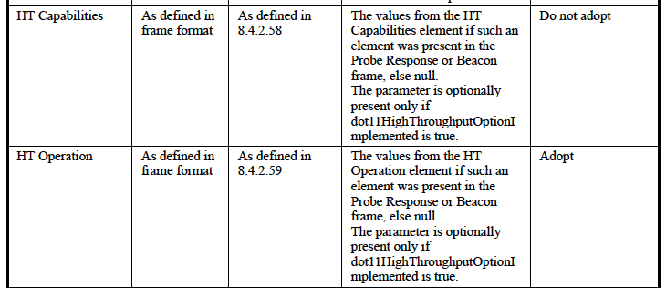
As indiciated in page 14 of P802.11ac_D5.0, VHT Capabilities and VHT Operation will be inserted “at the end of the second table”, in which the “second table” refers to the elements of the BSSDescriptionSet parameter. The following shows the snapshot of the text.
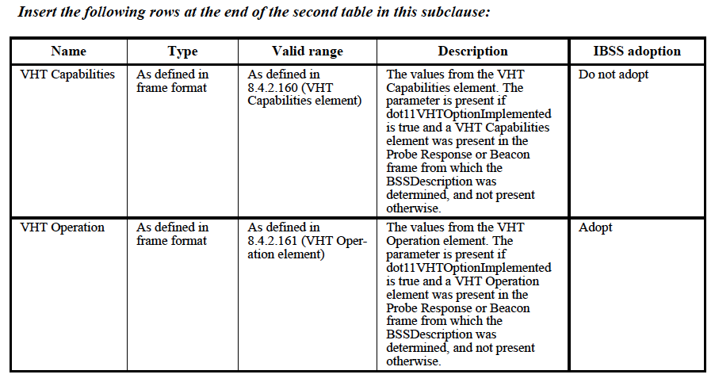
Proposed Resolution:
Rejected. Given VHT Capabilities and VHT Option are included in the BSSDescriptionSet parameter, they are not required to be added to the parameter list of MLME-SCAN.confirm primitive.

CID 10147

CID | Clause | Page | Line | Comment | Proposed Change
10147 | 6.3.4.2.2 | 15 | 7 | Shouldn't the OperationalVHTMCS_NSSSet be a super set of the values contained in the BSSBasicVHTMCS_NSSSet parameter? | Add the description that this set is a superset of the <VHT-MCS, NSS> tuples contained in the BSSBasicVHTMCS_NSSSet parameter.

Discussion:
As referred to clause 6.3.4.2.2 (Semantics of the service primitive) in IEEE802.11-2012 (c.f., page 116), both the OperationalRateSet parameter and the HTOperationalMCSSet parameter are explicitly described as a superset of the rates contained in the BSSBasicRateSet parameter and a superset of the MCS values in the BSSBasicMCSSet parameter, respectively. See the following snapshot for reference.

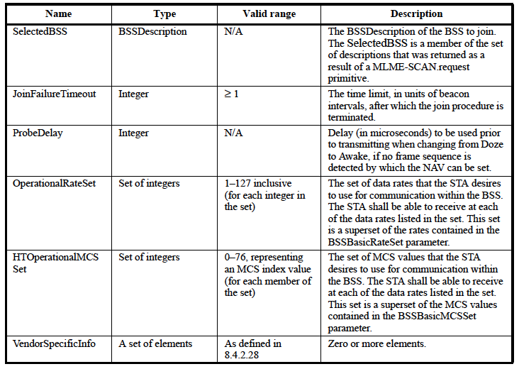

Referring to P802.11ac_D5.0, the BSSBasicVHTMCS_NSSSet parameter is defined as the set of MCS and number of spatial stream tuples (i.e., the set of <VHT-MCS, NSS> tuples) that are supported by all VHT STAs that are members of a VHT BSS, while the OperationalVHTMCS_NSSSet parameter is the set of <VHT-MCS, NSS> tuples constrained so that the MCS values are expressible using the encoding described for the Supported VHT-MCS and NSS Set field.

The commenter is correct that the OperationalVHTMCS_NSSSet parameter is a superset of the <VHT-MCS, NSS> tuples contained in the BSSBasicVHTMCS_NSSSet parameter but it is not explicitly stated in the following table in clause 6.3.4.2:

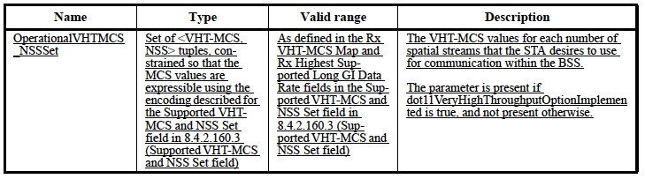

Proposed Resolution:
Accepted.

TGac Editor: Please add the following sentence right after the first paragraph of description in line 7 of page 15:
The VHT-MCS values for each number of spatial streams that the STA desires to use for communication within the BSS. This set is a superset of the <VHT-MCS, NSS> tuples contained in the BSSBasicVHTMCS_NSSSet parameter.

CID 10221

CID | Clause | Page | Line | Comment | Proposed Change
10221 | 6.3.7.5.2 | 18 | 23 | The VHT Capabilities here are what the AP supports | Change "STA" to "AP" in the description of the VHT Capabilities parameter in the MLME-ASSOCIATE.response

Discussion:
As referred to clause 6.3.7.5 (MLME-ASSOCIATE.response) in IEEE802.11-2012 (c.f., page 130), MLME-ASSOCIATE.response primitive is sent by an AP as a response to an MLME-ASSOCIATE.indication primitive. The commenter correctly points out that the VHT Capabilities parameter in the MLME-ASSOCIATE.response primitive specifies the parameters within the VHT Capabilities element that are supported by the AP, rather than the STA.

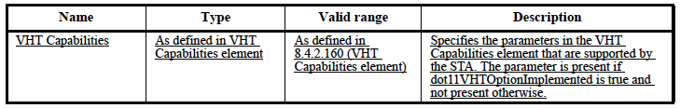

Proposed Resolution:
Accepted.

TGac Editor: Please apply the following changes to line 24 of page 18 under the column “Description”:
Specifies the parameters in the VHT Capabilities element that are supported by the AP.

CID 10222

CID | Clause | Page | Line | Comment | Proposed Change
10222 | 6.3.8.3.2 | 20 | 8 | The VHT Capabilities here are what the AP supports | Change "STA" to "AP" in the description of the VHT Capabilities parameter in the MLME-REASSOCIATE.confirm

Discussion:
As referred to clause 6.3.8.3 (MLME-REASSOCIATE.confirm) in IEEE802.11-2012 (c.f., page 135), MLME-REASSOCIATE.confirm primitive is sent by an AP as a response to an MLME-REASSOCIATE.request primitive. The VHT Capabilities parameter in the MLME-REASSOCIATE.confirm primitive specifies the parameters within the VHT Capabilities element that are supported by the AP.

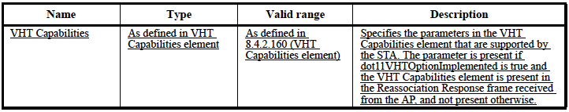

Proposed Resolution:
Accepted.

TGac Editor: Please apply the following changes to line 8 of page 20 under the column “Description”:
Specifies the parameters in the VHT Capabilities element that are supported by the AP.

CID 10189

CID | Clause | Page | Line | Comment | Proposed Change
10189 | 6.3.8.4.2 | 21 | 10 | Why is the VHT Capabilities Element present in the Association Request frame received from the STA? This subclause describes the MLME-REASSOCIATE.indication and I believe the VHT Capabilities Element be present in Reassociation Request frame received from the STA. | Please replace "Association Request frame" with "Reassociation Request frame" in the description.

Discussion:
As referred to Clause 6.3.8 (Reassociate) in page 18 of P802.11ac_D5.0, the discussion is related to reassociation, rather than association.

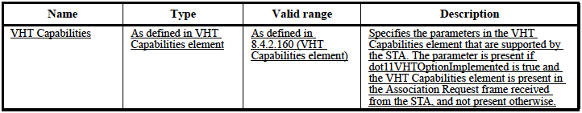

Proposed Resolution:
Accepted.

TGac Editor: Please apply the following changes to line 10 of page 21 under the column “Description”:
The parameter is present if dot11VHTOptionImplemented is true and the VHT Capabilities element is present in the Reassociation Request frame received from the STA, and not present otherwise.

CID 10223

CID | Clause | Page | Line | Comment | Proposed Change
10223 | 6.3.8.5.2 | 21 | 63 | The VHT Capabilities here are what the AP supports | Change "STA" to "AP" in the description of the VHT Capabilities parameter in the MLME-REASSOCIATE.response

Discussion:
As referred to clause 6.3.8.5 (MLME-REASSOCIATE.response) in IEEE802.11-2012 (c.f., page 141), MLME-REASSOCIATE.response primitive is sent by an AP as a response to an MLME-REASSOCIATE.indication primitive. The commenter points out correctly that the VHT Capabilities parameter in the MLME-REASSOCIATE.response primitive specifies the parameters within the VHT Capabilities element that are supported by the AP, rather than the STA.

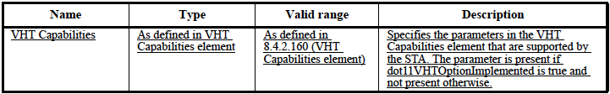

Proposed Resolution:
Accepted.

TGac Editor: Please apply the following changes to line 63 of page 21 under the column “Description”:
Specifies the parameters in the VHT Capabilities element that are supported by the AP.

CID 10169

CID | Clause | Page | Line | Comment | Proposed Change
10169 | 6.3.11.2.4 | / | / | The baseline describes the restriction of the ResultCode parameter in the resulting MLME-START.confirm primitive when there are unsupported rates or unsupported MCSs. There should be a similar restriction when there are any unsupported <VHT-MCS, NSS> tuples contained in the BSSBasicVHTMCS_NSSSet parameter. | Add a similar description referring to the third paragraph in 6.3.11.2.4 of IEEE Std 802.11-2012.

Discussion:
In P802.11ac_D5.0, clause 6.3.11.2.4 is cited by clause 9.3.1 (General) related to DCF:

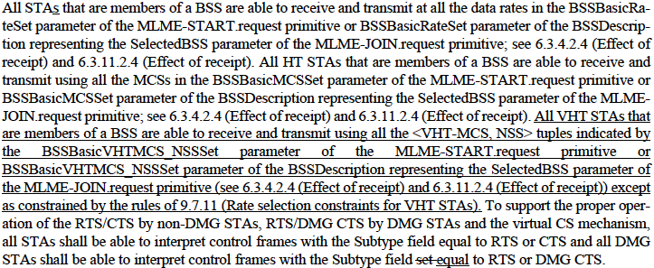

 | MLME-START.request primitive | SelectedBSS parameter of  the MLME-JOIN.request primitive
All STAs | BSSBasicRateSet parameter | BSSBasicRateSet parameter of  the BSSDescription
All HT STAs | BSSBasicMCSSet parameter | BSSBasicMCSSet parameter of  the BSSDescription
All VHT STAs | All the <VHT-MCS, NSS> tuples indicated by the BSSBasicVHTMCS_NSSSet parameter | BSSBasicVHTMCS_NSSSet parameter of  the BSSDescription

In IEEE802.11-2012, however, the BSSBasicVHTMCS_NSSSet parameter is not mentioned in clause 6.3.11.2.4 (c.f., page 151 and the snapshot below). It means that the reference of clause 6.3.11.2.4 in clause 9.3.1 is broken. The suggestion here is to follow the commenter’s suggested remedy to add a description in this clause on a restriction when there are any unsupported <VHT-MCS, NSS> tuples contained in the BSSBasicVHTMCS_NSSSet parameter.

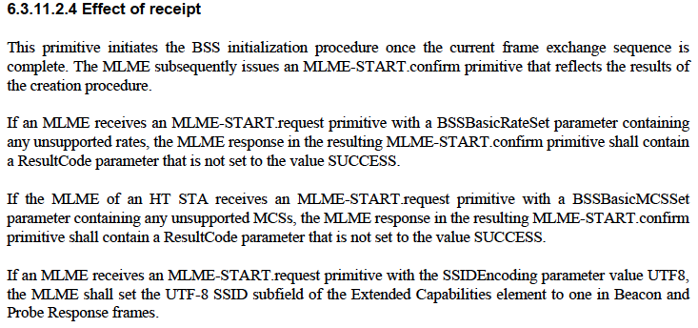

There are additional problems related to this comment, however.

Additional Problem #1: Clause 6.3.11.2:
As referred to clause 6.3.11.2 (MLME-START.request) in P802.11ac_D5.0 (c.f., page 22), the MLME-START.request primitive contains BSSBasicRateSet parameter, OperationalRateSet parameter, BSSBasicMCSSet parameter, and HTOperationalMCSSet that will be used by the ResultCode parameter as described in clause 6.3.11.24. However, this primitive does not include any corresponding parameter for all VHT STAs that are members of a BSS, namely the BSSBasicVHTMCS_NSSSet parameter and the OperationalVHTMCS_NSSSet parameter:

MLME-START.request(
SSID,
SSIDEncoding,
BSSType,
BeaconPeriod,
DTIMPeriod,
CF parameter set,
PHY parameter set,
IBSS parameter set,
ProbeDelay,
CapabilityInformation,
BSSBasicRateSet,
OperationalRateSet,
Country,
IBSS DFS Recovery Interval,
EDCAParameterSet,
DESRegisteredLocation,
HT Capabilities,
HT Operation,
BSSMembershipSelectorSet,
BSSBasicMCSSet,
HTOperationalMCSSet,
Extended Capabilities,
20/40 BSS Coexistence,
Overlapping BSS Scan Parameters,
MultipleBSSID,
InterworkingInfo,
AdvertisementProtocolInfo,
RoamingConsortiumInfo,
Mesh ID,
Mesh Configuration,
QMFPolicy,
DMG Capabilities,
Multi-band,
Multiple MAC Addresses,
DMG Operation,
Clustering Control,
CBAP Only.
PCP Association Ready,
VHT Capabilities,
VHT Operation,
VendorSpecificInfo
)

Without BSSBasicVHTMCS_NSSSet parameter and OperationalVHTMCS_NSSSet parameter in the MLME-START.request primitive, any change to the clause 6.3.11.2.4 is meaningless. The suggestion here is to add these two parameters to the MLME-START.request primitive

Additional Problem #2: Clause 6.3.4.2.4:
Recall in clause 9.3.1, both clause 6.3.4.2.4 and clause 6.3.11.2.4 are cited. As referred to clause 6.3.4.2.4 (Effect of receipt) for MLME-JOIN.request primitive (c.f., pages 116-117), the BSSBasicVHTMCS_NSSSet parameter is not mentioned. In other words, it is similar to the clause 6.3.11.2.4 that a description is missing on a restriction when there are any unsupported <VHT-MCS, NSS> tuples contained in the BSSBasicVHTMCS_NSSSet parameter in this clause:

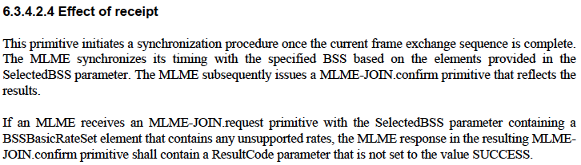

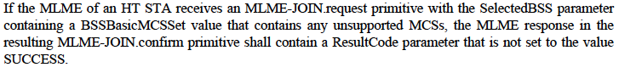

Again, the suggestion here is to follow the commenter’s suggested remedy to add a description in this clause (i.e., not only in clause 6.3.11.2.4 as suggested by the commenter, but also clause 6.3.4.2.4) on a restriction when there are any unsupported <VHT-MCS, NSS> tuples contained in the BSSBasicVHTMCS_NSSSet parameter.

Additional Problem #3: Clause 6.3.4.2.2:
Recall in Clause 9.3.1 on the following description related to VHT STAs:

“All VHT STAs that are members of a BSS are able to receive and transmit using all the <VHT-MCS, NSS> tuples indicated by the BSSBasicVHTMCS_NSSSet parameter of the MLME-START.request primitive or BSSBasicVHTMCS_NSSSet parameter of the BSSDescription representing the SelectedBSS parameter or the MLME-JOIN.request primitive (see 6.3.4.2.4 (Effect of receipt) and 6.3.11.2.4 (Effect of receipt)) except as constrained by the rules of 9.7.11 (Rate selection constraints for VHT STAs)”.

The MLME-JOIN.request primitive is in the following form:

MLME-JOIN.request(
SelectedBSS,
JoinFailureTimeout,
ProbeDelay,
OperationalRateSet,
HTOperationalMCSSet,
OperationalVHTMCS_NSSSet,
VendorSpecificInfo
)

As for the SelectedBSS parameter, it contains a number of parameters including BSSDescription (c.f., pages 109-114 of IEEE802.11-2012), which in turn consists of parameters, such as the BSSBasicRateSet parameter and OperationalRateSet parameter for all STAs that are members of a BSS, as well as the BSSBasicMCSSet parameter and HTOperationalMCSSet parameter for all HT STAs that are members of a BSS. Referring to the table of BSSDescription, however, both the BSSBasicVHTMCS_NSSSet parameter and the OperationalVHTMCS_NSSSet parameter for all VHT STAs that are members of a BSS are missing here. The suggestion here is to add these parameters to BSSDescription.

Proposed Resolution:
Revised.

TGac Editor: Please add the following in page 23 related to MLME-START.request primitive:
6.3.11.2.4 Effect of receipt

Insert as the second last paragraph:

If the MLME of a VHT STA receives an MLME-START.request primitive with a BSSBasicVHTMCS_NSSSet parameter containing any unsupported <VHT-MCS, NSS> tuple, the MLME response in the resulting MLME-START.confirm primitive shall contain a ResultCode parameter that is not set to the value SUCCESS.

TGac Editor: Please apply the following changes to Clause 6.3.11.2.2 in page 22 related to MLME-START.request primitive. Note that these changes are in response to “Additional Problem #1”.
MLME-START.request(
SSID,
SSIDEncoding,
BSSType,
BeaconPeriod,
DTIMPeriod,
CF parameter set,
PHY parameter set,
IBSS parameter set,
ProbeDelay,
CapabilityInformation,
BSSBasicRateSet,
OperationalRateSet,
Country,
IBSS DFS Recovery Interval,
EDCAParameterSet,
DESRegisteredLocation,
HT Capabilities,
HT Operation,
BSSMembershipSelectorSet,
BSSBasicMCSSet,
HTOperationalMCSSet,
Extended Capabilities,
20/40 BSS Coexistence,
Overlapping BSS Scan Parameters,
MultipleBSSID,
InterworkingInfo,
AdvertisementProtocolInfo,
RoamingConsortiumInfo,
Mesh ID,
Mesh Configuration,
QMFPolicy,
DMG Capabilities,
Multi-band,
Multiple MAC Addresses,
DMG Operation,
Clustering Control,
CBAP Only.
PCP Association Ready,
VHT Capabilities,
VHT Operation,
BSSBasicVHTMCS_NSSSet,
OperationalVHTMCS_NSSSet,
VendorSpecificInfo
)

TGac Editor: Please add the following entries to the table in page 23 related to MLME-START.request primitive:
Name | Type | Valid Range | Description
BSSBasicVHTMCS_NSSSet | Set of <VHT-MCS, NSS> tuples | As defined in 8.4.2.160 | The set of MCS and NSS tuples that shall be supported by all VHT STAs to join this BSS. The STA that is creating the BSS shall be able to receive and transmit at each of the MCS and NSS tuples listed in the set.
OperationalVHTMCS_NSSSet | Set of <VHT-MCS, NSS> tuples, constrained so that the MCS values are expressible using the encoding described for the Supported VHT-MCS and NSS Set field in 8.4.2.160.3 (Supported VHT-MCS and NSS Set field) | As defined in the Rx VHT-MCS Map and Rx Highest Supported Long GI Data Rate fields in the Supported VHT-MCS and NSS Set field in 8.4.2.160.3 (Supported VHT-MCS and NSS Set field) | The VHT-MCS values for each number of spatial streams that the STA desires to use for communication within the BSS. This set is a superset of the <VHT-MCS, NSS> tuples contained in the BSSBasicVHTMCS_NSSSet parameter.  The parameter is present if dot11VeryHighThroughoutOptionImplemented is true.

TGac Editor: Please add the following in page 15 related to MLME-JOIN.request primitive. . Note that these changes are in response to “Additional Problem #2”.
6.3.4.2.4 Effect of receipt

Insert as the last paragraph:

If the MLME of a VHT STA receives an MLME-JOIN.request primitive with a SelectedBSS parameter containing a BSSBasicVHTMCS_NSSSet parameter that contains any unsupported <VHT-MCS, NSS> tuple, the MLME response in the resulting MLME-JOIN.confirm primitive shall contain a ResultCode parameter that is not set to the value SUCCESS.

TGac Editor: Please append the following entries to the table in page. Note that these changes are in response to “Additional Problem #3”.
Name | Type | Valid Range | Description
BSSBasicVHTMCS_NSSSet | Set of <VHT-MCS, NSS> tuples | As defined in 8.4.2.160 | The set of MCS and NSS tuples that shall be supported by all VHT STAs to join this BSS. The STA that is creating the BSS shall be able to receive and transmit at each of the MCS and NSS tuples listed in the set.
OperationalVHTMCS_NSSSet | Set of <VHT-MCS, NSS> tuples, constrained so that the MCS values are expressible using the encoding described for the Supported VHT-MCS and NSS Set field in 8.4.2.160.3 (Supported VHT-MCS and NSS Set field) | As defined in the Rx VHT-MCS Map and Rx Highest Supported Long GI Data Rate fields in the Supported VHT-MCS and NSS Set field in 8.4.2.160.3 (Supported VHT-MCS and NSS Set field) | The VHT-MCS values for each number of spatial streams that the STA desires to use for communication within the BSS. This set is a superset of the <VHT-MCS, NSS> tuples contained in the BSSBasicVHTMCS_NSSSet parameter.  The parameter is present if dot11VeryHighThroughoutOptionImplemented is true.

