IEEE P802.11
Wireless LANs
LB190 - Comment Resolution
Date: Jan 10, 2013
Author(s):
Name | Affiliation | Address | Phone | email
Chao-Chun Wang | MediaTek |  |  | Chaochun.wang@mediatek.com
James Yee | MediaTek |  |  | james.yee@mediatek.com
Sigurd Schelstraete | Quantenna |  |  | sigurd@quantenna.com
Brian Hart | Cisco |  |  | Brian.Hart@Cisco.com
Abstract
This document provides resolution for the following CIDs:
7201, 7202, 7203, 7247, 7248, 7249, 7228, 7246, 7384, 7204

The comments are based on D4.0.
Edits for the proposed resolutions are based on D4.0.

Note for version r3.
Only the CID highted in green were resolved. The rest CIDs will be presented again after further revising.

- Note for version r4.
- Resolving CID 7201, 7202, and 7203.

CID | Clause Number | Page | Line | Comment | Proposed Changes
7203 | 8.4.2.162 | 102 | 36 | The description for the 160 MHz Utilization fields is does not match the formula. The formula does not make sense. The field is described as the "percentage of time that the 160 MHz or 80+80 MHz channel was busy". However, the formula would suggest that it is the percentage of time the primary 160/80+80 MHz channel is busy while CCA indicates busy. The only definition in the spec for "160/80+80 MHz channel busy" is CCA(BUSY, {primary}) or CCA(BUSY, {secondary}) or CCA(BUSY,{secondary40}) or CCA(BUSY,{secondary80}). So the formula is really saying time(CCA(BUSY, {primary})+CCA(BUSY, {secondary})+CCA(BUSY,{secondary40})+CCA(BUSY,{secondary80}))/time(CCA(BUSY,{primary})+CCA(BUSY,{secondary})+CCA(BUSY,{secondary40}+CCA(BUSY,{secondary80}), which 1. Clearly this is useless. | Remove the 160 MHz Utiliation field
7202 | 102.29 | 29 | 8.4.2.162 | The description for the 80 MHz Utilization fields is does not match the formula. The formula does not make sense. The field is described as the "percentage of time that the primary 80 MHz channel was busy". However, the formula would suggest that it is the percentage of time the primary 80 MHz channel is busy while CCA indicates busy. The only definition in the spec for "primary 80 MHz channel busy" is CCA(BUSY, {primary}) or CCA(BUSY, {secondary}) or CCA(BUSY,{secondary40}). So the formula is really saying time(CCA(BUSY, {primary})+CCA(BUSY, {secondary})+CCA(BUSY,{secondary40}))/time(CCA(BUSY,{primary})+CCA(BUSY,{secondary})+CCA(BUSY,{secondary40}+CCA(BUSY,{secondary80}), which is really the percentage of time the primary 80 MHz channel is busy relative to the time any of the subchannels are busy. It is not clear how a STA benefits from this information. | Remove the 80 MHz Utiliation field
7201 | 102.22 | 22 | 8.4.2.162 | The description for the 40 MHz Utilization fields is does not match the formula. The formula does not make sense. The field is described as the "percentage of time that the 40 MHz channel was busy". However, the formula would suggest that it is the percentage of time the primary 40 MHz channel is busy while CCA indicates busy. The only definition in the spec for "primary 40 MHz channel busy" is CCA(BUSY, {primary}) or CCA(BUSY, {secondary}). So the formula is really saying time(CCA(BUSY, {primary})+CCA(BUSY, {secondary}))/time(CCA(BUSY,{primary})+CCA(BUSY,{secondary})+CCA(BUSY,{secondary40}+CCA(BUSY,{secondary80}), which is really the percentage of time the primary 40 MHz channel is busy relative to the time any of the subchannels are busy. It is not clear how a STA benefits from this information. | Remove the 40 MHz Utilization field

Discussion:

The 40 (80, 160) MHz channel utilization field is defined as the percentage of time, linearly scaled with 255 representing 100%, that the primary 40 (80, 160) MHz channel was busy.

This percentage is computed using the formula,

40 MHz Utilization = 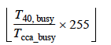

80 MHz Utilization = 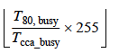,

160 MHz Utilization = 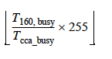

“where T_{cca_busy} is the number of microseconds during which the CS mechanism, as defined in 9.3.2.2 (CS mechanism), has indicated a channel busy condition.

T_{40, busy}, T_{80, busy}, and T_{160, busy} are defined to be the number of microseconds during which the AP was transmitting a 40 MHz PPDU to a VHT STA, 80 MHz PPDU, or a 160 MHz PPDU respectively.”

The commenter points out that “ … . However, the formula would suggest that it is the percentage of time the primary 80 MHz channel is busy while CCA indicates busy. The only definition in the spec for "primary 80 MHz channel busy" is CCA(BUSY, {primary}) or CCA(BUSY, {secondary}) or CCA(BUSY,{secondary40}). So the formula is really saying

time(CCA(BUSY, {primary})+CCA(BUSY, {secondary})+CCA(BUSY,{secondary40}))

_____________________________________________________________________________

time(CCA(BUSY,{primary})+CCA(BUSY,{secondary})+CCA(BUSY,{secondary40}+CCA(BUSY,{secondary80}),

which is really the percentage of time the primary 80 MHz channel is busy relative to the time any of the subchannels are busy.”

In “22.3.19.5.3 CCA sensitivity for signals occupying the primary 20 MHz channel”,
“The PHY shall issue a PHY-CCA.indication(BUSY, {primary}) if one of the conditions listed in Table 22-27 (Conditions for CCA BUSY on the primary 20 MHz) is met in an otherwise idle 20 MHz, 40 MHz, 80 MHz, 160 MHz or 80+80 MHz operating channel width.”

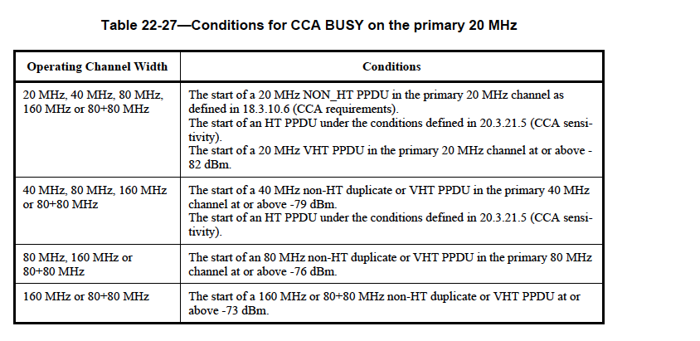

In the case that an operating channel is 80Mhz or above, according to table Table 22-27 “Conditions for CCA BUSY on the primary 20 MHz,” the PHY shall issue a PHY-CCA.indication(BUSY, {primary}), when “The start of an 80 MHz non-HT duplicate or VHT PPDU in the primary 80 MHz channel at or above -76 dBm. “.

That is if the operating channel is 80Mhz and the signal level is above -76 dBm in the primary 80MHz channel, the PHY shall issue a PHY-CCA.indication(BUSY, {primary}.

It is clear that the original definition is vague. Since PHY-CCA.indication(BUSY, {primary}) already captures the loading information of pimary 20MHz plus usable secondary channels of the operating channel, what should really by measured is the loading on the secondary channel over a measureing period.

- The socndary channel is busy either because there is data traffic or interference. By providing the secondary channel loading information, an AP can figure out the true loading of the secondary channels.

As for the last part of the comments, “It is not clear how a STA benefits from this information”, it is really up to an implementor to decide how to take advantage of this information.

Proposed Response:

Revised

Proposed Resolution Text:

Revising 8.4.2.162

8.4.2.162 Extended BSS Load element

[D 4.0. p 126, line 32-33]
The Extended BSS Load element reported by the AP contains information on MIMO spatial stream underutilization and bandwidth utilization by MU capable STAs. The element format is defined in Figure 8- 401bx. A STA receiving the element might use the information it conveys in an implementation specific AP selection algorithm.

[D 4.0. p 126, line 38-46] revising the following diagram

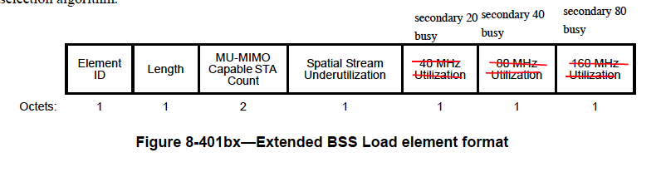
……..

[D 4.0. p 127, line 5]

T_{busy} is the number of microseconds during which CCA indicated the channel was busy during the measurement duration. The resolution of the CCA busy measurement is in microseconds.

…….

Delete [D 4.0. p 127, line 21 – 60] (in red box) and replaced with the following;
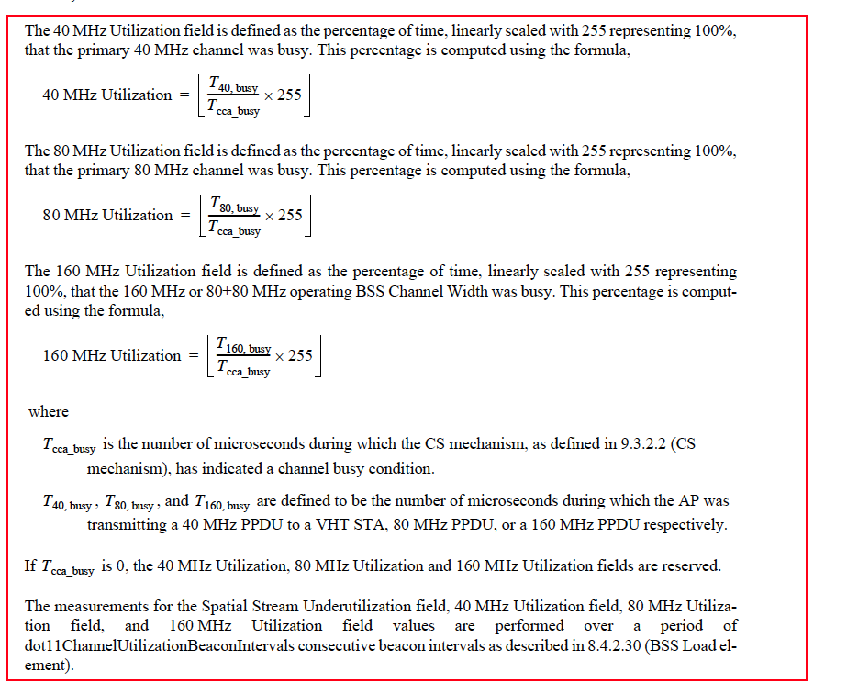
- The measurement of the observable loading on each of the secondary 20, 40 and 80 MHz channels in conjunction with the measurement on the primary 20 MHz channel provide a STA with the loading on 40the , 80, 160, and 80+80MHz channels.

- The Secondary W1 Channel Busy Time is computed as the sum of the times from PHY-CCA.indication(BUSY,{W2}) to the next issue of a PHY-CCA.indication primitive and that overlap the measurement interval, for W1 = 20, 40 or 80, and where W2 equals secondary, secondary40 or secondary80 for W1 = 20, 40 or 80 respectively.

- The Observable Secondary 20, 40, and 80 MHz Utilization fields are defined using the formula,

- Observable Secondary W1 Utilization = Integer((Secondary W1 Channel Busy Time /(dot11ChannelUtilizationBeaconIntervals X dot11BeaconPeriod X 1024)) X 255),

- where dot11ChannelUtilizationBeaconIntervals represents the number of consecutive beacon intervals during which the secondary channel busy time is measured.

CID | Clause Number | Page | Line | Comment | Proposed Changes
7247 | 102.03 | 3 | 8.4.2.162 | Clarify N_max_SS | Replace "N_max_SS is the maximum number of spatial streams" with "N_max_SS is the maximum number of spatial streams supported by the AP"

Discussion:

The proposed editorial change makes the sentence clearer.

Proposed Response:

Accept.

Proposed Resolution Text:

Replace "N_max_SS is the maximum number of spatial streams" with "N_max_SS is the maximum number of spatial streams supported by the AP"

CID | Clause Number | Page | Line | Comment | Proposed Changes
7248 | 102.19 | 19 | 8.4.2.162 | What is the reserved value of the Spatial Stream Underutilization field?  It seems all values 0-255 are currently allowed. How does the AP report that no measurement could be made because T_busy is 0? | Specify reserved value
7249 | 102.54 | 54 | 8.4.2.162 | What is the reserved value of the 40 MHz Utilization, 80 MHz Utilization and 160 MHz Utilization fields?  How does the AP report that no measurement could be made because T_cca_busy is 0? | Specify reserved value

Discussion:

[7248]

The latest draft says, “If T_busy is 0, the Spatial Stream Underutilization field is reserved.”, but failed to specify a value.

[7249]

The latest draft says, “If T_cca__busy is 0, the 40 MHz Utilization, 80 MHz Utilization and 160 MHz Utilization fields are reserved.”, but failed to specify a value.

Since the cca_busy including transmitting and receiving operations, the only possibility that cca_busy is the AP is idle. As the result, the numerator and denominator of the formula are both zero. Accordingly 0/0 = 0.

Even thought the formula can’t differentiate whether the AP is not measuring or the numerator is zero. It is a common understanding that the AP will not send out BSS load information if it is not measuring.

Since reserved value in MAC is zero. There is no need to explicitly specifying a value.

Proposed Response:

Reject.
The reserved value means zero.

Proposed Resolution Text:

CID | Clause Number | Page | Line | Comment | Proposed Changes
7228 | 96.08 | 8 | 8.4.2.160.2 | I can imagine why TX VHT-MCS Map is required e.g. for link adaptation. But from VHT sounding protocol in 9.31.5, no STA will check SU Beamformer Capable. A VHT beamformee will accepted NDP Announcement that is addressed to it. | Remove "SU Beamformer Capable" otherwise give me the reason why "SU Beamformer Capable" is required.  The same change or reason should be also applied to "MU Beamforming Capable".

Discussion:

This bit is helpful for an STA to choose to associate with a “beamformer capable” AP if the STA is beamforming capable.

Proposed Response:

Reject

The bit is helpful for an STA to choose to associate with a “beamformer capable” AP if the STA is beamforming capable.

CID | Clause Number | Page | Line | Comment | Proposed Changes
7246 | 97.36 | 36 | 8.4.2.160.1 | Definition of "Compressed Steering number of beamformer Antennas Supported" needs further conditions for MU-capable STA | In the case of MU capable STA, the value of the field should be the minimum of N_STS,total and the max # streams the STA can receive in an NDP - since there is no requirement that these values are actually the same

Discussion:

It makes sense for the three values listed in the description of the “Compressed Steering number of beamformer Antennas Supported” to be identical. However, it is a priori possible to design a system where this is not the case. Specifically, the sounding capabilities could exceed the capabilities of receiving data PPDUs (as is the case in SU). Equality is implied in the standard. In order to remove any ambiguity, it is proposed to add the below text to section 9.31.5.2 (D4.2).

With the proposed change, the comment is resolved and no change is needed to the definition or encoding of the field "Compressed Steering number of beamformer Antennas Supported" in Table 8-138v (D4.2).

Proposed change in 9.31.5.2:

----- Start of modified text -----

(…) The TXVECTOR parameter CH_BANDWIDTH of the PPDU containing the VHT Compressed Beamforming feedback shall be set to indicate a bandwidth not wider than that indicated in the RXVECTOR parameter CH_BANDWIDTH of the received VHT NDP frame. A STA ignores received VHT NDP Announcement, VHT NDP, and Beamforming Report Poll frames if dot11VHTSUBeamformeeActivated is false.

A VHT Beamformee shall indicate the maximum number of space-time streams it can receive in a VHT NDP in the (currently named) “Compressed Steering number of beamformer Antennas Supported” Field. If the Beamformee is a non-AP STA, this shall also be the maximum total number of space-time streams (N_STS,total) that the STA can receive in a VHT MU PPDU.

An example of the VHT sounding protocol with a single VHT beamformee is shown in Figure 9-41a.

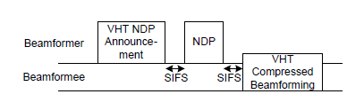

Figure 9-41a—Example of the sounding protocol with a single VHT beamformee

----- End of modified text -----

CID | Clause Number | Page | Line | Comment | Proposed Changes
7384 | 97.36 | 36 | 8.4.2.160.2 | "Compressed Steering Number of Beamformer Antennas Supported" field name does not match definition/encoding | Come up with a better name for the field

Discussion:

It’s true that a field by the same name exists in 802.11n. However, the description of the field in both standards (11n and 11ac) is significantly different.

Compare:

11n | 11ac
Indicates the maximum number of beamformer antennas the beamformee can support when compressed beamforming feedback matrix is required | The maximum number of space-time streams that the STA  can receive in a VHT NDP, the maximum value for NSTS,total  that can be sent to the STA in a VHT MU PPDU if the STA is  MU beamformee capable and the maximum value of Nr that  the STA transmits in a VHT Compressed Beamforming frame.
Table 1: definition of “Compressed Steering Number of Beamformer Antennas Supported” in 11n and 11ac
Note the differences:
- “Antennas” (11n) vs. “Space-time streams” (11ac)
- Explicit reference to compressed feedback for 11n, while this is superfluous for 11ac since it is the only allowed feedback format
- Sounding-only for 11n, while 11ac mentions both sounding and reception of data frames and adds references to MU

These differences justify a change in name to better cover the use of this field in 11ac.

Proposal:
The following new name is proposed: “Beamformee STS capability”

Note: references to this field (as it applies to 11ac) also appear in:
- 8.4.2.1.160.2 (Figure 8-401bq and Table 8-183v)
- 9.29.3
- 9.31.6
- 22.3.11.3
- 9.31.5.2 (if proposed resolution to comment 7246 is accepted)
(All references are according to D4.2)
If a change in naming is accepted, the change should also be reflected in those places. It should not be changed in places where it refers to the 11n field.

CID | Clause Number | Page | Line | Comment | Proposed Changes
7204 | 98.11 | 11 |  | The describition for TXOP Power Save Mode for a non-AP STA sounds like it reports its current operating mode. Is the expectation that the STA changes is its TXOP Power Save behavior after association? If so, how does this get signaled to the AP (I don't see any description for this)? It is not clear to me that this is even necessary (signaling operating mode). | Make the VHT TXOP PS field indicate a capability not a mode of operation. Change definition to "Indicates support for VHT TXOP Power Save. Change the encoding to "Set to 0 if not supported. Set to 1 if supported."

Discussion:

Agree with the comment

Proposed Response:

Revised.

Replace the definition of VHT capabilities infor field, VHT TXOP PS encoding field with

“
Set to 0 when the VHT STA does not support TXOP Power Save Mode.
Set to 1 when the VHT STA supports TXOP Power Save Mode.

“

