IEEE P802.11 Wireless LANs
Proposed802.11ai Specification Text for AP/Network Status Information
Date:2012-11-04
Author(s):
Name | Affiliation | Address | Phone | email
Lei Wang | InterDigital Communications | 781 Third Ave., King of Prussia, PA 19406 | 1 858 205 7286 | leiw@billeigean.com
Jing-Rong Hsieh | HTC Corp. | 1F, 6-3 Baoqiang Road, Xindian district, New Taipei City, Taiwan |  | jing_hsieh@htc.com
KatsuoYunoki | KDDI R&D Laboratories | 3-10-10 Iidabashi, Chiyoda-ku, Tokyo, Japan | +81 80-6744-6231 | yunoki@kddilabs.jp
Dapeng Liu | China Mobile | 32 Xuanwumen West Street Beijng, Xicheng District, 100053 China | +86-13911788933 | liudapeng@chinamobile.com
Abstract
This submission proposesthe 802.11ai specification text for the AP/Network Status information in Beacon / Probe Response, based on the feature described in Section 6.3,4 in the 802.11ai Specification Framework Document (SFD), 12/0151r13[Ref-1], and also based on a further detailed proposal in Contribution 12/1272[Ref-5].
The numbering of the clauses is taken from 2012 revision of IEEE802.11 standard [Ref-2].

Introduction
To facilitate a fast initial link setup, a high-level description about the feature of providing AP availability indicator in Beacon / Probe Responsehas been accepted in Subsection, 6.3.4, in the 802.11ai Specification Framework Document (SFD), 12/0151r13[Ref-1].
The 802.11Task Group (TGai) has issued a new call for contributions for Specification Tex for the TGai detailed Draft Text,12/0992r1[Ref-4].
As a response to the TGai Call-for-Contributions, this document proposes further detailed text for TGaiSpecification Document, to provide detaileddescriptions / specifications for the feature of the AP availability information provisioning.

Conventions
In this contribution, the proposed 802.11ai Specification Document text will be presented as an amendment text based on the baseline 802.11 standard, 802.11-2012 [Ref-2]. The following format conventions are used:
- The new added text is marked asblue underline text;
- The deleted text is marked asred strikethrough text;
- The unchanged baseline standard text stays in black text in the context of proposedTGai specification text;
- The editorial instruction is marked asitalic text highlighted by Yellow;
- The quoted TGai SFD text is marked as green italic text; and
- Any other text, e.g., discussions, proposed motions, etc., is in black text, but not in the context of proposed TGai specification text.

Background
Based on Subsection 6.3.4 in TGai Specification Framework Document (SFD) [Ref-1], the following text is included to provide a high-level description about the feature of provisioning the AP availability indicator:
AP may include an indicator for AP availability to attachment to the Beacon and Probe Response.

In additions, multiple contributions have been submitted to TGai previously to provide further details about this feature. The following are some examples:
  - KDDI: 11/1565r0[Ref-6], AP Status Broadcast
    - include IEs, e.g., BSS load or other IEs related with AP status and performance in Beacon.
    - Include WAN Status info in GAS Query Response;
  - China Mobile contribution: 12/0545r1[Ref-7], Access Control Mechanism for FILS
    - In 11ai management frames, e.g.: beacon, probe response , GAS, carry the network load information for STA’s AP/Network selection:
    - the congestion information of the AP; The available bandwidth information etc.
  - HTC contribution: 12/1051r2[Ref-8], Multi-channel information for AP discovery
    - AP can attach the loading information of BSSs on other channels in the probe response and beacon, e.g., A condensed and aggregated loading information; Use a coarser unit to represent info such as BSS load, BSS Average access delay, BSS Available Admission Capacity
The purpose of providing AP availability information in Beacon/Probe Response is for the STA to have a fast AP/Network selection, by avoiding selecting a congested or near-congested AP/Network and also by avoiding the query overhead. Note that AP Availability info in Beacon / Probe Response is not about the physical link availability, as it assumes that the STA already can receive Beacon / probe response.
Based on the previous relevant TGai contributions, a new contribution, 12/1272[Ref-5], is submitted to provide further supporting materials for the text proposal of this contribution, where AP availability information is proposed to be presented by:
- BSS/AP status/load indicators; and
- Access Network link, or called Backhaul Link, status/load indicators.
In addition, it proposes to use the BSS Load IE as defined in Subsection 8.4.2.30 in 802.11-2012 standard[Ref-2], as theBSS/AP Status/load Indicator, and define a new IE, called Backhaul Link Status IE to carry the Backhaul Link Status/Load indicators.

Proposed 802.11ai Specification Text
Instructions to Editor: insert the following paragraph as the last paragraph in Subsection 8.4.2.30 in the 802.11-2012 standard:
If the value of dot11FILSActivated is true, the BSS Load IE shall be included in Beacon and Probe Response frames.

Instructions to Editor: insert the following new subsection underSubsection 8.4.2 in the 802.11-2012 standard:

8.4.2.ai1 Backhaul Link Status Element
The Backhaul Link Status Element provides the status information of the Backhaul link that connects the BSS/AP to external networks. The format of the Backhaul Link Status element is defined in Figure 8-ai-1.

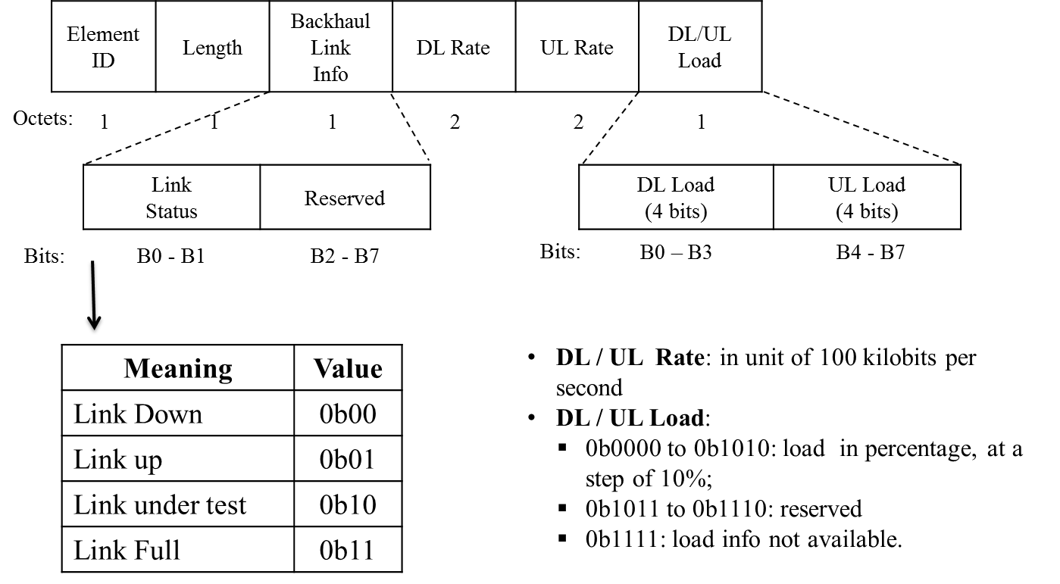
Figure 8-ai-1 Backhaul Link Status Element Format

The Element ID field is set to the value given in Table 8-54 for this element.
The Length field is set to 6 octets.
The 2-bit Link Status subfield in the Backhaul Link Information field indicates the operational status of the backhaul link. When it sets to “Link Full” status, i.e., 0b11, it indicates that the backhaul link is operating at capacity and no additional devices will be permitted to associate with the AP/BSS.
The 2-byte Downlink (DL)Rate field is a positive integer whose value is an estimate of the Backhaul link current downlink rate in unit of 100 kilobits per second. The Downlink refers to the backhaul link direction from external network to the BSS/AP. For backhaul links that do not vary in rate or those for which no accurate estimation can be made, this attribute contains the nominal rate. If the backhaul downlink rate is greater than the maximum value of this field, the maximum value is reported. The downlink rate value is set to zero when the downlink rate is unknown.
The 2-byte Uplink (UL)Rate Field is a positive integer whose value is an estimate of the Backhaul link's current uplink speed in unit of 100 kilobits per second. The Uplink refers to the backhaul link direction from the AP/BSS to external network. For backhaul links that do not vary in rate or those for which no accurate estimation can be made, this attribute contains the nominal rate. If the backhaul uplink rate is greater than the maximum value of this field, the maximum value is reported. The uplink rate value is set to zero when the uplink rate is unknown.
The 4-bit Downlink Load field is a coded indicator, representing the current percentage loading of the downlink backhaul connection. In cases where the downlink load is unknown to the AP, the value is set to 0b1111. The algorithm to calculate downlink load and the measurement duration are implementation dependent.
The 4-bit Uplink Load field is a coded indicator, representing the current percentage loading of the uplinkbackhaul connection. In cases where the downlink load is unknown to the AP, the value is set to 0b1111. The algorithm to calculate downlink load and the measurement duration are implementation dependent.
If the value of dot11FILSActivated is true, the Backhaul Link Status IE shall be included in Beacon and Probe Response frames.

Instructions to Editor: insert a row of the Backhaul Link Status IE in Table 8-54 in the 802.11-2012 standard:
Table 8-54—Element IDs
Element | Element ID | Length of indicated element (in octets) | Extensible
......
Backhaul Link Status (see 8.4.2.ai1) | 143 | 6
Reserved | 143144– 173
......

Instructions to Editor: insert a row of the Backhaul Link Status IE in Table 8-115 as a new subelement for the neigbhor report in the 802.11-2012 standard:
Table 8-115 —Optional subelement IDs for neighbor report
Subelement ID | Name | Length field  (octets) | Extensible
......
72 | Backhaul Link Status | 6
7273– 220 | Reserved
......

Instructions to Editor: insert the following paragraph in Subsection 8.4.2.39, near the end, before the paragraph starting with “The Vendor Specific ...”, in the 802.11-2012 standard:
The Backhaul Link Status subelement is the same as the Backhaul Link Status element as defined in 8.4.2.ai1.

Straw-Polls and Motions
The following lists the draft straw-polls and motions that are intended to present to the TGai Group in next Face-to-Face meeting.
Motion-1: Include the text proposed in Section 4 of this contribution (12/1271) into the TGai Draft Specification Document (D0.1).

Move:
Second:

Result: Yes: ____________; No: _________________; Abstain: _____________________

References:
- 11-12-0151-13-00ai-Proposed-Specification-Framework-Document.docx
- IEEE Std 802.11 – 2012
- IEEE Std 802.11ai/D0.1
- 11-12-0992-01-00ai-call-for-specification-text-contributions-for-the-tgai-detailed-draft-text
- 11-12-1272-00-00ai-AP-Network-status-info
- 11-11-1565-00-00ai-ap-status-broadcast
- 11-12-0545-01-00ai-access-control-mechanism-for-fils
- 11-12-1051-02-00ai-multi-channel-information-for-ap-discovery

