IEEE P802.11 Wireless LANs
Proposed 802.11ai Specification Text for
Probe Request based Rapid Scan
Date: 2012-11-01
Author(s):
Name | Affiliation | Address | Phone | Email
Jonathan Segev | Intel | Em Hamoshavot 94  Azorim Park, Israel | +972-54-2403587 | jonathan.segev@intel.com
Adrian Stephens | Intel |  |  | adrian.stephens@intel.com
Abstract
The submission proposes 802.11ai specification text for Active Scanning enhancement,
The numbering of the clauses is taken from 2012 revision of IEEE802.11 standard [Ref-2].

Background
To facilitate a fast initial link setup, a method for quick and efficient discovery of FILS APs as an enhancement to scanning procedure is provided. The procedure is used when there is no prior knowledge of FILS AP STAs over one or more scanned channels.
The procedure enables the discovery of FILS AP operating on the channel by using the existing Probe Request message sent to a reserved unicast address indicating FILS capability addressee. The Probe Request is thus ACKed by FILS capable AP STAs. If an ACK is detected or the CCA identifies FALSE (channel is busy) post the SIFS, the request STA infers FILS capable AP coverage of the channel else it infers no FILS capable AP available on the channel and switches to the next channel or complete end the search instance.
The main advantages of using the procedure are:
- The enhanced Active Scan procedure is more efficient in latency wise, reducing latency factor of x10 – x20 for AP discovery.
- It furthers reduces PWR by x10-x20 factor due the shortened procedure enabling sampling of the channel at a much higher rate using same PWR and much shortened latency.
- It prevents a Probe Response storm and substantially reduces medium usage of on channel without 11ai coverage. Refer to IEEE 802.11-12/1033r1 and XXX
- The Rapid Scan can enhance both Active and Passive Scan procedures as the 2nd stage of AP identity discovery can use both procedures.
As a response to the TGai Call-for-Contributions, this document proposes detailed text for TGai Specification Document, for the passive scanning enhancement related features / functionalities, based on the TGai SFD.

Conventions
In this contribution, the proposed 802.11ai specification Document text will be presented as an amendment text based on the baseline 802.11 standard, 802.11-2012 ‎[Ref-2] and preceding amendments. The following format conventions are used:
- The new added text is marked as blue underline text;
- The deleted text is marked as red strikethrough text;
- The unchanged baseline standard text stays in black text in the context of proposed TGai specification text;
- The editorial instructions are marked as [parenthesis italic bold text highlighted by Yellow];
- Values that are under control of ANA (Assigned Numbers Authority) are marked <ANA>.
- The quoted TGai SFD text is marked as green italic text; and
- Any other text, e.g., discussions, proposed motions, etc., is in black text, but not in the context of proposed TGai specification text.

Proposed 802.11ai Specification Text

[Insert a subclause 9.3.2.8x as follows:
9.3.2.8x ACK of Probe Request Frames
A FILS capable AP or a FILS capable IBSS STA that receives a Probe Request frame with the DA field set to <ANA assigned OUI> shall transmit an ACK frame as described in 9.3.2.8. A STA that transmits a Probe Request using the Rapid Scan procedure interprets any response as described in 10.1.4.4. The RA field of ACK frame shall be set to TA field of the triggering Probe Request.

[Modify 3rd paragraph in subclause 10.1.4.1 as follows:]
To actively scan, the STA shall transmit Probe request frames containing the desired SSID or one or more SSID List elements. When the SSID List element is present in the Probe Request frame, one or more of the SSID elements may include a wildcard SSID (see 8.4.2.2). The exact procedure for determining the SSID or SSID List values in the MLME-SCAN.request primitive is not specified in this standard. When a STA scans for a BSS whose AP does not support the SSID List element, or for a BSS for which AP support of the SSID List element is unknown, the SSID element with an SSID or wildcard SSID shall be included in the MLME-SCAN.request primitive. Upon completion of scanning, an MLME-SCAN.confirm primitive is issued by the MLME indicating all of the BSS information
received. In addition to the Active Scan or Passive Scan, a FILS capable STA may also use the Rapid Scan procedure to identify likely FILS capable AP coverage of the scanned channels. If the STA identifies AP coverage on one or more channels it shall continue and identify the APs by decoding the following Probe Response messages as described below.

NOTE—MLME-SCAN.request primitives and resulting Probe Request frames may include a Request element that can be used to request radio measurement information from the scanned BSSs. Requested radio measurement information from the scanned BSSs is included in the Probe Response frames and in the MLME-SCAN.confirm primitive.

[Modify subclause 10.1.4.3.3 as follows:]
10.1.4.3.3 Active scanning procedure
Upon receipt of the MLME-SCAN.request primitive with ScanType indicating an active scan, a STA shall use the following procedure:
If the STA is a non AP, FILS capable STA and the dot11FilsOptionRapidScanImplemented is set to true, the STA may execute the Rapid Scanning procedure (refer to 10.1.4.4) as part of the Active scanning procedure.
For each channel to be scanned which may be a subset of the ChannelList if the Rapid Scanning procedure has been executed:
….

[Insert a new subclause after subclause 10.1.4.3.3:]
10.1.4.4 Rapid Scanning procedure
10.1.4.4.1 Introduction
Rapid Scanning is a process of identifying the existence of AP coverage over the scanned channels enabling the STA to quickly and efficiently identify channels with APs supporting Rapid Scan from the set of channels requested by MLME-SCAN.request primitive. Implementation of the Rapid Scan is mandatory for FILS capable AP STA. A STA may perform the Rapid Scan procedure on any subset of the ChannelList.

10.1.4.4.2 Rapid scanning procedure
For each channel to be scanned preform the following procedure:
a) Wait until the ProbeDelay time has expired or a PHYRxStart.indication primitive has been received.
b) Perform the Basic Access procedure as defined in 9.3.4.2.
c) Send a Rapid Scan request frame to the broadcast destination address if a wildcard BSSID is indicated in the MLME-Scan.Request or to a unicast destination address if the specific BSSID is indicated in the MLME-Scan.Request.
d) Set to 0 and start a ProbeTimer.
e) If PHY-CCA.indication (busy) primitive has been detected before the ProbeTimer reaches ACKTimeout (as defined in 9.3.2.8), perform Active or Passive Scan procedure or mark the channel as valid for subsequent Active or Passive Scan, else set NAV to 0 and scan next channel.

See figure 10-x:
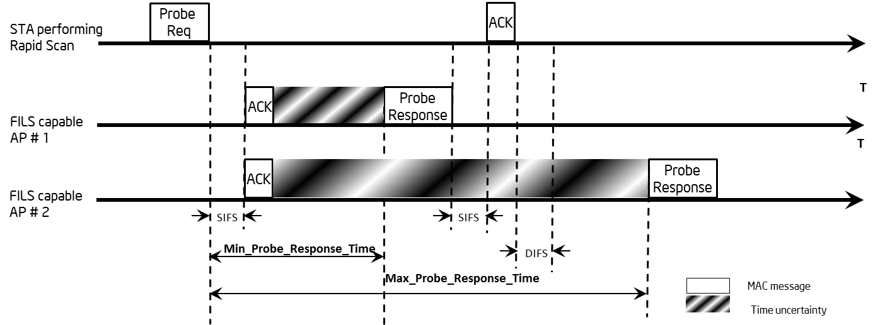

Figure 10-x Rapid Scan

References:
- 11-12-xxxx-00-00ai-Rapid Scanning.pptx
- 11-12-1033-01-00ai-Rapid Scanning.pptx
- 11-12-1040-02-00ai-tgai-spec-text-for-rapid-scanning.docx

