IEEE P802.11 Wireless LANs
Proposed 802.11ai Specification Text for Active Scanning Enhancement
Date: 2012-09-11
Author(s):
Name | Affiliation | Address | Phone | Email
Jonathan Segev | Intel | Em Hamoshavot 94  Azorim Park, Israel | +972-54-2403587 | jonathan.segev@intel.com
Adrian Stephens | Intel |  |  | adrian.stephens@intel.com
Mark Hamilton | Polycom | 1765 W 121st Ave, Westminster, CO, USA | +1-720-8727445 | Mark.Hamilton@polycom.com
Giwon Park | LGE |  |  | giwon.park@lge.com
Kiseon Ryu | LGE |  |  | kiseon.ryu@lge.com
Abstract
The submission proposes 802.11ai specification text for Active Scanning enhancement,
The numbering of the clauses is taken from 2012 revision of IEEE802.11 standard [Ref-2].

Background
To facilitate a fast initial link setup, a method for quick and efficient discovery of FILS APs as an enhancement to scanning procedure is provided. The procedure is used when there is no prior knowledge of FILS AP STAs over one or more scanned channels.
The procedure enables the discovery of FILS AP operating on the channel by using a new control message Rapid Scan Request sent to a group broadcast address which is ACKed by FILS capable AP STAs. If no ACK is detected infers no AP supporting the Rapid Scan Procedure exists thus no FILS support exists for this channel by any AP.
The STA then moves to the next channel in search for FILS capable AP.
The main advantages of using the procedure are:
- Since there is a x20 factor between the Active Scan and Rapid scan procedure durations the non AP STA is able to identify the AP with a much lower delay and lower power enabling a higher polling rate. Refer to IEEE 802.11-12/1033r1.
- Substantially reduces medium usage on non 11ai channels.
- The Rapid Scan can enhance both Active and Passive Scan procedures as the 2nd stage of AP identity discovery can use both procedures.
As a response to the TGai Call-for-Contributions, this document proposes detailed text for TGai Specification Document, for the passive scanning enhancement related features / functionalities, based on the TGai SFD.

Conventions
In this contribution, the proposed 802.11ai specification Document text will be presented as an amendment text based on the baseline 802.11 standard, 802.11-2012 ‎[Ref-2] and preceding amendments. The following format conventions are used:
- The new added text is marked as blue underline text;
- The deleted text is marked as red strikethrough text;
- The unchanged baseline standard text stays in black text in the context of proposed TGai specification text;
- The editorial instructions are marked as [parenthesis italic bold text highlighted by Yellow];
- Values that are under control of ANA (Assigned Numbers Authority) are marked <ANA>.
- The quoted TGai SFD text is marked as green italic text; and
- Any other text, e.g., discussions, proposed motions, etc., is in black text, but not in the context of proposed TGai specification text.

Proposed 802.11ai Specification Text

[Modify table 8-1a in subclause 8.2.4.1.3 ]

Table 8-1a - Valid type and subtype combinations
Type value  b3 b2 | Subtype value  b7 b6 b5 b4 | Control Frame Extension value  b11 b10 b9 b8 | Description
01 | 0110 | 0000 | Reserved
01 | 0110 | 0001 | Reserved
01 | 0110 | 0010 | Poll
01 | 0110 | 0011 | SPR
01 | 0110 | 0100 | Grant
01 | 0110 | 0101 | DMG CTS
01 | 0110 | 0110 | DMG DTS
01 | 0110 | 0111 | Grant ACK
01 | 0110 | 1000 | SSW
01 | 0110 | 1001 | SSW-Feedback
01 | 0110 | 1010 | SSW-ACK
<ANA> | <ANA> | <ANA> | Rapid Scan Req
01 | 0110 | 1011 1100-1111 | Reserved

[Insert a new subclause 8.3.1.x:]
8.3.1.x Rapid Scan Request frame format
The format for the Rapid Scan Request frame is shown in table 8-xxx.
 | Frame control | Duration | RA | FCS
Octets | 2 | 2 | 6 | 4

The Duration field is set to include the duration in microseconds required to transmit one ACK frame plus one SIFS interval.
The RA field is set to the broadcast group address or the unicast BSSID as received from the MLME-Scan.Req

[Insert a subclause 9.3.2.8x as follows:
9.3.2.8x ACK of Rapid Scan Request Frames
A FILS capable AP or a FILS capable IBSS STA that receives a Rapid Scan Request frame shall transmit an ACK frame as described in 9.3.2.8 if the RA field is set to the group broadcast address or if the RA field matches is BSSID. A STA that transmits a Rapid Scan Request frame interprets any response as described in 10.1.4.4. The RA field of ACK frame shall be set to group broadcast address

[Modify 3rd paragraph in subclause 10.1.4.1 as follows:]
To actively scan, the STA shall transmit Probe request frames containing the desired SSID or one or more SSID List elements. When the SSID List element is present in the Probe Request frame, one or more of the SSID elements may include a wildcard SSID (see 8.4.2.2). The exact procedure for determining the SSID or SSID List values in the MLME-SCAN.request primitive is not specified in this standard. When a STA scans for a BSS whose AP does not support the SSID List element, or for a BSS for which AP support of the SSID List element is unknown, the SSID element with an SSID or wildcard SSID shall be included in the MLME-SCAN.request primitive. Upon completion of scanning, an MLME-SCAN.confirm primitive is issued by the MLME indicating all of the BSS information
received. In addition to the Active Scan or Passive Scan, a STA may also use the Rapid Scan procedure to identify likely AP coverage the scanned channels. If the STA identifies AP coverage on one or more channels it may than proceed to identifying the APs using Active or Passive scan procedures on those channels.

NOTE—MLME-SCAN.request primitives and resulting Probe Request frames may include a Request element that can be used to request radio measurement information from the scanned BSSs. Requested radio measurement information from the scanned BSSs is included in the Probe Response frames and in the MLME-SCAN.confirm primitive.

[Modify subclause 10.1.4.3.3 as follows:]
10.1.4.3.3 Active scanning procedure
Upon receipt of the MLME-SCAN.request primitive with ScanType indicating an active scan, a STA shall use the following procedure:
If the STA is a non AP, FILS capable STA and the dot11FilsOptionRapidScanImplemented is set to true, the STA may execute the Rapid Scanning procedure (refer to 10.1.4.4) prior to the following Active scanning procedure.
For each channel to be scanned which may be a subset of the ChannelList if the Rapid Scanning procedure has been executed:
….

[Insert a new subclause after subclause 10.1.4.3.3:]
10.1.4.4 Rapid Scanning procedure
10.1.4.4.1 Introduction
Rapid Scanning is a process of identifying the existence of AP coverage over the scanned channels enabling the STA to quickly and efficiently identify channels with APs supporting Rapid Scan from the set of channels requested by MLME-SCAN.request primitive. Implementation of the Rapid Scan is mandatory for FILS capable AP STA.

10.1.4.4.2 Rapid scanning procedure
For each channel to be scanned preform the following procedure:
a) Wait until the ProbeDelay time has expired or a PHYRxStart.indication primitive has been received.
b) Perform the Basic Access procedure as defined in 9.3.4.2.
c) Send a Rapid Scan request frame to the broadcast destination address if a wildcard BSSID is indicated in the MLME-Scan.Request or to a unicast destination address if the specific BSSID is indicated in the MLME-Scan.Request.
d) Set to 0 and start a ProbeTimer.
e) If PHY-CCA.indication (busy) primitive has been detected before the ProbeTimer reaches ACKTimeout (as defined in 9.3.2.8), perform Active or Passive Scan procedure or mark the channel as valid for subsequent Active or Passive Scan, else
f) Set NAV to 0 and scan next channel.

See figure 10-x:
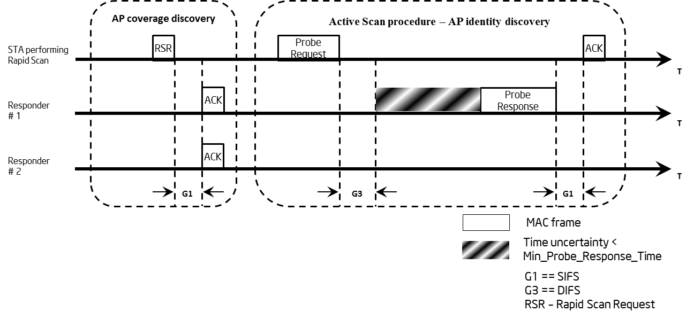
Figure 10-x Rapid Scan

References:
- 11-12-1033-01-00ai-Rapid Scanning.pptx
- IEEE Std 802.11 – 2012

