IEEE P802.11  
Wireless LANs

|  |  |  |  |  |
| --- | --- | --- | --- | --- |
| LB 188 Comments Resolutions for Sub-Clause 9.19 (Part 1) | | | | |
| Date: 2012-9-06 | | | | |
| Author(s): | | | | |
| Name | Affiliation | Address | Phone | Email |
| Chunhui (Allan) Zhu | Samsung Electronics | 75 W. Plumeria Dr,  San Jose, CA, USA | +1-408-544-2751 | [c.zhu@samsung.com](mailto:c.zhu@samsung.com) |
|  |  |  |  |  |

This document provides resolutions for comments in sub-clause 9.19 of draft spec D3.0 (LB188). All CIDs are for MAC ad hoc.

* Sub-clause 9.19.2.2: 6767
* Sub-clause 9.19.2.2a: 6420, 6041, 6419, 6104, 6105, 6819, 6417, 6558
* Sub-clause 9.19.2.6: 6317

Revision notes:

* 0994r0: initial document before presentation.
* 0994r1: On 8/9, the TGac teleconference approved resolutions to all CIDs except CID 6417.
* 0994r2: this revision provides resolution to CID 6417.
* 0994r3: this revision provides revised resolution to CID 6417 after communicating with the commenter.

**Sub-clause 9.19.2.2: 6767**

|  |  |  |  |  |  |
| --- | --- | --- | --- | --- | --- |
| **CID** | **Page** | **Clause** | **Comment** | **Proposed Change** | **Resolution** |
| 6767  David Hunter | 125.59 | 9.19.2.1  (Note this should be under 9.19.2.2). | "in the sense that" does not belong in a normative statement. | Replace "in the sense that they" with "that". | Accepted. |

The spec text:

The TXOP limit may also be exceeded by transmitting a VHT NDP Announcement frame and NDP or Beamforming Report Poll frame ~~in the sense~~ that ~~they~~ fit within the TXOP limit but the response causes the TXOP limit to be exceeded.

**Sub-clause 9.19.2.2a: 6041, 6420, 6419, 6104, 6105**

|  |  |  |  |  |  |
| --- | --- | --- | --- | --- | --- |
| **CID** | **Page** | **Clause** | **Comment** | **Proposed Change** | **Resolution** |
| **6041**  Adrian Stephens | 126.24 | 9.19.2.2a | The addition: "In addition, each A-MPDU shall contain frames from the same TC of the same AC as defined in 8.6.3 (A-MPDU contents)."  is incorrect. 8.6.3 only constrains MPDUs to the same TC in the data enabled immediate response context. This is the only context that can be used to deliver data for which an immediate Block Ack agreement exists. However, data can be delivered for delayed BA agreements or with Ack Policy No Ack for TIDs where a Block ack policy does not exist, and these are not constrained.  Also a "shall do <x> as defined <elsewhere>" is not a good thing to put in the spec. If it's already defined elsewhere, a "shall" here is unnecessary. | Replace cited sentence with: "Note that, each A-MPDU formatted according to the data enabled immediate response context contains frames from the same TC of the same AC as defined in 8.6.3 (A-MPDU contents)." | **Revised**  Insert “(identified by TID)” after “same TC” in the proposed change.  The inserted text establishes a link between TC and TID. |
| **6420**  Mark RISON | 126.00  (Note this should be 126.24). | 9.19.2.2a | 8.6.3 does not require all the data frames to come from the same AC (see e.g. "Delayed Block Ack data" in Table 8-284), let alone things like control frames, which don't have an AC (see e.g. "ACK MPDU" in Table 8-284) | Delete the "In addition, each A-MPDU shall contain frames from the same TC of the same AC as defined in 8.6.3 (A-MPDU contents)." at line 24 and the NOTE at line 32. Extend NOTE 1 in 8.6.3 at 98.43 to give a forward reference to 9.19.2.2a | **Revised**  See the resolution for CID 6041.  Note that NOTE 1 in 8.6.3 at 98.43 has already provided a reference to 9.19.2, which covers 9.19.2.2a. |
| **6419**  Mark RISON | 126.25 | 9.19.2.2a | 8.6.3 uses the term "TID", not "TC" | Change to "TID" | **Revised**  See the resolution for CID 6041. |
| Discussion:  We have had a long discussion on which is better, TID or TC.  On one hand, it was agreed that TC is more accurate in this context since we only talk about EDCA. See Doc #11-12/0474r3 for details (CID 6419 of LB187).  On the other hand, the commenter is right that “8.6.3 uses the term "TID", not "TC"”. | | | | |
| **6105**  Liwen Chu | 126.32 | 9.19.2.2a | This note is redundant since P126L23 has the same sentence with shall. | Remove the note. | **Accepted** |

***TGac Editor, please change the existing text (TGac D3.0, P126L18-32) as below***.

This mode only applies to an AP that supports DL MU-MIMO. The AC associated with the EDCAF that is granted an EDCA TXOP becomes the primary AC. TXOP sharing is achieved when primary AC traffic is transmitted in an MU PPDU and resources permit traffic from secondary ACs to be included, targeting up to four STAs. The inclusion of secondary AC traffic in an MU PPDU shall not increase the duration of the MU PPDU beyond that required to transport the primary AC traffic. Note that, each A-MPDU formatted according to the data enabled immediate response context contains frames from the same TC (identified by TID) of the same AC as defined in 8.6.3 (A-MPDU contents). If a destination is targeted by frames in the queues of both the primary AC and at least one secondary AC, the frames in the primary AC queue shall be transmitted to the destination first, among a series of downlink transmissions within a TXOP. The decision of which secondary ACs and destinations are selected for TXOP sharing, as well as the order of transmissions, are implementation specific and out of scope for this specification.

**Sub-clause 9.19.2.2a: 6104**

|  |  |  |  |  |  |
| --- | --- | --- | --- | --- | --- |
| **CID** | **Page** | **Clause** | **Comment** | **Proposed Change** | **Resolution** |
| **6104**  Liwen Chu | 126.25 | 9.19.2.2a | This "shall" is too restrictive. Here is an example. Primary AC is AC_VO. The AP transmits AC_BE A-MPDU to STA2, but can't receive BLKACK from STA2. before the AP sends the following MU PPDU in the TXOP, the AP receives AC_VO MSDU for STA2 from the up layer. Per the "shall", the AP can't retransmit the AC_BE. This may increase buffer management requirement. | Change to "If a destination is targeted by frames in the queues of both the primary AC and at least one secondary AC where the secondary AC's frames are not already transmitted in the TXOP, the frames in the primary AC queue shall be transmitted to the destination first, among a series of downlink transmissions within a TXOP" | **Rejected**  Changing the rule as proposed will make the rule complicated and cannot guarantee fairness. After all, the TXOP is won by the primary AC and it shall not be disadvantaged by other ACs who share its TXOP. |

**Sub-clause 9.19.2.2a: 6819, 6417, 6558 (regarding figure 9-19b)**

|  |  |  |  |  |  |  |  |  |  |  |  |
| --- | --- | --- | --- | --- | --- | --- | --- | --- | --- | --- | --- |
| **CID** | | **Page** | | **Clause** | | **Comment** | **Proposed Change** | | **Resolution** | | |
| **6819**  kaiying Lv | | 126.38 | | 9.19.2.2a | | In 11aa, there are two more ACs defined. So there should be six AC(s) in all in 11ac. | Revise the spec accordingly. | | **Rejected**  There are only 4 ACs; AAC_VO and AAC_VI are not really ACs that can affect the channel access mechanism. | | |
| **Discussion**:  It is clear that eventually there are 4 ACs, VO, VI, BE and BK. | | | | | | | | | | | |
| **6417**  Mark RISON | 127.00 | | 9.19.2.2a | | Figure 9-19b is helpful, but could be made more helpful by showing some other things, e.g.:  - more than one MPDU to a given STA in a given A-MPDU  - not having anything to transmit to a given STA in a given A-MPDU  - not being able to transmit an MPDU to a given STA in a given A-MPDU, even though it would fit, because the UP is different  - transmitting to BE before VO, where both are secondary ACs  - not having any pad in (at least one of) the primary AC transmissions, but pad being fine in the other transmissions, for a given PPDU - having more than one secondary AC in one of the A-MPDUs  - transmitting for the primary AC in preference to the secondary AC | | | Add other things as suggested | | **Revised**  Among the suggested “other things”, the following are added to the figure.  1) not having anything to transmit to a given STA in a given A-MPDU;  2) transmitting BE frames before VO frames, where both are secondary ACs  3) having more than one secondary AC in one of the A-MPDUs  See the new figure in 12/0994r3. | |
| **Discussion**:  Each suggested “other thing” is discussed below.  - more than one MPDU to a given STA in a given A-MPDU  >> There will be too many details to show in one frame, e.g. multiple MPDUs in one A-MPDU. Space wise (i.e. page width) there is no enough room. In addition, there is no much need since the A-MPDU concept is clear: it could contain multiple MPDUs. The purpose of this figure is to illustrate MU transmission. So this will NOT be added to the figure.  - not having anything to transmit to a given STA in a given A-MPDU  >> This will be illustrated. For example, in the last downlink PPDU, one of the STAs has no data to receive.  - not being able to transmit an MPDU to a given STA in a given A-MPDU, even though it would fit, because the UP is different  >> This will not be illustrated. The commenter seemed to request an illustration that two MPDUs targeting the same STA cannot be transmitted in a given A-MPDU. This is difficult to illustrate; it is easier to illustrate what you can do then to illustrate what you can’t do.  Plus, this has been a rule since the 11n era so it does not seem very important.   - transmitting to BE before VO, where both are secondary ACs    >>This will be illustrated in the figure. In the spec we have “The decision of which secondary ACs and destinations are selected for TXOP sharing, as well as the order of transmissions, are implementation specific and out of scope for this specification.” Therefore, as an example implementation, we can transmit BE traffic before VO traffic.  - not having any pad in (at least one of) the primary AC transmissions, but pad being fine in the other transmissions, for a given PPDU  >> This has been illustrated in the figure; for downlink phase 2 and phase 3, AC_VI (the primary AC) has no paddings.  - having more than one secondary AC in one of the A-MPDUs  >> This will be illustrated.  - transmitting for the primary AC in preference to the secondary AC  >> This has been illustrated. | | | | | | | | | | |
| 6558  Sigurd Schelstraete | 127.31 | | 9.19.2.2a | | The frame exchange sequence for a MU-MIMO PPDU is illustrated in Figure 9-19b, including BAs, BARs, ... This sequence is never spelt out explicitly in the text in a single place. It would be helpful to add text to clearly describe this new frame sequence.  (BTW, should this also be added in Annex G?) | | | Add text describing the MU-PPDU + acknowledgement frame sequence. | | | **Rejected**  The acknowledgement mechanism will be the same as in 11n. It is not necessary to provide implementation guidance again in 11ac. |

***TGac Editor, please replace Figure 9-19b (TGac D3.0, P127) with the figure below***.

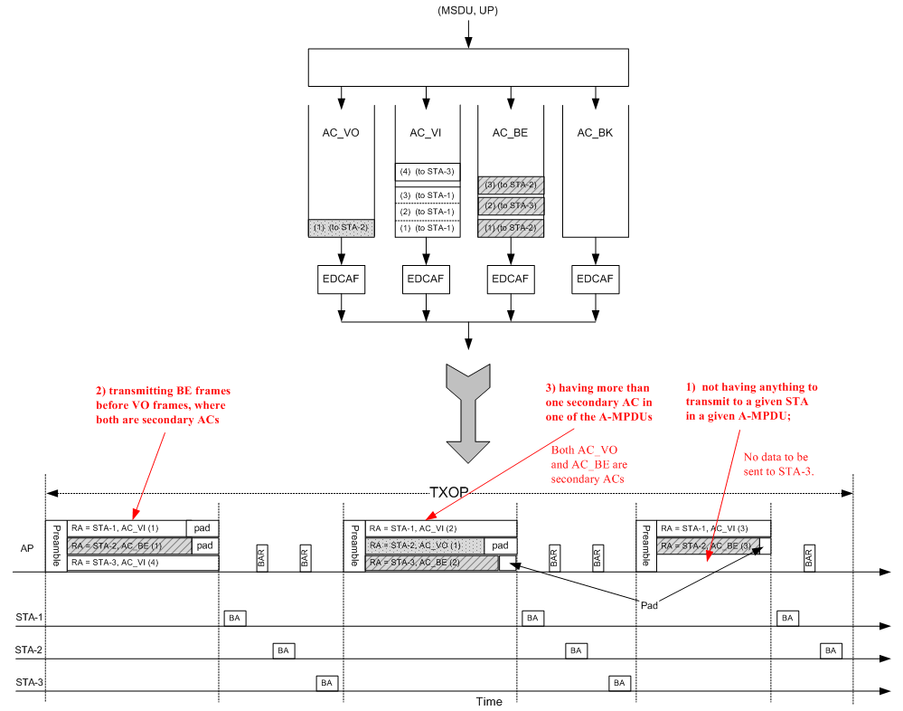

**Sub-clause 9.19.2.6:**

|  |  |  |  |  |  |
| --- | --- | --- | --- | --- | --- |
| **CID** | **Page** | **Clause** | **Comment** | **Proposed Change** | **Resolution** |
| **6317**  Mitsuru Iwaoka | 132.05 | 9.19.2.6.1 | As VHT variant HT control field does not have DEI bit, 2nd and 5th paragraph of 9.19.2.6.1 "General" needs to be modified. | Replace "HT Control Field" to "HT variant HT Control field" in IEEE P802.11aa D9.0 p.72 Line 17 and Line29.  (Note: this should be on p73 of 802.11aa D9.0) | **Accepted** |
| **Background**:  DEI stands for “drop eligibility indicator”. It was introduced by the 802.11aa amendment (see figure below).    *The DEI subfield is 1 bit in length and is set by the transmitting STA to indicate the suitability of the corresponding MSDU or A-MSDU to be discarded if there are insufficient resources at the receiving STA. If there are insufficient resources, a STA that receives an MPDU whose DEI subfield is equal to 1 carrying all or part of an MSDU or A-MSDU, should discard the MSDU or any MSDUs contained within the A-MSDU, in preference to MSDUs carried in MPDUs whose DEI subfield is equal to 0. See 10.26.2. In an MMPDU the DEI subfield is reserved. The mechanisms for determining whether the resources are insufficient or when to discard MSDUs or A-MSDUs are beyond the scope of this standard*.  In 802.11ac, we defined two formats for the HT Control field, the HT variant and the VHT variant.        It is clear that the VHT variant HT Control field does not have the DEI field.  ***Instructions to TGac Editor:***   1. Note the changes should be made to the .11aa spec, not the .11ac draft spec D3.0. May need to include the relevant text in the .11ac spec. 2. There may be other places where this situation applies. Please do a global search. | | | | | |