IEEE P802.11
Wireless LANs
Resolutions to Comments on 9.28 Link Adaptation
Date: 2012-04-05
Name | Affiliation | Address | Phone | email
Allert van Zelst | Qualcomm | Straatweg 66-S | +31 346 259663 | allert@qaulcomm.com
Hongyuan Zhang | Marvell | 5488 Marvell Ln, Santa Clara, CA 95054 | 408-222-1837 | hongyuan@marvell.com
Simone Merlin | Qualcomm | San Diego, CA, USA |  | smerlin@qualcomm.com
Yong Liu | Marvell
Abstract
This document proposes resolutions to TGac Letter Ballot 187 CIDs 4196, 4961, 5378.

CIDs 4196, 4961, 5378 (self reference)
4196 | Allert Van Zelst | 9.28.3 | 123.42 | "When computing the MFB estimate for an MFB requester, the MCS, N_STS(#3475) and, for unsolicited  MFB, BW field values in the MFB subfield from the MFB responder shall indicate a combination which is  in the responder's VHT Rx Supported MCS Set (see 9.7.11.1 (VHT Rx Supported MCS Set)) and the request-  er's VHT Tx Supported MCS Set (see 9.7.11.2 (VHT Tx Supported MCS Set)), where the BW for solicited  MFB is that defined in 9.28.3 (Link adaptation using the VHT variant HT Control field).(11/1518r5)"  So the last line refers to the section itself? Wouldn't it be clearer to combine this text with the referred text, which I assume is:  "In a solicited MFB response to an MRQ that was not carried in an NDPA frame, the MFB is computed based  on RXVECTOR parameters CH_BANDWIDTH, GROUP_ID, NUM_STS, N_TX, FEC_CODING, BEAM-  FORM and STBC of the received PPDU from which the MRQ was triggered and may additionally be based  on other factors which are not part of the RXVECTOR. The VHT N_STS(#3475) subfield of the MFB sub-  field of VHT format variant(Ed) HT Control field shall be set to an equal or smaller value than the RXVEC-  TOR parameter NUM_STS of the received PPDU from which the MRQ was triggered; If the VHT  N_STS(#3475) subfield is set to a smaller value than the RXVECTOR parameter NUM_STS, the MFB re-  sponder shall be computed assuming estimate the recommended MCS under the assumption that the MFB  requester will transmit the space first N_STS space-time streams in the corresponding to the lowest VHT  N_STS indices are used for transmissionPPDU carrying MRQ(#3775)." | Merge the two paragraphs listed in the comment, or find a better way of referencing. | Revise - Most of the cited paragraph is covered in 9.28, hence it can be deleted. Instead the following is added: “For unsolicited MFB that is not in the same PPDU as a VHT Compressed Beamforming frame, the N_STS subfield of the MFB subfield of VHT  variant HT Control field shall be set to an equal or smaller value than the RXVECTOR parameter NUM_STS of the received PPDU from which the MFB parameters are estimated.” (see 12/0480r0)
4961 | Nir Shapira | 9.28.3 | 123.47 | Circular reference. Refference to 9.28.3 is circular and is not specific enough since 9.28.3 is a long section | Suggest explicitly defining BW in this context | Revise - Most of the cited paragraph is covered in 9.28, hence it can be deleted. Instead the following is added: “For unsolicited MFB that is not in the same PPDU as a VHT Compressed Beamforming frame, the N_STS subfield of the MFB subfield of VHT  variant HT Control field shall be set to an equal or smaller value than the RXVECTOR parameter NUM_STS of the received PPDU from which the MFB parameters are estimated.” (see 12/0480r0)
5378 | Youhan Kim | 9.28.3 | 123.42 | The reference "9.28.3" is a reference to itself. | The reference refers to P124L38-48. Hence, combine P123L42-47 with P124L38-48. | Revise - Most of the cited paragraph is covered in 9.28, hence it can be deleted. Instead the following is added: “For unsolicited MFB that is not in the same PPDU as a VHT Compressed Beamforming frame, the N_STS subfield of the MFB subfield of VHT  variant HT Control field shall be set to an equal or smaller value than the RXVECTOR parameter NUM_STS of the received PPDU from which the MFB parameters are estimated.” (see 12/0480r0)

Discussion

The following paragraph, that is cited in the comments, can be removed because it is redundant or implicit (except for its requirement to limit the MCS feedback (MFB) by the supported TX MCS set of the recipient of the MFB, but we believe that this limitation by MCS got mistakenly introduced from draft 1.0 to draft 2.0; note that 11n doesn’t require to limit the MCS in the MFB either; it only requires to limit the number of spatial streams to those supported in transmit mode by the recipient of the MFB):”

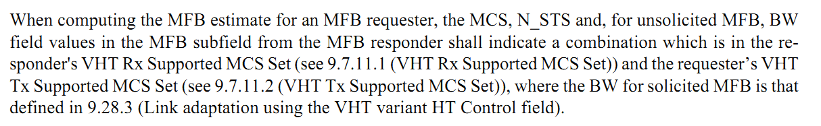

The paragraph can be removed, because solicited MFB that is a response to an MRQ that was not carried in an NDPA is covered by:

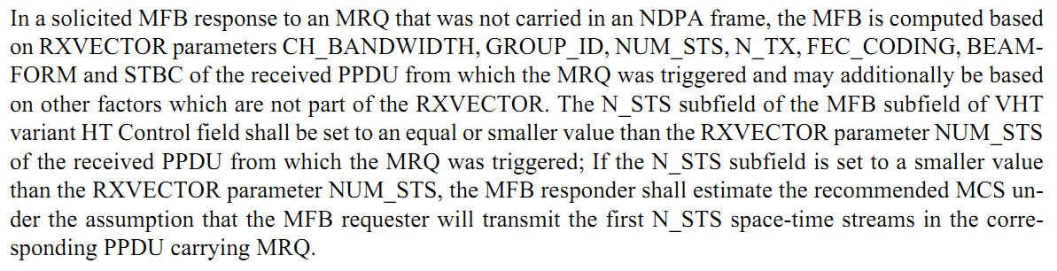

And solicited and unsolicited MFB for an NDPA NDP sequence are covered by:

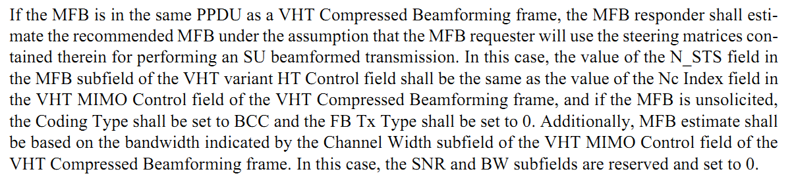

Most other unsolicited MFB parameters are covered by:

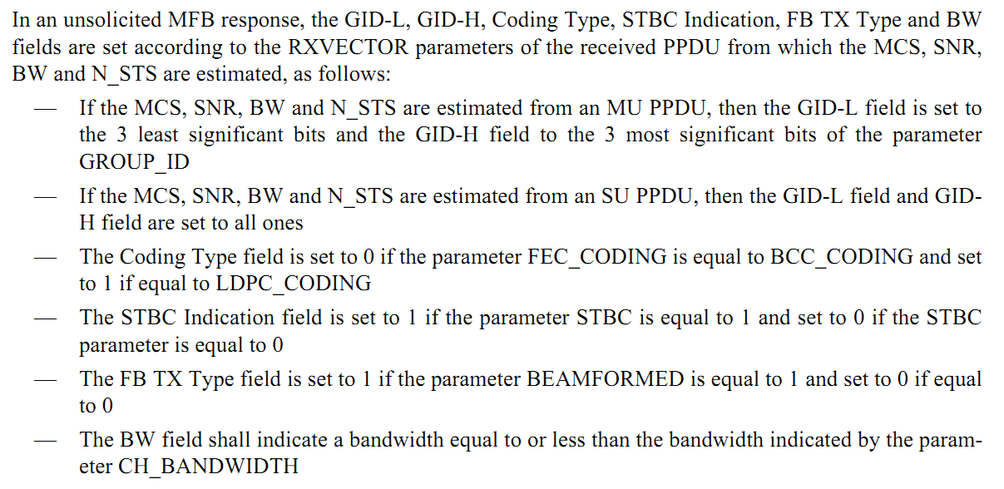

So we only need to cover the N_STS for the unsolicited MFB when it is not in the same PPDU as a VHT Compressed Beamforming frame. If this is set to a value less than or equal to the N_STS of the packet where the MFB is computed on, it automatically falls within the capabilities of the recipient of the MFB. Therefore the suggestion is to add the new paragraph to 9.28 as proposed in below resolution.

Resolution

Editor, please remove the following paragraph that starts at line 42 of page 123 of Draft 2.0:

Editor, please add the following paragraph at line 62 of page 124 of Draft 2.0:

For unsolicited MFB that is not in the same PPDU as a VHT Compressed Beamforming frame, the N_STS subfield of the MFB subfield of VHT variant HT Control field shall be set to an equal or smaller value than the RXVECTOR parameter NUM_STS of the received PPDU from which the MFB parameters are estimated.

