IEEE P802.11
Wireless LANs
Sub-Clause 9.19 Comments Resolutions for LB 187 (Part 1)
Date: 2012-03-30
Author(s):
Name | Affiliation | Address | Phone | Email
Chunhui (Allan) Zhu | Samsung Electronics | 75 W. Plumeria Dr,  San Jose, CA, USA | +1-408-544-2751 | c.zhu@samsung.com

This document provides resolutions for comments in sub-clause 9.19 of draft spec D2.0. All CIDs are for MAC ad hoc.
- Sub-clause 9.19.2.2: 4538, 4400, 4401
- Sub-clause 9.19.2.2a: 4611, 4933, 4403, 4831, 4832, 4161, 5419, 4404

Sub-clause 9.19.2.2: 4538

CID | Page | Clause | Comment | Proposed Change | Resolution
4538  David Hunter | 111.24 | 9.19.2.2 | Where is the process of associating ACs specified? | Need a specification somewhere of the process of associating ACs (including what they can and can't be associated with). Or drop the "associating" language about ACs if the idea is only that this is the AC of a specific EDCAF (in that case "associate" is a confusing term). | Revised

Proposed Resolution:

As the result of discussion during the 3/20/2012 TGac teleconference, the word “corresponding” is used to replace the word “associated”.

TGac Editor, please change the existing text (TGac D2.0, P111L23-L25) as below.

The sharing of the EDCA TXOP occurs when an EDCAF has obtained access to the medium, making the corresponding AC the primary AC, and includes traffic from queues associated with other ACs in MU PPDUs transmitted during the TXOP.

Sub-clause 9.19.2.2: 4400

CID | Page | Clause | Comment | Proposed Change | Resolution
4400  Brian | 111.45 | 9.19.2.2 | Clarify in draft: is a single A-MPDU allowed to include a single A-MPDU containing an A-MSDU of many MSDUs? Or not? Related question: does "single" bind just to MSDU, or to each of MMPDU, AMSDU or AMPDU. If only the former, move single MPDU to the end for clarity. If the latter, duplicate "single" 4x | As in comment | Revised  See doc # 11-12/474 for resolution

Discussion:

For the first question: this was inherited from 11n text. And by definition, a single A-MPDU is allowed to include a single A-MPDU containing an A-MSDU of many MSDUs. So there is no confusion here.

For the second question: the word “single” does bind to all four types of frames. However, because one PPDU can only hold one A-MPDU anyways, the word “single” can be saved for “A-MPDU”. See revision in the proposed resolution below.

Proposed Resolution:

TGac Editor, please change the existing text (TGac D2.0, P111L45) as below.

2) An SU PPDU carrying a single MSDU, a single MMPDU, a single A-MSDU, or an A-MPDU

Sub-clause 9.19.2.2: 4401

CID | Page | Clause | Comment | Proposed Change | Resolution
4401  Brian | 112.33 | 9.19.2.2 | We are adding a new shall on legacy STAs | Limit "shall" to VHT STAs | Accepted  See doc # 11-12/474 for resolution

Proposed Resolution:

TGac Editor, please change the existing text (TGac D2.0, P112L32-33) as below.

If the TXOP holder address is obtained from a control frame, a VHT STA shall save the value of the address with the Individual/Group bit forced to 0.

Sub-clause 9.19.2.2a: 4611

CID | Page | Clause | Comment | Proposed Change | Resolution
4611  Jing-Rong Hsieh | 112.49 | 9.19.2.2a | As revealed in Figure 9-19b, the STA-2 and STA-3 can receive traffic from mutiple ACs in the same TXOP. Therefore, would it be possible to incorporate the similar idea of TXOP sharing to SU MIMO as in MU MIMO in current MAC sublayer function? | Consider the possibility to apply TXOP sharing mode in SU-MIMO scenario. In other words, the SU MIMO transmission contains two or more A-MPDUs which carry traffic from different ACs in separate A-MPDUs. | Rejected  This has been discussed in the TG and consensus was to keep the SU TXOP operating rules as in 11n.

Discussion:

Note that TXOP sharing cannot be applied to SU case because there is no sharing among different STAs. Allowing multi-AC traffic in one SU TXOP will cause fairness issue; this is not an issue in the MU case because the primary AC always has frames to send during the TXOP.

Sub-clause 9.19.2.2a: 4933

CID | Page | Clause | Comment | Proposed Change | Resolution
4933  Mitsuru Iwaoka | 112.49 | 9.19.2.2a | This sentence states only a VHT AP can support MU-MIMO, but a mesh STA can support MU-MIMO. | Replace the word "an AP" to "a VHT AP and a mesh STA" in this paragraph. | Rejected

Discussion:

Mesh STA and AP are two different entities, although they may reside in one physical device. Mesh STA cannot operate in DL MU-MIMO mode.

Sub-clause 9.19.2.2a: 4403 and 4831

CID | Page | Clause | Comment | Proposed Change | Resolution
4403  Brian | 112.61 | 9.19.2.2a | "shall" in note!? | un-note it or un-shall it | Revised
4831  Mark Rison | 112.61 | 9.19.2.2a | QoS Data frames in an A-MPDU are supposed to be from the same TID, not just the same AC (see 8.6.3 in the baseline) | Change "from the same AC" to "from the same TID" | Accepted

Proposed Resolution:

Put this sentence back in the normal text in the paragraph above it and add the “same TC of the same AC” wording. TC is more accurate than TIC since in EDCA environment only TC applies.

TGac Editor, please change the existing text (TGac D2.0, P112L49-61) as below.

This mode only applies to an AP that supports DL MU-MIMO. The AC associated with the EDCAF that is granted an EDCA TXOP becomes the primary AC. TXOP sharing is achieved when primary AC traffic is transmitted in an MU PPDU and resources permit traffic from secondary ACs to be included, targeting up to four STAs. The inclusion of secondary AC traffic in an MU PPDU shall not increase the duration of the MU PPDU beyond that required to transport the primary AC traffic. In addition, each A-MPDU shall contain frames from the same TC of the same AC as defined in 8.6.3 (A-MPDU contents). If a destination is targeted by frames in the queues of both the primary AC and at least one secondary AC, the frames in the primary AC queue shall be transmitted to the destination first, among a series of downlink transmissions within a TXOP. The decision of which secondary ACs and destinations are selected for TXOP sharing, as well as the order of transmissions, are implementation specific and out of scope for this specification.

NOTE—Each A-MPDU shall contain frames from the same AC as defined in 8.6.3 (A-MPDU contents).

Sub-clause 9.19.2.2a: 4832 and 4161

CID | Page | Clause | Comment | Proposed Change | Resolution
4832  Mark Rison | 113.00 | 9.19.2.2a | Figure 9-19b seems to be suggesting MSDUs (namely AC_VI(1) and AC_VO(2)) can be fragmented. Fragmentation is not allowed in an A-MPDU | If the intent of the numbered blocks in the top left part of the figure is to show sequences of MSDUs to be sent to a given destination, then this needs to be clarified (e.g. by putting dashed separators between MSDUs, and by saying e.g. "(to STA-1)" for each) | Accepted
4161  Ahmadreza Hedayat | 113.10 | 9.19.2.2a | While having a figure to explain the sharing TXOP might be useful, but Figure 9-19b is more of a whitepaper figure and does not fit much into the spec. The wording in this subclause clearly and concisly explain the rules of TXOP sharing. | Remove Figure 9-19b and lines 1-4. | Rejected  This has been discussed during comment resolution to draft D1.0. The consensus was that having an illustration making it easier for understanding. Maybe the better way to resolve this is to make the figure better.
4404  Brian | 113.17 | 9.19.2.2a | Top RHS figure is an indication of destination (good) but also a conversion to time that is not ultimately used (the bottom figure reorders the frames), nor described. Seems only to create confusion. | Mirror image so the frame ordering lines up with the bottom figure exactly, and/or add explanation going from subfig 2 to 3 ("frame reordering is allowed within the MU TXOP e.g. to reduce latency to QoS flows"), and/or delete time-component of top right subpicture | Revised

Discussion:

It was agreed, during the 3/29/2012 TGac teleconference, that deleting the upper right sub-figure will make the illustration clearer.

Proposed Resolution:

TGac Editor, please replace figure 9-19b (TGac D2.0, P113L46) with the following figure.

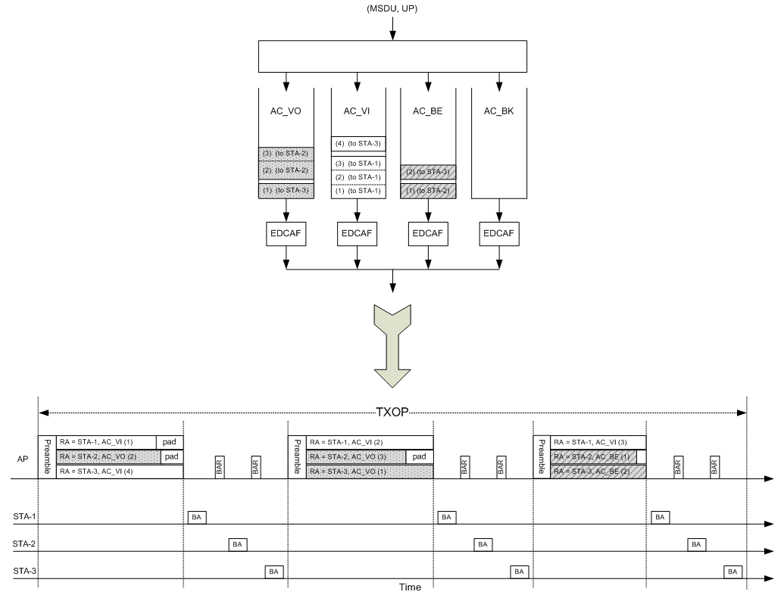

Figure 9-19b—Illustration of TXOP sharing and PPDU construction

Sub-clause 9.19.2.2a: 5419

CID | Page | Clause | Comment | Proposed Change | Resolution
5419  Yusuke Asai | 113.14 | 9.19.2.2a | There is no definition of MU-TXOP. On the context in TGac D2.0, there is no special difference between MU-TXOP and TXOP. | Replace MU-TXOP with TXOP. Ditto in P113/L33, P117/L37, P117L39 and P118/L56. | Accepted

Discussion:

The group agreed to use only TXOP for both SU and MU cases.

Resolution:

TGac Editor, please replace all MU TXOP with TXOP and check all revised sentences to match their original meanings.

