IEEE P802.11
Wireless LANs
Clause 22.3.10 Comment Resolution for D2.0
Date: 08 March 2012
Author(s):
Name | Affiliation | Address | Phone | email
Eldad Perahia | Intel Corporation |  |  | eldad.perahia@intel.com
Abstract
This document provides resolutions for CIDs: 5175, 5176, 5270, 5178, 5177, 5179, 5180, 5181, 5182, 5183, 5184, 5185, 5186, 5480, 5443, 5187, 4092, 5189, 5190, 5191, 5192, 5445, 5195

Clause 22.3.10.1 (Data Field) General

CID | Page | Clause | Comment | Proposed Change | Resn Status | Resolution
5175 | 220.13 | 22.3.10.1 | Clarify "all bits" | Replace "all bits (including PHY pad bits)" with "all bits (i.e. SERVICE fields, PSDU and PHY pad bits)" | V | Revise. The sentence “For both BCC and LDPC, all bits (including the PHY pad bits) shall be encoded.” isn’t necessary since 22.3.10.5.1 states “The Data field shall be encoded using either…” and the definition of the Data field includes SERVICE, PSDU, and PHY pad bits.  TGac editor: delete paragraph on page 220, line 13-14
5176 | 220.41 | 22.3.10.1 | Inconsistent use of N_DBPS | N_DBPS,u is defined as N_DBPS for user u. In Table 22-6, it says that N_DBPS is undefined for MU.  Delete sentence and replace with "is defined in Table 22-6" | A | Agree

Clause 22.3.10.3 CRC calculation for VHT-SIG-B

CID | Page | Clause | Comment | Proposed Change | Resn Status | Resolution
5270 | 221.58 | 22.3.10.3 | NDP PPDUs have no service field, so the CRC detection cannot be done at receivers. The correctness of the VHT-SIG-B bits recovered by receivers cannot be guaranteed. The wrong VHT-SIG-B bits may lead to seriously bad consequences. | Improve the NDP structure to avoid this problem. | R | Reject. The NDP PPDU is an SU PPDU, see 22.3.12. A receiver can ignore VHT-SIG-B since no information is required from it for processing an SU PPDU, see 22.3.21. Therefore no change is necessary.

Clause 22.3.10.4 Scrambler

CID | Page | Clause | Comment | Proposed Change | Resn Status | Resolution
5177 | 222.41 | 22.3.10.4 | Use consistent terminoogy | Replace "pad parts" with "PHY pad bits" | A | Agree.

Clause 22.3.10.5 Coding

CID | Page | Clause | Comment | Proposed Change | Resn Status | Resolution
5178 | 222.05 | 22.3.10.5.2 | Use consistent terminoogy | Replace "pad parts" with "PHY pad bits" | A | Agree.
5179 | 223.30 | 22.3.10.5.2 | Inconsistent use of N_DBPS | N_DBPS,u is defined as N_DBPS for user u. In Table 22-6, it says that N_DBPS is undefined for MU.  Delete sentence and replace with "is defined in Table 22-6" | A | Agree.
5180 | 223.34 | 22.3.10.5.2 | Ambiguous wording | Replace "Zero tail bits" with "Tail bits with value zero" | A | Agree.
5181 | 223.41 | 22.3.10.5.3 | Missing variable "i" | Replace "0 < N_SYM N_DBPS,u/N_ES,u" with "0 <= i < N_SYM N_DBPS,u/N_ES,u" | A | Agree.
5182 | 223.41 | 22.3.10.5.3 | Replace N_ES with N_ES,u | Replace N_ES with N_ES,u | A | Agree.
5183 | 224.65 | 22.3.10.5.5 | Inconsistent use of N_ES | N_ES,u is defined as N_ES for user u. In Table 22-6, it says that N_ES is undefined for MU.  Delete sentence and replace with "is defined in Table 22-6" | A | Agree.
5184 | 225.01 | 22.3.10.5.5 | Inconsistent use of N_DBPS | N_DBPS,u is defined as N_DBPS for user u. In Table 22-6, it says that N_DBPS is undefined for MU.  Delete sentence and replace with "is defined in Table 22-6" | A | Agree.

Clause 22.3.10.6 Stream parser

CID | Page | Clause | Comment | Proposed Change | Resn Status | Resolution
5185 | 226.33 | 22.3.10.6 | Stream parser operation is described per symbol | N_SS blocks of N_CBPSS correspond to one symbol. This is not clear from the text.  Add "per symbol" after "N_CBPSS bits" | R | Reject. N_CBPSS, in Table 22-6, is defined as Number of coded bits per symbol per spatial stream. Adding “per symbol” afterword would read as “Number of coded bits per symbol per spatial stream per symbol”. The repetition of “per symbol” could add confusion. Later on P227L17 it is stated that groups of bits are taken of each OFDM symbol.
5186 | 226.65 | 22.3.10.6 | Don't use N_ES for LDPC | N_ES is not defined for LDPC. Instead of "assuming" it to be equal to 1, use separate equations to define N_block (Eq. 80) for BCC and LDPC. Likewise for M (Eq 81). | V | Revise. The entire cited sentence “For the purpose of this subclause, PPDUs encoded by the LDPC code shall be assumed to have N_ES=1”, makes a special definition for N_ES specific this subclause. So N_ES is in fact defined for this subclause.  However, Table 22-6 defines N_ES specifically for BCC, but several other instances in the document N_ES is used for both BCC and LDPC. The simplest way to clean this up is to define N_ES=1 for LDPC in Table 22-6.  TGac editor, add additional definition to N_ES in Table 22-6 as follows, “For LDPC, N_ES=1 for SU PPDU and N_ES,u=1 for MU PPDU for user u, u=0, …N_u-1”.  TGac editor, delete paragraph on P226L64/65

Clause 22.3.10.7 Segment parser & Clause 22.3.10.7 BCC interleaver

CID | Page | Clause | Comment | Proposed Change | Resn Status | Resolution
5480 | 228.43 | 22.3.10.7 | "frequency subblock" is not a general term. | Change "frequency subblock" to "frequency segment". The same problems are also in some other places. Please search it in the spec. | R | Reject. The segment parser applies also to contiguous 160 MHz that has only one frequency segment, so frequency segment would not be the proper term in this case. The subclause defines frequency subblocks as N_CBPSS/2 bits.
5443 | 228.57 | 22.3.10.7 | R is already used as coding rate in Table 22-5. | Use an alternative character. | V | Revise. Agree in principle. TGac editor replace “R” with “N_res” in two instances on P228L57 and once on P228L61.
5187 | 229.43 | 22.3.10.8 | Interleaver is per symbol | Replace "the bits at the output of the stream parser" with "the bits for one symbol at the output of the stream parser" | R | Reject. N_CBPSS, in Table 22-6, is defined as Number of coded bits per symbol per spatial stream. Furthermore, the first sentence describing the “Clause 18 interleaver” is “All encoded data bits shall be interleaved by a block interleaver with a block size corresponding to the number of bits in a single OFDM symbol…”

Clause 22.3.10.9 Constellation mapping

CID | Page | Clause | Comment | Proposed Change | Resn Status | Resolution
4092 | 233.06 | 22.3.10.9.1 | Figure 22-18. The labelling of individual points is in a font that is too small to read conveniently on the printed page. The IEEE-SA requires that its printed standards be readable. | Find a way to represent this data in an accessible way.  e.g. split the diagram into four quarters, or label the points in hex, or list the values in a table. | V | Revise. The diagram is split into four quarter. Refer to new figures in 12/0250.  TGac editor, replace Figure 22-18 with new figures.
5189 | 234.04 | 22.3.10.9.1 | User index missing | d' does not have user index (u) | V | Revise. Agree in principle. In addition there are several other places where d is missing the user index.  TGac editor: add superscript u to d’ on P233L4, P234L42, and twice on P234L50, and to d-tilde on P239L54, P240L4, P240L22, P240L39
5190 | 234.05 | 22.3.10.9.1 | Wrong index | Replace "i=0 for 20 MHz, ..." with "l=0 for 20 MHz, ..."  Replace "i=0,1 for 160 MHz, ..." with "l=0,1 for 160 MHz, ..." | V | Revise. Agree in principle. This highlights why it important to not define the same thing multiple times, it increases the odds of getting it wrong.  TGac editor: replace “i=0” with “l=0” on P234L5 and L6. Delete “( for 20, 40 and 80 MHz, for 160  and 80+80 MHz)” on P234L1-2.
5191 | 234.42 | 22.3.10.9.2 | User index missing | d' does not have user index (u) | A | Agree. See CID 5189
5192 | 234.50 | 22.3.10.9.2 | User index missing | d' and d'' do not have user index (u) | A | Agree. See CID 5189

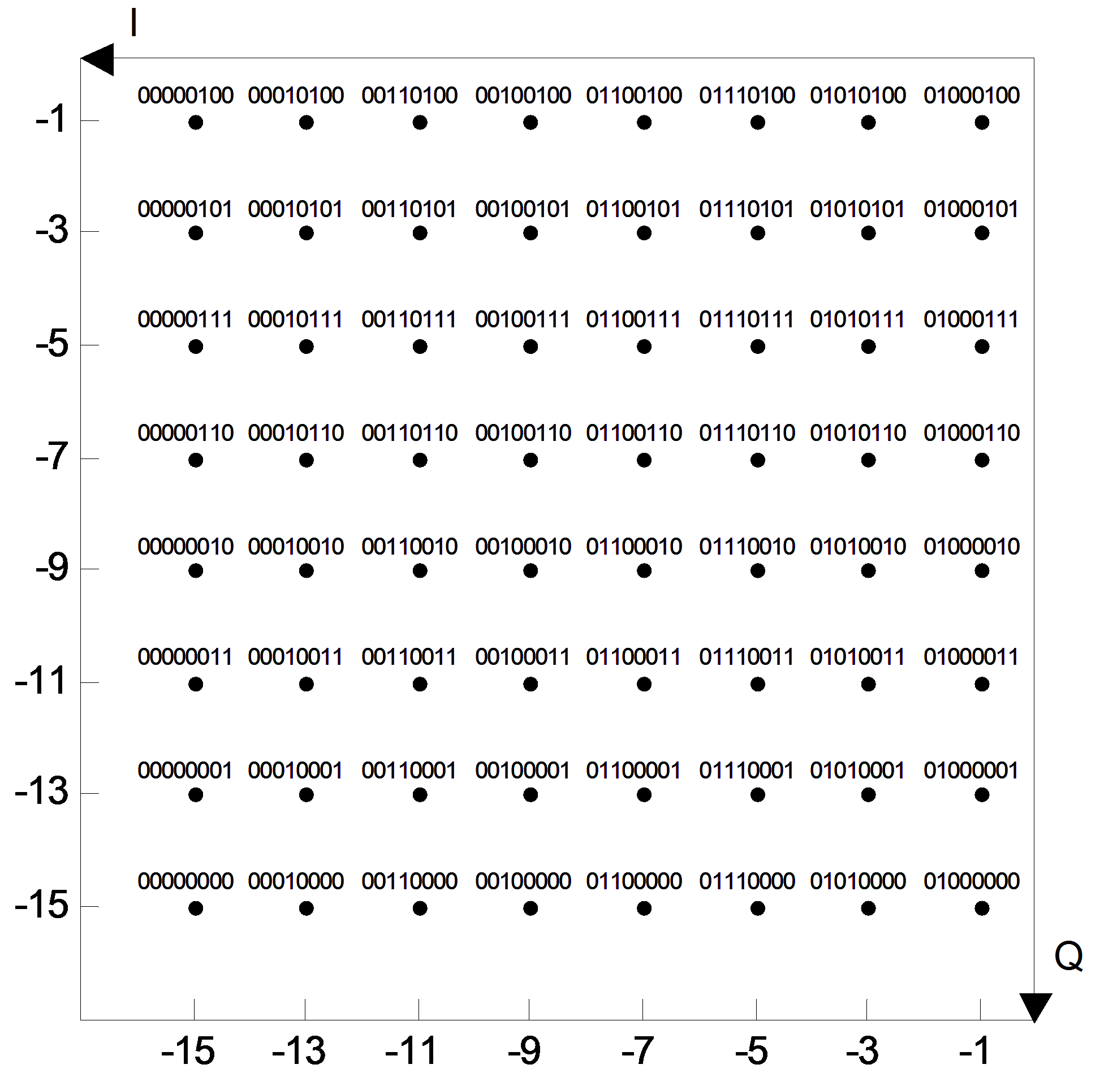
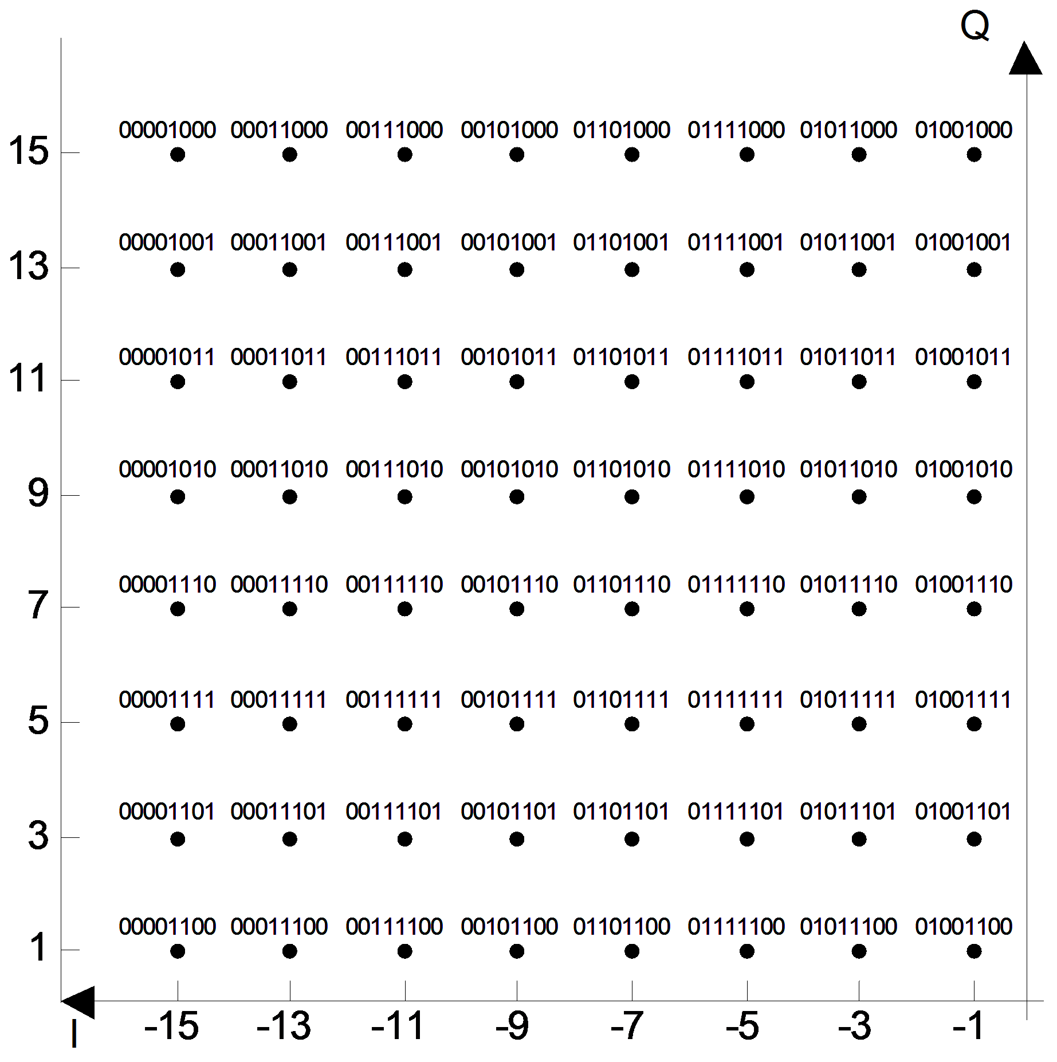
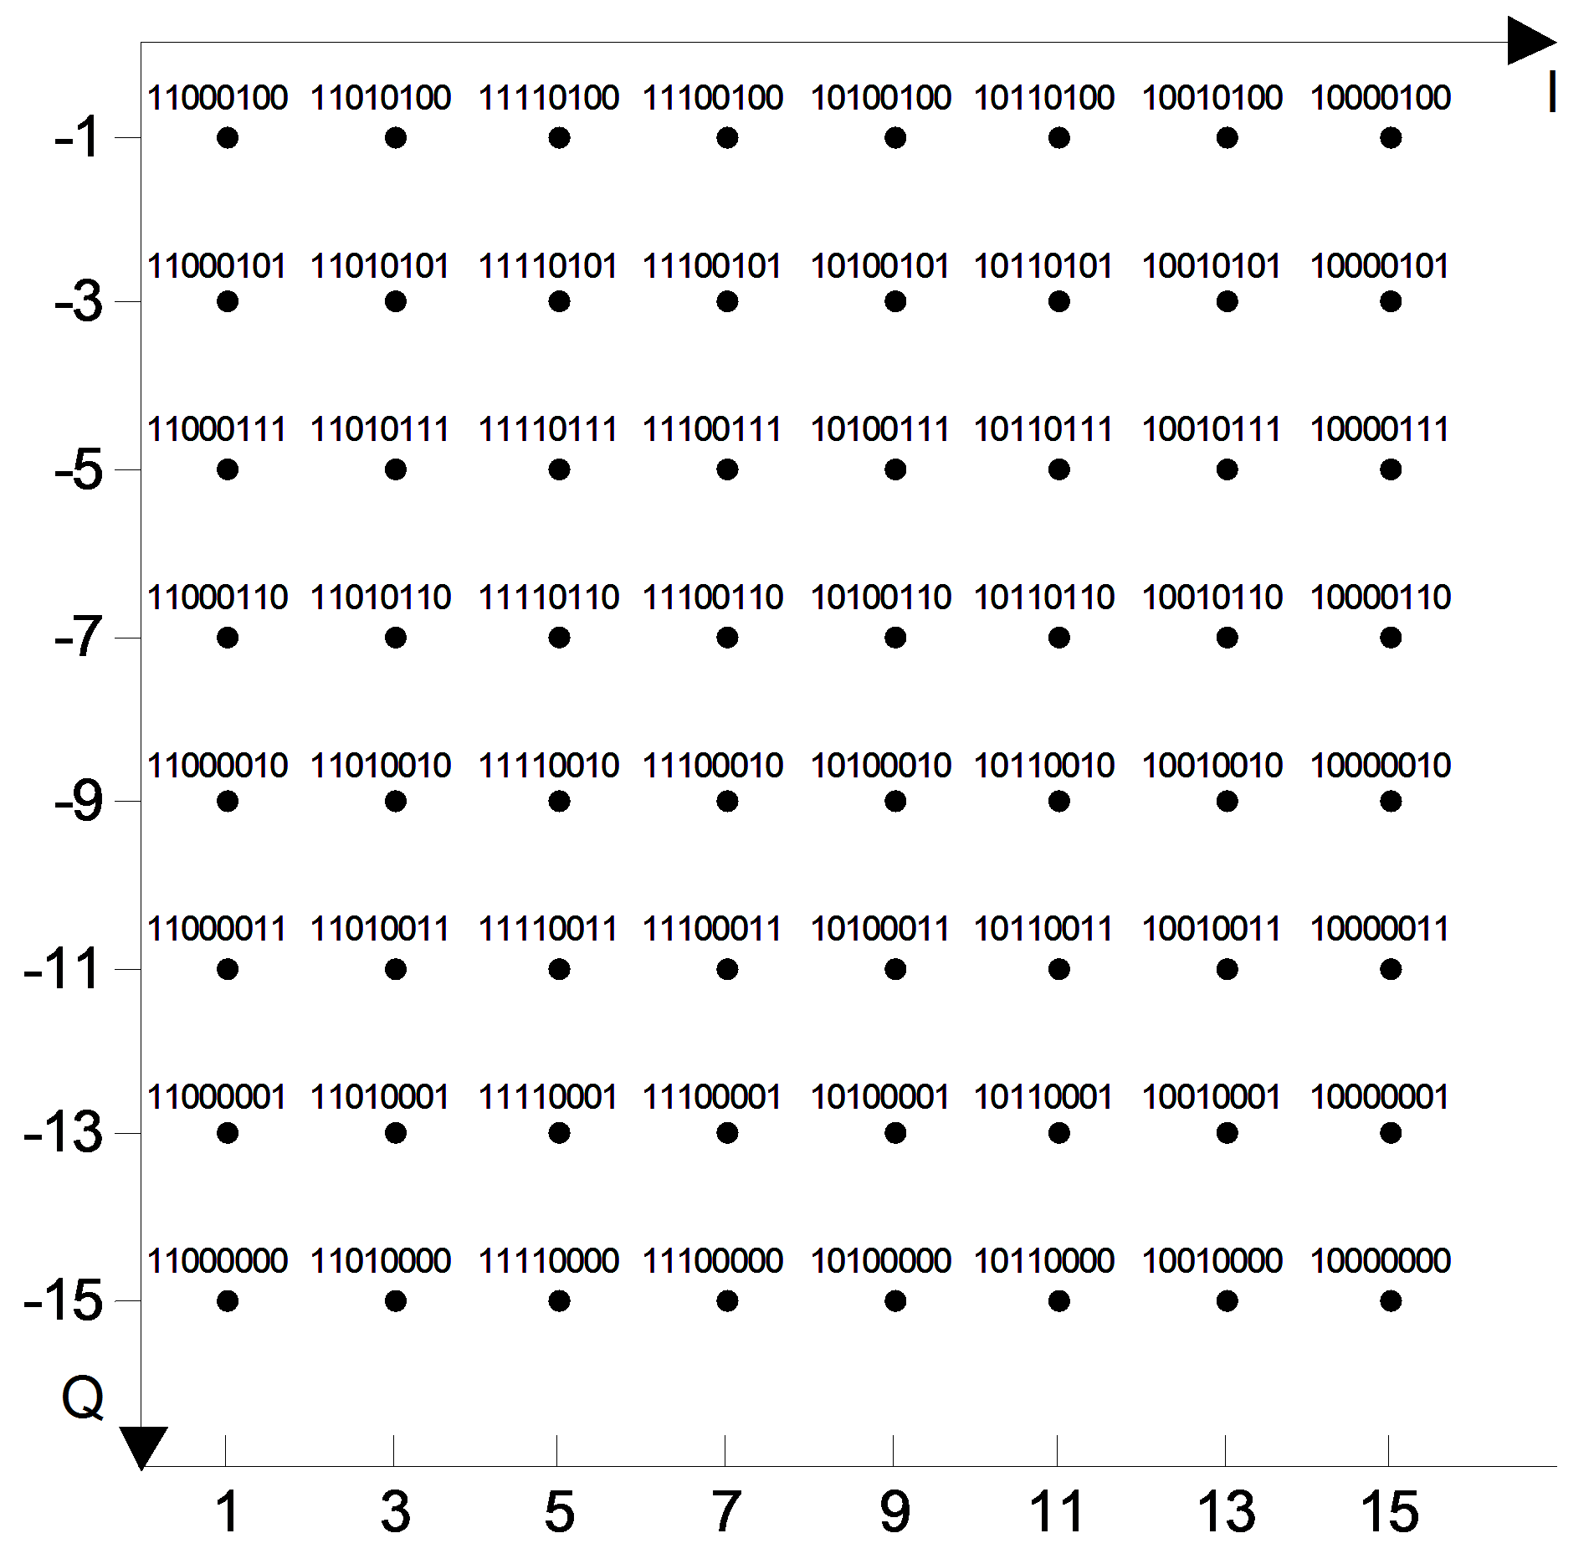
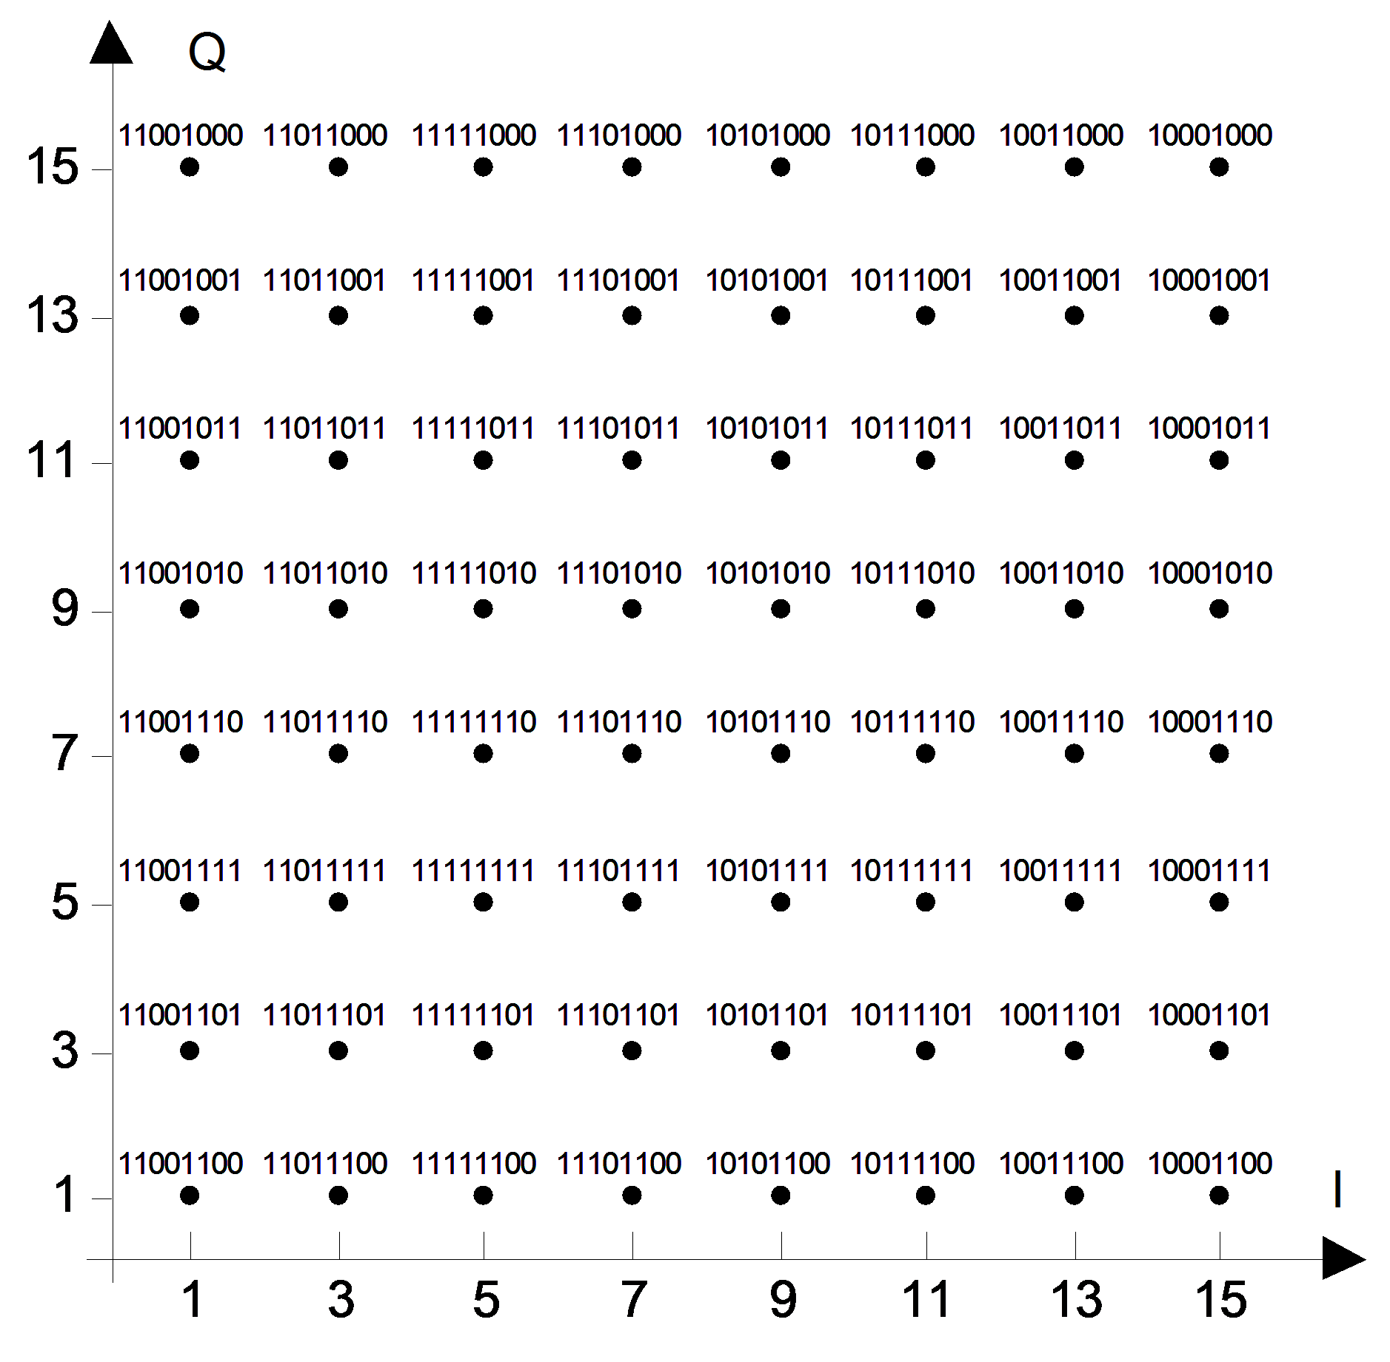

Clause 22.3.10.11 OFDM modulation

CID | Page | Clause | Comment | Proposed Change | Resn Status | Resolution
5445 | 239.54 | 22.3.10.11.1 | "d" does not have a parameter of user index. Ditto for 40, 80, 160 and 80+80 MHz in 22.3.10.11.1. | Change the superscript of "d" as (t_seg, u). | A | Agree. See CID 5189
5195 | 240.56 | 22.3.10.11.1 | Q can be either spatial mapping or steering matrix | Replace "spatial mapping matrix" with "spatial mapping/steering matrix" | A | Agree

