IEEE P802.11  
Wireless LANs

|  |  |  |  |  |  |
| --- | --- | --- | --- | --- | --- |
| 11-12-0047-01-00ad-Fixes-and-Clarifications | | | | | |
| Date: 12 January 2012 | | | | | |
| Author(s): | | | | | |
| Name | Affiliation | Address | Phone | email | |
| Payam  Torab | Broadcom  Corporation | 5300 California Avenue  Irvine, CA 92617 | +1 949-926-6840 | [ptorab@broadcom.com](mailto:ptorab@broadcom.com) | |
| Knut Odman | Broadcom Corporation | 16340 West Bernardo Dr  San Diego, CA 92127 | +1 858-521-5147 | [kodman@broadcom.com](mailto:kodman@broadcom.com) |
| Chris Hansen | Broadcom Corporation | 190 Mathilda Place  Sunnyvale, CA 9408 | +1 408-543-3378 | [chansen@broadcom.com](mailto:chansen@broadcom.com) |

Abstract

[This document is provided as part of resolution to CID 6001]

Summary of the fixes and clarifications:

* Enhance TSPEC semantics to be able to uniquely identify a DBand allocation between two endpoints A and B. Specifically, with the current semantics, a TSPEC cannot differentiate between two airtime allocations created between A and B (one created by A, another created by B) that use the same Allocation ID. Direction semantics needs to be added to the TSPEC.
* For A-MPDUs sent in the data enabled immediate response context, data MPDUs that are sent under an HT-immediate Block Ack agreement should also include QoS Null.
* The “More Data” bit in the MAC header now has a new meaning associated with reverse direction access. The legacy text around the bit usage should be removed.
* Minor nits and editorial corrections

# TSPEC binding to allocation – direction issue

**Background**

A common DBand allocation (SP or CBAP) is allowed to accommodate multiple flows (TSPECs), including flows in the opposite direction with respect to data flow. TSPEC 3 in the following figure demonstrates the scenario (top diagram for SP, diagram at the bottom for CBAP).

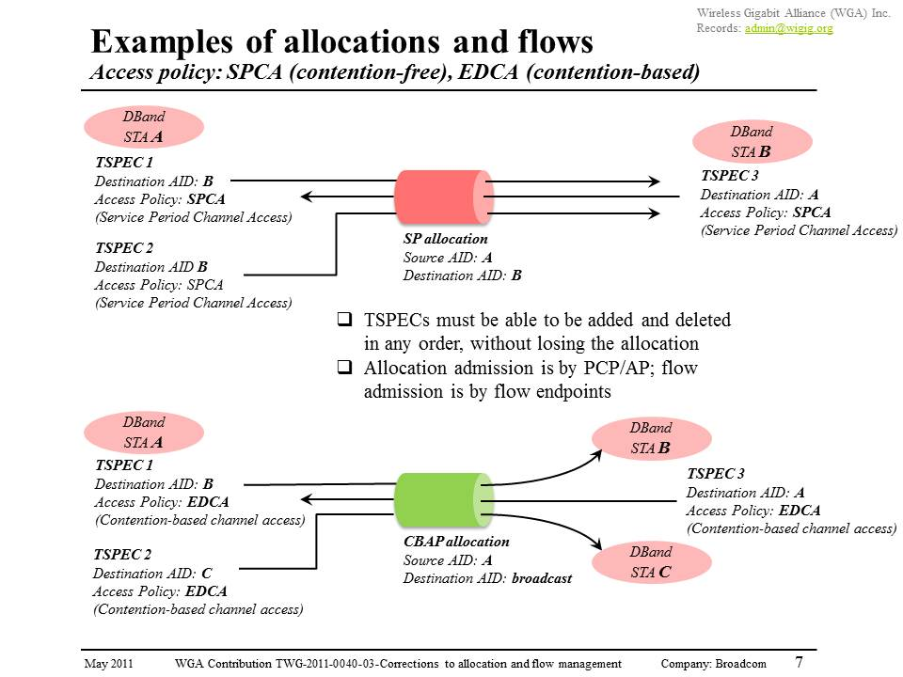

Note that although TSPEC 3 in the above cases is mapped to an allocation created by STA A, that does not mean that STA B can initiate a frame exchange; specifically, STA B is allowed to send only in response to an RD grant, or using an A-MPDU in data enabled immediate response context (i.e., an aggregate of control response and data MPDUs).

**Problem Statement**

1. Text needs clarification to allow TSPEC 3 in the above scenarios
2. TSPEC semantics needs enhancement to uniquely identify a DBand allocation between endpoints A and B. Specifically, there may be –two– allocations between A and B, using the same Allocation ID, and TSPEC must be able to refer to one or another.
3. “TS Info” field within the TSPEC has no reserved bits left

**Resolution**

1. To clarify aggregation usage, modify the following paragraph in 8.4.2.32 (TSPEC element) as follows,

The Allocation ID subfield is defined only for the DBand, and is 4 bits in length. Traffic Streams can share the allocation through TSPEC aggregation. See Appendix XYZ for examples of TSPEC aggregation.

The Allocation ID subfield is used as follows:

1. Modify the following paragraph in 10.4.14 (PTP TS Operation) as follows,
2. Clarify the definition of the TSPEC direction bits as follows,

|  |  |  |
| --- | --- | --- |
| Bit 5 | Bit 6 | Usage |
| 0 | 0 | Uplink, defined as follows,  OBand: MSDUs/A-MSDUs are sent from the non-AP STA to HC  DBand: MSDUs/A-MSDUs are sent by the non-AP originator of the ADDTS Request frame |
| 1 | 0 | Downlink, defined as follows,  OBand: MSDUs/A-MSDUs are sent from the HC to the non-AP STA  DBand: MSDUs/A-MSDUs are sent by the non-AP recipient of the ADDTS Request frame |

1. Make the TSPEC a 60-byte element in DBand

Note that a PTP TSPEC is a TSPEC exchanged between two non-AP DBand STAs. The format of the 12 PTP TSPEC is the same as the TSPEC, and hence the element format described in this subclause applies to both the PTP TSPEC and the non-PTP TSPEC. When transmitted in the DBand, the TSPEC element carries additional fields. These fields are not present when this element is transmitted in the OBand.

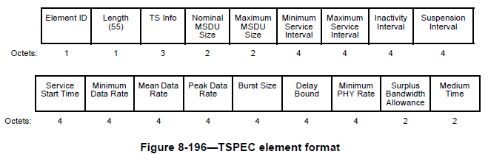

Editor – please append the TSPEC in DBand with this field.

|  |  |
| --- | --- |
|  | DBand Attributes |
| Octets: | 5 |
|  |  |

1. Move all DBand extensions from “TS Info” to “DBand Attributes”

The DBand Attributes field is 5 octets in length and is defined in Figure yy.

|  |  |  |  |  |  |
| --- | --- | --- | --- | --- | --- |
| B0-B3 | B4-B5 | B6 | B7 | B8-B9 | B10-B39 |
| Allocation ID | Reserved | Allocation Direction | A-MSDU subframe | Reliability | Reserved |

Figure yy DBand Attributes

* The Allocation Direction is 1 bit in length and is set to 1 when the originator of the ADDTS Request is also the source of the allocation identified by Allocation ID, and 0 otherwise. Allocation Direction is set to zero when Allocation ID is zero.

1. Create a new informational appendix to give examples of TSPEC aggregation

Appendix XYZ: TSPEC aggregation in DBand

Examples of TSPEC aggregation include but are not limited to

* Traffic Streams between two DBand STAs A and B, having an access policy of SPCA, even if they flow in opposite directions, sharing an SP allocation created with A as Source AID and B as Destination AID
* Traffic Streams between DBand STA A and other DBand STAs, having an access policy of EDCA, even if they flow in opposite directions (some having STA A as source and some having STA A as destination), sharing a CBAP allocation created with A as Source AID and broadcast Destination AID.

Figure x and Figure y show examples of TSPEC aggregation in DBand.



**Figure XYZ.1 Example of TSPEC aggregation (SPCA and EDCA access policies)**



**Figure XYZ.2 Example of TSPEC aggregation (SPCA, EDCA and SEMM access policies)**

# A-MPDU Contents

**Problem Statement**

Data MPDUs sent under an HT-immediate Block Ack agreement should also include QoS Null.

**Resolution**

Referring to Table 8-284 in the baseline (RevMB Draft 10.0), copied below,

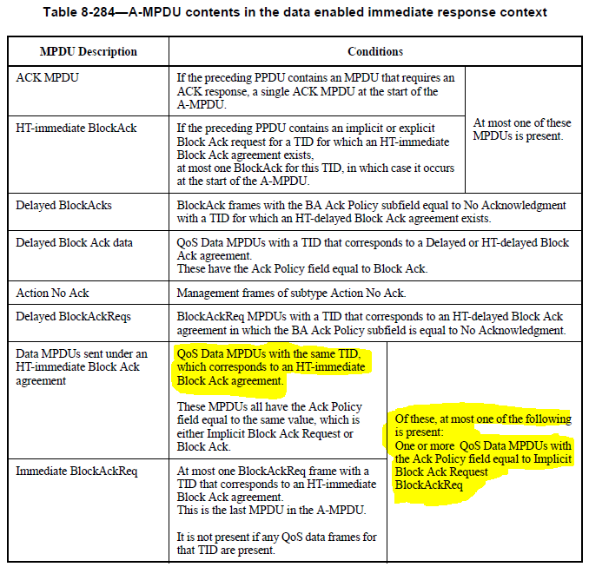

Edit the first highlighted sentence as follows,

QoS Data MPDUS with the same TID, which corresponds to an HT-immediate Block Ack agreement, or in the DBand QoS Null MPDU

Edit the second highlighted sentence as follows,

Of these, at most one of the following is present:

QoS Null MPDU (in the DBand only) with Ack Policy set to No Acknowledgment

One or more QoS Data MPDUs with the Ack Policy field equal to Implicit Block Ack Request

BlockAckReq

# Deprecated use of “More Data” bit

**Background**

The “More Data” bit in MAC header acquired a new meaning in 1.1.2 – it is used to assist a data sender with the decision of granting an RD.

**Problem Statement**

Legacy (and wrong) text still remains, which needs to be deleted.

**Resolution**

Delete the following paragraph in 10.2.5.2.4 (Power management mode operation of a non-PCP/non-AP STA with or without a wakeup schedule),

# Nits, editorial

**9.33.6.6.4 Interference report**

All values conveyed in the TSCONST field shall refer to the allocation identified by the Allocation ID field of the TSPEC.

Change all “ADDTS request” instances (those referring to the frame) to “ADDTS Request”