IEEE P802.11  
Wireless LANs

|  |  |  |  |  |
| --- | --- | --- | --- | --- |
| Comment Resolution on CID 3739,3743 | | | | |
| Date: 2011-11-08 | | | | |
| Author(s): | | | | |
| Name | Affiliation | Address | Phone | email |
| Tianyu Wu | Huawei Technologies | F1-17, Bantian, Longgang District, Shenzhen, P.R.China | +86-13715288322 | wutianyu@huawei.com |
| Jianhan Liu | MediaTek |  |  | jianhan.liu@mediatek.com |
| James Wang | MediaTek |  |  | james.wang@mediatek.com |
| Tom Pare | MediaTek |  |  | thomas.pare@mediatek.com |
| Edward Au | Huawei Technologies |  |  | edward.au@huawei.com |

The document proposes resolutions for the following CIDs:

MAC: 3739, 3743.

|  |  |  |  |  |  |
| --- | --- | --- | --- | --- | --- |
| 3739 | 8.3.1.9 | 26.01 | In MU-MIMO, the SINR at each STA is not known at the AP. This is because the existing SNR feedback is estimated by the STAs based on the NDP frame without inter-STA interference. | Add SINR feedback field in Block Ack frame using reserved bits. See our proposal "SINR feedback via Block ACK in MU-MIMO transmission" for details. | AGREE IN PRINCIPLE**.** See the text change in doc 11/1528r0. |
| 3743 |  | 44.00 | The structure of VHT format HT Control field is not clear. | To make the structure more clear, please redesign the bits allocation of VHT format HT Control. | Withdrawn |

**Discussion:**

*MU-MIMO sounding protocol is based on unprecoded NDP so that the SNR feedback is calculated based on SU transmission. However, in MU-MIMO transmission, there exists additional inter-STA interference. Although HT control field might be used to feedback SINR during MU-MIMO transmissions, the support of HT control field is optional. Moreover, using HT control field for SINR feedback may introduce more overhead.*

*During MU-MIMO transmissions, the actual SINR can be much smaller than the SNR feedback during NDP sounding. This may lead to inaccurate MCS selection, extra sounding overhead or inaccurate group selection.*

*Example: If the SNR at STA1 is 20dB, and the leaking interference power is 10% of the signal power, the SINR became 10 dB. This may lead to three MCS level difference.*

*Further throughput improvement can be achieved by Group Selection or User Power Allocation when information of Inter-STA Interference is available.*

*Inter-STA interferences in MU-MIMO can be introduced by:*

* *Channel estimation errors*
* *Channel variations, Channel aging, ill-conditioned channel*

***It’s better to feedback some interference indication during MU-MIMO transmission. The feedback can be used to:***

* *Efficient Link adaptation*
  + *SINR indicates the true condition at the STAs*
  + *Fast convergence to best MCS*
* *Smart User Selection*
  + *E.x., AP can set Nsts=0 for “the un-selected user” within the group*
* *Channel Re-sounding Selection*
  + *E.x., AP can choose the right STA with an inaccurate channel to perform Resounding*
* *Fine tuning of Pre-coding*
  + *E.X., user power allocation (not TPC) can be applied based on SINR and LIS*
    - *User power allocation during MU-MIMO transmission is completely transparent to receiver*

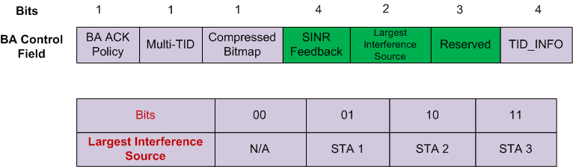

**Proposed resolution:**

TGac Editor: Pls change the spec as following:

**8.3.1.9 BlockAck frame format**

**8.3.1.9.1 Overview**

**Change Figure 8-22 as shown (using 6 reserved bits for MU-MIMO Feedback)**



**Figure 8-22—BA Control field**

**Insert the following as the ninth paragraph of 8.3.1.9.1:**

MU_INT field contains six bits. The first four bits (B3 to B6) indicate the average delta Signal-to-Interference-Noise-Ratio (SINR) feedback defined as



where $\overline{SINR}$ and $\overline{SNR}$ are the average SINR and SNR over all subcarriers and spatial streams. The four bits, B3 to B6 indicate 0-15dB of delta SINR in one dB step. The last two bits (B7 to B8) indicate the largest interference source (LIS) within the MU group. LIS is defined as follows.

00: indicates there is no information on LIS

01: indicates LIS is the STA in the first position within the MU group except the STA itself

10: indicates LIS is the STA in the second position within the MU group except the STA itself

11: indicates LIS is the STA in the third position within the MU group except the STA itself

The bits in MU_INT field are reserved in SU case.