IEEE P802.11
Wireless LANs
TGac Draft 1.0 resolution on comments related to
Static and Dynamic RTS/CTS
Date: 2011-11-02
Author(s):
Name | Affiliation | Address | Phone | email
Peter Loc | IWT Inc. | Cupertino CA 95014, USA |  | Peterloc@iwirelesstech.com

Baseline is 11ac D1.2

COEX CIDs addressed: 2612, 2932, 2933, 2936

2612 | Kafle, Padam | 9.3.6 |  |  | The efficiency of the group addressed frames transmission has been neglected by 802.11ac. In 802.11ac the RTS CTS mechanism is used to detect the availability of the secondary channels. However, the RTS CTS cannot be used for group addressed as stated in 9.3.6. | Allow RTS transmission to individual address and CTS response from the STA before the transmission of the group addressed frames. | Disagree. There have been various proposals on the exchange protocol of RTS/CTS prior to the transmission of grouped address frames but none has shown significant improvement in efficiency due to the overhead of CTS frames. The commentor is encouraged to bring a submission to the TGac task group for further consideration.
2932 | Loc, Peter | 9.3.2.7 | 72 | 15 | By not transmitting a CTS after receiving a (Static) RTS directed to it, the targeted VHT-STA violates the CTS procedure described in subclause 9.3.2.7 of Draft P802.11REVmb_D9.0. Furthermore, the lack of CTS will force the initiator to invoke the backoff procedure to contend for the channel with other STAs and there is a good chance that the initiator may not get access to the channel for retransmitting the RTS and has to wait until the end of the current TxOP to contend for the channel again. | Change "Otherwise the STA shall not respond with a CTS frame." to "Otherwise the STA responds with a CTS frame in the primary channel." | Accept in principal
2933 | Loc, Peter | 9.3.2.7 | 72 | 29-30 | By not transmitting a CTS after receiving a (Dynamic) RTS directed to it, the targeted VHT-STA violates the CTS procedure described in subclause 9.3.2.7 of Draft P802.11REVmb_D9.0. Furthermore, the lack of CTS will force the initiator to invoke the backoff procedure to contend for the channel with other STAs and there is a good chance that the initiator may not get access to the channel for retransmitting the RTS and has to wait until the end of the current TxOP to contend for the channel again. | Change "Otherwise the STA shall not respond with a CTS frame." to "Otherwise the STA responds with a CTS frame in the primary channel." | Counter. See below
2936 | Loc, Peter | 9.3.2.7 | 72 | 8-30 | To meet the requirements stated in this clause, all VHT STAs must keep track of the CCA IDLE time prior to receiving any packet at all times. A VHT STA only uses the CCA IDLE time after receiving a Static or Dynamic RTS that the RA . In a typical network, most packets are transmitted without the preceding RTS/CTS but VHT STAs will be wasting their power on computing, updating and resetting the CCA IDLE counters even when they are not transmitting or receiving their own packets. |  | Duplicated CID 2937
2937 | Loc, Peter | 9.3.2.7 | 72 | 8-30 | To meet the requirements stated in this clause, all VHT STAs must keep a running count of the CCA IDLE time prior to receiving any type of packet. Only when the receiving packet is a STATIC/DYNAMIC RTS and the RA matches its address, a VHT STA uses the count to determine the responses to the RTS initiator. In a typical network, most packets are transmitted without the preceding RTS/CTS but all VHT STAs will be wasting their power on computing, updating and resetting the CCA IDLE counters even when they are not transmitting or receiving their own packets in anticipation of receiving a STATIC/DYNAMIC RTS. The overhead is too high to gain a rather small benefit. | There are several possible solutions to this problem, 2 of which are mentioned here: 1) Change "shall" to "may" on line 10 or 2) implement a trigger mechanism for computing CCA IDLE count as outlined in submission 11-11-0636-02-00ac-comment-resolution-PowerSave.doc

Discussion:

On CID 2932 :

Per Draft P802.11REVmb_D10.1, 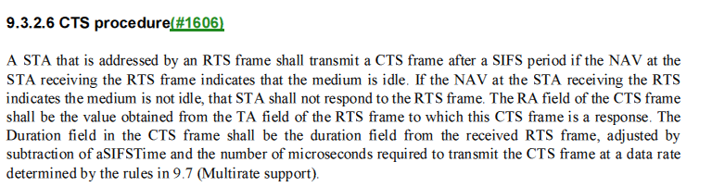

To meet this rule, the proposal herein is to accept the proposed resolution and to instruct the editor to replace the sentence on page 85, line 9

_ Otherwise the STA shall not respond with a CTS frame

with the following paragraph:

If the NAV indicates idle and CCA has not been idle for all secondary channels in the channel width indicated by the RTS frame’s RXVECTOR parameter CH_BANDWIDTH_IN_NON_HT a period PIFS prior to the start of the RTS frame, then the STA shall respond with a non-HT CTS frame after a SIFS period in the primary channel.

CID 2933
Currently in TGac Draft 1.2, page 85, Lines 16-24

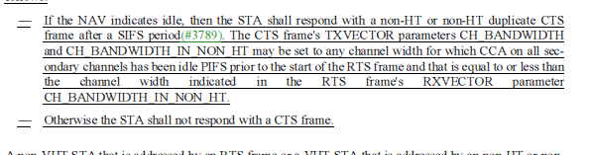

The proposal herein is to counter the proposed resolution and to instruct the editor to remove the sentence on page 85, line 24

_ Otherwise the STA shall not respond with a CTS frame

