IEEE P802.11
Wireless LANs
D1 Comment Resolution, Length values
Date: 2011-07-19
Author(s):
Name | Affiliation | Address | Phone | email
Peter Loc | IWT Inc. | Cupertino CA 95134, USA |  | Peterloc@iwirelesstech.com

Baseline is 11ac D1.1

MAC CIDs addressed: 2000, 2312, 3346, 3549, 2313, 2314,2931

MAC

2000 | Aboul-Magd, Osama | 8.2.3 | 20 | 15 | A maximum MPDU size of 11,454 octets is defined. However it seems that it will never be used unless a corresponding increase in the A-MSDU size is also supported. A maximum A-MSDU size of 7935 octets will always fit in an MPDU of size 7991 octets, and there is no need for the 11,454 MPDU maximum size | Identify scenarios where 11,454-octet MPDU will be used, or increase the A-MSDU to fit in the an 11,454-octet MPDU, or remove the 11,454 as a maximum MPDU size. | Accept in principle. The max. MPDU size should be based on the max. length of A-MSDU. 11454 byte length is an arbitrary value that should not be advertised.
2312 | Grigat, Michael | 8.2.3 | 20 | 37 | Max MPDU 11454 minus depicted Header/FCS in Fig. 8-1 yields 11416 octets | Clarify, how calculation in Note is related to Fig. 8-1. Are there optional elements in the MAC frame format? | Counter. See 11/1258r0
3346 | Rosdahl, Jon | 8.2.3.11 | 20 | 11 | The description should cover A-MSDUs received by VHT STAs, the types of PPDU duration constraints, regulatory constraints and the MAC header. Splitting it up into bullets would make it more digestible | Change to:  The Frame Body field is of variable size, but constrained by, amongst other things:  * the maximum PPDU duration (e.g. non-HT SIGNAL LENGTH, HT_MF or VHT L-SIG L_LENGTH, HT_GF aPPDUMaxTime, any non-zero TXOP Limit)  * the maximum MSDU size (2304 octets)  * the maximum A-MSDU size supported by an non-VHT HT STA recipient in HT_MF or HT_GF format PPDUs (3839 or 7935 octets)  * the maximum MPDU size supported by a VHT STA recipient (3895, 7991 or 11454 octets)  * any regulatory constraints (e.g. CS4-msBehavior)  * the fields present in the MAC header (e.g. QoS Control, Address 4, HT Control) | Counter. See 11/1258r0
3549 | Stephens, Adrian | 8.3.2.1 | 28 | 23 | Experience has shown that these statements are almost always wrong. It not initially, then after subsequent amendment.  Please be aware that REVmb D9.0 has removed most of the "lets do some maths to work out the maximum length of the MPDU and get it wrong" statements, because they frequently got it wrong. | When you update to the REVmb D9.0 baseline, remove any "do some maths with the MSDU and MMPDU maximum lengths in the hopelessly optimistic hope we got it right" statements. | Accept in principle. See 11/1258r0
2313 | Grigat, Michael | 8.3.2.1 | 28 | 14 | Fig 8-27: Sum of Octets is higher than maximum MPDU length of 11 454 octets | Indicate, which fields of the Data frame are optional. | Counter.  See 11/1258r0
2314 | Grigat, Michael | 8.3.3.1 | 28 | 39 | Fig. 8-30: Sum of Octets is higher than maximum MPDU length of 11 454 octets | Indicate, which fields of the Management frame are optional. | Counter.  See 11/1258r0
2931 | Loc, Peter | 8.2.3 | 20 | 27-29 | The fact that there is no management frame that can exceed 1 Kbyte in length, the calculation of the max frame body size should be calculated using the MAC header of the data frame, not the MAC header of the Management frame. | Change the Max frame size to 11424. Change the NOTE to:"The maximum Frame Body size (11424 octets) is arrived at by subtracting the length of the shortest QoS Dataframe MAC header (26 octets) and FCS from the maximum MPDU length of 11454 octets." | Counter.  See 11/1258r0

Discussion:

In Draft P802.11REVmb_D10.1, the maximum frame body sizes for both of the MAC and data frames are based on the maximum length of A-MSDU plus the 16 bytes of CCMP encryption. For 802.11ac, since the the maximum length of A-MSDU does not change from 802.11n, which is equal to 7951 bytes (7935+16), draft 802.11ac should reference the MAC and data frame formats as shown in subclauses 8.2.3 and 8.3.2 respectively of the Draft P802.11REVmb_D10.1.

For those who are interested in knowing how the maximum length of A-MSDU was calculated, it is based on an assumption that most implementation may have up to 8 blocks of data (x 1024 bytes/block) minus 256 bytes control block. The 256-byte control block is chosen to be large enough to satisfy most implementations. The lower value of A-MSDU is based on 4 blocks of data minus 256-byte control block.

Extracts from:
Draft P802.11REVmb_D10.1, subclause 8.2.3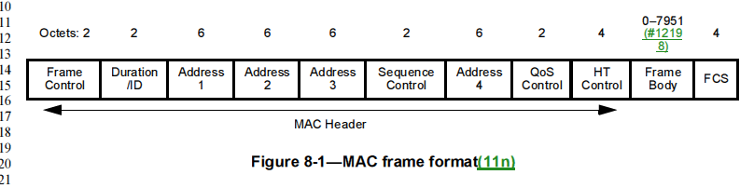

Draft P802.11REVmb_D10.1, subclause 8.3.2
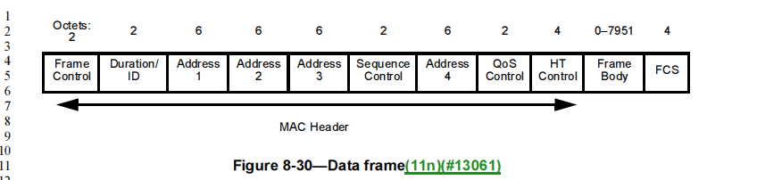

Proposed resolution:

Instruction to the editor: remove the following subclauses from the Draft 1.1

