IEEE P802.11
Wireless LANs
Resolutions to Miscellaneous MAC Comments
Date: Sep 21, 2011
Author(s):
Name | Affiliation | Address | Phone | email
Chunhui (Allan) Zhu | Samsung Electronics |  | +1-408-544-2751 | c.zhu@samsung.com
Abstract
This document provides resolutions to misc MAC comments. The following CIDs are covered in this document.
- Sub-Clause 8.2.4.1.8: 3696, 2325
- Sub-Clause 9.19.2.2: 3806
- Sub-Clause 9.22.5.3 (in 11mb): 3079
- Sub-Clause 9.24: 3568
- Sub-Clause 10.8.3: 2580, 3337, 3439, 3581

CID | Page | Line | Clause | Comment | Proposed Change | Resolution
3696 | 20.06 | 6 | 8.2.4.1.8 | The added text for the More Data field is coming after sentence: "The More Data field is set to 0 in all other directed frames." The added text does not fit to More Data field explanations. | Please correct the clause and make the 802.11ac addition compatible with the existing base text. | Agree in Principle  The text of this paragraph describes an exception of the “all other directed frames”. Need to change the existing base text.  See the resolution in 11-11/1194.
2325 | 21.08 | 8 | 8.2.4.1.8 | Is this signalling between the VHT AP and a single VHT STA (in individually addressed frames)? If so, clarify the usage (individualy addressed, and frame types), and why is the last sentence of this paragraph plural? If this is for group addressed frames, the prerequisitie for the non-AP STAs being VHT capable needs to be clarified - must all STAs in the BSS be VHT? | Clarify this paragraph's intended usage scenarios, and detail the pre-requisites. | Agree in Principle  The description of this paragraph is not clear. This is the signalling between the VHT AP and a single VHT STA. It is not for group addressed frames.  See the resolution in 11-11/1194.

Discussion:

The description of the More Data field for the TXOP PS purpose is not integrated into the existing text gracefully. For example, in the general description of the field, the first paragraph of this subclause, it says,

“The More Data field is 1 bit in length and is used to indicate to a STA in PS mode that more BUs are buffered for that STA at the AP. The More Data field is valid in directed data or management type frames transmitted by an AP to a STA in PS mode. A value of 1 indicates that at least one additional buffered BU is present for the same STA.”

This description does not cover the case of TXOP PS mode, in which the STAs are running in Active mode. In addition, this is the signalling between the VHT AP and a single VHT STA. So the placement of this added paragraph should be relocated to before the description of the group addressed frames.

TGac editor: insert the following new paragraph in REVmb D8.0 at P412, L32, before the sentence “The More Data field is set to 0 in all other directed frames.” as follows

In a VHT BSS where the TXOP power save feature is supported at both the AP and an individual STA (as determined from its VHT capabilities element), the More Data field indicates that more BUs are buffered for that STA at the AP (see 10.2.1.4a for the operation of TXOP power save). A value of 1 in individually addressed frame transmitted by the VHT AP to a VHT STA in TXOP PS mode indicates that at least one additional buffered BU is present for the same STA.

TGac editor: Delete the paragraphs in D1.0, P21, L3-L9

CID | Page | Line | Clause | Comment | Proposed Change | Resolution
3806 | 79.48 | 48 | 9.19.2.2 | "associated with secondary ACs (secondary ACs)" What does this mean? | Clarify or fix this notation. | Agree in Principle  Some editorial errors exist in this paragraph.  See the resolution in 11-11/1194.

TGac editor: modify D1.0 P79, L46-L48, as follows

The sharing of the EDCA TXOP occurs when an EDCAF associated with the primary AC has obtained access to the medium and shares access with EDCAFs associated with secondary ACs during MU PPDU transmission.

CID | Page | Line | Clause | Comment | Proposed Change | Resolution
3079 | 85.43 |  | 9.22.5.3 | 9.22.5.3 L-SIG TXOP protection rules at the TXOP responder. Clarify that an VHT STA shall not use this mode. |  | Agree in Principle  A VHT STA should not use L-SIG TXOP protection.  See the resolution in 11-11/1194.

Discussion:

This can be resolved by setting VHT STA’s L-SIG TXOP Protection Support field in the HT Capability element to zero so a VHT STA will never use the L-SIG TXOP protection.

TGac editor: modify D1.0 P85, L43, as follows

Insert the following sub-clause title.

9.22.5.3 L-SIG TXOP protection rules at the TXOP responder

Insert the following sentence at the end of this sub-clause.

A VHT STA shall always set the L-SIG TXOP Protection Support field to zero during association and re-association.

CID | Page | Line | Clause | Comment | Proposed Change | Resolution
3568 | 85.54 | 54 | 9.24 | The definition of non-A-MPDU frame includes VHT single MPDU, so "It is a non-A-MPDU frame or a VHT single MPDU," is a tautology. | Remove the phrase "or a VHT single MPDU" when applied to non-A-MPDU frame. | Agree  See the resolution in 11-11/1194.

TGac editor: modify D1.0 P85, L54, as follows

— It is a non-A-MPDU frame and

CID | Page | Line | Clause | Comment | Proposed Change | Resolution
3581 | 95.17 | 17 | 10.8.3 | "Any local maximum transmit power received in the combination of a VHT Transmit Power Envelope  element and an Extended Power Constraint element from the AP in its BSS or another STA in  its IBSS and"  Is there an MBSS case to cover too? | Make any necessary statement about MBSS. | Agree in Principle  Note the MBSS coverage has already been done by 11s and has been reflected in REVmb 10.1.
3439 | 95.35 | 35 | 10.8.3 | Local Maximum Transmit Power is per BSS and does not provide means to control power per STA (according to its link budget and QoS requirements) for the purpose of interference reduction. Suggest to add TPC per STA that would apply to its uplink (STA to AP) transmissions | Details will be provided in TG meeting | Disagree  In the absence of any details, this comment is rejected.
3337 | 95.46 | 46 | 10.8.3 | Either? Hm, so a VHT STA is not required to use a VHT TPE IE and EPC IE? And if it does, it is required to not use an HT PC IE? | Clarify | Agree in Principle.  The requirements are not clear and should be clarified.  See the resolution in 11-11/1194.
2580 | 95.47 | 47 | 10.8.3 | For VHT the Transmit Power Envelope element is replacing the Country element. Won't applications in regulated domains require the Country element? | Add the Transmit Power Envelope element as a third member of the combination, instead of a replacement to the Country element. | Disagree  The Country element is advertised as the regulatory maximum transmit power and is covered by the first sentence of this paragraph.  See the resolution in 11-11/1194.

Discussion:

This paragraph makes it possible that a VHT AP/STA is not required to use the the combination of a VHT Transmit Power Envelope element and an Extended Power Constraint element. Instead, a VHT AP/STA is allowed to use the combination of a Country element and a Power Constraint element only, which I believe is not our intent.

To better understand all the elements to be considered, their definitions are listed below.

- The Country element as defined in REVmb D10.1
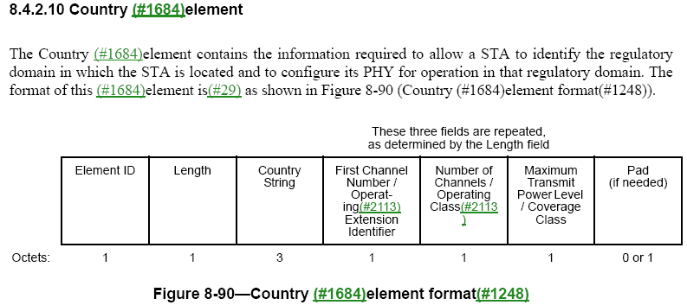

The Maximum Transmit Power Level field is a signed number and is(#29) 1 octet in length. It indicates the maximum power, in dBm, allowed to be transmitted. As the method of measurement for maximum transmit power level differs by regulatory domain, the value in this field is(#29) interpreted according to the regulations applicable for the domain identified by the Country String.

- The Power Constraint element as defined in REVmb D10.1

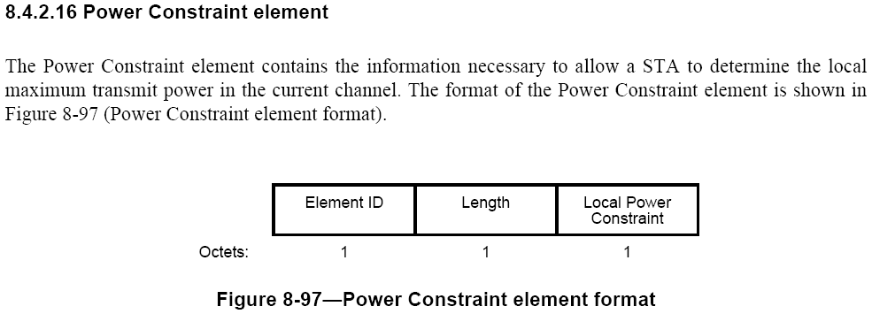

The field is coded as an unsigned integer in units of decibels(#64). The local maximum transmit power for a channel is thus defined as the maximum transmit power level specified for the channel in the Country element minus the local power constraint specified for the channel (from the MIB) in the Power Constraint element.

- The VHT Transmit Power Envelope element as defined in TGac Draft Spec D1.1

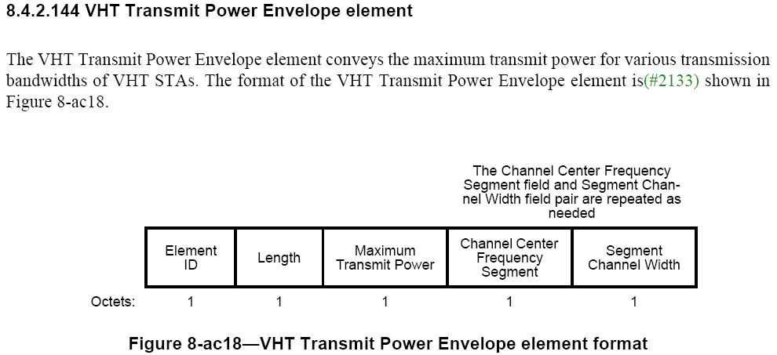

The Maximum Transmit Power field defines the maximum transmit power limit of the transmission bandwidth defined by the VHT Transmit Power Envelope element. The Maximum Transmit Power field is a 2's complement signed integer(#3805) and is 1 octet in length. It indicates the permitted maximum power in dBm.

- The Extended Power Constraint element as defined in TGac Draft Spec D1.1

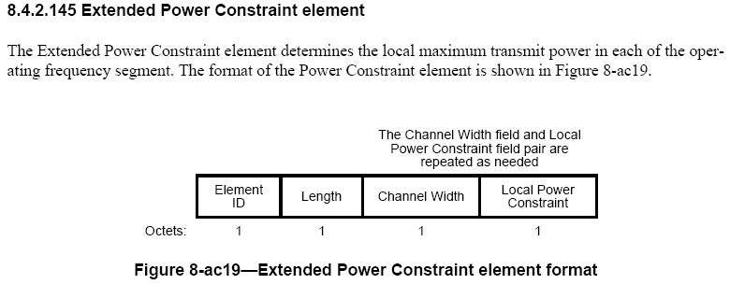

The Local Power Constraint field is encoded as an unsigned integer in units of decibels. The local maximum transmit power for a channel is (#3338) defined as the maximum transmit power level specified for the channel in the VHT Transmit Power Envelope element minus the local power constraint specified for the channel (from the MIB) in the Extended Power Constraint element.

Based on these definitions, it is clear that the combination of a VHT Transmit Power Envelope element and an Extended Power Constraint element are enough for VHT STAs to advertise their local maximum transmit power. Note the Country element is advertised as the regulatory maximum transmit power and is covered by the first sentence of this paragraph. In addition, the Power Constraint element is not an appropriate one for VHT STAs since VHT STAs require local power constraint for different bandwidths.

The descriptions for VHT and non-VHT cases are separated to avoid ambiguities.

TGac editor: modify REVmb D10.1 P1150, L1-L6, as follows

An AP in a BSS, a STA in an IBSS, and a mesh STA in a MBSS (11s) shall advertise the regulatory maximum transmit power for that
STA’s operating channel in Beacon frames and Probe Response frames using a Country element. A non-VHT AP in a BSS, a non-VHT STA in an IBSS, and a non-VHT mesh STA in a MBSS (11s) shall advertise the local maximum transmit power for that STA’s operating channel in Beacon frames and Probe Response frames using the Power Constraint element. A VHT AP in a BSS, a VHT STA in an IBSS, and a VHT mesh STA in a MBSS shall advertise the local maximum transmit power for that STA’s operating channel in Beacon frames and Probe Response frames using the combination of a VHT Transmit Power Envelope element and an Extended Power Constraint element.

