IEEE P802.11
Wireless LANs
D1.0 Comment Resolution – Spectral Flatness
Date: 2011-09-14
Author(s):
Name | Affiliation | Address | Phone | email
Youhan Kim | Qualcomm | 1700 Technology Drive  San Jose, CA 95110 |  | youhan.kim@qca.qualcomm.com

Comments are based on 11ac D1.0. Proposed resolutions are based on 11ac D1.1. Changes indicated by a mixture of Word track-changes and instructions. For equation changes, Latex notation is sometimes used. E.g. a_{xyz}^b denotes a_{xyz}^{b}

Following CIDs are addressed:
2703, 3225

CID | Page | Clause | Comment | Proposed Change | Resolution
2703 | 182.19 | 22.3.18.2 | Unlike other BW modes, all subcarriers are used in obtaining the average power per subcarrier in case of 160 MHz. Many TX filters have higher attenuation at band edges. Hence, averaging accross all subcarriers may result in lower average power per tone, and may lead to more stringent spectral flatness requirement for 160 MHz compared to other BW modes. Note that an 80+80 MHz capable STA may put its two frequency segments adjacent to each other to transmit a 160 MHz packet. In this case, subcarriers near the DC of 160 MHz is bandedge of each frequency segments, hence probably will have higher attenuation as well. Furthermore, subcarriers -129~-127 and 127~129 do not contain any energy, hence should be excluded from averaging. | Change the 'Averaging subccarrier indices (inclusive)' column for 160 MHz to be '-172 to -129, -126 to -44, +44 to +126, and +129 to +172'. | AGREE IN PRINCIPLE. See 11/1189r1.

Discussion:
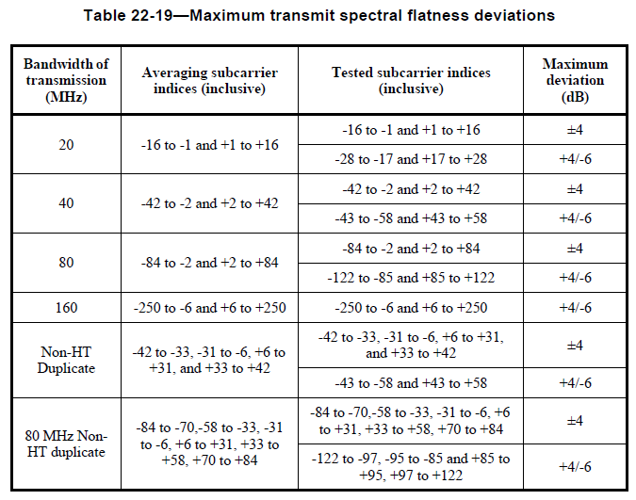

In case of 20/40/80 MHz, the averaging (for average energy computation) is performed over ‘inner’ subcarriers. Furthermore, there are two regions, each with different spectral flatness requirement. Inner subcarriers are required to meet the +/- 4 dB requirement, while the outer subcarriers are required to meet +4/-6 dB.

Note that contiguous 160 MHz and non-contiguous 80+80 MHz are designed to be interoperable with each other (same tone allocation, etc.) Hence, an 80+80 MHz capable device could have two TX RF chains, each supporting only max. 80 MHz. When operating under 160 MHz mode, the device would simply place the two 80 MHz segments adjacent to each other. However, this means that the spectral flatness of a 160 MHz signal from such 80+80 MHz devices would be difficult to meet +/-4 dB near the center of 160 MHz (Region C in Figure 1).
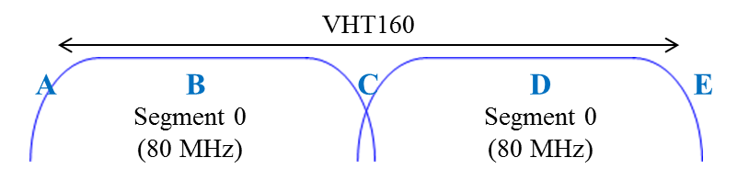
Figure 1. 160 MHz transmit spectrum from an 80+80 MHz device.

Hence, D1.0 had made the spectral flatness requirement for 160 MHz to be +4/-6 dB throughout the entire spectrum. However, in doing so, the subcarriers over which the averaging should be performed were not chosen appropriately.

Consider the hypothetical VHT80 TX spectrum shown in Figure 2, which meets the spectral flatness requirement. Then, suppose we widen this TX spectrum by ~2x (250/122) to get a VHT160 TX spectrum, as shown in Figure 3. Because the averaging is performed over all subcarriers in case of VHT160, the 0 dB reference is now lower, and hence the spectrum in Figure 3 is now violating the TX spectral flatness requirement of D1.0.

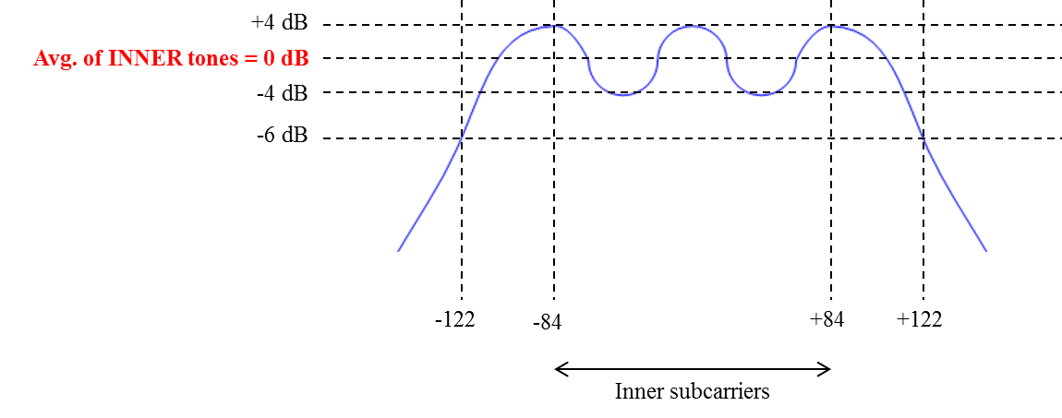
Figure 2. Hypothetical VHT80 TX spectrum
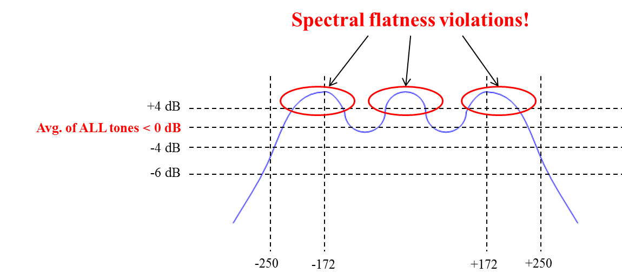
Figure 3. VHT160 TX spectrum by simply widening the VHT80 spectrum of Figure 2.

We suggest to limit the subcarriers over which averaging is performed to be the intersection between
- Inner subcarriers of each 80 MHz portion
  - -84 to -2 and +2 to +84 of lower and upper 80 MHz
-212 to -130, -126 to -44, +44 to +126, and +130 to +212
- Inner subcarrier of 80 MHz scaled by 250/122 (250 tones in VHT160, 122 tones in VHT80)
  - 80 MHz: -84 to -2 and +2 to +84
-172 … +172

This results in -172 to -130, -126 to -44, +44 to +126, and +130 to +172.

In addition, it should not be difficult for both the contiguous 160 MHz and non-contiguous 80+80 MHz devices to meet the +/-4 dB transmit spectral flatness requirement within the regions B and D of Figure 1 (tone indices -172 to -130, -126 to -44, +44 to +126, and +130 to +172). Hence, it is proposed to set the spectral flatness requirement of regions B and D to +/-4 dB, similar to the other BW (20/40/80) cases.

CID | Page | Clause | Comment | Proposed Change | Resolution
3225 | 180.29 | 22.3.18.1 | The flatnees spec for 160MHz non-HT duplication is missing. | as per comment | AGREE IN PRINCIPLE. See 11/1189r1.

Discussion:
As in case of VHT160, tones within -172 to -44, and +44 to +172 (excluding DC and guard tones of each 20 MHz) should meet ±4 dB requirement. Tones outside of that should meet +4/-6 dB.

Change:
22.3.18.2 Spectral flatness

Change Table 22-19 (D1.1) as follows:

Format | Bandwidth of transmission (MHz) | Averaging subcarrier indices (inclusive) | Tested subcarrier indices (inclusive) | Maximum deviation (dB)
VHT | 20 | -16 to -1 and +1 to +16 | -16 to -1 and +1 to +16 | ±4
 |  |  | -28 to -17 and +17 to +28 | +4/-6
 | 40 | -42 to -2 and +2 and +42 | -42 to -2 and +2 and +42 | ±4
 |  |  | -58 to -43 and +43 to +58 | +4/-6
 | 80 | -84 to -2 and +2 and +84 | -84 to -2 and +2 to +84 | ±4
 |  |  | -122 to -85 and +85 to +122 | +4/-6
 | 160 | -172 to -130, -126 to -44, +44 to +126, and +130 to +172 | -172 to -130, -126 to -44, +44 to +126, and +130 to +172 | ±4
 |  |  | -250 to -173, -43 to -6, +6 to +43, and +173 to +250 | +4/-6
non-HT duplicate | 40 | -42 to -33, -31 to -6, +6 to +31, and +33 to +42 | -42 to -33, -31 to -6, +6 to +31, and +33 to +42 | ±4
 |  |  | -43 to =58 and +43 to +58 | +4/-6
 | 80 | -84 to -70, -58 to -33, -31 to -6, +6 to +31, +33 to +58, +70 to +84 | -84 to -70, -58 to -33, -31 to -6, +6 to +31, +33 to +58, +70 to +84 | ±4
 |  |  | -122 to -97, -95 to -85 and +85 to 95, +97 to +122 | +4/-6
 | 160 | -172 to -161, -159 to -134, -122 to -97, -95 to -70, -58 to -44, +44 to +58, +70 to +95, +97 to +122, +134 to +159, +161 to +172 | -172 to -161, -159 to -134, -122 to -97, -95 to -70, -58 to -44, +44 to +58, +70 to +95, +97 to +122, +134 to +159, +161 to +172 | ±4
 |  |  | -250 to -225, -223 to -198, -186 to -173, -43 to -33, -31 to -6, +6 to +31, +33 to +43, +173 to +186, +198 to +223, +225 to +250 | +4/-6

