IEEE P802.11  
Wireless LANs

|  |  |  |  |  |
| --- | --- | --- | --- | --- |
| Proposed Specification Framework for TGah | | | | |
| Date: 2012-1-19 | | | | |
| Author(s): | | | | |
| Name | Affiliation | Address | Phone | email |
| Minyoung Park | Intel | 2111 NE 25th Ave, Hillsboro OR 97124, USA | 503-712-4705 | minyoung.park@intel.com |
|  |  |  |  |  |
|  |  |  |  |  |
|  |  |  |  |  |
|  |  |  |  |  |

Abstract

This document provides the framework from which the draft TGah amendment will be developed. The document provides an outline of each the functional blocks that will be a part of the final amendment. The document is intended to reflect the working consensus of the group on the broad outline for the draft specification. As such it is expected to begin with minimal detail reflecting agreement on specific techniques and highlighting areas on which agreement is still required. It may also begin with an incomplete feature list with additional features added as they are justified. The document will evolve over time until it includes sufficient detail on all the functional blocks and their inter-dependencies so that work can begin on the draft amendment itself.

# 0 Revision Notes

|  |  |
| --- | --- |
| R0 | Initial draft document with a table of content |
| R1 | Added supporting bandwidth modes [11/1294r0]  Added the number of tones for 2MHz PHY transmission and the tone spacing for all other bandwidth modes [11/1311r0] |
| R2 | Added max number of space-time streams [11/1275r1]  Added channelization [11/1329r1] |
| R3 | Modified South Korea channelization [11/1422r0]  Added support for a new frame format for a short beacon [11/1503r1] |
| R4/5 | Added the motions passed in January 2012 |

# 1 Definitions

# 2 Abbreviations and Acronyms

S1G sub 1 GHz

PLCP physical layer convergence procedure

STA station

MAC medium access control

MCS0 BPSK, ½ code rate

# 3 S1G Physical Layer

This section describes the functional blocks of the physical layer.

## 3.1 Channelization

R.3.1.A: The draft specification shall include support for 1 MHz, 2 MHz, 4 MHz, 8 MHz, and 16 MHz PHY transmissions. [11/1294r0]

R.3.1.B: An 802.11ah STA shall support reception of 1 MHz and 2 MHz PHY transmissions. [11/1294r0]

R.3.1.C: The 2 MHz PHY transmission shall be an OFDM based waveform consisting of a total of 64 tones (including tones allocated as pilot, guard and DC). Note: This implies a tone spacing of 31.25 kHz. [11/1311r0]

R.3.1.D: The tone spacing for all other bandwidths PHY transmissions shall be same as the tone spacing in the 2 MHz PHY transmission. [11/1311r0]

R.3.1.E: The draft specification shall include the following channelization [11/1329r1]

1. South Korea [11/1422r0]

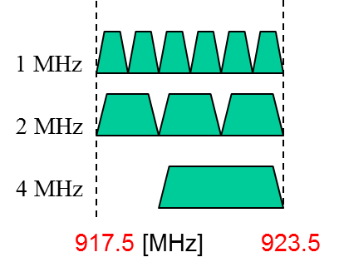

1. Europe

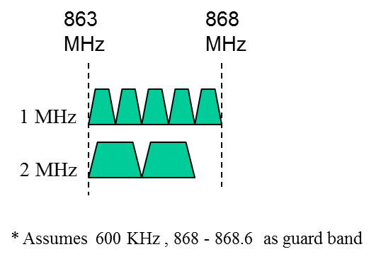

1. Japan

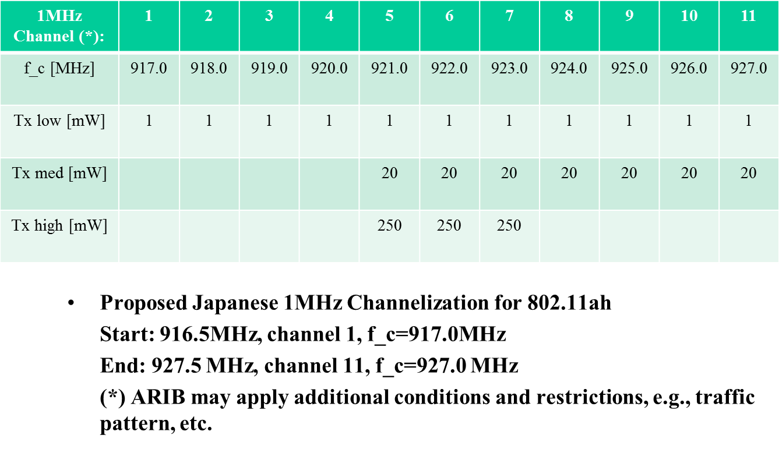

1. China

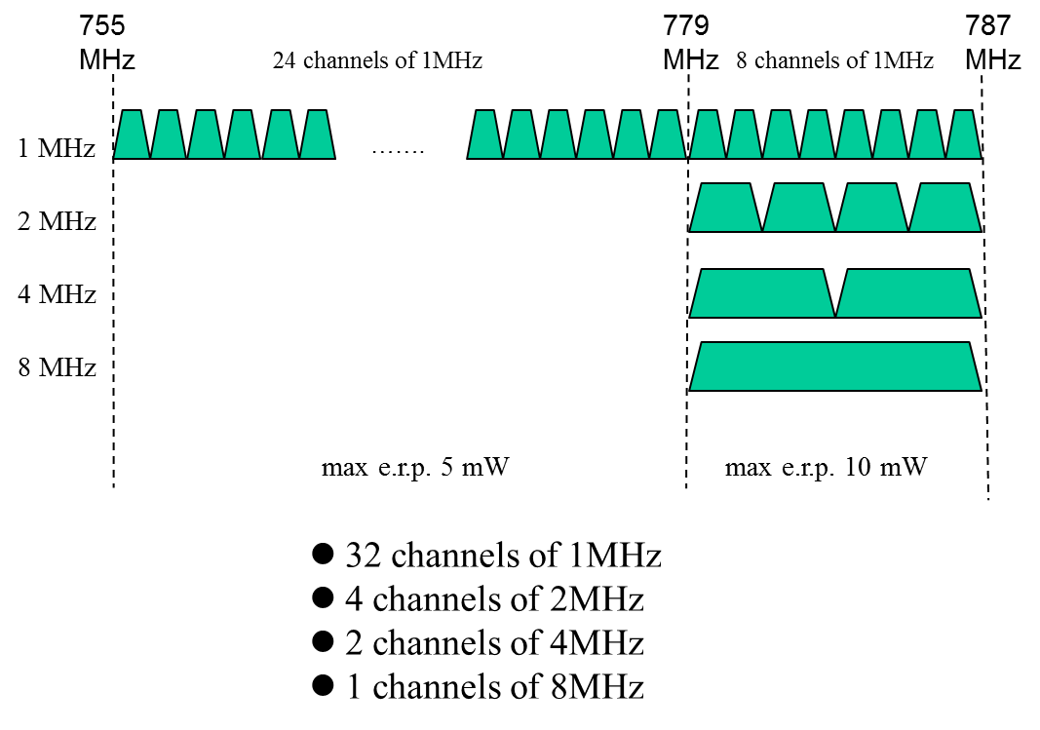

1. Singapore [12/111r1]:

* Supporting bands: 866-869 MHz, 920-925MHz

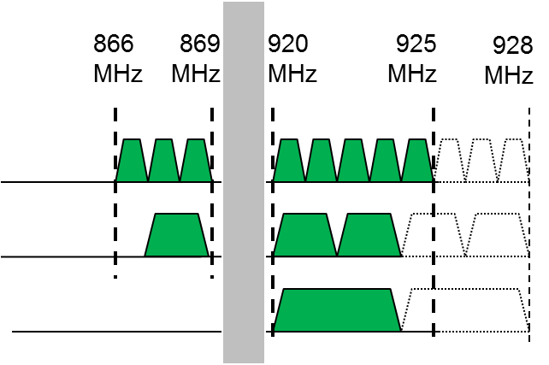

## 3.2 S1G PLCP Sublayer

R.3.2.A: 11ah defines single stream pilots in the LTF, SIG and Data fields of SU packets, using the first column of P matrix for multi-stream mapping, as below:

* For MU packets, the same single stream pilot is applied starting from MU-LTF1.
* The transmitted pilot tone signals, in the k-th tone and n-th OFDM symbol is expressed as:

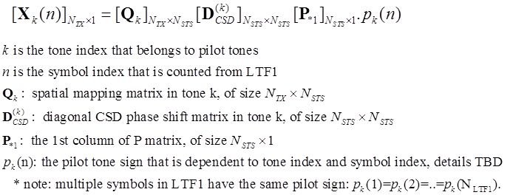

### 3.2.1 Preamble

R.3.2.1.A: In any 11ah short GI packet, short GI starts from the 2nd Data symbol, and the 1st Data symbol is always long GI.

* Include Multi-stream or MU packets

R.3.2.1.B: STF and LTF sequences for higher FFT sizes are based on 11ac [12/115r0,slide7]

R.3.2.1.C: The draft specification shall include 2-bit Ack Indication (00: Ack; 01: BA; 10: No Ack; 11: reserved) in SIG.

### 3.2.1.1 PHY greather than or equal to 2 MHz

R.3.2.1.1.A: The general structure for SU open-loop packet is similar to 11n green field preamble, as below:

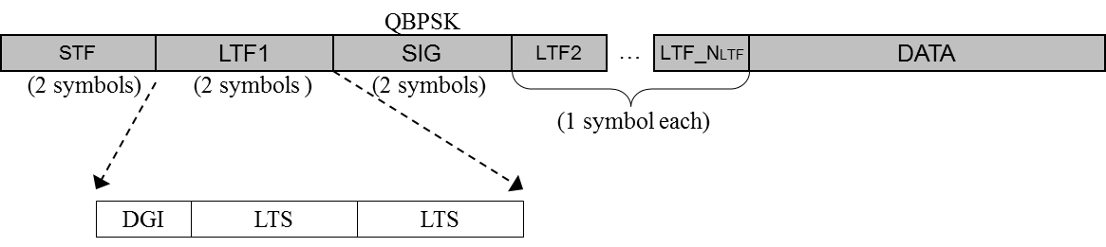

Each field is defined as follows:

* STF Field
  1. Use the same tone design as in 11n, i.e. in each 2MHz, STF occupies 12 non-zero tones in {±4 ±8 ±12 ±16 ±20 ±24}.
  2. None-zero tones are mapped to space-time streams using the first column of P matrix, the same way as in 11n GF preamble.



* LTF Fields
  1. Define the 11ah LTF signs for >= 2MHz PPDUs the same as the VHTLTF signs in the corresponding 11ac packets with the same FFT sizes.
  2. In data tones of LTF, the mapping from NSTS space-time streams to NLTF LTFs is the same as in 11n green field preamble, with the P matrix.



### SIG Field

* 1. 2 symbols, each modulated using Q-BPSK, same as in 11n green field preamble.
  2. 52 data tones, modulated using 11n/11ac MCS0.
     1. Note that 11n HTSIG uses 48 data tones.
  3. Data tones are mapped to multiple space-time streams using the first column of P matrix—the same as in 11n GF preamble.



R.3.2.1.1.B: MU packets use a “mixed-mode” format shown below:

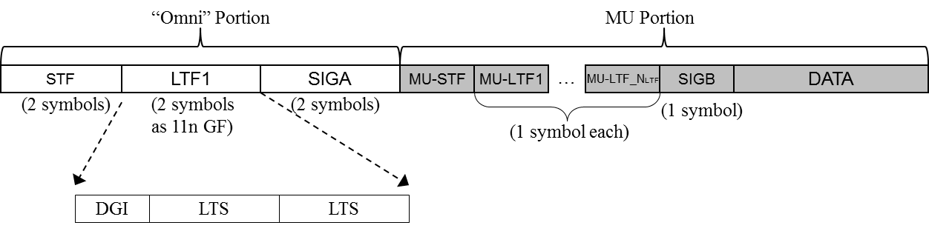

1. Omni Portion
   1. LTF1 and SIG field both have 52 data tones.
      1. Different from the legacy portion of 11n MM preamble and 11ac preamble.
   2. STF/LTF1/SIG fields applies single stream in each subcarrier (without the 1st column P matrix mapping as seen in SU preamble), similar to the legacy portion of 11n MM preamble and 11ac preamble.



* 1. SIG field subfield definition is different from SU, and the two symbols in SIG field are modulated using QBPSK and BPSK respectively
     1. **Refer to later “auto-detection” slide.**

1. MU Portion
   1. MU-STF is the same as (downclocked) 11ac VHT-STF.
   2. Modulation flows of MU-STF, MU-LTFs, and SIGB are the same as 11ac MU packets.
      1. i.e. all streams for all users are trained by MU-LTFs.
      2. Up to 4 space-time stream across all users (refer to [11/1275r1]).

R.3.2.1.1.C: SU/MU autodetection

1. For >=2MHz SU and MU packets, the 1st SIG symbol is always QBPSK
   1. Used for autodetection between 1MHz and 2MHz preamble—refer to [11/1482r3].
2. The 2nd SIG symbol is used for autodetection between SU and MU packets.

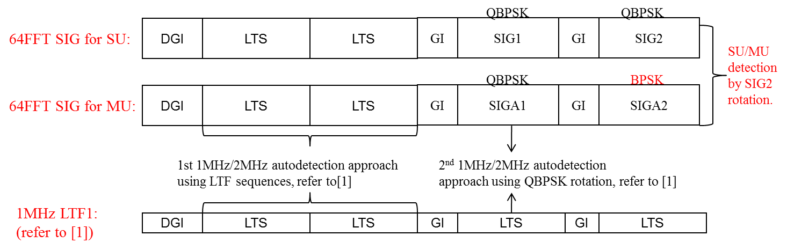

R.3.2.1.1.D: 4/8/16 MHz frame format

1. For 4MHz, 8MHz, and 16MHz packets, the STF/LTF/SIG field designs are similar to 11ac 40/80/160MHz.
   1. STF/SIG fields are repeated and phase rotated (same as in 11ac) over each 2MHz subband.
   2. LTF signs in the tones of each 2MHz subband, when overlapping with the tones with a stand-alone 2MHz LTF, have the same values as the corresponding signs in 2MHz LTF.

R.3.2.1.1.E: SIG field content for >=2MHz

1. 2MHz SIGA
   * Recall that SU and MU are differentiated by autodetection

|  |  |  |
| --- | --- | --- |
|  | **SU** | **MU** |
| Length / Duration | 9 | 9 |
| MCS | 4 |  |
| BW | 2 | 2 |
| Aggregation | 1 |  |
| STBC | 1 | 1 |
| Coding | 2 | 5 |
| SGI | 1 | 1 |
| GID |  | 6 |
| Nsts | 2 | 8 |
| PAID | 12 |  |
| Reserved | 8 | 10 |
| CRC | 4 | 4 |
| Tail | 6 | 6 |
| **Total** | **52** | **52** |

* 1. LENGTH/DURATION: in num of symbols when aggregation is 1, is in num of bytes when aggregation is 0, Mandate AMPDU for packet sizes > 511 bytes and for MU.
  2. STBC: Same as in 11ac (Alamouti code on all streams or none).
  3. Nsts: for SU (2 bits), represents 1~4 STS; for MU (8 bits), represents 0~3 STS per user for the 4 users.
  4. Coding: for SU 1 bit indicates BCC/LDPC, the other bits indicates additional symbol during LDPC encoding process; for MU, 4 bits indicates BCC/LDPC of 4 clients, and 1 bit indicates whether additional symbols happens for any user when encoding LDPC (same as 11ac).
  5. MCS: for SU, 4 bit MCS index; for MU, reuse 3 bits for BCC/LDPC indicator for users 2~4—similar as in 11ac VHTSIGA.
  6. Aggregation: Mainly applicable for SU, reserved for MU.
  7. CRC: 4 bits of CRC should be enough as shown in the Appendix
  8. GID: 6-bit GID as in 11ac for MU, not needed for SU.
  9. PAID: 12 bits PAID to accommodate more clients than 11ac, not needed for MU.

1. 2MHz SIGB (MU)

|  |  |  |  |  |
| --- | --- | --- | --- | --- |
|  | **BW (MHz)** | | | |
|  | **2** | **4** | **8** | **16** |
| MCS | 4 | 4 | 4 | 4 |
| Tail | 6 | 6 | 6 | 6 |
| CRC | 8 | 8 | 8 | 8 |
| Reserved | 8 | 9 | 11 | 11 |
| **Total** | 26 | 27 | 29 | 29 |

### 3.2.1.2 1 MHz mode PHY

R.3.2.1.2.A: The 802.11ah specification shall use the following STF and LTF sequences for 32 FFT:

1. STF sequence [12/115r0,slide4]
   * Tone index=[-12 -8 -4 4 8 12]
   * Values: [0.5, -1, 1, -1, -1, -0.5]x(1+j)x γ   where γ is a normalization factor
   * γ = 2.4 for MCS0 rep2, 1.7 otherwise

* LTF sequence [12/115r0, slide7]
  + Tone index is [-16 -15 -14 …. -1 0 1 ….. 14 15]   
    =[0 0 0 1 -1 1 -1 -1 1 -1 1 1 -1 1 1 1 0 -1 -1 -1 1 -1 -1 -1 1 -1 1 1 1 -1 0 0]

R.3.2.1.2.B: The 802.11ah draft specification shall have a 4 symbol packet detection section for the 1 MHz mode [11/1482r4, motion2].

1. A 3 dB power boost is only applied for 2x repetition MCS
2. Have same periodicity as 2 MHz STF with following tone allocations:
   1. For 2MHz {±4 ±8 ±12 ±16 ±20 ±24}
   2. For 1MHz {±4 ±8 ±12}.

R.3.2.1.2.C: The 802.11ah draft specification shall have the general preamble structure for 1MHz SU open loop packet as in the figure below [11/1482r4, motion3].

* The relationship between NSTS and NLTF is the same as 11n/11ac (for 2 through 4 streams), using the same P matrix (for 1 through 4 streams)
* 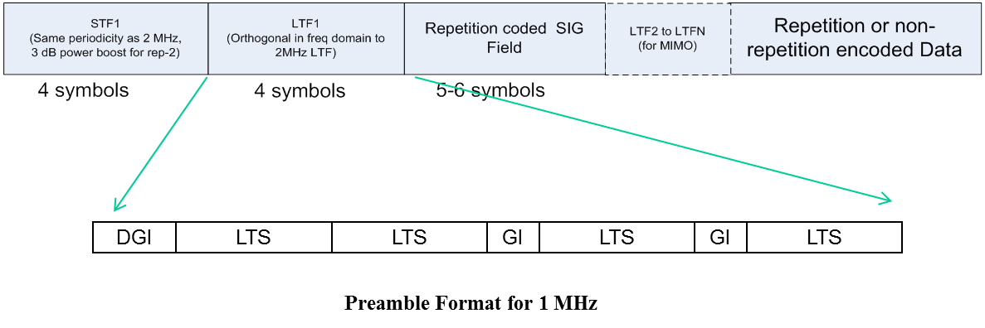

R.3.2.1.2.D: The 802.11ah draft specification shall have 1MHz SIG field contents as follows.

|  |  |  |
| --- | --- | --- |
| **SIG Field** | **Bits** | **Comments** |
| STBC | 1 | Same as in 11ac |
| Num SS | 2 | Number of spatial streams for SU |
| SGI | 1 | Short Guard Interval |
| Coding | 2 | 1st bit is coding type (LDPC/BCC), 2nd bit is for LDPC Nsym ambiguity |
| MCS | 4 | MCS |
| Aggregation bit | 1 | Signals use of AMPDU |
| Length | 9 | Length field (in symbols when aggregation is ON, is in bytes when aggregation is OFF, Mandate AMPDU for packet sizes > 511 bytes |
| Reserved | 6 (TBD) | Some possible uses are MAC bits or any other new features etc. Details TBD |
| CRC | 4 | 4 bits of CRC should be enough |
| Tail | 6 (TBD) | Tail-biting can be explored |
| **Total** | **36** |  |

* **SIG goes at BPSK-rate ½ -rep 2**
* **No MU transmissions for the 1MHz mode**
* **No AID supported** 
  + Details on next slide
* **Leaves 6 reserved bits assuming tail is present**

### 3.2.2 Transmission flow

3.2.2.1 Transmission flow for 11ah regular non-repetition MCSs

R.3.2.2.1.A: The general transmission flow for 11ah regular non-repetition MCSs is shown below.

* Apply the same Tx flowin 11ac in the data tones for the data field.

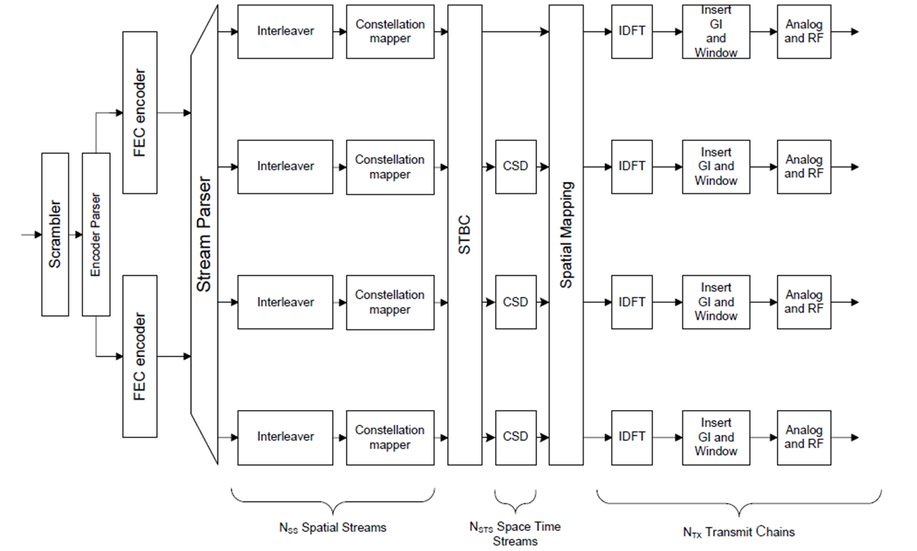

R.3.2.2.1.B: The 11ah stream parser is the same as 11ac.

R.3.2.2.1.C: The 11ah encoder parser and segment parser (16MHz only) are the same as 11ac; NES in the MCSs of 2/4/8/16MHz is the same as the corresponding values in 11ac; and NES = 1 in all the MCSs of 1MHz.

R.3.2.2.1.D: The 802.11ah specification framework shall have the following transmission flow for MCS0-Rep2 mode.[12/1484r6]

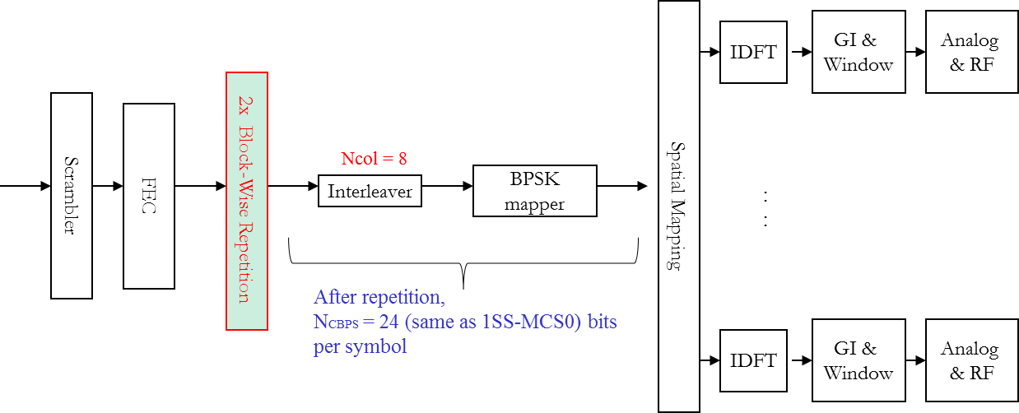

* MCS0 Rep2 is applied only for single space-time stream.
  + NSS=1, no STBC
* The “2x block-wise repetition”performed on a per-OFDM symbol basis:
  + Cout=[C1….C2NDBPS , C1….C2NDBPS ], where [C1….C2NDBPS] are the FEC output bits per symbol.
  + Interleaver parameters are the same as regular MCS0.
  + Ncol = 8
* Receiver may conduct MRC combining to improve SNR.

### 3.2.3 Tone plans

3.2.3.1 >= 2MHz PHY

R.3.2.3.1.A: >=2MHz follows the same tone plans as the corresponding FFT sizes in 11ac [11/1484r6].

3.2.3.2 1 MHz PHY

R.3.2.3.2.A: Define the 1MHz tone allocation as: 24 Data tones, 2 Pilot tones at tone indices +/-7, 3 Guard tones on left and 2 guard tones on right, and 1 DC tone [11/1484r6].

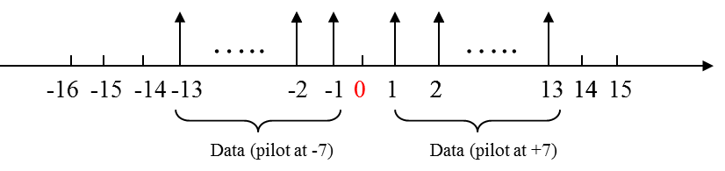

R.3.2.3.2.B: The 802.11ah specification shall use Ncol=8 as the 32 FFT interleaver choice.

## 3.3 Modulation and Coding Scheme (MCS)

R.3.3.A: The 802.11ah specification shall allow following 11ah MCSs [11/1484r6]:

1. For 1MHz, 11ac MCS0~9, as well as an MCS0-rep2 mode and more modes TBD.
2. For >=2MHz, the MCS tables for BCC are the same as the corresponding tables in 11ac before downclocking, i.e. same MCS exclusions for BCC as in 11ac.

R.3.3.B: The 802.11ah specification shall adopt MCS0 rep 2 as the lowest rate for 1 MHz [11/1484r4, motion1].

## 3.4 Spatial Multiplexing

R.3.4.1.A: The maximum number of space-time streams (NSTS) in a data PPDU transmission shall be less than or equal to 4. [11/1275r1]

# 4 MAC Layer

This section describes the functional blocks of the MAC layer.

## 4.1 Power Save

R.4.1.A: An AP may provide its TSF timer accuracy information to non-AP STAs [12/130r0]**.**

R.4.1.B: The 802.11ah draft specification shall define the following operation mode. [12/127r1]

1. STA may send a PS-Poll at any time
2. AP shall respond immediately to a PS Poll with either
   1. Data for the requesting STA, or
   2. ACK frame with 1bit-field indicating
      1. 1: traffic is buffered (as indicated in the TIM map), stay awake (i.e. a service period starts)
      2. 0: no traffic is buffered, go back to sleep
      3. The bit used in current ACK frame format is the More Data field

## 4.2 Channel Access

## 4.3 Large Number of STAs Support

4.3.1 Traffic Indication Map (TIM) operation

R.4.3.1.A: The complete traffic indication bitmap shall be divided into one or more segments and transmitting in one or more TIM elements for a large network [12/117r0].

R.4.3.1.B: When the complete traffic indication bitmap is divided into multiple segments, the range of the AIDs (bitmap) each segment is covering shall be known to the STAs [12/117r0].

## 4.4 Frame Formats

4.4.1 Short Beacon frame format

R.4.4.1.A: The draft specification shall provide support for a new frame format for a short beacon (content is TBD). [11/1503r1]

R.4.4.1.B: The draft specification shall define a Short Beacon interval, in units of TUs, and to require that the Beacon Interval is an integer multiple of the Short Beacon Interval.

R.4.4.1.C: The Frame Control type/subtype indication for the Short Beacon.

* Frame Control
  + To indicate a Short Beacon we build on type/subtype field modifications proposed by 11ad
  + Propose: B3 B2 = 11  
     B7 B6 B5 B4 = 0 0 0 1 (currently reserved)  
    as indication of Short Beacon

R.4.4.1.D: The Short Beacon should include a compressed SSID field.

R.4.4.1.E: The Short Beacon should include a 4 byte Timestamp containing the 4 LSBs of the AP Timestamp.

R.4.4.1.F: The Short Beacon shall include a 1 byte Change Sequence Field that is incremented whenever critical network information changes.

R.4.4.1.G: The Short Beacon should optionally include a field indicating duration to next full beacon.

**References:**

11/1294r0 Spec Framework Text for 11ah Bandwidth Modes

11/1311r0 Spec Framework Text for PHY Numerology

11/1275r1 Spatial stream support in TGah specification

11/1329r0 Motions and Strawpoll on Channelization for 11ah

11/1318r0 Japanese Channelization for 802.11ah

11/1320r1 11ah Channelization of China