IEEE P802.11
Wireless LANs
Proposed Specification Framework for TGah
Date: 2011-11-07
Author(s):
Name | Affiliation | Address | Phone | email
Minyoung Park | Intel | 2111 NE 25th Ave, Hillsboro OR 97124, USA | 503-712-4705 | minyoung.park@intel.com

Abstract
This document provides the framework from which the draft TGah amendment will be developed. The document provides an outline of each the functional blocks that will be a part of the final amendment. The document is intended to reflect the working consensus of the group on the broad outline for the draft specification. As such it is expected to begin with minimal detail reflecting agreement on specific techniques and highlighting areas on which agreement is still required. It may also begin with an incomplete feature list with additional features added as they are justified. The document will evolve over time until it includes sufficient detail on all the functional blocks and their inter-dependencies so that work can begin on the draft amendment itself.

0 Revision Notes
R0 | Initial draft document with a table of content
R1 | Added supporting bandwidth modes [11/1294r0]  Added the number of tones for 2MHz PHY transmission and the tone spacing for all other bandwidth modes [11/1311r0]
R2 | Added max number of space-time streams [11/1275r1]  Added channelization [11/1329r1]
R3 | Modified South Korea channelization [11/1422r0]  Added support for a new frame format for a short beacon [11/1503r1]

1 Definitions

2 Abbreviations and Acronyms

S1G sub 1 GHz
PLCP physical layer convergence procedure
STA station
MAC medium access control

3 S1G Physical Layer

This section describes the functional blocks of the physical layer.

3.1 Channelization

R.3.1.A: The draft specification shall include support for 1 MHz, 2 MHz, 4 MHz, 8 MHz, and 16 MHz PHY transmissions. [11/1294r0]

R.3.1.B: An 802.11ah STA shall support reception of 1 MHz and 2 MHz PHY transmissions. [11/1294r0]

R.3.1.C: The 2 MHz PHY transmission shall be an OFDM based waveform consisting of a total of 64 tones (including tones allocated as pilot, guard and DC). Note: This implies a tone spacing of 31.25 kHz. [11/1311r0]

R.3.1.D: The tone spacing for all other bandwidths PHY transmissions shall be same as the tone spacing in the 2 MHz PHY transmission. [11/1311r0]

R.3.1.E: The draft specification shall include the following channelization [11/1329r1]
- South Korea [11/1422r0]
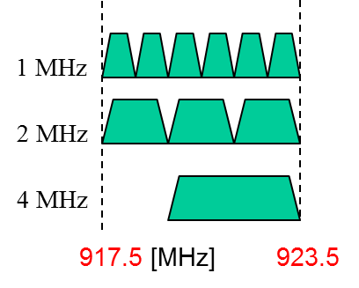
- Europe

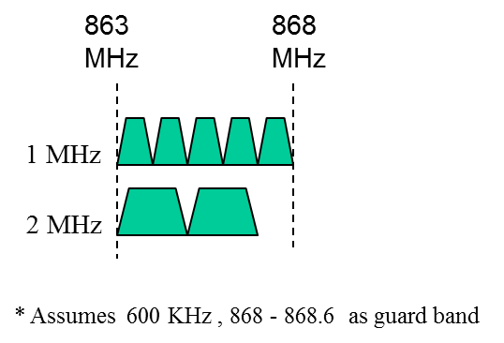

- Japan
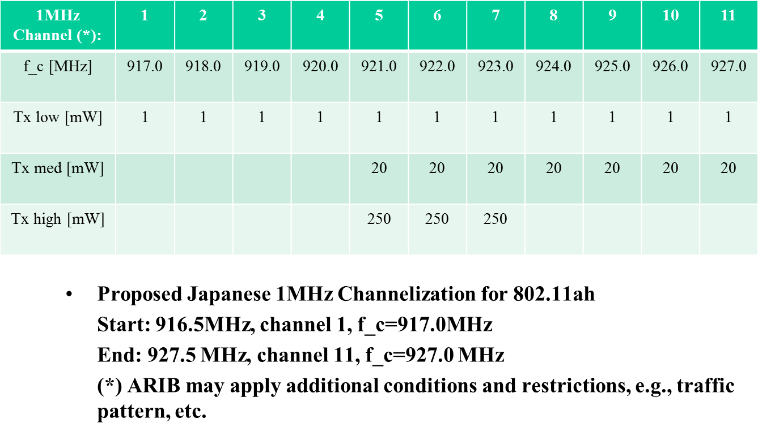

- China
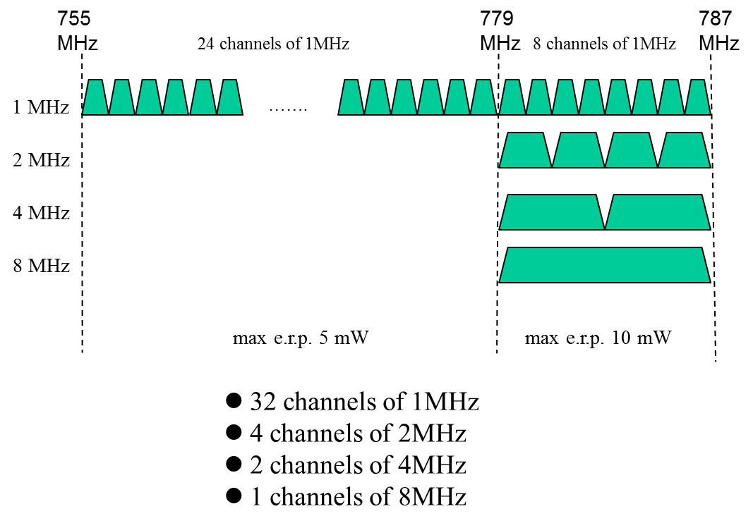

3.2 S1G PLCP Sublayer

3.3 Modulation and Coding Scheme (MCS)

3.4 Spatial Multiplexing

R.3.4.1.A: The maximum number of space-time streams (N_{STS}) in a data PPDU transmission shall be less than or equal to 4. [11/1275r1]

4 MAC Layer

This section describes the functional blocks of the MAC layer.

4.1 Power Save

4.2 Channel Access

4.3 Large Number of STAs Support

4.4 Frame Formats

4.4.1 Short Beacon frame format
R.4.4.1.A: The draft specification shall provide support for a new frame format for a short beacon (content is TBD). [11/1503r1]

References:
11/1294r0 Spec Framework Text for 11ah Bandwidth Modes
11/1311r0 Spec Framework Text for PHY Numerology
11/1275r1 Spatial stream support in TGah specification
11/1329r0 Motions and Strawpoll on Channelization for 11ah
11/1318r0 Japanese Channelization for 802.11ah
11/1320r1 11ah Channelization of China

