IEEE P802.11
Wireless LANs
11-11-0859-00-00ad-MoreData_field
Date: 09 June 2011
Author(s):
Name | Affiliation | Address | Phone | email
Payam  Torab | Broadcom  Corporation | 5300 California Ave.  Irvine, CA 92617 | +1 949-926-6840 | ptorab@broadcom.com
Abstract
This document provides an improved usage of the “More Data” bit in the Frame Control field that results in better utility for the bit in DBand. A DBand STA sets the bit to 1 in any frame it sends out simply if it has data to send during the same SP/TXOP. The information tha the other end has data to send if it is given a chance to transmit can be used to grant an RD for example, or to dynamically adjust SP duration.
A closely related problem – the absence of More PPDU bit in control response frames in DBand to grab an RD grant – is also resolved.

Problem Statement

This document provides an improved usage of the “More Data” bit in the Frame Control field that results in better utility for the bit in DBand. A DBand STA sets the bit to 1 in any frame it sends out simply if it has data to send during the same SP/TXOP. The information that the other end has “qualified” data to send (e.g., data frames belonging to a TSPEC mapped to the same SP) can be used to grant an RD for example, or to dynamically adjust the SP duration.

A closely related problem – the absence of an appropriate More PPDU bit in control response frames in DBand to indicate More PPDU in response to an RD grants - is also resolved. As shown in the diagram below, a DBand RD grantee that is also required to send a control response frame such as an Ack or Block Ack, currently does not have a direct way of setting More PPDU to 1 to accept the RD grant (control response frames do not have a QoS Control header, and control wrapper frames are not supported in DBand) – the grantee either has to aggregate a QoS frame (including QoS Null) to be able to tell More PPDU = 1. Aggregating control response and data farmes may not be desirable all the time. Aggregating something as simple as a QoS Null has a performance penalty too, because the aggregate is subject to the minimum MPDU start spacing (density spacing). The simpleset solution is to exempt QoS null frames from density spacing. This is particularly justified given that density spacing was introduced to satisfy decryption speed limits from one MPDU to the next in the aggregate, and since QoS Null frames have no payload they obviously do not go through encryption/decryption.

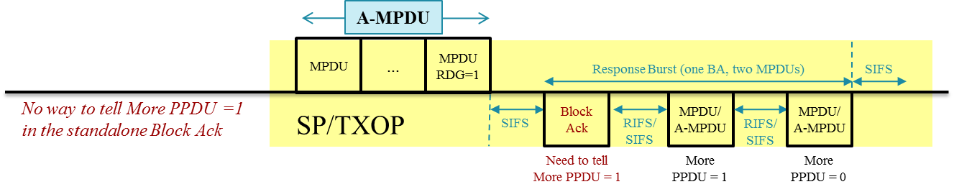

More Data field
Editor instruction: change this subclause as follows

The More Data field is 1 bit in length and is used differently in the OBand and in the DBand.

In the OBand, the More Data field is used as follows:

- It is used to indicate to a STA in PS mode that more MSDUs, A-MSDUs, or MMPDUs are buffered for that STA at the AP. The More Data field is valid in directed data or management type frames transmitted by an AP to a STA in PS mode. A value of 1 indicates that at least one additional buffered MSDU, A-MSDU, or MMPDU is present for the same STA.

- It is optionally set to 1 in directed data type frames transmitted by a CF-Pollable STA to the PC in response to a CF-Poll to indicate that the STA has at least one additional buffered MSDU available for transmission in response to a subsequent CF-Poll.

- For a STA in which the More Data Ack subfield of its QoS Capability element is 1 and that has APSD enabled, an AP optionally sets the More Data field to 1 in ACK frames to this STA to indicate that the AP has a pending transmission for the STA.

- It is set to 0 in all other directed frames.

- It is set to 1 in group addressed frames transmitted by the AP when additional group addressed MSDUs or MMPDUs remain to be transmitted by the AP during this beacon interval. The More Data field is set to 0 in group addressed frames transmitted by the AP when no more group addressed MSDUs or MMPDUs remain to be transmitted by the AP during this beacon intervaland in all group addressed frames transmitted by non-AP STAs.

In the DBand, the More Data field is used as follows:

- In directed frames, it is set to 1 to indicate that the STA has MSDUs or A-MSDUs buffered for transmission to the frame recipient during the same SP/TXOP.

- It is set to 1 in group addressed frames transmitted by the AP when additional group addressed bufferable units (BUs) remain to be transmitted by the AP during this beacon interval. The More Data field is set to 0 in group addressed frames transmitted by the AP when no more group addressed BUs remain to be transmitted by the AP during this beacon interval.

A DBand STA does not set the More Data bit to 1 if it does not have any MSDUs or A-MSDUs buffered for transmission to the frame recipient during the same SP/TXOP.

9.12.3 Minimum MPDU Start Spacing

Editor instruction: change the first paragraph as follows

An HT STA and a DBand STA shall not start the transmission of more than one MPDU within the time limit described in the Minimum MPDU Start Spacing field declared by the intended receiver. To satisfy this requirement, the number of octets between the start of two consecutive MPDUs in an A-MPDU, measured at the PHY SAP, shall be equal or greater than

t_{MMSS} × r/8

where
t_{MMSS} is the time (in microseconds) defined in the “Encoding” column of Table 8-123 (Subfields of the A-MPDU Parameters field) for an HT STA and of Table 13 for a DBand STA for the value of the Minimum MPDU Start Spacing field
r is the value of the PHY Data Rate (in megabits per second) defined in clause 21 for a DBand STA and for an HT STA defined in 19.6 (Parameters for HT MCSs) based on the TXVECTOR parameters: MCS, GI_TYPE, and CH_BANDWIDTH

In DBand, QoS Null frames are not subject to this spacing, i.e., no extra octets are needed before QoS Null frames.

