IEEE P802.11
Wireless LANs
HIP DEX for Fast Initial Authentication in 802.11Date: 2011-05-10Author(s):NameAffiliationAddressPhoneemailKonstantinos GeorgantasHelsinki Institute for Information Technology0030-6974343988Konstantinos.Georgantas@hiit.fiRobert MoskowitzVerizon Business15210 Sutherland, Oak Park, MI 48237, USA+1-248-219-2059rgm@htt-consult.com

Why someone may need a fast initial authentication in 802.11 wireless networks?
- Moving users with high velocity between Aps .
- Big amount of users entering an AP.
- Smaller and smaller cell areas.

The ultimate goal would be to acheive an authentication process of a single roundtrip. By introducing HIP DEX in 802.11 networks for authentication purposes this goal is half way acheived. That means that there can be an authentication mechanism that provides the necessary keying material and establishes the needed security associations in two roundtrips. Moreover the intra-BSS handovers can avoid reauthentications by introducing a new network model.

More specific details are included in “Lightweight Authentication and Key Management on 802.11 Wireless Networks” by Konstantinos Georgantas and Andrei Gurtov submitted in IEEE GLOBECOM 2011. Due to the pending conference response only the main points of the paper shall be presented hereby.

Introduce a new network hierarchy
- Move the authenticator – HIP responder one level above Figure 1.
- Authenticate only when ESS transition occurs.
- Let the APs act as relays.
- Introduce a port based Network Access Control allowing HIP only traffic until the Initiator is authenticated.

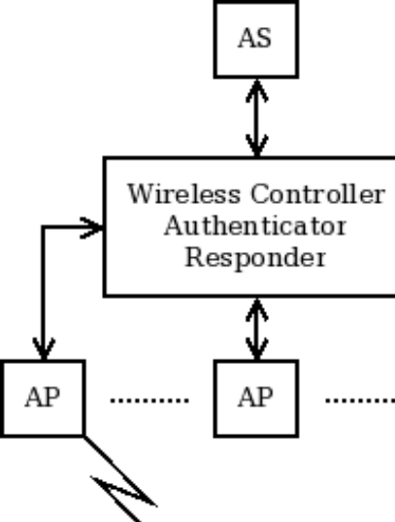
Figure New network architecture
HIP DEX
As far as HIP DEX is concerned HIP datagrams can run over 802.11 Authentication frames and the HIP UPDATE message can act as a rekeying mechanism. Of course EAP can run on HIP if this is desired. The basic operation of DEX follows in Figure 2. Through this process the Initiator and the Authenticator can derive the MK and PTK. The GTK can be sent later through an UPDATE message.

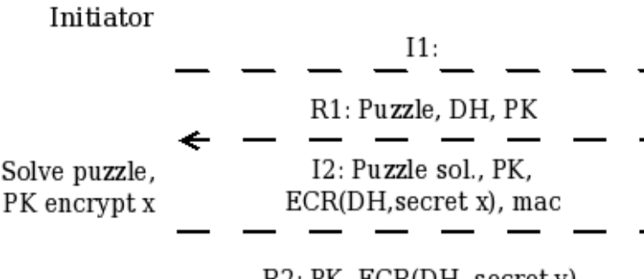
Figure HIP DEX message exchanges
The overall proposed solution operation can be summarized in Figure 3.

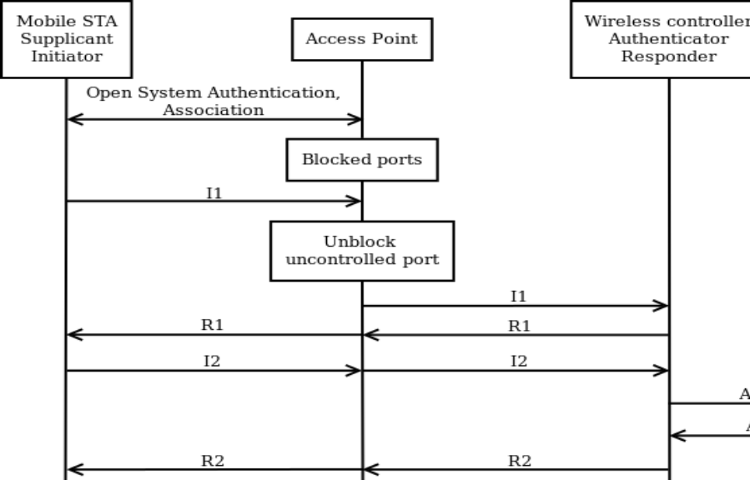
Figure Proposed operation

References:
[1] R. Moskowitz, “Key Negotiation using DIET HIP.” [Online], Available at: https://mentor.ieee.org/802.15/dcn/10/15-10-0412-06-wng0-key-negotiation-using-diet-hip.ppt, 2010.
[2] R. Moskowitz, “Summary and Comments, FIA Security Analysis.” [Online], Available at: https://mentor.ieee.org/802.11/dcn/10/11-10-0980-00-0fia-fia-security-analysis-bobm.pptx, 2010.
[3] K. Georgantas, A. Gurtov, “Lightweight Authentication and Key Management on 802.11 Wireless Networks”, unpublished.

