Wireless LANs
IEEE 802.11 Timeline & Ballot Tool
Date: 2010-11-10
Author(s):
Name | Affiliation | Address | Phone | email
Alex Ashley | NDS Ltd | One London Road, Staines, Middlesex, TW18 4EX, UK |  | aashley at nds dot com
Abstract
The IEEE 802.11 timeline tool is a web application that is currently being hosted by the Google App Engine.

The application is based upon the model, view, controller paradigm. It uses databases to hold information on the IEEE 802.11 projects and ballots, scripts to control the “business logic” of viewing and modifying this data, and HTML templates that render the data that you see in your web browser.

The main advantage of this approach is that it allows changes to the visual appearance without requiring any change to the data or control logic.

Introduction
The IEEE 802.11 timeline tool is a web application that is currently being hosted by the Google App Engine. The URL for the site is:

http://ieee80211timeline.appspot.com/

To ensure that this application stays within the free usage quota, access to all parts of this website apart from the front page requires a username and password. Contact Alex Ashley if you would like to request access.

The application is based upon the model, view, controller paradigm. It uses databases to hold information on the IEEE 802.11 projects and ballots, scripts to control the “business logic” of viewing and modifying this data, and HTML templates that render the data that you see in your web browser.

The main advantage of this approach is that it allows changes to the visual appearance without requiring any change to the data or control logic.

Timeline Tool
The timeline tool is used to view, manage and export the IEEE 802.11 timeline chart.

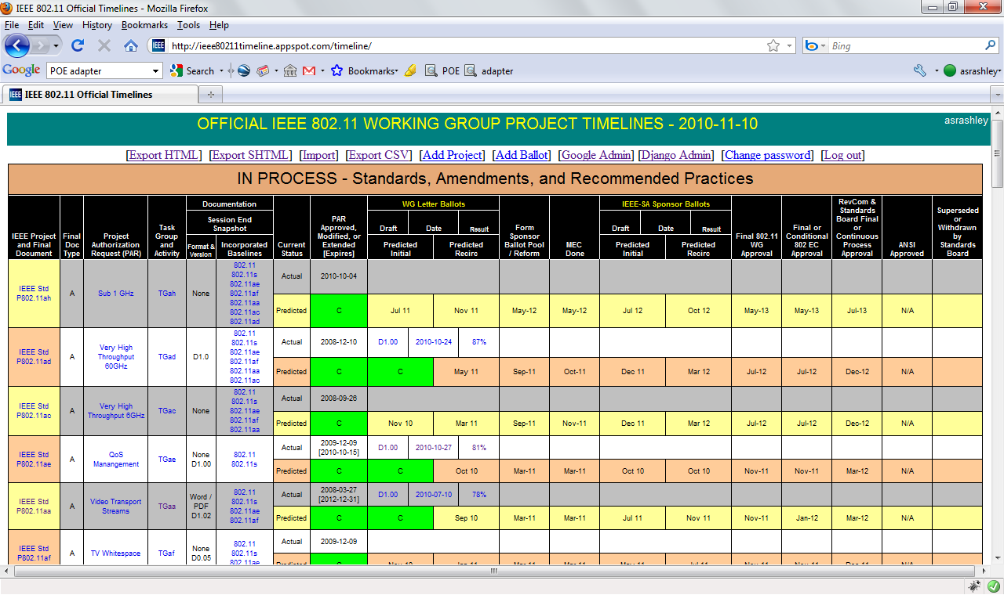

Edit/Delete Project
To modify a project, click on the link in the first column (“IEEE Project and Final Document”) of the table, for the project you are editing. For example, to edit the 11aa project, you click on the “IEEE Std P802.11aa” link in the left hand column. This will take you a web based form that contains all the data for the selected project:

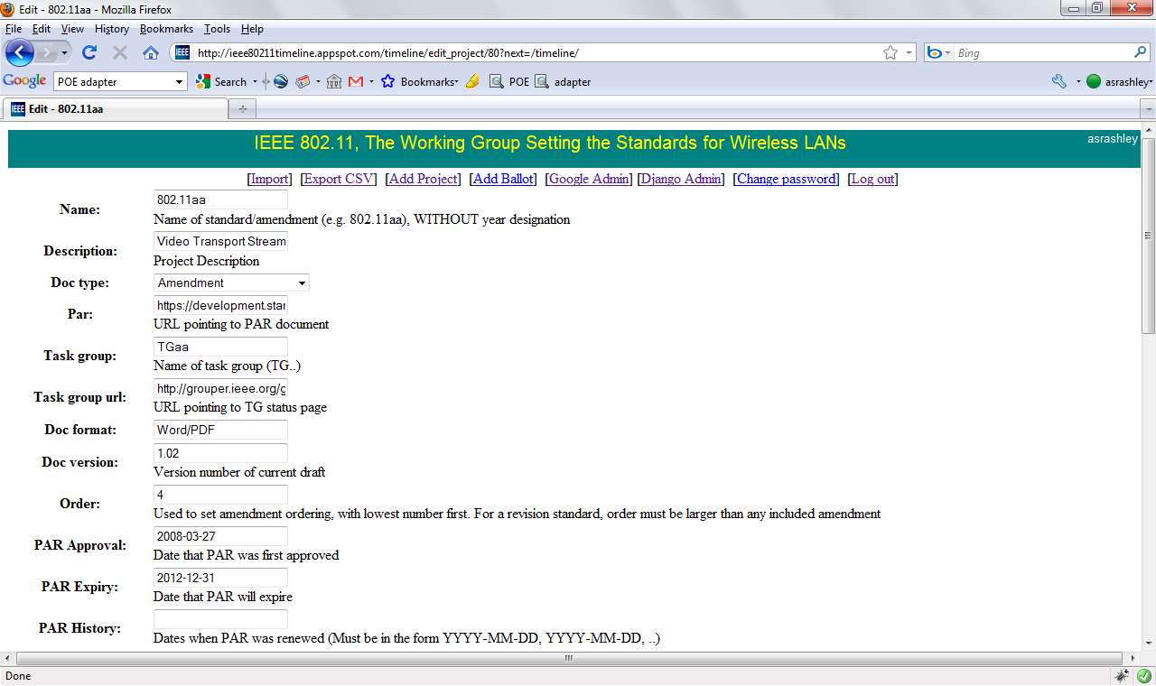

You simply edit each field and then click the “Save” button to save changes. The “Cancel” button will cause all changes to be lost and return you to the previous page. The “Delete” button will take you to a “Do you really want to delete this project?” page, where you need to confirm that you really do want to delete this project.

The date fields must be entered in the form YYYY-MM-DD (e.g. 2010-06-21).

The URL fields (“Par”, “Task group url”) must not have any spaces in their URL. If the document you need to point to has spaces in them, replace each space with %20. For example “my document.doc” becomes “my%20document.doc”.

The “Baseline” field is used for two different purposes. For an amendment project, it points to the baseline standard document on which this amendment is based. For example the baseline for P802.11v is “802.11-2007” where as the baseline for P802.11aa is 802.11 (REVmb).

For a revision standard (e.g. REVmb) the “Baseline” field is used to point to the standard that it replaces. For REVmb, this means that the “Baseline” field is set to “P802.11-2007”.

The “Order” field also has two different purposes. For an amendment project, it is set to the amendment number, with 1 as the first amendment. For a revision standard, it is set to a number greater than the amendment number that is incorporated in that revision. For example if the REVmb project has its order field set to 10, it means that it will incorporate amendments 1 to 9.

Add Project
There is a menu at the top of the page:

Under in the “timeline” menu option there is an “Add project” item. Clicking on the “Add project” menu item takes you to a page that is identical to the edit project page, except that it allows a new project to be created.

Edit Ballot
Each ballot shown on the timeline page is a clickable link that will take you to a page to edit the ballot.

This will take you to a web form that allows editing of the data for the selected ballot:

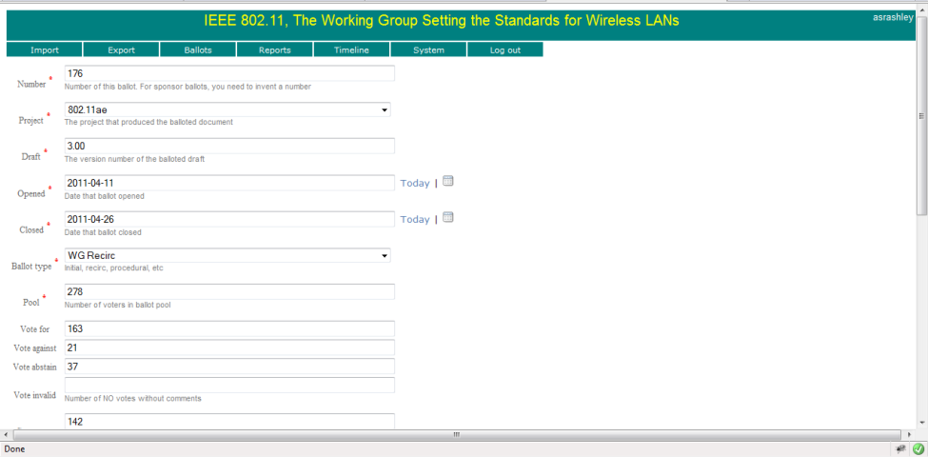
You simply edit each field and then click the “Save” button to save changes. The “Cancel” button will cause all changes to be lost and return you to the previous page. The “Delete” button will take you to a “Do you really want to delete this ballot?” page, where you need to confirm that you really do want to delete this ballot.

The date fields should be entered in the form YYYY-MM-DD (e.g. 2010-06-21). You can also click on the calendar icon (if you have JavaScript enabled) to select a date from a pop-up calendar.

The URL fields must not have any spaces in their URL. If the document you need to point to has spaces in them, replace each space with %20. For example “my document.doc” becomes “my%20document.doc”. If you have JavaScript enabled, the “save” button will automatically escape these spaces for you.

Sponsor ballots do not have a working group member visible number, but each ballot in the database needs a ballot number because it is used as the primary key in the database. When the existing sponsor ballot data was imported in to the database, sponsor ballots were given ascending numbers starting at 10000.

Add Ballot
Clicking on the “Add Ballot” button takes you to a page that is identical to the edit ballot page, except that it allows a new ballot to be created.

The “Number” field is pre-populated with a unique number that can be used for adding a sponsor ballot.

Processing Updates
In order to allow the timeline page to render in a timely fashion, behind the scenes some extra data is pre-computed and stored in the database. Background tasks are triggered to run on the server hosting the timeline tool as soon as updates are made to projects or ballots. Sometimes you will see the title at the top of the page will change to “Processing Updates” and the export menu will be disabled. When you see “processing updates” you can still interact with the web page, but some changes might not have propagated in to the page you are viewing. The page will be automatically reloaded at regular intervals until all the background process has completed.

Export Timeline
The “Export HTML” and “Export SHTML” create “clean” versions of the timeline page, without the top level menu and without the hyperlinks to edit ballots and projects. The “Export HTML” version will produce a standalone web page that can be uploaded to the “grouper” HTTP server. The “Export SHTML” server produces a file that contains SHTML server side include directives that cause the menu template to be incorporated.

Letter Ballot tool
The Letter Ballot tool allows production of the Working Group and Sponsor Ballot pages that list the open and closed ballots. This tool has two links: “Working Group Ballots” and “Sponsor Ballots”

Working Group Ballots
The “Working Group Ballots” link takes you to a page that shows the open and closed working group ballots, and allows ballots to be added, edited and deleted.
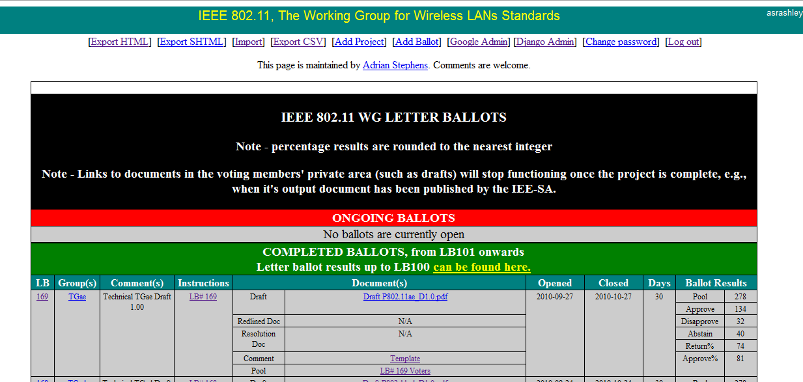

Each item in the “LB” column has a link that takes you to a page that allows the ballot to be edited. The details of the edit ballot page are identical to the timeline tool “edit ballot” page.

Each item in the “Group(s)” column has a link that takes you to a page that allows a project to be edited. The details of the edit project page are identical to the timeline tool “edit project” page.

Sponsor Ballots
The “Sponsor Ballots” link takes you to a page that shows the open and closed sponsor ballots, and allows ballots to be added, edited and deleted.

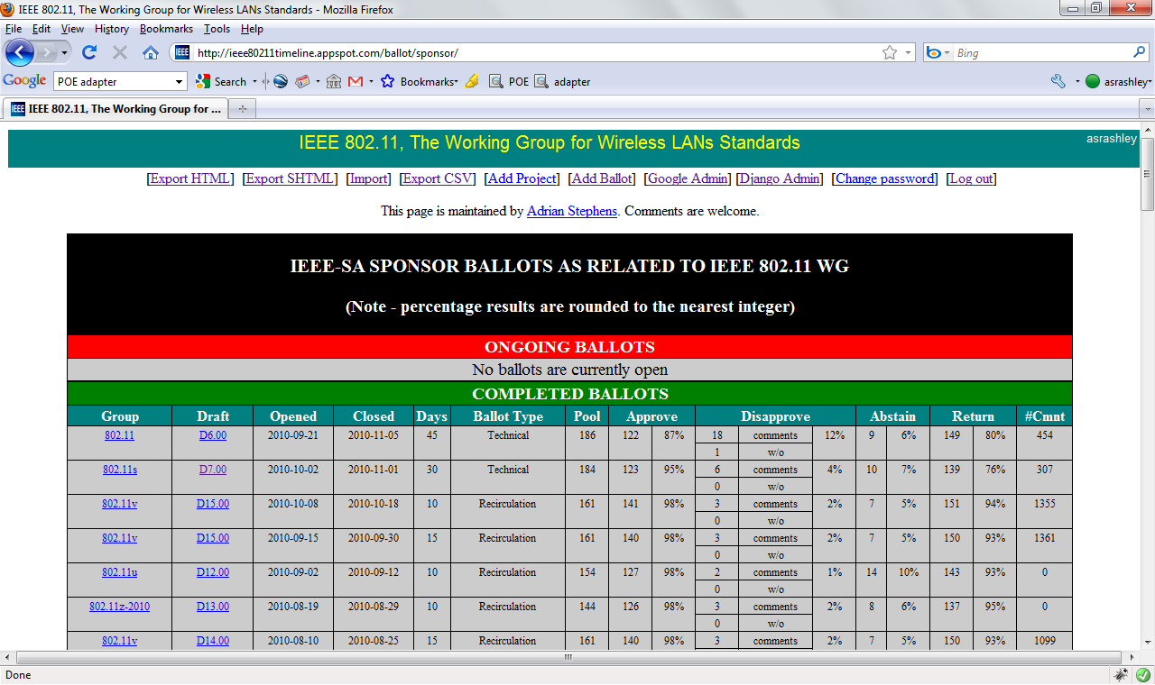
Each item in the “Group” column has a link that takes you to a page that allows a project to be edited. The details of the edit project page are identical to the timeline tool “edit project” page.
Each item in the “Draft” column has a link that takes you to a page that allows the ballot to be edited. The details of the edit ballot page are identical to the timeline tool “edit ballot” page.

Processing Updates
In order to allow the ballot pages to render in a timely fashion, behind the scenes some extra data is pre-computed and stored in the database. Background tasks are triggered to run on the server hosting the timeline tool as soon as updates are made to projects or ballots. Sometimes you will see the title at the top of the page will change to “Processing Updates” and the export menu will be disabled. When you see “processing updates” you can still interact with the web page, but some changes might not have propagated in to the page you are viewing. The page will be automatically reloaded at regular intervals until all the background process has completed.

Meeting Reports
The meeting reports tool allows the web page that lists the minutes and meeting reports of each 802.11 session.
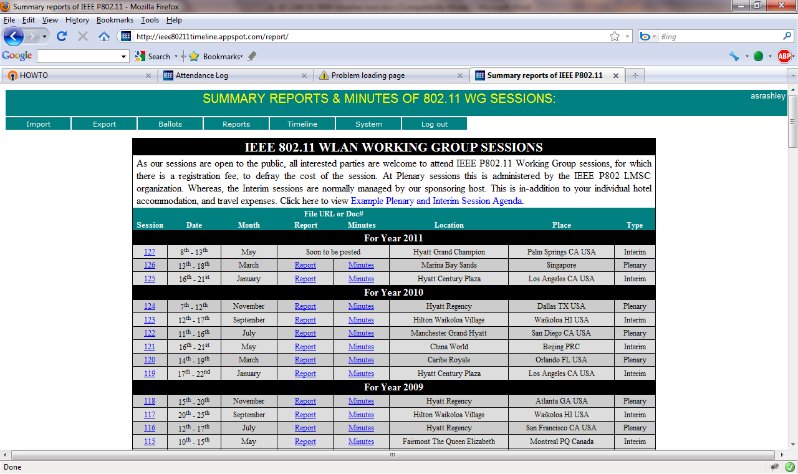
To edit a session, click on the session number in the session column. To add a new session, use the “Add report” menu item in the “Reports” menu.

Exporting Data
The project and ballot data can be exported from the database, as a way of keeping a backup of this data and to allow bulk edits of the data without using the web based tool.

The format of the data is a comma separated value file (CSV) that can be widely parsed by many applications, for example Microsoft Excel.

The file consists of two sections, the project section and the ballot section.

The project section consists of a header of:
pk,name,description,doc_type,par,task_group,task_group_url,doc_format,doc_version,baseline,order,par_date,par_expiry,initial_wg_ballot,recirc_wg_ballot,sb_form_date,sb_formed,initial_sb_ballot,recirc_sb_ballot,mec_date,mec_completed,wg_approval_date,ec_approval_date,revcom_approval_date,ansi_approval_date,withdrawn_date,withdrawn,history,wg_approved,ec_approved,published,slug

This header is followed by each project, one line per project.

The ballot section consists of a header of:
number,draft,opened,closed,ballot_type,pool,vote_for,vote_against,vote_abstain,vote_invalid,comments,instructions_url,draft_url,redline_url,resolution_url,template_url,pool_url,project_id,project.task_group

This header is followed by each ballot, one line per ballot.

The meeting report section consists of a header of:
id,session,start,end,cancelled,pending,report,minutes_doc,minutes_pdf,venue,location,meeting_type

This header is followed by each meeting report, one line per session.

The format and contents of each field is described in the appendix of this document.

Importing Data
The import page allows a previously exported CSV file to be loaded in to the database. If the primary key field refers to an item that is already in the database, the item in the database will be updated. If the primary key refers to an item that is not in the database, the item will be added. The one exception to this rule is that ballots may have a ballot number of zero, which causes the import tool to auto-create a number for this ballot.

When importing a ballot, the project_id field must either contain the primary key of the project to which the ballot pertains, or has the value zero. If the project_id is zero, the project.task_group field must contain the exact text of the task_group field of the project. For example project_id=0 and project.task_group=TGmb.

The import tool also allows an HTML version of the working group or sponsor ballot pages to be directly imported. The import tool will parse the HTML to extract the HTML tables and try to parse ballots from these pages. This feature is obviously very sensitive to changes in the HTML layout and should be considered a second best method of importing, compared to using a CSV file.

Application Environment
The application is written in the Python programming language and is based upon the Django web development framework. As the application is hosted on the Google App Engine (GAE), a database abstraction layer is required because Django requires the use of a relational database, but the GAE datastore is non-relational database. The timeline tool uses the django-nonrel abstraction layer to allow Django to use the GAE datastore.

http://www.python.org/
http://code.google.com/appengine/
http://www.djangoproject.com/
http://www.allbuttonspressed.com/projects/django-nonrel

To run the timeline tool locally, you need to install Python, the GAE development environment, unzip the timeline tool source code and then place the django-nonrel source code in the same directory as the timeline tool source code, as described below. At the time of writing, GAE requires the use of Python v2.5.
Download the following:
- Google App Engine for Python
- django-nonrel
- djangoappengine
- djangotoolbox
Install the Google App Engine. Unzip the django-nonrel source code in to a temporary location.
Copy the following folders into the same directory where you have unzipped the source code:
- django-nonrel/django => <timeline_dir>/django
- djangotoolbox/djangotoolbox => <timeline_dir>/djangotoolbox
- django-dbindexer/dbindexer => <timeline_dir>/dbindexer
- djangoappengine => <timeline_dir>/djangoappengine
Once finished, you should have a directory that contains:
<DIR> ballot
<DIR> django
<DIR> djangoappengine
<DIR> djangotoolbox
<DIR> media
<DIR> project
<DIR> templates
<DIR> timeline
<DIR> util
app.yaml
cron.yaml
index.yaml
LICENSE-2.0.txt
manage.py
queue.yaml
robots.txt
settings.py
test.bat
urls.py
__init__.py
To test that the code is working correctly, run the unit tests:

If using Windows, by typing the following in a command prompt window:

runtests.bat

If you are running the software on a Unix platform, use:

manage.py test util ballot project timeline

This should produce “OK” after running all the tests.

Before you can use the development web server, you need to create the local databases and create a super-user account.
manage.py syncdb
manage.py createsuperuser

The local development web server can be started using:

manage.py runserver

and then opening http://localhost:8000/ in a web browser.

Appendix: Database model

Project Model
Field Name | Type | Maximum Size | Required | Description
pk | IntegerField |  | Yes  (primary key) | Primary key. Not editable.
name | CharField | 20 | Yes | Name of standard/amendment (e.g. 802.11aa), WITHOUT year designation
slug | SlugField | 15 | N/A | Used to create a unique name for each group. Not editable.
description | CharField | 100 | Yes | Project Description
doc_type | CharField enum ( 'A', 'STD', 'RP', 'COR' ) | 4 | Yes | ( 'A', 'Amendment'),  ( 'STD', 'Standard'),  ( 'RP', 'Recommended Practice'),  ( 'COR' , 'Corrigendum')
par | URLField |  | No | URL pointing to PAR document
task_group | CharField | 10 | Yes | Name of task group (TG..)
task_group_url | URLField |  | No | URL pointing to TG status page
doc_format | CharField | 20 | No
doc_version | DecimalField | ####.## | No | Version number of current draft
baseline | IntegerField |  | No | Primary key value of baseline standard.
order | IntegerField |  | Yes | Used to set amendment ordering, with lowest number first. For a revision standard, order must be larger than any included amendment
par_date | DateField |  | Yes | Date that PAR was first approved
par_expiry | DateField |  | No | Date that PAR will expire
history | CharField | 60 | No | Dates when PAR was renewed (Must be in the form YYYY-MM-DD, YYYY-MM-DD, ..)
initial_wg_ballot | DateField |  | No | Estimated Date of initial WG ballot
recirc_wg_ballot | DateField |  | No | Estimated Date of recirculation WG ballot
sb_form_date | DateField |  | No | Date that sponsor ballot will be formed or was formed
sb_formed | BooleanField |  |  | Sponsor pool has been formed
initial_sb_ballot | DateField |  | No | Estimated Date of initial SB ballot
recirc_sb_ballot | DateField |  | No | Estimated Date of recirculation SB ballot
mec_date | DateField |  | No | Estimated/Actual date of mandatory editorial co-ordination
mec_completed | BooleanField |  |  | MEC has been performed
wg_approval_date | DateField |  | No | Estimated/Actual date of WG approval
wg_approved | BooleanField |  |  | WG has approved doc
ec_approval_date | DateField |  | No | Estimated/Actual date of EC approval
ec_approved | BooleanField |  |  | EC has approved doc
revcom_approval_date | DateField |  | No | Estimated/Actual date of Revcom approval
published | BooleanField |  |  | Document has been published
ansi_approval_date | DateField |  | No | Actual date of ANSI approval
withdrawn_date | DateField |  | No | Actual date when document was withdrawn
withdrawn | BooleanField |  |  | Document has been withdrawn

Ballot Model
Field Name | Type | Maximum Size | Required | Description
number | IntegerField |  | Yes  (primary key) | Number of this ballot. For sponsor ballots, you need to invent a number
draft | DecimalField | ####.## | Yes | The version number of the balloted draft
opened | DateField |  | Yes | Date ballot openend
closed | DateField |  | Yes | Date ballot closed
ballot_type | CharField enum ('WI', 'WR, 'SI, 'SR',  'PROC') | 5 | Yes | 'WI' = WG Initial  'WR' = WG Recirc  'SI' = SB Initial  'SR' = SB Recirc  'PROC' = Procedural
pool |  |  | No | Number of voters in ballot pool
vote_for | IntegerField |  | No
vote_against | IntegerField |  | No
vote_abstain | IntegerField |  | No
vote_invalid | IntegerField |  | No | Number of NO votes without comments
comments | IntegerField |  | No | Number of comments
instructions_url | URLField |  | No | URL pointing to ballot instruction
draft_url | URLField |  | No | URL pointing to draft document
redline_url | URLField |  | No | URL pointing to redline version of draft
instructions_url | URLField |  | No | URL pointing to ballot instruction
resolution_url | URLField |  | No | URL pointing to comment resolutions document
template_url | URLField |  | No | URL pointing to comment submission template
pool_url | URLField |  | No | URL pointing to voter pool

MeetingReport Model
Field Name | Type | Maximum Size | Required | Description
session | IntegerField |  | Yes (must be unique) | Number of the session.
start | DateField |  | Yes | Session start date
end | DateField |  | Yes | Session end date
cancelled | BooleanField |  | No | Session was cancelled?
pending | BooleanField |  | No | Reports are in-progress and will be provided later
report | URLField |  | No | URL pointing to meeting report
minutes_doc | URLField |  | No | URL pointing to meeting minutes in Word format
minutes_pdf | URLField |  | No | URL pointing to meeting minutes in PDF format
venue | CharField | 100 | Yes | Name of meeting venue
location | CharField | 100 | Yes | Location of meeting venue
meeting_type | CharField enum ('P', 'I, 'S') | 2 | Yes | 'P' = Plenary  'I' = Interim  ‘S’ = Special

References:

