IEEE P802.11
Wireless LANs
Normative Text Proposal for DownLink Protection
Date: 2007-07-17
Author(s):
Name | Company | Address | Phone | email
Jari Jokela | Nokia | Visiokatu 3, Tampere, Finland | +358504860445 | Jari.jokela@nokia.com
Subbu Ponnuswamy | Aruba Networks | 1322 Crossman Ave Sunnyvale, CA 94089 | +1 408 754 1213 | subbu@arubanetworks.com
Emily Qi | Intel |  | +1 503 264 7799 | emily.h.qi@intel.com
Adrian Stephens | Intel |  | +1 (503) 616-3800 | adrian.p.stephens@intel.com
Yossi Tsfati | Texas Instruments | 26 Zarchin St, Raanana, Israel | +972-97476927 | Yossit@ti.com
Menzo Wentink | Conexant | Oudegracht 3, Uterecht, Netherlands | +31 65 183 6231 | menzo.wentink@conexant.com
Artur Zaks | Texas Instruments | 26 Zarchin St, Raanana, Israel | +972-  9 7476853 | Arturz@ti.com
Jing Zhu | Intel | 2111, NE 25th Ave., Hillsboro, OR 97124 | +1 (503) 265 7073 | jing.z.zhu@intel.com
Notice: This document has been prepared to assist IEEE 802.11. It is offered as a basis for discussion and is not binding on the contributing individual(s) or organization(s). The material in this document is subject to change in form and content after further study. The contributor(s) reserve(s) the right to add, amend or withdraw material contained herein.

Release: The contributor grants a free, irrevocable license to the IEEE to incorporate material contained in this contribution, and any modifications thereof, in the creation of an IEEE Standards publication; to copyright in the IEEE’s name any IEEE Standards publication even though it may include portions of this contribution; and at the IEEE’s sole discretion to permit others to reproduce in whole or in part the resulting IEEE Standards publication. The contributor also acknowledges and accepts that this contribution may be made public by IEEE 802.11.

Patent Policy and Procedures: The contributor is familiar with the IEEE 802 Patent Policy and Procedures <http:// ieee802.org/guides/bylaws/sb-bylaws.pdf>, including the statement "IEEE standards may include the known use of patent(s), including patent applications, provided the IEEE receives assurance from the patent holder or applicant with respect to patents essential for compliance with both mandatory and optional portions of the standard." Early disclosure to the Working Group of patent information that might be relevant to the standard is essential to reduce the possibility for delays in the development process and increase the likelihood that the draft publication will be approved for publication. Please notify the Chair <stuart@ok-brit.com> as early as possible, in written or electronic form, if patented technology (or technology under patent application) might be incorporated into a draft standard being developed within the IEEE 802.11 Working Group. If you have questions, contact the IEEE Patent Committee Administrator at <patcom@ieee.org>.
Abstract
This submission contains the normative text for Co-Located Interference Enhancements for Downlink Protection. This submission is related to TGv Objective: Power Saving (Req. #2071).

The text is aligned with P802.11v-D0.13.
7.2.3.4 Association Request frame format
Insert new rows into table 10 as shown below:\
Order | Information | Notes
25 | Co-located Interference Query | The CLI Query element may be present if  dot11WirelessManagementImplemented is true and the CLI reporting bit in the Wireless Network Management Capability is set to 1.

7.2.3.5 Association Response frame format
Insert new rows into table 11 as shown below:\
Order | Information | Notes
26 | Co-located Interference Request | The CLI Request element may be present if  dot11WirelessManagementImplemented is true, the CLI reporting bit in the Wireless Network Management Capability is set to 1, and the CLI Query element is present in the corresponding Association Request frame.

7.2.3.6 Reassociation Request frame format
Insert new rows into table 12 as shown below:\
Order | Information | Notes
24 | Co-located Interference Query | The CLI Query element may be present if  dot11WirelessManagementImplemented is true and the CLI reporting bit in the Wireless Network Management Capability is set to 1.

7.2.3.7 Reassociation Response frame format
Insert new rows into table 13 as shown below:\
Order | Information | Notes
23 | Co-located Interference Request | The CLI Request element may be present if  dot11WirelessManagementImplemented is true, the CLI reporting bit in the Wireless Network Management Capability is set to 1, and the CLI Query element is present in the corresponding Reassociation Request frame.

7.3.2 Information Elements
Insert Element IDs x to x+13 into Table 26 and change the Reserved row accordingly: Insert Element IDs x to x+17 into Table 26 and change the Reserved row accordingly:

Information Element | Element ID | Length (in octets)
Co-located Interference Query | x+16 | 3
Co-located Interference Request | x+17 | 3

Add the new subsection 7.3.2.78 of section 7.3.2:
7.3.2.78 Co-located Interference Query Information Element
The format of the Co-located Interference Query Information Element is shown in Figure vx1.
1 1 1
Octets:
Element ID
Length
CLI
Query Info
Figure vx1 – Co-located Interference Query element format

The format of the CLI query info field is shown in Figure vx2.
The value of the Unsolicted Transmission Query field is set to 1 if the STA wants to send CLI response at any time.
The value of the Absence Protection Query field is set to 1 if the STA wants to have downlink protection in the presence of absence notification.

1 1 6
Bits:
Unsolicted Transmission Query
Absence
Protection Query

Reserved
Figure vx2 – Co-located Interference Query info field format

Add the new subsection 7.3.2.79 of section 7.3.2:
7.3.2.79 Co-located Interference Request Information Element
The format of the Co-located Interference Request Information Element is shown in Figure vx3
1 1 1
Octets:
Element ID
Length
CLI
Request Info
Figure vx3 – Co-located Interference Request element format

The format of the CLI query info field is shown in Figure vx4.

The Automatic Response Enabled field is set to 1 by the requesting STA to enable the receiving STA to send the Co-located Interference Response frames automatically with reporting period interval (see Co-located Interference Response) or when the STA detects a change in the co-located interference. A change event could occur when the co-located interference is detected, when the level of co-located interference significantly changes, when the periodicity of co-located interference changes, or when the co-located interference is no longer present. The requesting STA can disable automatic reporting by sending a Co-located Interference Request frame with the Automatic Response Enabled field set to 0.

The Absence Protection Enabled field is set to 1 by the requesting STA to enable the downlink protection in the presence of deterministic absence notification. The requesting STA may disable the downlink protection by sending a Co-located Interference Request frame with the Absence Protection Enabled field set to 0.

The Report Timeout field contains a value in units of 10TU during which a reporting STA shall not generate further Co-located Interference Response frame after the previous Co-located Interference Response frame. If the Report Timeout field is set to 0 and the Automatic Response Enabled field is set to 1, the receiving STA may send the Co-located Interference Response frames at any time.

1 1 6
Bits:
Automatic Response Enabled
Absence Protection Enabled
Report
Timeout
Figure vx4 – Co-located Interference Request info field format

7.4.11 Wireless Network Management action details
Insert new rows into table v45 as shown below:\
Action field value | Description
13 | Co-located Interference Request Query
14 | Co-located Interference Response Request
15 | Co-located Interference Response
15-255 16-255 | Reserved

7.4.11.14 Co-located Interference Request Frame Format
Change the first paragraph of 7.4.11.14 as follows:
The Co-located Interference Request frame uses the Action frame body format and is transmitted by a STA
to request Co-located Interference Response frames autonomously, or in response to a Co-located Interference Query frame. The format of the Co-located Interference Request frame body is shown in Figure v86.
Remove Figure v87 of 7.4.11.14

Change the 5th paragraph of 7.4.11.14 as follows:
The Request Info field is shown in Figure v87. The Request Info field is as specified in Figure vx4 in 7.3.2.78.

Remove the 6th and 7th paragraph of 7.4.11.14

7.4.11.15 Co-located Interference Response

Change Figure v89 of 7.4.11.15 as follows:
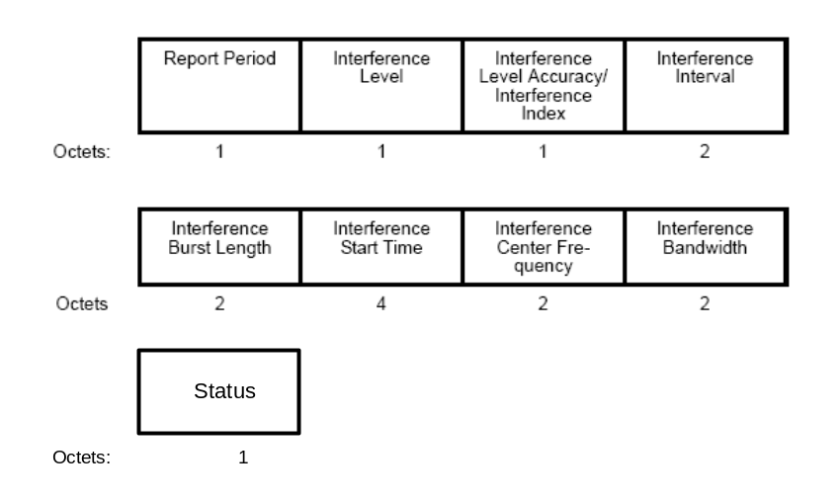

Change the fourth paragraph of 7.4.11.15 as follows:
The Dialog Token field is set to the nonzero value received in the Co-located Interference Request frame to identify the request/response transaction. If a Co-located Interference Response frame is being transmitted, but not in response to a Co-located Interference Request frame, the Dialog Token field is set to zero.

Change the fifth paragraph of 7.4.11.15 as follows:
The Report Period field indicates how often the STA shall automatically report the co-located interference.
The field is in units of 100 TUs. See 11.20.9 for further details. When the Absence Notification bit in the Status field is 1, indicating an absence event, the Report Period field indicates the number of absence bursts of the event. If the event has been terminated the field is set to 0. If the number of absence bursts is variable the field shall be set to 65535.

Add a new paragraph to the end of 7.4.11.15 as follows:
The format of the status field is shown in Figure vx5. The Absence Notification bit indicates whether there are absence events caused by the repoted co-located interference.

Add the following figure of 7.4.11.15:
1 7
Bits:
Absence
Notification

Reserved
Figure vx5 – Co-located Interference Response status field format

Add a new section of 7.4.11 as follows:

7.4.11.16 Co-located Interference Query
The Co-located Interference Query frame uses the Action frame body format and is transmitted by a STA
to query Co-located Interference Request frames. The format of the Co-located Interference Query
frame body is shown in Figure vx6.

Category
Action
Dialog Token
Query Info
1 1 1 1
Octets:
Figure vx6 – Co-located Interference Query frame body format

The Category field is set to the value indicating the Wireless Network Management category, as specified in
Table 24 in 7.3.1.11.
The Action field is set to the value indicating Co-located Interference Query, as specified in Table v45 in
7.4.11.
The Dialog Token field is set to any nonzero value to identify the query / request transaction.
The Query Info field is shown in Figure vx2 in 7.3.2.78.

11.1.3.4 Synchronizing with a BSS
Change the third paragraph of 11.1.3.4 as follows:
In addition to these synchronization parameters, a STA joining an infrastructure BSS will adopt each of the parameters found in the BssDescription of the MLME-JOIN.request except Local time, Capability Information, and BSSBasicRateSet parameters, and Wireless Network Management Capability element. Local time is not adopted but is used as a local variable in adopting the TSF as described in 11.1.2.4. The Capability Information reflects the capabilities of the sender and is not adopted but may be used to determine local configuration or behavior. The BSSBasicRateSet parameter is not adopted but may determine if the STA can join the BSS. A STA joining an IBSS will adopt the same parameters except the CF parameter set (since contention free period is not permitted in an IBSS).

11.1.4 Adjusting STA timers
Change the third paragraph of 11.1.4 as follows:
All Beacon and Probe Response frames carry a Timestamp field. A STA receiving such a frame from another STA in an IBSS with the same SSID shall compare the Timestamp field with its own TSF time. If the Timestamp field of the received frame is later than its own TSF timer, the STA in the IBSS shall adopt all parameters contained in the Beacon frame, except the Capability bits, Supported Rates information element, and Extended Supported Rates information element, and Wireless Network Management Capability element.

11.20.9 Co-located Interference Reporting
Add the following new paragraphs to the end of 11.20.9 as follows:

When a requesting STA that sent Co-located Interference Request frame with the Absence Protection Enabled field set to 1 to responding STA receives a Co-located Interference Response frame from the responding STA with the Absence Notification bit set to 1, the Interference Burst Length field set to the range of (0, 65535), and the Interference Interval field set to the range of (0, 65535), indicating a deterministic absence event, the requesting STA shall not transmit any unicast frames that overlap with the absence bursts, to the responding STA.

When a requesting STA that sent Co-located Interference Request with the Absence Protection Enabled field set to 1 to the responsing STA receives from the responding STA a Co-located Interference Response frame with the Absence Notification bit set to 1, and the Interference Burst Length field or the Interference Interval field set to 0 or 65535, indicating a non-determinsitic absence event, the requesting STA may transmit RTS regardless of frame length and RTS threshold.

After a STA receives a Co-located Interference Request frame with the Automatic Response Enabled field set to 1 and the Report Timeout field set to 0, the responding STA may send Co-located Interference Response frame at any time.

A STA may broadcast Co-located Interference Response frame in an IBSS.

