IEEE P802.11
Wireless LANs
TGr Security Architecture State Machines
(v05-Work-In-Progress Document)
Date August 4, 2006
Author(s):
Name | Company | Address | Phone | email
Kapil Sood | Intel Corp. | 2111 NE 25th Ave JF3-206  Hillsboro OR 97124 | +1-503-264-3759 | Kapil.Sood@intel.com
Nancy Cam-Winget | Cisco Systems | 3625 Cisco Way, San Jose CA 95134 | +1-408-853-0532 | ncamwing@cisco.com
Jesse Walker | Intel | 2111 NE 25th Ave, JF3-206, Hillsboro OR 97124 | +1-503-712-1849 | Jesse.Walker@intel.com
Rajneesh Kumar | Cisco Systems | 170 W Tasman Drive  San Jose, Ca 95124 | +1-408-527-6148 | rajneesh@cisco.com
Lily Chen | NIST | 100 Bureau Dr.  Gaithersburg, MD 20878 | (301) 975 - 6974 | llchen@nist.gov
Frank Ciotti | Motorola | 7700 W. Parmer Ln, PL67, Austin, TX | 512-996-5753 | Frank.ciotti@motorola.com
Michael Montemurro | Research In Motion | 5090 Commerce Dr,  Mississauga, ON. L4W 5W4 | 905-629-4745  Ext 4999 | mmontemurro@rim.com
Abstract
The document provides the text updates to partially address multiple LB comments (47 320 324 831 873 891 892 913 915 929 954 978 980 987 988 1009 1019 1049 1058 1096 1131 1147 1181 1182 1285 1464 1466 1468), sectioned under Tech Issue 8 (11-06-0578-08-000r). Updates are made to TGr draft D2.2, and rev-ma-7.0-redline.

The text addresses a subset of changes discussed and proposed in 11-06-0566-02-000r-tgr-security-architecture.ppt), and in 11-06-1135-00-000r-ft-state-machines (other changes are in different text submissions). This submission addresses comments from LB82 around Security Architetcure for Fast Transitioning with specific state machine diagrams and text.

Notice: This document has been prepared to assist IEEE 802.11. It is offered as a basis for discussion and is not binding on the contributing individual(s) or organization(s). The material in this document is subject to change in form and content after further study. The contributor(s) reserve(s) the right to add, amend or withdraw material contained herein.

Release: The contributor grants a free, irrevocable license to the IEEE to incorporate material contained in this contribution, and any modifications thereof, in the creation of an IEEE Standards publication; to copyright in the IEEE’s name any IEEE Standards publication even though it may include portions of this contribution; and at the IEEE’s sole discretion to permit others to reproduce in whole or in part the resulting IEEE Standards publication. The contributor also acknowledges and accepts that this contribution may be made public by IEEE 802.11.

Patent Policy and Procedures: The contributor is familiar with the IEEE 802 Patent Policy and Procedures <http:// ieee802.org/guides/bylaws/sb-bylaws.pdf>, including the statement "IEEE standards may include the known use of patent(s), including patent applications, provided the IEEE receives assurance from the patent holder or applicant with respect to patents essential for compliance with both mandatory and optional portions of the standard." Early disclosure to the Working Group of patent information that might be relevant to the standard is essential to reduce the possibility for delays in the development process and increase the likelihood that the draft publication will be approved for publication. Please notify the Chair <stuart.kerry@philips.com> as early as possible, in written or electronic form, if patented technology (or technology under patent application) might be incorporated into a draft standard being developed within the IEEE 802.11 Working Group. If you have questions, contact the IEEE Patent Committee Administrator at <patcom@ieee.org>.
Updates based on TGr Draft D2.2

Section 5 to be updated

Create a new Section 8A.6
8A.6 FT Security Architecture State Machines
The Fast Transition (FT) normative state machines decribed in this section elicit the behavior of the FT protocol mechanisms with an objective to enhance interoperability. However, it must be emphasized that the means of implementing this behavior within specific implementations and architectures, is outside the scope.

The FT key holder architecture diagram describes the key management entities that are authorized to receive and store PMK-R0 and PMK-R1 keys. The cryptographic boundary of PMK-R0 shall be the R0KH. Once delivered from R0KH to the R1KH, the cryptographic boundary of PMK-R1 shall be the R1KH. The FT R0KH and FT R1KH shall be part of 802.11 SME RSNA Key Management, whose behavior is decribed within this section.

RSNA Key Management
FT R0 Key Holder
FT R1 Key Holder
MLME_Action
MLME_Reassoc
MLME_Auth
MA_UNITDATA

Fig A1: Key Holder Architecture

FT RSNA Key Management uses the MA_UNITDATA interface to send/receive EAPOL-Key data-frames for FT Initial Association and TKIP countermeasures, MLME interfaces described below for FT mechanisms, and MLME_SETKEYS and MLME_SETPROTECTION primitives. FT Key Management defines three new mechanisms for Key Management delivery and reception:

- The MLME_ACTION interfaces for FT key management over the DS,
- The MLME_AUTH interface for key management over the air, and
- The MLME_REASSOC interface for key management over the air.

Some of the state machine design considerations are as follows:
- Events received in a state, which are not depicted in the FT state machine diagrams shall be treated as error conditions, with the exception of TKIP countermeasures which can be received and sent in any state.
- The TKIP countermeasure messages can be received in any FT state, as per procedures defined in Clause 8.3.2.4, and shall be processed using the KCK1X key.
- Events which are valid in all states are indicated with an “*” in FT state machines.
8A.6.1 R0 Key Holder AP State Machine
There is one R0 Key Holder state machine, which incorporates the FT Initial Association and the FT mechanisms key management.

The state diagram in Fig X1 consists of:
- The FT-R0-AUTHENTICATION, INIT-802-1X-XXKEY, INIT-PSK-XXKEY, CALC-PMK-R0, CALC-PMK-R1, FT-R0-AUTH-DONE, and FT-R0-AUTH-CLEANUP are the states which handle R0 Key Holder functions including key hierarchy instantiation, key generation, and cleanup.
- This state machine interacts with the R1 key holder AP state machines.

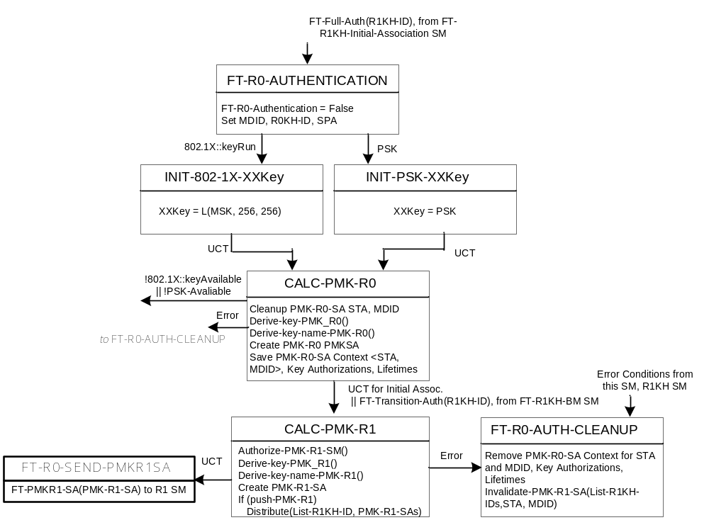
Fig X1: R0 Key Holder AP State Machine

8A.6.1.1 R0 Key Holder AP State Machine states
CALC-PMK-R0:

CALC-PMK-R1:

FT-R0-AUTH-CLEANUP:

FT-R0-AUTH-DONE:

FT-R0-AUTHENTICATION:

INIT-802-1X-XXKEY:

INIT-PSK-XXKEY:

8A.6.1.2 R0 Key Holder AP State Machine variables
<To Be Added>

8A.6.1.3 R0 Key Holder AP State Machine procedures
<To Be Added>

8A.6.2 R1 Key Holder AP FT Initial Association State Machine
There is one R1 Key Holder state machine for FT Initial Association. FT Initial Association R1 key holder state machine has different functions and interactions that the other R1 key holders state machines,and as such, is depicted by a distinct state machine.

The state machine defined in Fig X2 consists of:
- The FT-AUTHENTICATION, FT-INIT-GET-R1_SA, FT-INIT-R1_SA, FT-PTKSTART, FT-PTK-CALC-NEGOTIATING, FT-PTK-CALC-NEGOTIATING2, FT-PTK-CALC-NEGOTIATING3, FT-PTK-INIT-DONE are the different states in this diagram. These handle PMK-R1 key reception, PTK handshake, cleanup and teardown.
- This state machine interacts with the R0 key holder state machine.

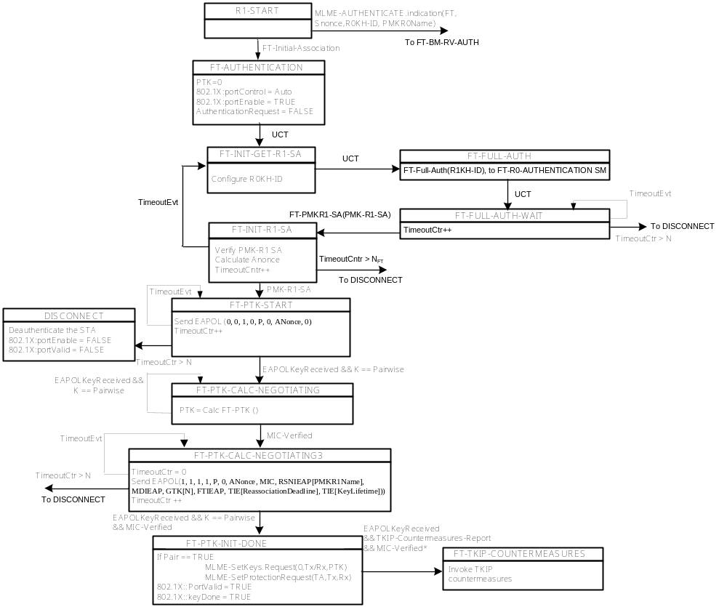
Fig X2: R1 Key Holder FT Initial Association AP State Machine

8A.6.2.1 R1 Key Holder AP FT Initial Association State Machine states
FT-AUTHENTICATION:

FT-INIT-GET-R1_SA:

FT-INIT-R1_SA:

FT-PTK-INIT-DONE:

FT-PTK-CALC-NEGOTIATING:

FT-PTK-CALC-NEGOTIATING2:

FT-PTK-CALC-NEGOTIATING3:

FT-PTKSTART:

8A.6.2.2 R1 Key Holder AP FT Initial Association State Machine variables
<To Be Added>

8A.6.2.3 R1 Key Holder AP FT Initial Association State Machine procedures
<To Be Added>

8A.6.3 R1 Key Holder AP FT State Machine
There is one R1 Key Holder AP state machine for all R1 key holders to which a STA can FT using the FT mechanism.

The state machine defined in Fig X3 consists of:
- The FT-BM-AUTHENTICATION,
- This state machine interacts with the R0 Key holder AP state machine to get the PMK-R1 Security Association.

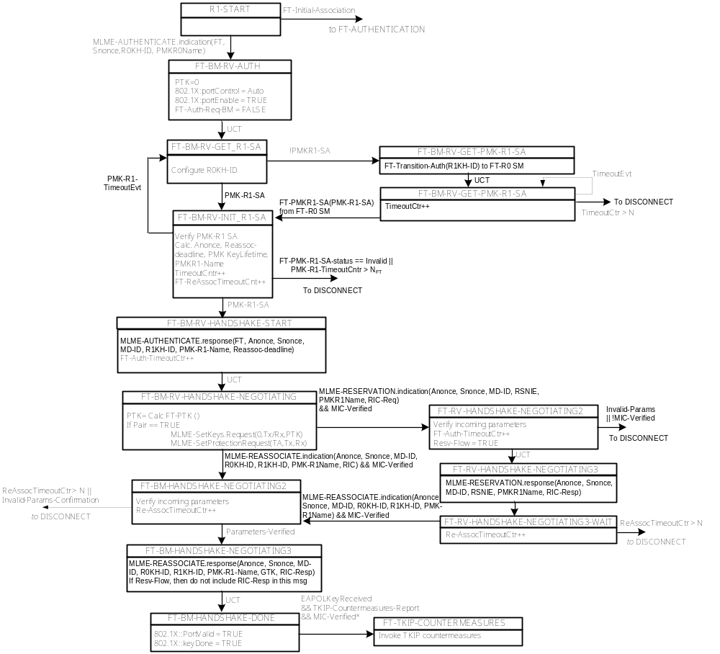
Fig X3: R1 Key Holder FT AP State Machine

8A.6.3.1 R1 Key Holder AP FT State Machine states

8A.6.3.2 R1 Key Holder AP FT State Machine variables
<To Be Added>

8A.6.3.3 R1 Key Holder AP FT State Machine procedures
<To Be Added>

8A.6.4 R0 Key Holder STA State Machine
There is one R0 Key Holder state machine on the STA, which incorporates the FT Initial Association and the FT mechanisms functions.

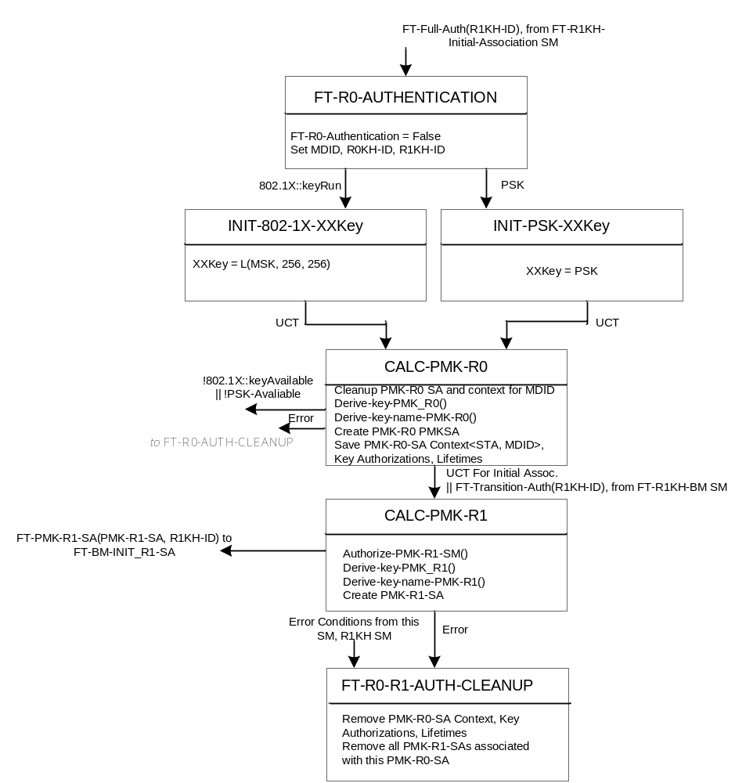
Fig X4: R0 Key Holder STA State Machine

8A.6.4.1 R0 Key Holder STA State Machine states

8A.6.4.2 R0 Key Holder STA State Machine variables
<To Be Added>

8A.6.4.3 R0 Key Holder STA State Machine procedures
<To Be Added>

8A.6.5 R1 Key Holder STA Initial Association State Machine
The R1 Key Holder Initial Association state machine on the STA, incorporates the functions necessary for deriving the PMK-R1 key on FT Initial Association.

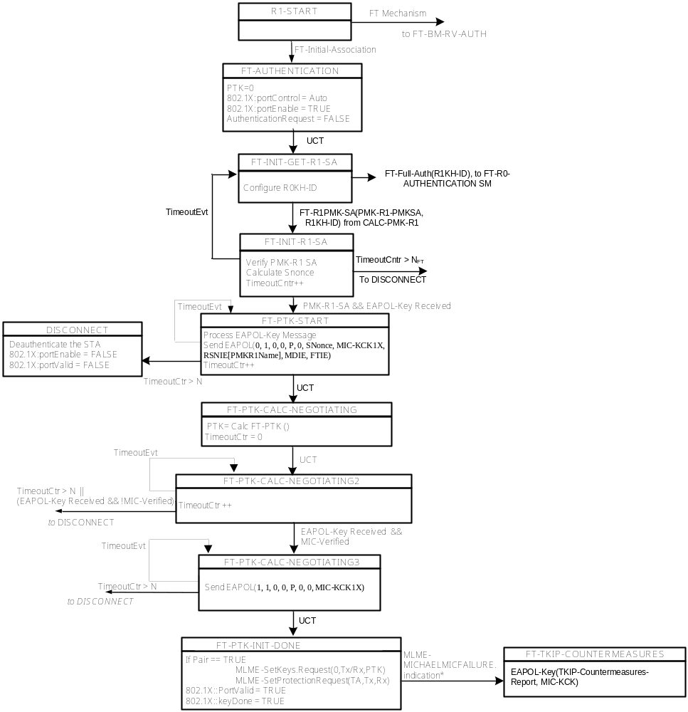
Fig X5: R1 Key Holder STA FT Initial Association State Machine

8A.6.5.1 R1 Key Holder STA Initial Association State Machine states

8A.6.5.2 R1 Key Holder STA Initial Association State Machine variables
<To Be Added>

8A.6.5.3 R1 Key Holder STA Initial Association State Machine procedures
<To Be Added>

8A.6.6 R1 Key Holder STA FT State Machine
The R1 Key Holder FT state machine on the STA incorporates the functions necessary for deriving the PMK-R1 key on FT.

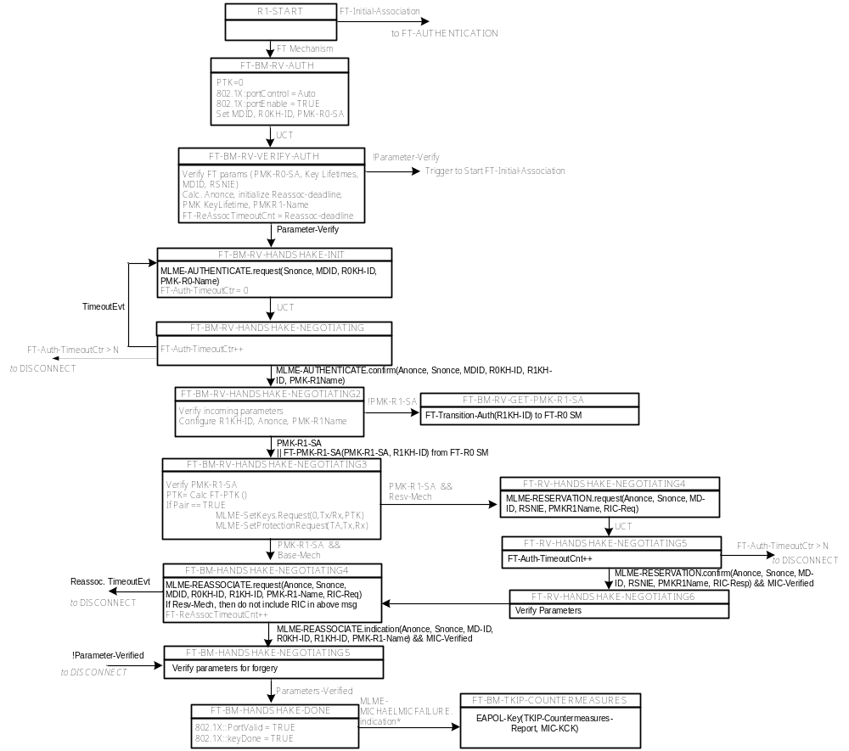
Fig X6: R1 Key Holder STA FT State Machine

8A.6.6.1 R1 Key Holder STA FT State Machine states

8A.6.6.2 R1 Key Holder STA FT State Machine variables
<To Be Added>

8A.6.6.3 R1 Key Holder STA FT State Machine procedures
<To Be Added>

