IEEE P802.11
Wireless LANs
Multipath Fading in Open OTA Tests
Date: July 2006
Author(s):
Name | Company | Address | email
Pertti Visuri | Airgain, Inc. | 5355 Ave Encinas, Carlsbad, CA 92008 | pvisuri@airgain.com
Oleg Abramov | Airgain, Inc. | 5355 Ave Encinas, Carlsbad, CA 92008 | oabramov@airgain.com
Shravan Surineni | Qualcomm, Inc. | 9 Damonmill Square Suite 2A, Concord, MA 01742 | shravans@qualcomm.com
Hooman Kashef | Conexant | 2401 Palm Bay Road NE.  Palm Bay, Florida 32905 | hooman.kashef@conexant.com
Steve Hawkins | Westell, Inc. | 750 N. Commons Drive  Aurora, IL 60504 | shawkins@westell.com
Larry Green | Ixia, Inc. | 420 E. Gutierrez Str.  Santa Barbara, CA, 93101 | LGreen@ixiacom.com
Allen Huotari | Linksys, a division of Cisco | 121 Theory Drive  Irvine, CA 92617 | ahuotari@cisco.com

Abstract
This document presents the justification for proposed sections for the IEEE 802.11 Task group T (Wireless Perfromance Evaluation) Draft Document. These sections and this report adress uncertainty in open over-the-air (OTA) tests caused by multipath fading and presents how it can be understood and managed by perfroming multiple measurements.

Notice: This document has been prepared to assist IEEE 802.11. It is offered as a basis for discussion and is not binding on the contributing individual(s) or organization(s). The material in this document is subject to change in form and content after further study. The contributor(s) reserve(s) the right to add, amend or withdraw material contained herein.

Release: The contributor grants a free, irrevocable license to the IEEE to incorporate material contained in this contribution, and any modifications thereof, in the creation of an IEEE Standards publication; to copyright in the IEEE’s name any IEEE Standards publication even though it may include portions of this contribution; and at the IEEE’s sole discretion to permit others to reproduce in whole or in part the resulting IEEE Standards publication. The contributor also acknowledges and accepts that this contribution may be made public by IEEE 802.11.

Patent Policy and Procedures: The contributor is familiar with the IEEE 802 Patent Policy and Procedures <http:// ieee802.org/guides/bylaws/sb-bylaws.pdf>, including the statement "IEEE standards may include the known use of patent(s), including patent applications, provided the IEEE receives assurance from the patent holder or applicant with respect to patents essential for compliance with both mandatory and optional portions of the standard." Early disclosure to the Working Group of patent information that might be relevant to the standard is essential to reduce the possibility for delays in the development process and increase the likelihood that the draft publication will be approved for publication. Please notify the Chair <stuart.kerry@philips.com> as early as possible, in written or electronic form, if patented technology (or technology under patent application) might be incorporated into a draft standard being developed within the IEEE 802.11 Working Group. If you have questions, contact the IEEE Patent Committee Administrator at <patcom@ieee.org>.

Multipath Fading in open Over-The-Air (OTA) Tests

1 Introduction

1.1 Variations in open OTA tests
In any open over-the-air (OTA) measurements there are several factors that can cause variations in the signal strength and thereby cause uncertainty in tests results of all variables that are affected by signal strength. These factors include:
- Local spatial variations caused by multipath fading
- Variations caused by antenna orientation because antenna gain is not the same in all directions
- Fast (within milliseconds) time variations
- Slow (within minutes and hours) time variations

The uncertainty caused by time dependent variations is usually compensated for by one of two techniques. Measuring for a sufficient duration and averaging the results works well for the fast variations. The effect of slow time variations can be avoided by performing any tests that are to be compared to one another within a short time period.
If (and only if) all the antennas in the devices or systems to be compared are exactly identical the local variations and the variations caused by antenna orientation can be controlled by specifying the antenna location and orientation and requiring that they (and the locations of any surrounding surfaces that can reflect the wireless signal) remain the same within certain tolerances between any measurements that are to be compared with one another.
However, if the antennas in the systems to be compared are not identical, it is not possible to define the “same location and orientation”. The following sections explains how uncertainty in this situation can be reduced by collecting representative samples of data points and using statistical methods to obtain the test results and their confidence limits.

1.2 Multipath Fading
Wireless signals reflect from surfaces in all environments to a varying degree, which depends on the material and on the angle of incidence. The reflected signals (and the direct line of sight signal if any) arrive at the receiving antenna from different directions and at varying phases depending on the path they traveled and their transformations in the reflections and other interactions with the environment. At the receiving antenna all of these varying signals add to or subtract from one another depending on their relative phases.
Figure 1. Multipath fading results from reflected signals arriving at different phases
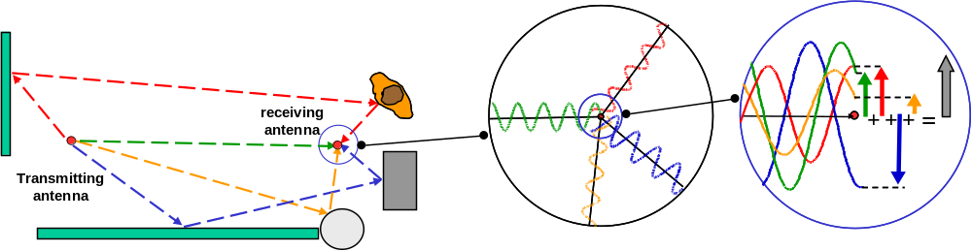

Figure 1 is a greatly simplified representation of this process. In reality there are countless signal paths as the transmitted signal propagates in all possible directions. A more appropriate mental model for the situation is to picture the transmitting antenna creating a vector field of electromagnetic signals that consists of the vectors of all reflections in every point within the environment that the signal reach.. This field is then received (perceived) by the receiving antenna and converted into a resultant signal for the receiver radio. The signal strength of this received radio input depends on the relative phases and polarizations of all of the millions of reflected signal vectors arriving at the receiver antenna.
The phases of the signals received from each direction depend on the exact length of their path and therefore on the location the receiving antenna. The shape of the field at each location depends on the exact location of the transmitting antenna and on the exact location and nature of every object and surface that reflects or otherwise interacts with the signals. As a result the signal strength received by the receiving antenna can vary significantly if either the receiving or transmitting antenna or the surrounding objects are moved.
Figure 2 demonstrates the variations in the signal received by a standard 802.11g access point with a dipole antenna as a function of the location of the antenna on a table top. The AP antenna was moved on a table top 5cm at a time on a ten by ten step grid (100 locations) with approximately one hundred signal strength measurements performed and averaged together to get the signal strength value for each location. Typical range for signal strength variations for 802.11 systems in indoor environments as a result of a move of several centimeters is 15dB.
Figure 2. Multipath fading causes typically 15dB signal strength variations indoors as a result of a few centimeters movement of either the receiving or transmitting antenna

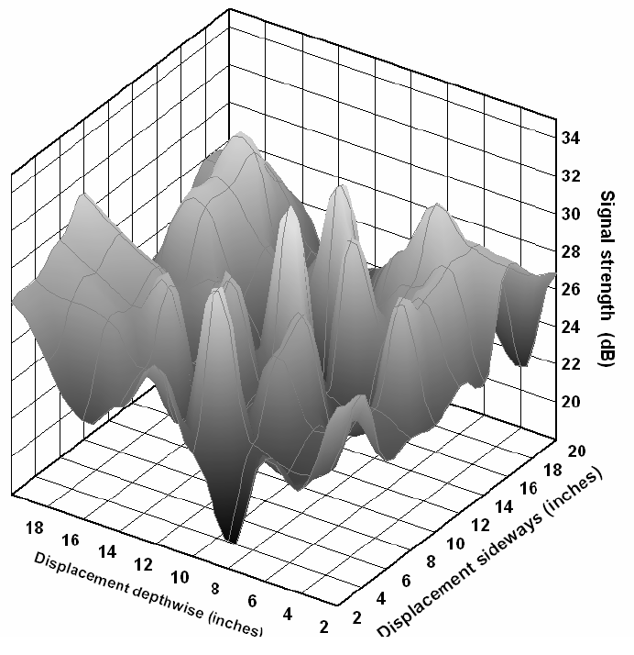
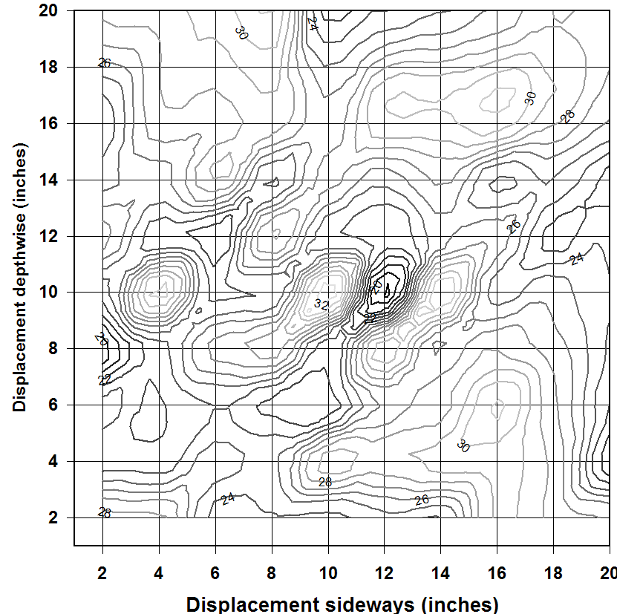
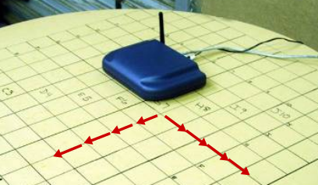

1.3 Different Antenna Systems
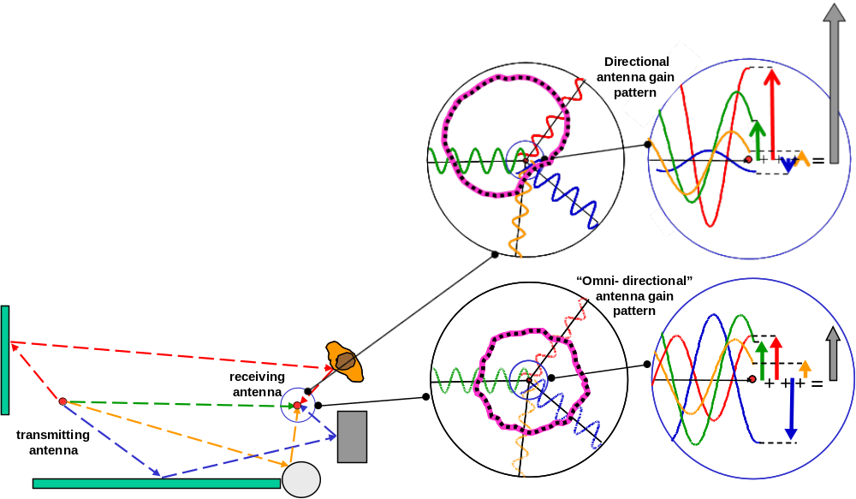
Any differences in the directional gain patterns of the antennas in the above described set up will have a major impact on the detail of the signal strength variations. In reality the efficiency with which any antenna receives (or radiates) a signal depends on the direction from which the signal is coming (or to which it is radiated). This will have an impact on the field every antenna creates and on the way a field is received (perceived) by every antenna. Figure 3 illustrates how different directional patterns will influence how signals from different directions add together or cancel one another producing a different signal in a given radio signal field. The illustration shows the effect at the receiving end, but the same physical phenomenon will affect the transmitting end in a similar way. The gain pattern of the transmitting antenna will influence the shape and nature of the signal vector field generated by the antenna in a given physical environment. The receiving antenna pattern influences how that field is converted to a signal in the antenna cable.
Figure 3. Reflected signals are amplified by the gain of the receiving antenna in each direction. If the gain patterns of two antennas are different, the received signal strengths will also be different

In practice the effect of the antenna gain pattern is that the received signal strength still depends acutely on the precise location of both the transmitting and receiving antenna, but in addition the local variation in any given environment for two antennas (either receiving or transmitting) will be different if the gain patterns (or orientations) of the two antennas are not completely identical.
The effect of antenna differences on the local variation of signal strength is illustrated in figure 4. It displays test results on systems with four different antenna systems. The test setup was similar to the one described for figure 2. Four different access points were moved across a table top to exactly the same locations in an environment that was kept constant during the experiment. All four were connected to the same wireless counterpart (WLCP) that was in a fixed location. The throughput of each AP was measured in each location of the 100 point test grid. The local variations are completely different. For each of the antenna systems there is a location on the table top where it performs better than all the other three.
Figure 4. The local variation of OTA throughput across a table top of 50 by 50 centimetres is completely different in four access points that have different antenna systems

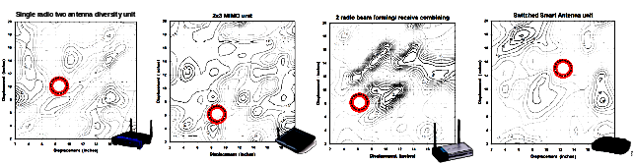

It is obvious that local variations have a major effect in over-the-air measurements when wireless systems with different antenna systems in are compared. It is also clear that when the antenna systems are different this effect can not be eliminated by placing the devices to be compared in the same location when their performance is measured.
When determining whether antennas are identical they need to be considered as installed in the devices and as used in realistic environments. All antennas, including external dipole antennas, are affected by reflections from the device to which they are attached and other objects that are in the near field (within a few wavelengths) of the antenna. These result in distortion of the antenna gain patterns. For example in a typical access point device with a dipole, just the reflections from conductive parts of the device cause +/- 2 dB variations that create asymmetries. Embedded antennas almost always have asymmetrical antenna patterns and are also influenced by positions and orientations in their real use. Test arrangements should include any objects that are typically in the near field of the antennas. For example for access points the table top or mounting wall, for handheld devices the hands and torso and for telephone handsets the users head and hands have dramatic impacts on the antenna patterns. Anechoic chamber measurements of antenna patterns should be used to determine whether two antennas are identical. There are standardized phantom models available for simulating objects in the near field in Chamber tests.

2 Sampling to Reduce Uncertainty

2.1 Using Averages of Several Data Points
As explained above the received signal strength in OTA tests depends on the locations of both the transmitting and receiving antenna and their gain patterns. It also depends on locations of surfaces and objects in the test environment. In most tests it is possible to keep the test environment constant between measurements of devices under test (DUTs) to be compared. However, in comparing different devices their antenna gain patterns may be different and, as was demonstrated in section 1, it is not helpful to keep the locations of the devices the same. The only way to manage the uncertainty caused by different local multipath effects in different antennas is to make several measurements.
Since the local variations caused by multipath fading are influenced by such a large number of factors (locations of reflective surfaces and antenna locations and gain patterns) their net effect can be considered to be random. This makes it possible to manage the uncertainty by making measurements in different locations and calculating the average of these data points. This works as long as the data points constitute a representative sample of values of the variable that is being measured.

2.2 Representative Samples
In order to reduce uncertainty by calculating averages of data points enough data points need to be collected so that they constitute a representative sample for the purposes of the test. Some requirements for the sample depend on the objective of the test and possible dependencies of the variables on each others. However, there are only three aspects to consider in making sure the sample is representative with regard to local multipath fading effects:
- Including different locations of the transmitting and receiving antennas
- Including different orientations of the transmitting and receiving antennas
- Number of data points in the sample
Usually only one of the devices in a wireless link is being tested (so called device-under-test DUT) while the other one is just providing the functions of a wireless counterpart (WLCP). Even in this case a representative sample must include multiple locations of both the WLCP and the DUT. This is because different antennas will receive (perceive) a certain field created by the transmitting antenna differently. To effectively reduce the uncertainty caused by multipath fading several different fields (created at different locations of the transmitting antenna) need to be included in the sample. In these different fields several locations of the receiving antenna must be included in the sample so that the sample represents all of the variations caused by multipath fading.
The need for moving both ends of every link should not be confused with possibly changing roles of each device in tests. In practical operation of 802.11 networks the devices at both ends of the link periodically transmit and receive so both the DUT and the WLCP may alternate in the roles of creating a field and receiving a signal in the field. Regardless of this, different locations of both ends of the links must be included in every test to make sure the sample is representative.

Different Locations of the Devices
Since the multipath effect is caused by the radio waves adding together or canceling because they arrive at the receiving antenna in different phases from different directions, the data points in a representative sample need to be collected at locations that are more than a quarter wavelength from every other location and that represent an area of at least three wavelengths across. For the 2.4GHz band (802.11 b/g/n) the half wavelength is about 6cm and the area required to be represented is about 37cm across and for the 5.8GHz band (802.11a/n) the numbers are 2.5cm and 15cm) To form a representative sample the locations should also be randomly selected with regard to the multipath fading effect. In normal home, office or outdoor environments the multipath effect itself is randomized by the multitude of reflecting surfaces surrounding the antenna. However, care should be taken to not align data point locations at the same distance (or exactly at multiples of half wavelength intervals) from a reflecting object. For example a concrete wall or a metal filing cabinet or home appliance could double the gain of an omnidirectional antenna (or severely lower the gain because of cancellation effects) in the direction facing the surface if the antenna is placed close to it at a distance that is a multiple of half wavelengths.

Different Orientations of the Devices
The data points in the sample should also be representative of different orientations of both the DUT and the WLCP(s) unless both have perfect omnidirectional patterns. Because of the random nature of the multipath effect, in most circumstances the effect of the orientation of the device is not correlated to its location. Therefore it would be acceptable to change the orientation of the device as the antenna location is changed. However, care should be taken to avoid systematically biased orientation/location combinations. For example the device should not be placed to provide a line of sight connection in one set of orientations and a completely obstructed path on the complementary set.

Dependencies between variables in the test
If there are systematic dependencies between variables in the test that influence the values of the measured variable, they should be considered in the test design and in forming the samples. One important example of this is measuring difference in throughput between two DUTs.
The throughput can only be improved by better receive sensitivity or transmit power (better signal) in conditions when it has not yet reached the maximum throughput for the device and the magnitude of the improvement caused by better signal is depends on the throughput level. Therefore it will not be correct to collect a sample of throughput measurements arbitrarily at different throughput levels into one sample and calculate the average improvement. The results would depend on how many of the sample points represent highest possible throughput and how they are distributed between other throughput levels.
For throughput comparison tests it is necessary to divide the collected comparative throughput data points into sub-samples so that each sub-sample represents a relatively narrow band of measured throughput levels of the DUTs. Then the averages of the improvement within each of these sub-samples can be calculated. The result will be a table indicating the throughput difference as a function of the throughput of one of the DUTs in the comparison or as a function of the average throughput of the DUTs in the test.

Number of Data Points
The number of data points required to have a representative sample depends on the acceptable level of uncertainty in the tests result. Another way of stating this is that it depends on the required level of confidence that the result of the test is within a certain error margin of the actual value that was the target of the measurement. The next section will present a detailed method for calculating the uncertainty in the result and it’s so called confidence limits. It is recommended that such calculation is performed to establish the need for the number of data points in each case.

2.3 Calculating the Result and Confidence Limits
As mentioned above the effect of multipath fading in different locations indoors can be considered to be random. Moreover, since the effect at the receiving antenna is effectively adding (or canceling) large number of signal contributions to the signal strength, the shape of the distribution of the net effect of this random variation is a so called normal distribution. This makes it relatively easy and straightforward to calculate the uncertainty in a measurement result. Figure 5 displays a comparison of a normal distribution and the distribution of the measured difference in signal strength between two antennas.
Figure 5.The distribution of measured values in OTA tests affected by multipath fading is close to so called normal distribution.

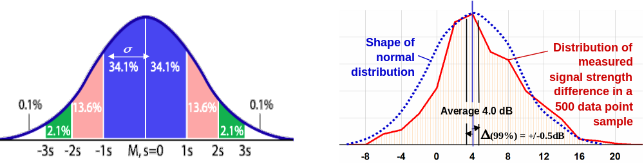
In a normal distribution 68% of samples fall within one standard deviation and 95% fall between
two standard
deviations from
the average

A representative sample of data points can be analyzed using well known and established statistical analysis tools. The most basic step is to calculate the average of data points in the sample to obtain the test result. The uncertainty in the measurement result can be estimated using the standard deviation (usually denoted by σ) of the values of data points, which for n measurements with results q_{k} and average value q, is approximated by:
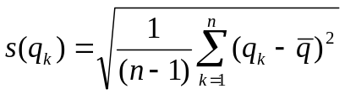

The standard uncertainty u of a single measurement q_{k} is given by:
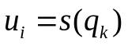

If n measurements are averaged together, this becomes:
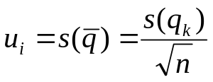
ave

The standard uncertainty is the common term used for calculations. It represents a ±1σ span of a normal distribution. In a normally distributed sample 68% of the sample points fall within the standard uncertainty band. When the concept is used for averages of data points it means that 68% of the averages of n points in the sample fall within the ±u_{ave} band. Typically, measurement uncertainties are expressed as an Expanded Uncertainty, U = k u_{c}, where k is the coverage factor. A coverage factor of k = 2 is typically used. This would represent a 95% confidence that the measured value is within the specified value of the expanded measurement uncertainty. The values of coverage factors for different confidence levels and numbers of sample points are given in Appendix 1.
The expanded measurement uncertainty is often expressed as confidence limits. Calculating the average of a representative sample of data points can be regarded as estimating the result that would be obtained if every theoretically possible data point would be included in the test and the “true average” of this exhaustive set (in case of multipath fading an infinite number) of data points would be calculated. Confidence limits calculated using the above formula are in the form of a deviation from the test result obtained by calculating the average of the data points in the sample. Each limit is associated with a chosen probability number. This number indicates the probability that the result is within the confidence limits from the “true average” value that would be obtained by measuring an exhaustive (infinite) number of data points.
For practical application of the above formulas it may be helpful to note that many popular spreadsheet or statistical analysis software packages have pre-defined formulas for calculating them. For example in Microsoft Excel the function calls for the above formulas are AVERAGE(<range of numbers>), (STDEV(<range of numbers>) and =CONFIDENCE(<1-confidence level>, <Standard deviation>, <number of measurements>). The formula assumes that the standard deviation is known and that the number of data points in the sample is large.
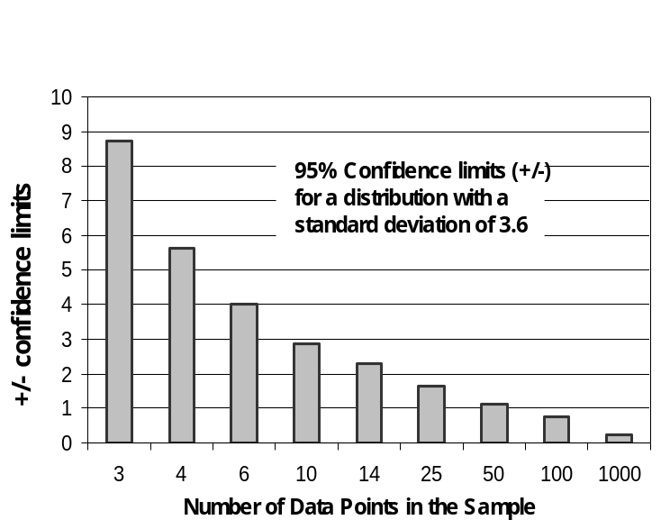
To illustrate the number of data points needed in a sample to achieve a certain confidence level figure 6 presents a calculation of the 95% confidence limits for a distribution that has a standard deviation of 3.6. This is a typical standard deviation for the signal strength variation due to indoor multipath fading. For example a sample size of ten data points would give a 95% confidence that the test result is within ±3dB of the average signal level in the area represented by the data points and 50 data points would reduce the uncertainty bands to ±1dB.
Figure 6.Values of Confidence Limits for different sample sizes when the standard deviation is 3.6

Using statistical methods to accurately test antenna systems in challenging real life conditions is not new. The basic mathematical treatment was presented excellently in the IEEE classic "Microwave Mobile Communications" by William C. Jakes. Leading cell phone manufacturers used statistical field measurements to accurately characterize cell phone antennas in indoor multipath conditions already in the mid 1980’s. According to their results, with large enough and representative samples it is possible to achieve ¼ dB accuracy. The approach described in this addendum is based on fundamentally the same principles, but here applied to the 802.11 systems.

Statistical approach of making multiple measurements appears to make it possible to reduce uncertainty caused by random variations by simply increasing the sample size. As can be seen from the formula for confidence limits above the confidence limits are inversely proportional to the square root of the number of data points. As seen from the coefficient values in Appendix 1 the limits also grow wider as the required probability that the result is within the limits is increased. It would appear that by increasing the sample size the accuracy and reliability of the result can be increased endlessly. This is actually true as long as the sample of data points is indeed representative of the phenomena to be measured and the error margin is caused by random variations only.

However, increasing sample size does not provide any improvement regarding uncertainty caused by systematic errors in the test set-up or instrumentation. It is important that for each particular test a separate analysis of systematic error possibilities will be carried out

An often used technique for improving the reliability of test results is to exclude data points that appear to be completely outside the normal range. This is normally done to avoid using data that was affected by an error in performing the measurement. The statistical tools provide an objective way of applying this technique. For example, it would be possible to calculate the confidence limits for a higher probability value, for example 99.9% and exclude all data points that are outside these limits. Then a new calculation of the result (average) and its confidence limits would be performed using the standard deviation and the number of data points in the remaining sample of these new “qualified” data points

It is worth noting that in many cases environmental factors causing variations in test results may be considered random when performing comparison tests. For example, people moving around in the test facility or data traffic on adjacent channels may be reasonably random as long as there is no systematic pattern between the activity (caused, for example by time of day) and the specific DUTs (within the comparison group) that are being tested. For example, these environmental factors would not be random if one set of DUTs are tested at night time and others during the work day. If the variations in such environmental factors are random, then collecting several data points and calculating averages also has the effect of reducing uncertainty caused by them. This way this method can be used for obtaining precise and repeatable results in real life operating conditions.

3. Test Design
While the criteria for making sure samples of data points are representative regarding multipath fading effects are relatively straightforward, there are other considerations in open OTA tests. The best approach depends on the objectives of the test and on the quantities being measured. The definition of which samples to collect and how to process their data is called test design. The following illustrates its importance by discussing a few examples.

If the objective is just to establish the OTA performance of a device as a function of range in a given environment, the test design may be relatively simple. If the measured quantity is throughput this would be called a “throughput vs. range” test design. In order to reduce the uncertainty caused

by multipath fading, a representative sample of data points, including different locations and orientations of both the DUT and WLCP, as explained in section 2.2, is collected at each “place” where the test is performed. This process needs to be repeated at each location (for example a table top) that represents a different distance between the DUT and WLCP (range). The data points measured at each range are averaged together to get the result for that range. A simple, but labor intensive method to collect data points at each range is to manually move and turn both the DUT and WLCP between measurements and measure several data points this way. For throughput tests, which typically take about a minute or longer, it is possible to combine the process of collecting data points and calculating the average by placing the DUT or the WLCP (or both separately) on a continuously rotating turntable and run the throughput test while the table is turning. Care would need to be taken to make sure the rotation speed is low enough to avoid problems with dynamic rate setting and that each tests would include the same number of rotations for each device in the tests set up. This method would effectively average the throughput across various locations and orientations of the antenna at the “place” where the turntable is used. Using a turntable in a test reduces the uncertainty caused by the location of the device that is on the turntable. To reduce the uncertainty caused by the location of the other end of the link and it would be necessary to perform several tests with different locations and orientations of the device in the other end and calculate their average. Alternatively it would also be possible to place both devices on (separate) rotating turntables during the measurements.

Continuously moving turntables can act as an averaging device in throughput tests since the measured variable is the amount of data transferred during the entire test. If a statistical estimate for the uncertainty caused by multipath fading is needed, it will be necessary to run several tests since a turntable throughput test provides only one data point for each test. Another alternative is to use stop-motion-turntables to automate the data gathering. They have been programmed to turn a pre-determined amount, then run a throughput test and record the result before turning again. They eliminate concerns about turntable speed affecting the rate setting performance of the devices and, since they provide several discrete data points, they facilitate calculating the uncertainty estimates, too. If a turntable is used to manage the effects of multipath fading in measurements of other quantities than throughput, for example signal strength or packet loss, the collection of data points and calculating averages needs to be arranged taking into account the specifics of the test.

If the test is designed to provide an absolute performance indication, for example in the form of “throughput at a <certain range> is a <certain value>” then it is important that the environment be specified as well. A test result, even using the above described tests design would only be relevant for the environment in which the test was performed. It is well known that the number of obstructions in the path, construction materials and design of the building will affect range performance of wireless devices. To get generally applicable absolute throughput vs. range results the tests need to include measurements in many different facilities that form a representative sample of the environments for which the overall result is intended to used. The test design for generally applicable absolute performance results can be quite complex since assuring that the collected samples are representative with regard to all relevant variables requires considering all factors affecting the performance.

Test design can be simpler when performances of two or more devices are to be compared with one another without having to accurately characterize the absolute performance. In this case many of the external variables can be kept constant between tests comparing different devices. However, there is another consideration if the performance attribute to be compared between the devices is throughput and the performance difference between the compared devices is caused by the quality of the wireless signal.

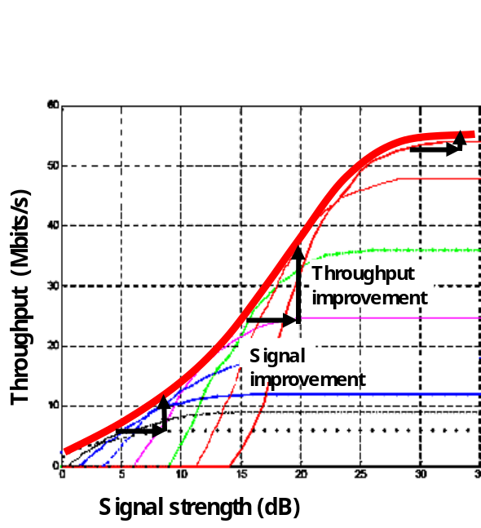
The magnitude of throughput improvement caused by better signal strength (SNR) is dependent on the level of the original throughput. As seen in figure 7, at very good signal conditions the throughput is already at the maximum 802.11 rate and is not affected by a better signal. At mid range the throughput is greatly increased by signal improvements and at low throughput rates the improvement with to signal quality is again smaller in absolute terms. However, in terms of percentage improvement the effect of better signal is highest at low throughput conditions.
Because of the non-linear dependency of throughput on the signal it is not meaningful to arbitrarily combine data points of the difference between DUTs measured at different throughput levels into a result. An effective test design for “throughput comparison” is to collect a set of comparative data for each of the DUTs at many locations that represent various throughput and signal conditions and then form sub-samples that each consist of measurement sets within a relatively narrow zone of throughput. For example, the average throughput of the set of DUTs in each location can be used as the basis to form these sub-samples. The data points within each sub-sample can then be averaged for each DUT to get a result of the measured throughput for each DUT at the general throughput level represented by that sub-sample. This way several results are obtained and the throughput of each DUT can in be presented as a function of the overall throughput level.
Figure 7. Throughput improvement caused by a constant signal improvement depends on the level of the throughput in the test

Figure 8 displays the measured data points and steps of processing the data using the “throughput comparison´ test design from an example test of two DUTs. In this case DUT₁ has a better antenna, but it processes the data more slowly at high throughputs. The test result reveals this as the performance is presented as a function of the general throughput level.
Figure 8. The steps of processing data in a “throughput comparison” test design for two DUTs:
- Measure the throughput of both DUT₁ and DUT₂ at the same locations/orientations using several different WLCP locations/orientations for each DUT measurement location
- Calculate the average throughput of DUT₁ and DUT₂ at each DUT/WLCP location/orientation combination where the measurements were made
- Arrange the DUT₁ and DUT₂ measurement pairs obtained at various DUT/WLCP locations into sub-samples (bins) based on the average throughput of DUT₁ and DUT₂ at each location
- Calculate the average throughput of all measurements in each sub-sample
separately for DUT₁ and DUT_{2.} In other words, calculate the average of each bin for
both DUT1 and DUT2.

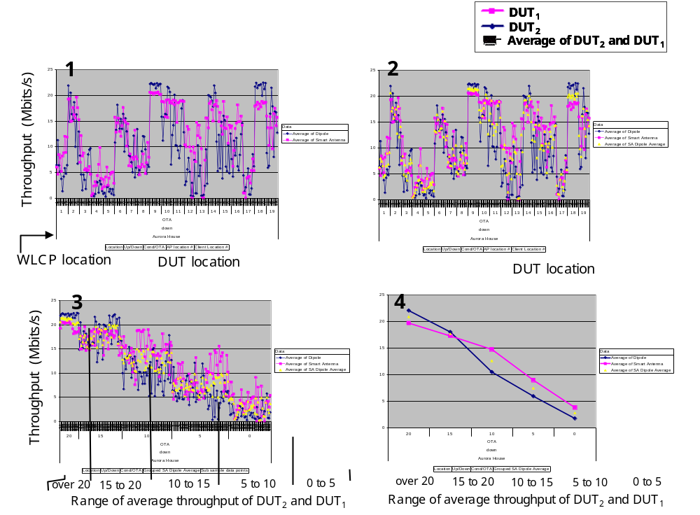

An important benefit of the “throughput comparison” test design is that it removes the effect of the specifics of the building and the selected “places” where the tests are run from the test results and makes it possible to compare tests made in different locations. In reviewing results of tests comparing the same two antenna systems in several different buildings at different times and even on different DUT platforms the results seem very consistent across locations. It appears that – as far as comparison tests between DUTs are concerned – it is possible to verify the results of one OTA test by performing another test at a different location and time using the “throughput comparison” test design.
An additional benefit of the “throughput comparison” test design is that the re-arrangement of the data points into sub-samples based on throughput level will usually result in having both several DUT and several WLCP locations represented in all of the sub-samples. Therefore it is not necessary to arrange to move both the DUT and WLCP as often as it is in a “throughput vs. range” test design where no re-arrangement into sub-samples can be done, since each sub sample represents a specific range (distance between DUT and WLCP).
It is, of course, also possible to compare throughput performance of DUTs using the standard “throughput vs. range” test design described above. However, it is not as efficient since at each range the throughput varies greatly with the exact orientation and location of the DUT and WLCP. More data points are needed in each location to reduce the uncertainty effectively since there is no way of combining data points from different locations to get larger sub-samples and better statistics. In a sense, the natural multipath fading variation is working against the test objective and more data will need to be collected to cover different throughput conditions and to achieve low uncertainty in the result. The test design for “throughput comparison” treats each set of comparison measurements for all DUTs measured at each specific location/orientation (combination of the DUT and WLCP) as an independent data point. This way each data point (a set of measured throughputs for all DUTs in the same location) can be included in the appropriate sub-sample when calculating the averages. In a way, the multipath fading works in favor of the test objectives since it helps collect data points at a wide range of throughput levels and the test design still assures that the dynamics of throughout vs. signal strength are taken into account when the data is processed.
An example of a simpler test design where dividing into sub-samples is not required is a “signal strength comparison” test. This test can be used for example to study improvement as a result of better amplifiers or antennas. Such improvement is not expected to be dependent of the original signal level (not considering higher order non-linearity effects). Therefore comparative data points can be collected at several locations representing various signal levels and the value for the improvement can be averaged across all data points to calculate a single result for the overall improvement.

References
- IEEE 802.11-06/0026r0 “OTA Comparing Systems with Different Antennas”, Pertti Visuri
- IEEE 802.11-05/1259r0 “Over the Air Field Testing 802.11 Systems”, Pertti Visuri
- IEEE 802.11-05/1641r1, “Metrics Template Example,” Tom Alexander.
- IEEE 802.11-06/416r1 “Sampling in OTA Tests”, Pertti Visuri
- IEEE 802.11-06/0769r2, “OTA Comparison Test Results and Test Design”, Pertti Visuri
- P802.11.2-D0.7, “Draft Recommended Practice for the Evaluation of 802.11 Wireless Performance.”
- “Short Range Wireless Communication - Fundamentals of RF System Design and Application”, Alan Bensky, Elsevier, Inc., 2004
- “802.11 Wireless Networks- the definitive guide”, Matthew. S. Cast, O’Reilly &Associates, Inc. 2002
- “Antennas for Information Super Skyways: An Exposition on Outdoor and Indoor Wireless Antennas”, Perambur S. Neelakanta et al., Research Studies Press, Ltd, 2003
- “Adaptive Antenna Arrays – Trends and Applications”, Sathish Chandran (Editor), Springer-Verlag, 2004
- NIST/SEMATECH e-Handbook of Statistical Methods, http://www.itl.nist.gov/div898/handbook/, 2/22/2006
- "Microwave Mobile Communications" William C. Jakes, IEEE Classic Reissue, IEEE Press 445 Hoes Lane, Piscataway, NJ, (IEEE Order Number PC0423-4) 1974
- “The Polarization Characteristics of 800 MHz Cell System Signals Measured on Operating Systems”, James Phillips, a declassified Motorola report from 1985, Motorola Mobile Communications, Libertyville, IL.

Appendix 1
Values of coverage factor k for different confidence levels and numbers of data points N
Confidence level
N-1 80% 90% 95% 98% 99% 99.8%

1. 3.078 6.314 12.706 31.821 63.657 318.313
2. 1.886 2.920 4.303 6.965 9.925 22.327
3. 1.638 2.353 3.182 4.541 5.841 10.215
4. 1.533 2.132 2.776 3.747 4.604 7.173
5. 1.476 2.015 2.571 3.365 4.032 5.893
6. 1.440 1.943 2.447 3.143 3.707 5.208
7. 1.415 1.895 2.365 2.998 3.499 4.782
8. 1.397 1.860 2.306 2.896 3.355 4.499
9. 1.383 1.833 2.262 2.821 3.250 4.296
10. 1.372 1.812 2.228 2.764 3.169 4.143
11. 1.363 1.796 2.201 2.718 3.106 4.024
12. 1.356 1.782 2.179 2.681 3.055 3.929
13. 1.350 1.771 2.160 2.650 3.012 3.852
14. 1.345 1.761 2.145 2.624 2.977 3.787
15. 1.341 1.753 2.131 2.602 2.947 3.733
16. 1.337 1.746 2.120 2.583 2.921 3.686
17. 1.333 1.740 2.110 2.567 2.898 3.646
18. 1.330 1.734 2.101 2.552 2.878 3.610
19. 1.328 1.729 2.093 2.539 2.861 3.579
20. 1.325 1.725 2.086 2.528 2.845 3.552
25. 1.316 1.708 2.060 2.485 2.787 3.450
30. 1.310 1.697 2.042 2.457 2.750 3.385
35. 1.306 1.690 2.030 2.438 2.724 3.340
40. 1.303 1.684 2.021 2.423 2.704 3.307
45. 1.301 1.679 2.014 2.412 2.690 3.281
50. 1.299 1.676 2.009 2.403 2.678 3.261

60. 1.296 1.671 2.000 2.390 2.660 3.232
70. 1.294 1.667 1.994 2.381 2.648 3.211
80. 1.292 1.664 1.990 2.374 2.639 3.195
90. 1.291 1.662 1.987 2.368 2.632 3.183
100. 1.290 1.660 1.984 2.364 2.626 3.174
1.282 1.645 1.960 2.326 2.576 3.090

Source: NIST/SEMATECH e-Handbook of Statistical Methods, http://www.itl.nist.gov/div898/handbook/, Feb 27, 2006http://www.itl.nist.gov/div898/handbook/eda/section3/eda3672.ht.

