IEEE P802.11
Wireless LANs
802.11 TGr Just-In-Time Transition Acceleration Proposal (JIT-TAP) Proposal
Date: 2005-05-17
Author(s):
Name | Company | Address | Phone | email
Kapil Sood | Intel Corp. | 2111 NE 25th Ave JF3-206  Hillsboro OR 97124 | +1-503-264-3759 | Kapil.Sood@intel.com
Abstract
This document specifies the Just-In-Time Transition Acceleration Protocol (JIT-TAP) proposal for Fast BSS transition.
Notice: This document has been prepared to assist IEEE 802.11. It is offered as a basis for discussion and is not binding on the contributing individual(s) or organization(s). The material in this document is subject to change in form and content after further study. The contributor(s) reserve(s) the right to add, amend or withdraw material contained herein.

Release: The contributor grants a free, irrevocable license to the IEEE to incorporate material contained in this contribution, and any modifications thereof, in the creation of an IEEE Standards publication; to copyright in the IEEE’s name any IEEE Standards publication even though it may include portions of this contribution; and at the IEEE’s sole discretion to permit others to reproduce in whole or in part the resulting IEEE Standards publication. The contributor also acknowledges and accepts that this contribution may be made public by IEEE 802.11.

Patent Policy and Procedures: The contributor is familiar with the IEEE 802 Patent Policy and Procedures <http:// ieee802.org/guides/bylaws/sb-bylaws.pdf>, including the statement "IEEE standards may include the known use of patent(s), including patent applications, provided the IEEE receives assurance from the patent holder or applicant with respect to patents essential for compliance with both mandatory and optional portions of the standard." Early disclosure to the Working Group of patent information that might be relevant to the standard is essential to reduce the possibility for delays in the development process and increase the likelihood that the draft publication will be approved for publication. Please notify the Chair <stuart.kerry@philips.com> as early as possible, in written or electronic form, if patented technology (or technology under patent application) might be incorporated into a draft standard being developed within the IEEE 802.11 Working Group. If you have questions, contact the IEEE Patent Committee Administrator at <patcom@ieee.org>.
Table of Contents
1 General 5
1.1 Contributors 5
1.2 Revision History 7
1.3 Working Notes and Issues 8
2 Introduction (Informative) 8
2.1 Background 8
2.2 Definitions 9
2.3 Fast Transition Architecture Description 10
2.3.1 Logical Service Interfaces 10
2.3.2 Overview of Services 10
2.3.3 Logical Service Interfaces 10
2.3.4 BSS-Transition Services 10
2.3.4.1 General Concepts 11
2.3.4.1.1 Discovery 11
2.3.4.1.2 Resource Allocation 11
2.3.4.1.3 The Fast Transition Gap 11
2.3.4.1.4 Fast Transition in an RSN 12
2.3.4.1.5 FBT Architecture Description 12
3 Overview of Transition Mechanisms 15
3.1.1 Capability Advertisement 15
3.1.2 Base Mechanism 15
3.1.3 Pre-Reservation Mechanism 16
4 Frame Formats 17
4.1 Fast Transition Authentication 17
4.1.1 Fast Transition (FT) Authentication frame sequence 18
4.1.1.1 FT Authentication frame: 1st frame 18
4.1.1.2 FT Authentication frame: 2nd frame 19
4.1.1.3 FT Authentication frame: 3rd frame 19
4.1.1.4 FT Authentication frame: 4th frame 20
4.2 Reassociation 20
4.2.1 Reassociation Request Frame Body 21
4.2.2 Reassociation Response Frame Body 21
4.3 Fast BSS Transition Action Frame 22
4.3.1 Fast BSS Transition Action frame details 22
4.3.1.1 FT Request 23
4.3.1.2 FT Response 23
4.3.1.3 FT Confirm 24
4.3.1.4 FT ACK 25
4.4 Information Elements 25
4.4.1 Count IE 25
4.4.2 Status codes 26
4.4.3 Fast Transition Resource IE (TRIE) 26
4.4.4 Fast Transition Security IE (TSIE) 27
4.4.5 Fast Transition Key Holder IE 27
4.4.6 Time Interval IE 27
4.4.7 Resource Information Container 28
4.4.7.1 RIC_DATA IE 28
4.4.7.2 RIC_ROOT IE 29
4.4.8 Authentication and Key Management (AKM) suites 30
4.4.9 FT 802.1X EAPOL-Key IE (EAPKIE) 30
5 Protocol Mechanisms 30
5.1 Authentication frame notation 30
5.2 EAPOL-Key frame notation 31
5.3 First Contact 32
5.4 Base Mechanism 33
5.5 Pre-Reservation Mechanism 34
5.5.1 Over-the-Air Fast BSS Transition with Reservation 35
5.5.2 Over-the-DS Fast BSS Transition with Reservation 36
5.6 QoS Procedures 37
5.6.1 Traffic Stream Operation 37
5.6.2 QoS procedures at the non-AP QSTA on (Re)-Association 37
5.6.3 QoS procedures at the TTAP on (Re)-Association 39
5.6.4 Reservation Procedures at the non-AP TSTA 40
5.6.5 Reservation Procedures at the Target TTAP 40
5.6.6 Reservation Procedures at the Current TTAP 41
5.7 RIC Usage for Pre-reservation 42
5.7.1 Constructing a RIC for Request 42
5.7.2 RIC processing by the target AP 43
5.7.3 Interpreting RIC in the response message 43
6 Layer Management 43
6.1 MLME SAP Interface for Resource Reservation 43
6.1.1 MLME-Reservation.request 44
6.1.1.1 Function 44
6.1.1.2 Semantics of the service primitive 44
6.1.1.3 When generated 44
6.1.1.4 Effect of receipt 44
6.1.2 MLME-Reservation.indicate 45
6.1.2.1 Function 45
6.1.2.2 Semantics of the service primitive 45
6.1.2.3 When generated 45
6.1.2.4 Effect of receipt 45
6.1.3 MLME-Reservation.response 46
6.1.3.1 Function 46
6.1.3.2 Semantics of the service primitive 46
6.1.3.3 When generated 46
6.1.3.4 Effect of receipt 47
6.1.4 MLME-Reservation.confirm 47
6.1.4.1 Function 47
6.1.4.2 Semantics of the service primitive 47
6.1.4.3 When generated 48
6.1.4.4 Effect of receipt 48
6.1.5 Updates to MLME-Reassociate 48
6.2 Broker Function 50
7 Security 51
7.1 Overview 51
7.2 Key Hierarchy 53
7.2.1 KDF 54
7.2.2 PMK-R0 55
7.2.3 PMK-R1 55
7.2.4 PMK-R2 55
7.2.5 PMK Distribution Within a Security Mobility Domain 56
7.2.6 PTK 57
7.2.7 Fast BSS Transition 802.1X EAPOL-Key frame 57
8 Annex Informative Section 58
8.1 Example Deployments using multiple SDs in an SMD 58
8.1.1 Controller Architecture 58
8.1.2 Standalone AP Architecture 59
8.2 Key Holder and SMD Naming 59
8.3 Broker Function and Policies 59
8.4 Transition Mechanism during Voice Flow 60

List of Figures

Figure 1 Representative Fast Transition Topology 14
Figure 2 Fast BSS Transition: Base Mechanism 15
Figure 3 Fast BSS Transition using Pre-reservation over the air 16
Figure 4 Fast BSS Transition using Pre-Reservation over the wire 17
Figure 5 IEEE 802.11 Authentication frame body 18
Figure 6 Presence of Challenge text information 18
Figure 7 Reassociation Request Frame Body 21
Figure 8 Reassociation Response Frame Body 22
Figure 9 Action frame Category 22
Figure 10 FBT Action Field Values 23
Figure 11 FT Request Frame format 23
Figure 12 FT Request Frame format 23
Figure 13 FT Confirm action frame body format 24
Figure 14 FT ACK action frame body format 25
Figure 15 FT Action Frame Count information element 26
Figure 16 Fast Transition Status Codes 26
Figure 17 Fast Transition Resource IE 26
Figure 18 Fast Transition Resource IE Description 26
Figure 19 Fast Transition Security IE 27
Figure 20 Fast Transition Security IE Description 27
Figure 21 Fast Transition Key Holder IE 27
Figure 22 Fast Transition Key Holder IE Description 27
Figure 23 Time Interval IE 28
Figure 24 Time Interval Type Description 28
Figure 25 RIC_DATA IE 29
Figure 26 RIC_DATA IE Control Options Description 29
Figure 27 RIC_ROOT IE 29
Figure 28 AKM Suites 30
Figure 29 Encapsulated FT 802.1X EAPOL-Key information element 30
Figure 30 First Contact to enable TSTA's Fast BSS Transition 32
Figure 31 MLME-Reservation Request 41
Figure 32 Traffic Stream Cleanup on Reservation Timeout 42
Figure 33 TS Active on successful Transition 42
Figure 34 Broker Function for Over-the-DS Communication 51
Figure 35 TGr Key Hierarchy 52
Figure 36 TGr Key Derivation Hierarchy 54
Figure 37: Key Distribution within Security Mobility Domain 56
Figure 38 Transition Mechanism in a Voice Call Flow 61

General

Contributors
Name | Company | Address | Phone | Fax | Email
Dorothy Stanley | Agere |  |  |  | dstanley@agere.com
Patrick Mourot | Alcatel | 1 Rue du Dr. A. Schweitzer  Illkirch 67400  France | +33 390 677 906 |  | patrick.mourot@alcatel.fr
Randy Chou | Aruba Networks
Kevin Hayes | Atheros Communications | 529 Almanor Ave.  Sunnyvale, CA 94085-3512 | +1 408 773-5275 |  | kevin@atheros.com
Matt Smith | Atheros Communications | 529 Almanor Ave.  Sunnyvale, CA 94085-3512 | +1 408 773-5252 |  | matt@atheros.com
Theodore Karoubalis | Atmel |  |  |  | tkaroubalis@athens.atmel.com
Ioanna Samprakou | Atmel |  |  |  | isamprakou@athens.atmel.com
Henry Ptasinski | Broadcom | 190 Mathilda Place  Sunnyvale, CA 94086 | +1 408 543-3316 |  | henryp@broadcom.com
Michael Montemurro | Chantry Networks | 1900 Minnesota Ct, Suite 125, Mississauga, ON. Canada | +1-905-567-6900 x237 | +1-905-567-9900 | mike@chantrynetworks.com
Nancy Cam-Winget | Cisco Systems | 3625 Cisco Way  San Jose, CA 95134 | +1-408-853-0532 | +1-408-853-0532 | ncamwing@cisco.com
Rajneesh Kumar | Cisco Systems | 170 West Tasman Drive.  San Jose, CA 95124 | +1-408-527-6148 | +1-408- 527 1708 | rajneesh@cisco.com
Pat Calhoun | Cisco Systems | 3625 Cisco Way, San Jose, CA 95134 | +1 408 853 5269 |  | pcalhoun@cisco.com
Bob O'Hara | Cisco Systems | 3625 Cisco Way, San Jose, CA 95134 | +1 408 853 5513 |  | Bob.ohara@cisco.com
Vishal Sinha | Foundry Networks | 2100 Gold Street, San Jose CA |  |  | vsinha@foundrynet.com
Florent Bersani | France Telecom | France Telecom R&D,  38 avenue du General Leclerc,  92794 Issy Les Moulineaux Cedex 9  France | +33 1 45 29 54 06 |  | florent.bersani@rd.francetelecom.fr
Paul Funk | Funk Software | 222 Third St.  Cambridge, MA 02142 | +1 617 497-6339 |  | paul@funk.com
Jon Edney | Intalk2k | The Old Chapel  Chapel Street  Stretham, Cambridgeshire  CB6 3JG, UK | +44 (0) 1353 648857 |  | jon.edney@intalk2k.com
Kapil Sood | Intel | 2111 NE 25th Ave, JF3-206, Hillsboro OR 97124 | +1-503-264-3759 | +1-503-264-4230 | Kapil.Sood@intel.com
Jesse Walker | Intel | 2111 NE 25th Ave, JF3-206, Hillsboro OR 97124 | +1-503-712-1849 | +1-503-264-4230 | Jesse.Walker@intel.com
Emily Qi | Intel | 2111 NE 25th Ave, JF3-206, Hillsboro OR 97124 | +1-503-264-7799 | +1-503-264-4230 | Emily.H.Qi@intel.com
Joe Kubler | Intermec |  | +1 303 530 0554 |  | joe.kubler@intermec.com
James Chen | Marvell | 700 First Avenue, MS 309  Sunnyvale, CA 94099 | +1 408 222 0638 |  | jamesc@marvell.com
Peter Loc | Marvell | 700 First Avenue, MS 309  Sunnyvale, CA 94099 |  |  | ploc@marvel.com
Steve Emeott | Motorola | 1301 E Algonquin Road, Schaumburg, IL 60196 | 847-576-8268 |  | Steve.Emeott@motorola.com
Tony Braskich | Motorola | 1301 E Algonquin Road, Schaumburg, IL 60196 | 847-538-0760 |  | Tony.Braskich@motorola.com
Floyd Simpson | Motorola | 8000 W Sunrise Boulevard, Plantation, FL 33322 | 954-723-5269 |  | Floyd.Simpson@motorola.com
Stephen Wang | Motorola | 8000 W Sunrise Boulevard, Plantation, FL 33322 | 954-723-8124 |  | Stephen.Wang@motorola.com
Stefano Faccin | Nokia | 6000 Connection Drive, Mail Drop NH3:400  Irving, TX 75039 | +1 972 894 4994 |  | stefano.faccin@nokia.com
Darwin Engwer | Nortel Networks | 4401 Great America Parkway  Santa Clara, CA 95054 | +1 408 495 7099 |  | dengwer@nortnetworks.com
Haixiang He | Nortel Networks |  | +1 978 288 7482 |  | haixiang@nortelnetworks.com
Chris Durand | Spectralink | Spectralink  5755 Central Avenue  Boulder CO 80301 | +1-303 583 5322 | +1-303 443 1746 | cdurand@spectralink.com
Keith Amann | Spectralink | Spectralink  5755 Central Avenue  Boulder CO 80301 | +1-303 583 5322 | +1-303 443 1746 | kamann@spectralink.com
Mike Moreton | ST Microelectronics | Abbey House, 1650 Arlington Business Park, Theale, Reading, RG7 4SA | +44 (0)118 929 8129 | +44 (0)118 929 8009 | mike.moreton@st.com
Paul Newton | ST Microelectronics | Abbey House, 1650 Arlington Business Park, Theale, Reading, RG7 4SA | +44 (0)118 929 8129 | +44 (0)118 929 8009 | paul.newton@st.com
Artur Zaks | Texas Instruments |  |  |  | arturz@ti.com

Revision History
Revision | Comments | Date
v0-01 | KS: Initial Draft | 22 March 2005
v0-02 | KS: Separate Informative Annex; Updated Contributors; | 30 March 2005
v0-03 | KS: Updated sections based on TGr Toronto ad-hoc meeting | 26 April 2005
v0-04 | KS: First Merged Draft | 2 May 2005
v0-05 | KS: Updated after review on 5/3/05 | 5 May 2005
v0-06 | KS: Updated after review on 5/6/05 | 6 May 2005
v0-07 | KS: Updated after review on 5/10/05 | 10 May 2005
v0-08 | KS: Updated after review on 5/13/05 | 13 May 2005
v0-09 | KS: Updated after review on 5/16/05 | 16 May 2005
v00 | KS: v09 issued as draft submission 00 | 17 May 2005
v10 | KS: Updated after presentation to TGr | 17 May 2005
v01 | KS: v10 issued as draft submission 01 | 18 May 2005

Working Notes and Issues

Introduction (Informative)

Background
The purpose of this work is to enhance the 802.11 Medium Access Control (MAC) layer to minimize the amount of time data connectivity between the Station (STA) and the Distribution System (DS) is lost during a Basic Service Set (BSS) transition. The scope of this proposal applies only to the STA<->Access Point (AP) connection state within the same Extended Service Set (ESS), and will not apply to the Independent Basic Service Set (IBSS) case. Determination of the need for a BSS transition, selection of which AP to BSS transition to (with the exception of the advertisement of the availability of fast BSS transition services to the STA), and determination of when to BSS transition are all outside the scope of this proposal.

Based on current and proposed amendments to the 802.11 standard, the general transition process (assuming PMK caching) consists of five stages: scanning; 802.11 authentication; re-association; PTK derivation – four-way handshake; and QoS admission control. The scanning process can occur at any time before the transition occurs. The STA can actively or passively scan for other AP’s in its vicinity that are part of the same ESS. At some point in the process, the STA choses a transition candidate and authenticates with a target AP. During this time, the STA can still exchange data with the DS through its current AP. The STA sends a re-association message to establish a connection at the target AP. The STA and the AP generate session keys based on an 802.1x authentication (which could be through pre-authentication and key caching), which allows the STA to exchange data with the DS. The STA then issues a QoS admission control request using an 802.11 action frame to re-establish its QoS streams.

The purpose of this proposal is to refine the transition process to minimize the time interval where the STA has lost data connectivity to the DS. It optimizes the 802.11 protocol to allow a TGr-enabled STA to establish security and QoS state at a new TGr-enabled AP with minimal connectivity lost to the DS. The overall changes to the protocol will not introduce any new security vulnerabilities beyond the current 802.11 standard and its amendments. It preserves the behaviour of legacy STA and AP’s.

The proposed amendment to the IEEE 802.11 standard is to refine the transition process to minimize the time interval where the STA has lost data connectivity to the DS.

The proposal addresses solutions to two classes of network infrastructures from a QoS perspective: one where the transition-enabled AP (TTAP) is capable of provisioning QoS resources at re-association time; and another where the TTAP needs to pre-reserve the network infrastructure resources before transitioning.

This proposal does not specifically address the solution to when or where a STA will roam. There are other tools which give the STA information that could be used in making this decision.

IEEE 802.11e enables the AP to convey QBSS IE in Probe responses/beacons. The QBSS IE has three fields which indicate the number of associated STA’s, the channel utilization for the BSS, as well as the available admission capacity. The QBSS metrics give information on the AP’s ability to accept new QoS streams.

IEEE 802.11k defines the neighbor reports, which can assist in optimizing scanning and give and indication of the load on each AP.

Definitions

AAA Key – Key information that is jointly negotiated between the SPA and AS as defined by RFC 3748. This key information is transported via a secure channel from the AS to the Authenticator. The PMK-R0 is derived from the AAA Key. (802.11i)

AS – Authentication Server. An entity that provides an authentication service to an Authenticator. This service determines, from the credentials provided by the SPA, whether the SPA is authorized to access the services provided by the Authenticator. (802.11i)

Authenticator – an entity at one end of a point-to-point LAN segment that facilitates authentication of the entity attached ot the other end of that link. (802.11i)

FBT – Fast BSS Transition

MSK – Per RFC 3748, MSK is the Master Session Key. The MSK is keying material that is derived between the EAP peer and server and exported by the EAP method to the NAS. The MSK is at least 64 octets in length.

NAS – Per RFC 3748, NAS is the Network Access Server.

PMK-R0 – top level TGr key hierarchy key shared between a STA and the R0 key holder used to derive PMK-R1 keys.

PMK-R1 – first level TGr key hierarchy key shared between a STA and the R1 key holder used to derive PMK-R2 keys.

PMK-R2 – second level TGr key hierarchy key shared between a STA and the R2 key holder used to derive PTK.

PTK – Pairwise Transient Key shared between a STA and BSSID used to protect 802.1X EAPOL and 802.11 data frames.

PTKID – the 16 octect identifier used to name and reference PTK.

Resource Mobility Domain – A unique identifier which specifies an AP’s over-the-DS reachability. All APs with same Resource Mobility Domain have over-the-DS reachability to all other APs in that Resource Mobility Domain.

R0KH-ID – the 16 octet identifier that is advertised as the holder of the PMK-R0.

R1KH-ID – the 16 octet identifier that is advertised as the holder of the PMK-R1

R2KH-ID – the 16 octet identifier that is advertised as the holder of the PMK-R1.

R0Name – the 16 octet globally unique identifier used to name and reference PMK-R0.

R1Name – the 16 octet globally unique identifier used to name and reference PMK-R1.

R2Name – the 16 octet globally unique identifier used to name and reference PMK-R2.

Security Domain (SD) – A single R0 Key Holder as a root, and all R0 key holder children R1 and R2 Key Holders. Each SD is a member of a Security Mobility Domain.

Security Mobility Domain (SMD) – A set of associated Security Domains (SD) capable of exchanging PMK-R1s between them. A station may perform fast transitions among all APs in an SMD.

SMD-ID – the 16 octet globally unique identifier used to name and reference an SMD.

SPA – Supplicant Address. Typically, this is the STA’s MAC address.

TRIE – Fast Transition Resource IE. A new IE for enabling fast transitions between APs, to carry QoS and resource specific information.

TSIE – Fast Transition Security IE. A new IE for enabling fast transitions between APs to carry security specific information.

TSTA - Transition-Enabled Station. The non-AP station capable of executing the fast BSS transition procedures, as defined in this standard proposal

TTAP – Transition Target Access Point.

Fast Transition Architecture Description

Logical Service Interfaces

Insert the following text to the end of the list of 802.11 architectural services and number appropriately:
- BSS-Transition Services

Overview of Services

Insert the following text to the end of the list of 802.11 architectural services and number appropriately:
- BSS-Transition Services

Logical Service Interfaces

Change the first paragTTAPh as follows:

Insert the following sections at the before clause entitled “Relationships between services”:

BSS-Transition Services
As wireless networking becomes more prevalent, is deployed in a variety of architectures, and supports applications such as telephony, shortcomings that could previously be ignored now become apparent.
This section deals with the problem of intermittent connectivity loss due to transitioning between BSSs in an ESS. Each time the wireless station must abandon its connection with one AP and establish a new connection with another, there is a brief loss of connectivity, which may result in packet loss. In many interesting cases, packet loss will have effects that are noticeable to the user, particularly when running real-time applications. With streaming TCP connections, loss of even a single packet will result in a transmission hiccup whose duration may be far in excess of the actual gap in connectivity. With real-time transmission of voice data, audible cracks and pops result. The more frequently the station must roam, the more annoying these packet losses will be.
This section defines an approach that minimizes the duration of connectivity loss during transition. This approach is scalable and secure, and accommodates a variety of 802.11 system architectures.

General Concepts
There are three state transitions involved when a STA transitions from its current AP to a New AP:
- Discovery - the station must locate and decide which AP it will transition;
- Resource establishment – the station may establish that the new AP will provide connection resources it needs to maintain active sessions.
- Transition - the station must abandon the current AP and establish a connection with a new AP.

Discovery
The STA must maintain a list of potential transition candidates so that it can transition to a new AP as quickly as possible when signal quality of the current association falls below some target level. The station will scan multiple channels for an AP with a better signal. This process typically takes hundreds of milliseconds. While scanning different channels, the station cannot receive on its current channel, and packets may be lost. In a QoS environment, the STA must maintain channel utilization metrics at the new AP so that it when it chooses to transition to a new AP, it can maintain adequate service levels for QoS streams.

BSS-transition services provide a mechanism for the STA to communicate and retrieve information on candidates prior to transition. The communications with the target AP can take place over-the-air or through its existing association.

Resource Allocation
If the station depends on a level of resources to maintain its current connection then it is the responsibility of the station to determine that such resources will be available before transitioning to the new access point. In a QoS environment, a QSTA must associate with the new Access Point prior to requesting resource reservations. This model significantly increases the transition latency, and furthermore, there is no guarantee that the target AP will be capable of delivering adequate services, causing the station to search for alternate Access Points.

BSS-transition services provide a mechanism for the STA to reserve resources at a candidate AP prior to transition or at re-association time. The STA can communicate with the target AP to reserve resources prior to association by communicating directly with the target AP, or indirectly through its existing Assocication. The resource allocation mechanism can be used to allocate any type of resources, which could include TSPEC’s in a QoS environment, or keying material in a secure environment.

The Fast Transition Gap
Once a suitable transition candidate has been found, the station must break its association with the current AP and associate to the new AP. During this time, packet loss can occur. If the station fails to establish the new connection it may immediately resume communication with the old AP so that the transition gap is always terminated by resumption of communications (either to the current or new AP), subject to overlapping RF coverage.

BSS Transition services provide a mechanism for the STA to (re-)associate with the target AP which minimizes any latency introduced from protocol overhead. The STA can choose to reserve resources at the AP prior to (re-)association, thereby reducing the probability of losing packets on transition.

Fast Transition in an RSN
The transition process in an RSNA environment is defined as:
- Setting up the radio for the new channel
- Exchanging (re)association request/response with the new AP.
- Performing authentication
- Performing key management
- Establishing other aspects of connection state, for example QoS
In an RSN, the latency introduced via 802.1X authentication is reduced via PMK caching and pre-authentication. When the station and the new AP have a cached security association, either due to a prior association or pre-authentication, the station does not need to re-authenticate to the new AP; however, it still must perform a 4-way handshake in order to establish session keys for data communication.
Even with this reduced pre-authentication exchange, latencies will be measured in the tens of milliseconds with well-powered stations and higher when handhelds are used.

A STA in an RSNA environment is able to pre-authenticate to a new AP prior to transition, using the connection to the current AP to communicate with the new AP via the DS. This allows the establishment of a PMKSA in advance of transition with an AP that has not yet been visited. Upon (re)association with an AP where pre-authentication has been accomplished, PMK caching can be utilized by presenting a PMKID in the (re)association request.

When an EAP authentication occurs to an AAA server, the AAA server informs the AP of the lifetime of the authentication; for example, RADIUS and Diameter servers return the Session-Timeout attribute. At some point in advance of expiration, the AP must initiate a re-authentication in order to allow the session to continue. Since a new PMK is generated as a result of authentication, the AAA lifetime represents an absolute maximum lifetime for a PMK.

In an RSNA, the AP does not communicate expiration information to the station. When the station attempts to re-associate with a cached PMKID, it may find that the AP does not accept it and a full authentication will ensue.

BSS-Transition services offer a new AKM which optimizes key management to reduce transition latencies. The scope of the PMKSA is communicated to the station, allowing it to select the appropriate PMK for pre-keying or determine that pre-authentication is required.The lifetime of the PMKSA is communicated to the station, allowing it to judge whether it should attempt pre-keying or perform pre-authentication.
Continuity of network service quality is enabled by the use of resource allocation either prior to re-association, or at re-association time. It introduces a new protocol which allows PTK’s to be derived prior to re-assocation, thereby minimizing transition latencies.

FBT Architecture Description
BSS-Transition services provides a mechanism to minimize the transition gap in a Robust Security Network between APs and QAPs. It enables a means to:
- Minimize “over the air” latency by piggybacking resource allocation
- Minimize PTK computation and plumbing latencies by enabling the STA to pre-compute prior to re-association
- Enable an “Authenticated” re-association exchange
- Removes the 802.11i 4-way handshake race conditions
- Enables allocation of QoS resources at reassociation time
- Ensure compatibility with non-RSN and non-QoS STA’s and AP’s

The BSS Transition services include:
- A new transition protocol which allows a STA and AP to allocate resources as part of the re-association; or pre-reserve resources prior to reassociation time;
- A new key management framework for security which allows the STA and the AP to pre-compute the PMK;
- A mechanism which uses the new transition protocol to perform PTK derivation at re-association time;
- A mechanism for allocating QoS resources at reassociation time using the new transition protocol changes.

The proposal addresses solutions to two classes of network infrastructures from a QoS perspective: one where the TTAP is capable of provisioning QoS resources at re-association time; and another where the TTAP needs to pre-reserve QoS resources prior to reassociation. The proposal provides two mechanisms for BSS-Transition:
- The basic BSS-transition mechanism allows resources to be allocated and committed during the re-association phase of the BSS-Transition. This solution would address the case where the AP was lightly loaded and the STA can determine resources are available from Beacon/Probe exchanges.
- BSS-Transition service provides a mechanism where the resources are allocated prior to re-association. This solution addresses the case where the infrastructure is under-provisioned; the DS infrastructure is slow; or the provider wants to offer guarantee service. This solution addresses networks with security infrastructure that require explicit messaging for resource reservation.

BSS-Transition services do not specifically address the solution to when or where a STA will roam. There are other tools which give the STA information that could be used in making this decision.

QoS mechanisms enable the AP to convey QBSS IE in Probe responses/beacons. The QBSS IE has three fields which indicate the number of associated STA’s, the channel utilization for the BSS, as well as the available admission capacity. The QBSS metrics give information on the AP’s ability to accept new QoS streams.

BSS Transition services define where a STA can roam. BSS Transition can only take place within an ESS. In a secure environment, the BSS Transition candidates for a STA are limited to AP’s that are members of the same Security Domain. In some infrastructures, resource policies may limit the STA to a subset of AP’s as transition candidates defined by the Mobility Domain. In the limiting case, the ESS, the Security Domain, and the Mobility Domain define the same set of AP’s. The Security Domain will always be a subset of the ESS, and the Mobility Domain will always be a subset of the Security Domain.

A representative BSS-Transition topology is given in Figure 1. A simple representative topology consists of a number of TTAP-enabled AP’s, and an Authentication Server. Inter-AP communication over the DS is assumed to be protected and authenticated. The TTAP-enabled STA has an established connection with the DS through AP1 and may have one or more QoS streams active. In this representative topology, the STA has two potential transition candidates, AP2 and AP3. The STA decides through scanning, 802.11k neighbor reports, and other means, that the best candidate for transition is AP2.

There are two mechanisms for the STA to issue resource requests to candidate AP’s. In one case, the STA could go off-channel from its current association and communicate over the air with the target AP. In the second case, the STA could communicate with the target AP through its existing AP. In either case, the STA uses the Resource Request Service Access Point (RRSAP) to generate and respond to resource reservation.

The RRSAP handles Resource Requests. The RRSAP on the STA is used to generate queries or resource requests. The RRSAP at the AP will receive and process Resource Requests from STA’s originating over the air or over the DS. The RRSAP can also forward resource requests on behalf of the STA over the DS to a potential transition candidate.

The STA may choose to reserve resources at the transition candidates prior to transition. Upon successful completion, resources are reserved at the target AP’s for a fixed length of time. The STA must complete the transition within the time limit in order to access its reserved resources.

Reservation policies can be applied to limit the number of reservations that a STA can make or limit the number of AP’s where the STA can concurrently reserve resources.

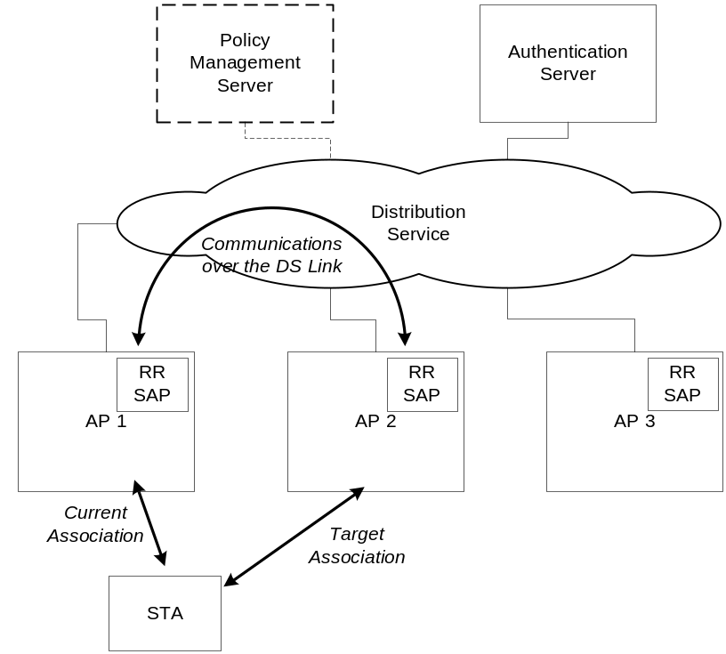
Figure 1 Representative Fast Transition Topology

BSS Transition service provides a generic mechanism to reserve resources at a TTAP candidate called the Resource Information Container (RIC). It provides a mechanism for the STA to build resource requests that could include mandatory and optional resources, or request for alternative resources.

In an RSN environment, the BSS-Transition service describes mechanisms to support pre-keying and resource pre-establishment between a station and an AP. It describes a key hierarchy to extend the scope of a PMK from a single AP to many APs in a complex network that may include both standalone APs and centralized architectures. It defines a new 802.11 authentication type, which allows the client to initiate a handshake to establish the PTK prior to (re)association.

Overview of Transition Mechanisms
With the reservation mechanisms being policy driven, it is feasible to have deployments that do not have pre-reservation. Thus, three Fast BSS Transitions are defined in this specification:

- Base Fast BSS Transition: this mechanism is executed when a TSTA must transition to a TTAP and does not require a reservation prior to its transition.

- Pre-reservation Fast BSS Transition: this mechanism is executed when a TSTA needs assurances that the required security and QoS resources be available prior to a transition.

APs must advertise both their capabilities and policies for supporting the Fast BSS Transition mechanisms.

Capability Advertisement
Fast Transition capability will be advertised in the extended capability bit Information Element. A separate Fast Transition IE is also defined, which may contain 2 additional IEs, one each for resource and security. The resource and security IEs exist only is QoS and security, respectively, are enabled on the network. All IEs will be advertised in Beacons and Probe Responses.

Base Mechanism
Fast BSS Transition capable systems must support the Fast BSS Transition Base Mechanism. The base mechanism enables TSTAs to transition to a TTAP in the event that it must transition without expending costs for invoking a reservation or in the event that the deployment policy only enforces the base mechanism.

The Fast BSS Transition (FBT) base mechanism optimizes the number of exchanges required to establish either the 802.11i PTKSA or the 802.11e QoS resources. New information elements are introduced to allow for the PTKSA and QoS resources provisionment.

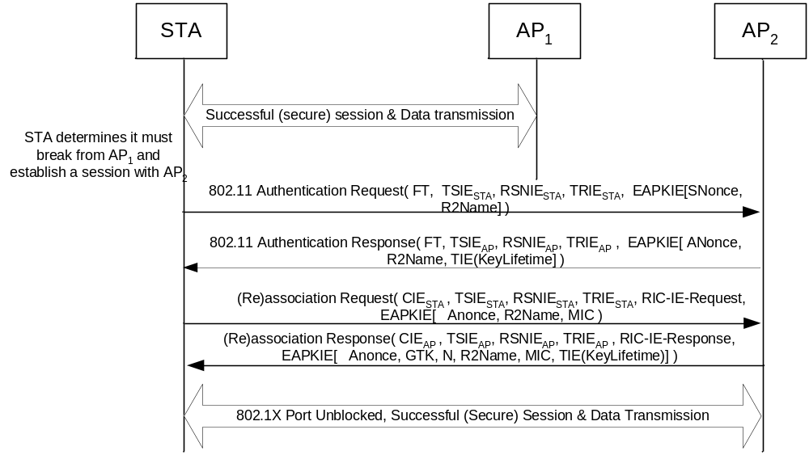
Figure 2 Fast BSS Transition: Base Mechanism

As shown in Figure 2, the FBT base mechanism defines a new 802.11 Authentication FBT algorithm to enable the TSTA and TTAP to specify the PTKSA to be established as well as provide the respective SNonce and ANonce to precompute the PTK prior to the TTAP committing QoS resources and TSTA to precompute the PTKSA. The PTKSA must be established to enable the integrity protection of the QoS resources specified in the (re)association exchange.

Note that the PTKSA request and response as well as the SNonce and ANonce triggers may be conducted either over-the-air as shown in Figure 2 or over the wire using the FBT Action Frame.

Pre-Reservation Mechanism
Fast BSS Transition (FBT) capable networks may allow TSTA’s to pre-reserve PTKSAs and QoS resources prior to (re)association. The FBT pre-reservation mechanism decouples the allocation of the security and QoS resources from the TSTA’s critical path, e.g. (re)association. The decoupling allows TSTAs better assurances of meeting the Fast BSS Transition time.

The notion of Resource Information Container (RIC) has been introduced to express resource requirements and various combinations of the resource requests. A RIC is essentially a collection of IEs that express the number of resources, the specification of the resource requirements and any relationship between these resource requirements.

Similar to the FBT Base Mechanism, the FBT pre-reservation mechanism uses the FBT 802.11 Authentication algorithm to enable the pre-reservation of both the security and QoS resources. Figure 3 demonstrates the message flow for an TSTA employing the FBT Pre-Reservation mechanism using the FBT 802.11 Authentication mechanism.

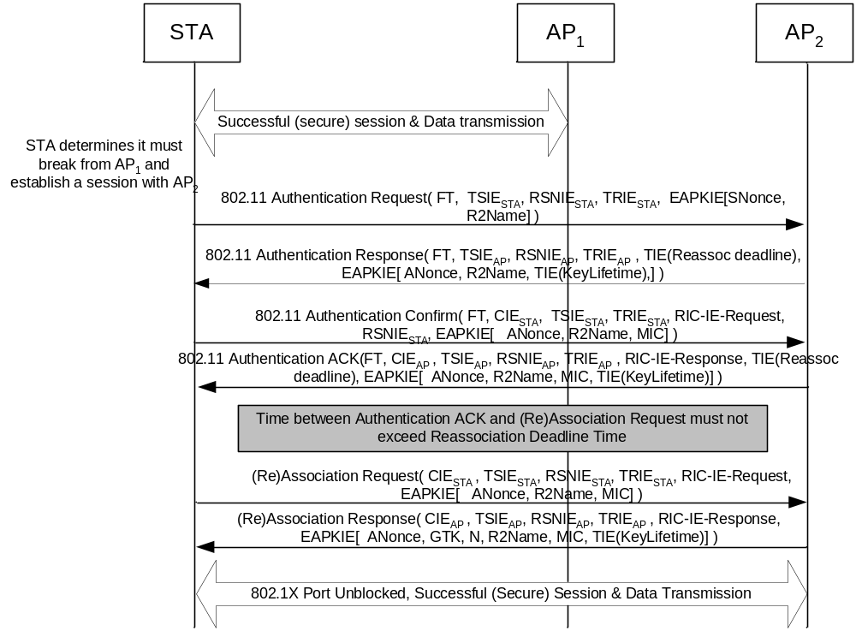
Figure 3 Fast BSS Transition using Pre-reservation over the air

To further optimize potential delays and latencies incurred in channel switching and messaging over the air, FBT Pre-Reservation can also be invoked using the current BSSID to relay the pre-reservation exchange to the TTAP. The figure below depicts the message flow for the FBT Pre-Reservation mechanism using the current BSSID.

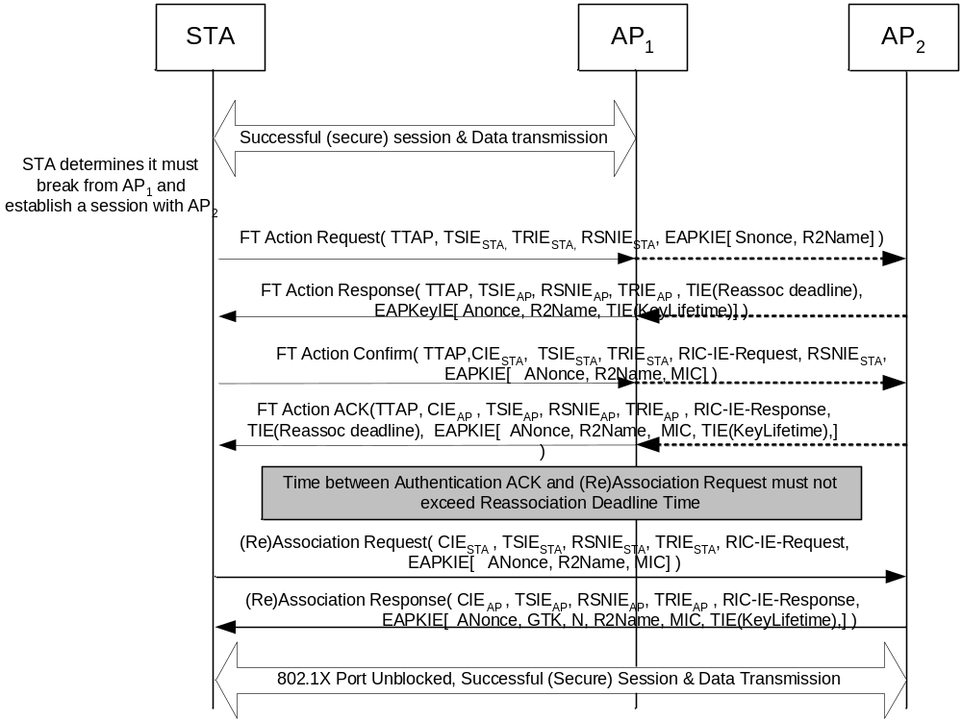
Figure 4 Fast BSS Transition using Pre-Reservation over the wire

Frame Formats

Fast Transition Authentication
A new algorithm number is specified to enable Fast Transitions (FT). The FT Authentication exchange is only valid when the FT capability is enabled; more specifically, when the Fast Transition Information Element is advertised by the BSSID and employed by the TSTA. The body of a management frame of subtype Authentication contains the information as shown in the figure below.

The Fast Transition Authentication algorithm allows a TSTA to initiate a Fast Transition. If the FT Authentication algorithm is selected, the TSTA will include its TSIE and TRIE in the FT Authentication Request. If Robust Security Network Association (RSNA) is enabled, the TSTA shall also include its SNonce contribution and include the key holder identities used for generating the PTK.

Order | Information
1 | Authentication algorithm number
2 | Authentication transaction sequence number
3 | Status code ¹
4 | Challenge text² or IE Count ³
5 | Fast Transition Resource IE (TRIE)³
6 | Fast Transition Security IE (TSIE)
7 | RIC IE³
8 | EAPK IE³
Notes:
1 – the status code information is reserved and set to 0 in certain Authentication frames as defined in Figure 6
2 – the challenge text information is only present in the Shared Key Authentication frames as defined in Figure 6
3 – this field is only present in the Fast Transition frames as defined in Figure 6
Figure 5 IEEE 802.11 Authentication frame body

The Fast Transition Authentication exchange may include a variable number of information elements to provision security and QoS resources. When RSNA is enabled, the QoS resource reservation mechanism is authenticated by the MIC specified in the EAPOL-IE. Further, the MIC specified in the EAPOL-IE shall protect all of the information commencing with the IE count to the (and including the) EAPOL-IE.

Authentication Algorithm | Authentication transaction sequence no. | Status code | Presence of fields 4 and beyond
Open System | 1 | Reserved | Not present
Open System | 2 | Status | Not present
Shared Key | 1 | Reserved | Not present
Shared Key | 2 | Status | Present
Shared Key | 3 | Reserved | Present
Shared Key | 4 | Status | Present
Fast Transition | 1 | Reserved | Not present
Fast Transition | 2 | Status | Present
Fast Transition | 3 | Reserved | Present
Fast Transition | 4 | Status | Present
Figure 6 Presence of Challenge text information

Fast Transition (FT) Authentication frame sequence
The FT Authentication frame sequence is invoked to initiate a Fast BSS Transition. In an RSNA enabled negotiation, the first two FT Authentication frames are used to allow each TSTA and TTAP to provide their random contributions SNonce and ANonce respectively. These values must be random and are used to generate the PTK. The first two message sequences are used to enable the TTAP to provision the PMK-R2 and for the TSTA and TTAP to compute the PTK. As the PTKSA must be established to protect the resource reservation in an RSNA enabled TSTA, no resources may be requested in the first two FT Authentication frames. If no RSNA is negotiated between the TSTA and TTAP, these first two frames are the equivalent of the 802.11 Open Authentication sequence.

The third and fourth FT Authentication frames are used to prove liveness of the PTK and to enable authenticated resource reservation. The FT Authentication frame sequence is always initiated by the TSTA and responded by the TTAP.

FT Authentication frame: 1st frame
The first frame of the FT Authentication frame sequence is used by the TSTA to initiate a Fast BSS Transition. When RSNA is enabled, the TSTA shall, in the TSIE, include the corresponding key names of the key hierarchy it is using to generate the PTK. By including the key names and their respective key holders, the TTAP can use this information to ensure it has the corresponding PMK-R2 or request for the appropriate PMK-R2. Additionally, the TSTA shall also include the SNonce as its random contribution to ensure the derivation of a fresh PTK.

Using the conventions of Clause 8 of the 802.11 (Reaff 2003) draft :
- Message Type: Management
- Message Subtype: Authentication
- Information Items:
  - Station Identity Assertion (in the SA field of the header)
  - Target AP Identity Assertion (in the DA field of the header)
  - Authentication Algorithm Identification = “Fast Transition”
  - Authentication Transaction Sequence number = 1
  - Authentication Algorithm dependent information:
    - TSIE must be included to negotiate the Fast Transition Capabilities
    - If RSNA is enabled the EAPKIE must be included with the SNonce and RSNIE values filled in, all other fields shall be zero.
    - If RSNA is enabled the RSNIE must include a PMKID count of 1 and the R2Name in the PMKID field.
- Direction of message: From TSTA to TTAP

FT Authentication frame: 2nd frame
The second frame of the FT Authentication frame sequence is used by the TTAP to respond to the requesting TSTA. When RSNA is enabled, the TTAP shall also, in the TSIE, echo the key holders and key names used to generate the PTK. Additionally it shall also include the ANonce.

The response shall also include a status and when RSNA is enabled, it may return with a key lifetime (for the FT key hierarchy) and a (re)association deadline. The reassociation deadline is the time allotted for the TSTA to initiate reassociation.

Using the conventions of Clause 8 of the 802.11 (Reaff 2003) draft :
- Message Type: Management
- Message Subtype: Authentication
- Information Items:
  - Station Identity Assertion (in the SA field of the header)
  - Target AP Identity Assertion (in the DA field of the header)
  - Authentication Algorithm Identification = “Fast Transition”
  - Authentication Transaction Sequence number = 2
  - Authentication Algorithm dependent information:
    - TSIE must be included in response to the Fast Transition Capabilities request
    - If RSNA is enabled the EAPKIE must be included with the ANonce and RSNIE values filled in, all other fields shall be zero.
    - If RSNA is enabled the RSNIE must include a PMKID count of 1 and the R2Name in the PMKID field.
    - If RSNA is enabled, FT Key lifetime must be included
    - (Re)association Deadline
    - Status
- Direction of message: From TTAP to TSTA

FT Authentication frame: 3rd frame
The third frame of the FT Authentication frame sequence is used by the TSTA to assert, in an RSNA enabled negotiation that it has a valid PTK and to authenticate a resource request. If no resources are required, then it may omit inclusion of the TSPEC IEs. Similarly, if no RSNA is enabled, the RSNIE and MIC values are omitted.

Using the conventions of Clause 8 of the 802.11 (Reaff 2003) draft :
- Message Type: Management
- Message Subtype: Authentication
- Information Items:
  - Station Identity Assertion (in the SA field of the header)
  - Target AP Identity Assertion (in the DA field of the header)
  - Authentication Algorithm Identification = “Fast Transition”
  - Authentication Transaction Sequence number = 3
  - Authentication Algorithm dependent information:
    - TRIE and TSIE must be included to confirm to the Fast Transition Capabilities
    - If RSNA is enabled the EAPKIE must be included with the ANonce and RSNIE values filled in, all other fields shall be zero. The MIC shall protect the contents of the FT Authentication frame starting with the IE count up to and including the EAPKIE. Additionally, the following bits shall be enabled: security, MIC, A (response is required) and Install.
    - If RSNA is enabled the RSNIE must include a PMKID count of 1 and the R2Name in the PMKID field.
    - If resources are being requested, the RIC resource request shall be included
- Direction of message: From TSTA to TTAP

FT Authentication frame: 4th frame
The fourth frame of the FT Authentication frame sequence is used by the TTAP to respond to the requesting TSTA. The fourth message serves as final confirmation of both liveness of the PTK to the TSTA and resource availability. Note however that the EAPOL-IE may be absent if RSNA is disabled; similarly the RIC-IE will be abset if no resources are requested.

The response shall also include a status and when RSNA is enabled, it may return with a key lifetime (for the FT key hierarchy) and a (re)association deadline. The reassociation deadline is the time allotted for the TSTA to initiate reassociation.

Using the conventions of Clause 8 of the 802.11 (Reaff 2003) draft :
- Message Type: Management
- Message Subtype: Authentication
- Information Items:
  - Station Identity Assertion (in the SA field of the header)
  - Target AP Identity Assertion (in the DA field of the header)
  - Authentication Algorithm Identification = “Fast Transition”
  - Authentication Transaction Sequence number = 4
  - Authentication Algorithm dependent information:
    - TRIE and TSIE must be included to acknowledge the Fast Transition Capabilities
    - If RSNA is enabled the EAPKIE must be included with the SNonce, RSNIE values filled in, all other fields shall be zero. The MIC shall protect the contents of the FT Authentication frame starting with the IE count up to and including the EAPKIE. Additionally, the following bits shall be enabled: security, MIC and Install.
    - If RSNA is enabled the RSNIE must include a PMKID count of 1 and the R2Name in the PMKID field.
    - If RSNA is enabled, FT Key lifetime must be included in the Time Interval IE
    - If resources are being requested, the RIC resource response shall be included along with (Re)association Deadline
    - Status
- Direction of message: From TTAP to TSTA

Reassociation
The reassociation request and response frame formats are enhanced to convey the respective requested and allocated security and QoS resources.

Reassociation Request Frame Body

The frame body of a management frame of subtype Reassociation Request contains the information shown in Figure 7. The Ressociation request is used to request or confirm the availability of resources the STA need to complete its connection the fast BSS-Transition. If RSNA is enabled, the TSTA must assert liveness of the PTK by including the ANonce provided by the TTAP and authenticate the frame by including a valid MIC in the EAPKIE. The MIC shall protect the fields starting with the IE Count up to and including the EAPKIE.

Order | Information | Notes
1 | Capability | As defined by 802.11 standard
2 | Listen Interval | As defined by 802.11 standard
3 | Current AP address | As defined by 802.11 standard
4 | SSID | As defined by 802.11 standard
5 | Supported Rates | As defined by 802.11 standard
6 | Extended Supported Rates | As defined by 802.11 standard
7 | Power Capability | As defined by 802.11 standard
8 | Supported Channels | As defined by 802.11 standard
9 | Count IE | Specifies the number of IEs succeeding this IE and if present, protected by the EAPKIE
10 | TRIE | A Fast Transition Resource IE to convey the Fast Transition resource capabilities.
11 | TSIE | A Fast Transition Security IE to convey the Fast Transition security capabilities.
12 | RIC Request IEs | The set of IEs that formulate a RIC request, for requesting QoS resources
… |  | Other IEs that may require protection
13 + n +1 | EAPKIE | An IE encapsulating EAPOL Key-Message to include the required information for a Fast Transition
Figure 7 Reassociation Request Frame Body
The RSN IE is present in the EAPKIE, and to avoid duplication, the RSN IE field has been removed from the Fast Transition re-association request frame. The RSN IE provided in the reassociation request must be bitwise identical to the RSN IE presented in the FT Authentication Request Frame.

Reassociation Response Frame Body
The frame body of a management frame of subtype Reassociation Response contains the information shown in Figure 8. The TTAP uses the Reassociation Response frame to respond to the TSTA resource and PTKSA requests. The TTAP will include TRIE, TSIE, RIC IE(s) and EAPKIE in response to the IE’s included in the Reassociation request. If RSNA is enabled, the TTAP must assert liveness of the PTK by including the SNonce provided by the TSTA and authenticate the frame by including a valid MIC in the EAPKIE. The MIC shall protect the fields starting with the IE Count up to and including the EAPKIE.

Order | Information | Notes
1 | Capability | As defined by 802.11 standard
2 | Listen Interval | As defined by 802.11 standard
3 | Current AP address | As defined by 802.11 standard
4 | SSID | As defined by 802.11 standard
5 | Supported Rates | As defined by 802.11 standard
6 | Extended Supported Rates | As defined by 802.11 standard
7 | Power Capability | As defined by 802.11 standard
8 | Supported Channels | As defined by 802.11 standard
9 | Count IE | Specifies the number of IEs succeeding this IE and if present, protected by the EAPKIE
10 | TRIE | A Fast Transition Resource IE to convey the Fast Transition resource capabilities.
11 | TSIE | A Fast Transition Security IE to convey the Fast Transition security capabilities.
12 | Time Interval IE | The time interval IE indicating the re-association timeout value. The STA must complete the reassociation within this interval.
13 | RIC Response IEs | The set of IEs that formulate a RIC response, for responses for QoS resources
… |  | Other IEs that may require protection
14 + n +1 | EAPKIE | An IE encapsulating EAPOL Key-Message to include the required information for a Fast Transition

Figure 8 Reassociation Response Frame Body

The RSN IE is present in the EAPKIE, and to avoid duplication, the RSN IE field has been removed from the the Fast Transition re-association response frame. The RSN IE provided in the reassociation request must be bitwise identical to the RSN IE presented in the TTAP Beacon Frame.

Fast BSS Transition Action Frame
A new action frame sequence is defined to affect the initial sequence of the FBT Base Mechanism and FBT pre-reservation mechanism. A new category field to support FBT is defined; thus enhancing the 802.11-2003 specification, the Action Frame category is defined as follows:

Name | Value | See Subclause
Spectrum management | 0 | 7.4.1
QoS | ??
Radio Resource Measurement | ??
Fast BSS Transition | TBD
Figure 9 Action frame Category

Fast BSS Transition Action frame details
Four Action frame formats are defined to specify Fast BSS Transition initiated through the currently associated BSSID (e.g. over the wire). The action field values associated with each frame format within the FBT category is defined in Figure 10:

Field | Value
FT Request | 0
FT Response | 1
FT Confirm | 2
FT ACK | 3
Reserved | 4-255
Figure 10 FBT Action Field Values

FT Request
The FT Request Action frame is used by an TSTA to trigger a pre-reservation request through the current associated BSSID.

 | Category | Action | TTAP | Count IE | TRIE | TSIE | RSNIE | EAPK IE
Octets: | 1 | 1 | 6 | 4 | N | M | Variable | 95
Figure 11 FT Request Frame format

The frame body of an FT Request contains the information shown in Figure 11 where:

Category: shall be set to TBD (representing the FBT action management frame)

Action : shall be set to 0

TTAP : shall be set to the BSSID value of the target AP.

Count IE : Number of IEs that follow this Count IE.

TRIE : shall be set to the Fast Transition Resource IE with the resource policy it is negotiating.

TSIE : shall be set to the Fast Transition Security IE with the security policy it is negotiating.

RSNIE : this field is only present when RSN is enabled and shall be set to the RSN IE as defined in Clause 7.3.2.25 (of the 802.11i specification). When present, the RSNIE defines the security policy negotiated by the TSTA. In addition, the TSTA must provide the R2Name used to generate a fresh PTKSA.

EAPKIE: this field is only present when RSN is enabled and RSN IE is specified. The EAPKIE must provide a random SNonce in the KeyNonce field.

FT Response
The FT Response action frame is transmitted by the current BSSID as a response to the TSTA’s FT Request. The frame body of the FT Response is as follows:

 | Category | Action | TTAP | Count IE | Time Interval IE | TRIE | TSIE | RSNIE | EAPK IE
Octets: | 1 | 1 | 6 | 4 | 5 | N | M | Variable | 95
Figure 12 FT Request Frame format

Category: shall be set to TBD (representing the FBT action management frame)

Action : shall be set to 1.

TTAP : shall be set to the BSSID value of the target AP.

Count IE : Number of IEs that follow this Count IE.

Time Interval IE : Time interval information element used to convey either the reassociation deadline time.

TRIE : shall be set to the Fast Transition Resource IE with the resource policy it is negotiating.

TSIE : shall be set to the Fast Transition Security IE with the security policy it is negotiating.

RSNIE : this field is only present when RSN is enabled and shall be set to the RSN IE as defined in Clause 7.3.2.25 (of the 802.11i specification). When present, the RSNIE defines the security policy advertised by the TTAP’s beacons. In addition, the TTAP must provide the R2Name used to generate a fresh PTKSA.

EAPKIE: this field is only present when RSN is enabled and RSN IE is specified. The EAPKIE must provide a random ANonce in the KeyNonce field and a KeyLifetime for the FT Key Hierarchy.

FT Confirm
The FT Confirm action frame is used by the TSTA to confirm to the TTAP receipt of the ANonce and to initiate both the liveness of the PTKSA and, if required, to request QoS resources. The FT Confirm action frame body format is as follows:

 | Category | Action | TTAP | Count IE | TRIE | TSIE | RSNIE | RIC-Request | EAPK IE
Octets: | 1 | 1 | 6 | 4 | N | M | Variable | Variable | 95
Figure 13 FT Confirm action frame body format
Category: shall be set to TBD (representing the FT action management frame)

Action : shall be set to 3.

TTAP : shall be set to the BSSID value of the target AP.

Count IE : Number of IEs that follow this Count IE.

TRIE : shall be set to the Fast Transition Resource IE with the resource policy it is negotiating.

TSIE : shall be set to the Fast Transition Security IE with the security policy it is negotiating.

RSNIE : this field is only present when RSN is enabled and shall be set to the RSN IE as defined in Clause 7.3.2.25 (of the 802.11i specification). When present, the RSNIE defines the security policy specified in the FT Request frame body.

RIC-Request: this field is present only if QoS resources are to be requested, this field shall be a sequence of RIC IEs (RRIE, RDIE), per RIC specification.

EAPKIE: this field is present only when RSN is enabled and RSN IE is specified. The EAPKIE must echo the ANonce in the KeyNonce field and authenticate all fields commencing with the Count IE and including the EAPKIE. The authentication tag shall be transmitted in the EAPOL-Key MIC field and use the same algorithms as specified by Clause 8.5.2 of the 802.11i specification.

FT ACK
The FT ACK action frame is transmitted by the current BSSID as a response to the TSTA’s FT Confirm. The frame body of the FT ACK is as follows:

 | Category | Action | TTAP | Count IE | Time Interval IE | TRIE | TSIE | RSNIE | RIC-Response | EAPK IE
Octets: | 1 | 1 | 6 | 4 | 5 | N | M | Variable | Variable | 95
Figure 14 FT ACK action frame body format

Category: shall be set to TBD (representing the FT action management frame)

Action : shall be set to 4.

TTAP : shall be set to the BSSID value of the target AP.

Count IE : Number of IEs that follow this Count IE.

Time Interval IE : Time interval information element used to convey the reassociation deadline time.

TRIE : shall be set to the Fast Transition Resource IE with the resource policy it is negotiating.

TSIE : shall be set to the Fast Transition Security IE with the security policy it is negotiating.

RSNIE : this field is only present when RSN is enabled and shall be set to the RSN IE as defined in Clause 7.3.2.25 (of the 802.11i specification). When present, the RSNIE defines the security policy specified in the FT Response frame body.

RIC-Response: this field is present only if QoS resources were requested, and this field shall be a sequence of RIC IEs, per RIC specification.

EAPKIE: this field is present only when RSN is enabled and RSN IE is specified. The EAPKIE must echo the SNonce in the KeyNonce field and authenticate all fields commencing with the Count IE and including the EAPKIE. The authentication tag shall be transmitted in the EAPOL-Key MIC field and use the same algorithms as specified by Clause 8.5.2 of the 802.11i specification.

Information Elements

Count IE
The Count IE specifies the number of IEs that follow the Count IE. When security is enabled, all IEs including and following this Count IE will be integrity protected, including EAPKIE.

Order | Size (octets) | Description
1 | 1 | TBD Element ID: FT Action Frame Count IE
2 | 1 | Length: must be set to 0x03
3 | 1 | Value reflects the number of IE’s succeeding this Count IE
Figure 15 FT Action Frame Count information element

Status codes
The status codes for Fast Transition are defined below:

Status Code | Meaning
0-50 | Already pre-allocated
51 | Invalid FT Action Frame Count
52 | Expected a reservation to precede FT
53 | Invalid TSPEC
54 | Invalid PMKID
55 | Invalid 802.1X IE
56-255 | Reserved
Figure 16 Fast Transition Status Codes

Fast Transition Resource IE (TRIE)
A new information element is defined to enable the advertisement of network infrastructure policy and information for resources that can assist an TSTA to decide which transition mechanism to use. A TTAP can advertise the TRIE through Beacon frame and Probe Response frame. This information element is defined in figure below.

Order | Size (octets) | Description
1 | 1 | Element ID. TBD
2 | 1 | Length
3 | 3 | Fast Transition Resource Mechanisms
Figure 17 Fast Transition Resource IE
The following table describes the configuration policies when the different settings are enabled. The AP and STA must support the basic FT mechanism.

Byte 0 | Bit 0: Reservation over air | AP supports Reservation over air, which is protected using a separate handshake protocol.
Byte 0 | Bit 1: Reservation over DS | AP supports Reservation over DS
Byte 0 | Bit 2: Reserve Option | Value 1: Reservation is Mandatory  Value 0: Reservation is Optional
Byte 0 | Bit 3-6: Reservation Limit | Number of APs at which a STA can reserve
Byte 0 | Bit 7: Reserved
Byte 1-16 |  | Resource Mobility Domain for inter AP communication over DS
Figure 18 Fast Transition Resource IE Description
The STA can use information from the TRIE to determine the transition mechanisms supported and recommended by the AP and infrastructure. The choice of executing any specific transition mechanism is left as discretion of the STA.

Fast Transition Security IE (TSIE)
A new information element is defined to enable the advertisement of network infrastructure security policy and information, which can assist a TSTA to decide which security mechanisms to use. An AP advertises this IE only when security during fast transitions is enabled on the network, through Beacon frame, Probe Response frames. This information element is defined in figure below.

Order | Size (octets) | Description
1 | 1 | Element ID. TBD
2 | 1 | Length
3 | N | Fast Transition Security Mechanism
Figure 19 Fast Transition Security IE
The following table describes the security parameters.

Byte 1-15 | Security Mobility Domain Identifier (SMD-ID)
Byte 16-31 | Key R0 Key Holder ID (R0KH-ID)
Byte 32-47 | Key R1 Key Holder ID (R1KH-ID)
Byte 48-63 | Key R2 Key Holder ID (R2KH-ID)
Figure 20 Fast Transition Security IE Description

Fast Transition Key Holder IE
A new information element is defined to enable the advertisement of network infrastructure security policy and information, which can assist a TSTA to decide which security mechanisms to use. An AP advertises this IE only when security during fast transitions is enabled on the network, through Probe Response frame. This information element is defined in figure below.

Order | Size (octets) | Description
1 | 1 | Element ID. TBD
2 | 1 | Length
3 | P | Fast Transition Key Holder Mechanism
Figure 21 Fast Transition Key Holder IE
The following table describes the security parameters.

Byte n |  | RO Holder List
Byte n-p |  | RO List (p=2 to k)
Figure 22 Fast Transition Key Holder IE Description

Time Interval IE
A new generic IE is introduced to define the time element, which may be used for specifying various types of time intervals and timeouts.

The Resource Reservation Timeout IE is defined as follows:

Order | Size (octets) | Description
1 | 1 | TBD Element ID: Return Interval IE
2 | 1 | IE length
3 | 1 | Type of Time interval and timeout
4 | 2 | Unsigned 16-bit integer representing the number of TUs (milliseconds).
Figure 23 Time Interval IE

0x00 | Reserved
0x01 | Re-Association Deadline
0x02 | Key Lifetime Interval
0x03-0xFF | Reserved
Figure 24 Time Interval Type Description

Resource Information Container
The Resource Information Container (RIC) refers to a collection of IEs that are used to express resource request in a resource request message. RIC is also used to convey responses to the corresponding responses.

Each atomic resource is contained in one IE. For example, a TSPEC is contained in an IE of the same format used for 802.11e.

Two new IE types are defined by 802.11r to introduce structure to the RIC. These are:
RIC_ROOT (RRIE): used as the RIC header
RIC_DATA (RDIE): used to describe each Resource Request. A simple Resource Request is an RDIE followed by single TSPEC.

The basic format of the RIC has one RRIE and a list of Resource Requests.

RRIE | Resource Request | Resource Request | Resource Request

In a fully specified RIC Each Resource Request comprises an RDIE followed by one or more TSPECs. If there are multiple TSPECs then these are treated as “choices” by the target AP. The AP shall attempt to allocate the first TSPEC and if this fails shall attempt to allocate the next TSPEC instead and so on until successful allocation or the end of the TSPEC list. Thus, an “OR” relationship exists between TSPECs that follow an RDIE.
Examples of Resource Requests:

RDIE | TSPEC | RDIE | TSPEC
The above is an example of two Resource Requests, each with a single RDIE.

RDIE | TSPEC | TSPEC
The above is an example of one Resource Request with a choice of 2 TSPECs. This indicates that the target AP can select one of the 2 TSPECs.

RIC_DATA IE

The RIC_DATA IE (RDIE) has a structure shown below:

Order | Size (octets) | Description
1 | 1 | TBD Element ID
2 | 1 | IE length
3 | 1 | RIC_DATA sequence number
4 | 1 | Control Options
Figure 25 RIC_DATA IE

RIC_DATA Sequence number – RIC_DATA Sequence number enumerates all RDIEs in the RIC. The sequence number should be used in the Re-Association request to refer to a successful resource allocation request that was done prior to transition.

Control Options – The control options octet has the format shown here:

Byte 0 | Bit 0: Mandatory | 1 indicates allocation of TSPEC is mandatory  0 indicates that allocation of TSPEC is optional
Byte 0 | Bit 1: Confirm | Request Messages: Always set to 0, ignored  Response Messages:  1 indicates allocation successful  0 indicates allocation failure
Byte 0 | Bit 2-3: Reserved | Reserved for future use
Byte 0 | Bit 4-7: TSPEC IE Count | Number of TSPEC IEs that follow this RDIE
Figure 26 RIC_DATA IE Control Options Description

Mandatory Bit Field: The Mandatory bit set to 1 indicates that one of the TSPECs that follow the RDIE must be allocatable/allocated for the resource request to be considered successful. If the Mandatory bit is set to 0, the AP should keep processing the rest of the request in RIC even if none of the TSPEC IEs following the RDIE is allocatable/allocated.

Confirm Bit Field: The Confirm bit is used only in response messages to indicate success or failure of the allocation and is set to zero and ignored in request messages.

Resource Count Field: Resource count indicates the number of TSPEC IEs, that following this RDIE.

RIC_ROOT IE

The RIC_ROOT IE (RRIE) has a structure shown below:

Order | Size (octets) | Description
1 | 1 | TBD Element ID
2 | 1 | IE length
3 | 1 | RRIE Identifier
4 | 1 | Count of RDIE IEs
5 | 6 | Target BSSID
Figure 27 RIC_ROOT IE

Where:
RRIE Identifier: A unique value intended to match responses to requests
RDIE Count: Number of RDIEs contained in a RIC IE
Target BSSID: The target BSSID to which the RIC IE is to be sent.

Authentication and Key Management (AKM) suites
The RSN IE format and contents contain the information as shown in Figure 46ta and described in Clause 7.3.2.25 of the IEEE 802.11i 2004 specification. Further, the AKM suites supported within the RSN IE are as specified in Clause 7.3.2.25.2 of the IEEE 802.11i 2004 specification with the following additions:

OUI | Suite Type | Meaning
OUI | Suite Type | Authentication Type | Key management Type
00-0F-AC | 3 | TGr Authentication negotiated over IEEE 802.1X or using PMKSA caching as defined by IEEE 802.11i 2004 specification | TGr key management as defined by this draft.
00-0F-AC | 4 | PSK | TGr key management as defined by this draft.
00-0F-AC | 4-255 | Reserved | Reserved
Figure 28 AKM Suites

FT 802.1X EAPOL-Key IE (EAPKIE)
A new information element is defined to encapsulate the FT 802.1X EAPOL-Key messages. This IE must be present in the 3rd and 4th FT Authentication messages or the FT Confirm and FT ACK action frames, the (re)association request and response when FT and security are enabled.

The encapsulated 802.1X EAPOL-Key information element is defined in Figure 29:
Order | Size (octets) | Description
1 | 1 | TBD Element ID: Encapsulated 802.1X IE
2 | 1 | Length of the 802.1X EAPOL-Key message
3 | n | 802.1X EAPOL-Key message
Figure 29 Encapsulated FT 802.1X EAPOL-Key information element

Protocol Mechanisms

Authentication frame notation

The following notation is used throughout the remainder of this clause to represent management frames of subtype Authentication:

Auth-FT(Alg, Seq, SC, Data)

where

Alg is the Authentication Algorithm Number field representing FT.

Seq is the Authentication Transaction Sequence Number field.

SC is the Status Code field.

Data is additional data carried in the payload of the message. It replaces the Challenge Text element defined in 802.11.

EAPOL-Key frame notation

This specification extends the EAPOL-Key frames, as defined in 802.11i. The extention in this specification allows the EAPOL-Key frames to convey and authenticate information about the security and resource contexts. The new information about security and resource contexts is conveyed in the Key Data portion of the EAPOL Key frame. The following notation is used throughout the remainder of this clause to represent this updated EAPOL-Key frames:

EAPOL-Key-FT(S, M, A, I, K, KeyRSC, ANonce/Snonce, MIC, RSNIE, GTK, N, KeyName, TSIE, TRIE, Keylifetime)

where

S means the initial key exchange is complete. This is the Secure bit of the Key Information field.

M means the MIC is available in the message. This is the Key MIC bit of the Key Information field.

A means a response is required to this message. This is used when the receiver should respond to this message. This is the Key Ack bit of the Key Information field.

I is the Install bit: Install/Not install for the pairwise key. This is the Install bit of the Key Information field.

K is the key type: P (Pairwise), G (Group/STAKey). This is the Key Type bit of the Key Information field.

KeyRSC is the key RSC. This is the Key RSC field used to convey the GTK’s receive sequence counter.

ANonce/Snonce is the Authenticator/Supplicant nonce. This is the Key Nonce field.

MIC is the integrity check, which is generated using the KCK. This is the Key MIC field.

RSNIE is the RSN information element. This is in the Key Data field.

GTK is the encapsulated GTK. This is in the Key Data field.

N is the key identifier, which specifies which index should be used for this GTK.

KeyName is the name of the Key being referenced by this exchange e.g. R2Name. This is in the RSNIE PMKID field.

TSIE is the Fast BSS Transition Security Information Element. This is in the Key Data field.

TRIE is the Fast BSS Transition Resource Information Element. This is in the Key Data field.

KeyLifetime is the lifetime of the TGr Key Hierarchy. That is, it is the lifetime of all the PMK keys, PMK-R0, PMK-R1 and PMK-R2. This is present in the Key Data field. This field is represented as the Time Interval IE (TIE) of type KeyLifetime.

Note that when the EAPOL-Key frame is encapsulated as an EAPKIE, then there may be other associated data that is protected by the MIC inside the EAPOL-Key frame.

First Contact

The FT mechanisms optimize the transitions across an ESS under different conditions. In particular, with RSN enabled networks a new key hierarchy is defined to further reduce the number of transactions required to establish a fresh PTKSA. The affect the full potential of FT mechanisms, a TSTA must instantiate the enabling of FT during (re)association. This enabling is referred to as first contact to ensure that all potential TTAPs, a TSTA may transition to, will affect the appropriate policies and store relevant information to enable FT.

Thus, on first contact, the TSTA asserts both the security and QoS policies it will employ throughout the duration of the FT session. This is achieved using the same message flows as defined by the 802.11-2003 specification and including 802.11i when RSN is enabled and 802.11e when QoS is enabled. The only distinction to affect an FT session is to assert the use of FT by including the TRIE and TSIE in the (re)association negotiation. The message flow is depicted in Figure 30.

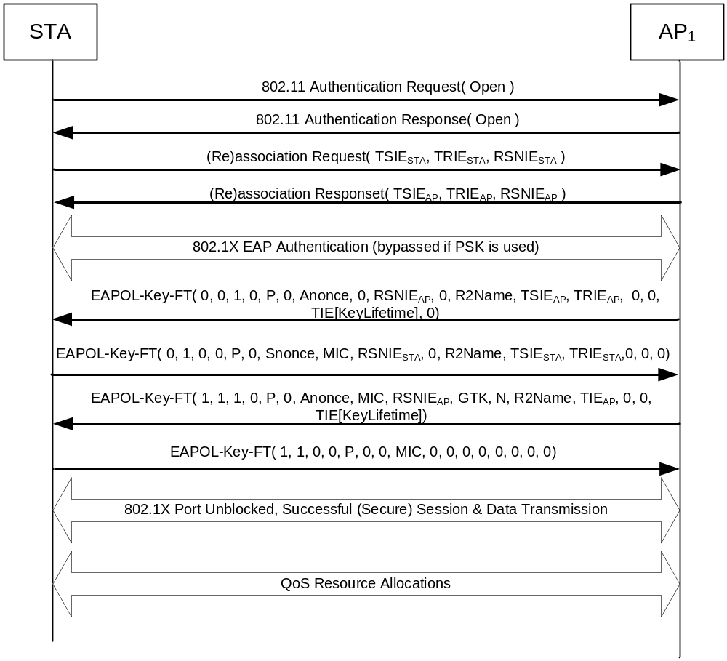
Figure 30 First Contact to enable TSTA's Fast BSS Transition

As shown in Figure 30, on first contact with the ESS within which the TSTA intends to use FT, the packet exchange between the TSTA and the TTAP is similar to that defined by 802.11-2003, 802.11i and 802.11e. In particular, with RSN-enabled, the TSTA first performs an 802.11 Authentication using the Open System Authentication Algorithm. Upon successful 802.11 open authentication, TSTA then sends a (re)association request to the TTAP and includes the TRIE AND TSIE to assert the use of Fast BSS Transitions for future transitions. Additionally, it includes its security capabilities in the RSN IE. The R2Name is set to 0’s (zeroes) as no PMKSA has been negotiated yet.

TSTA->TTAP: Auth-FT(0, 0, 0, 0)
TTAP->TSTA: Auth-FT(0, 1, SC, 0)

If the SC returned by the TTAP is 0, indicating success, the TSTA continues with (Re)Association:

TSTA->TTAP: (Re)Association Request ( TRIE_{STA}, TSIE_{STA}, RSNIE_{STA} )
TTAP->TSTA: (Re)Association Response ( )

On successful (re)association, the SPA on the TSTA and the 802.1X Authenticator on the TTAP then proceed with an 802.1X EAP authentication. The 802.1X EAP exchange is sent between the TSTA and TTAP using EAPOL messages carried in 802.11 data frames.

Upon successful completion of the 802.1X EAP authentication, the 802.1X Authenticator receives the required information to define its PMKSA:
- TTAP’s BSSID, PMK-R2, R0Name, R1Name, R2Name, R0KH-ID, R1KH-ID, R2KH-ID, SPA and FT KeyLifetime

While the TTAP’s 802.1X Authenticator receives most of the information from its parent (R2KH-ID), the TSTA holds all the information to derive the PMKSA directly. Thus, following a successful 802.1X EAP authentication, the TTAP and TSTA then perform a FT 4-way handshake similar to the 802.11i handshake. The FT EAPOL-Key frame notation is defined in Section 1.2.7.

TTAP->TSTA: Data(EAPOL-Key-FT(0, 0, 1, 0, P, 0, ANonce, 0, RSNIE_{AP}, 0, 0, R2Name, 0, 0, KeyLifetime))

TSTA->TTAP: Data(EAPOL-Key-FT(0, 1, 0, 0, P, 0, SNonce, MIC, RSNIE_{STA}, 0, 0, R2Name, TRIE_{STA}, TSIE_{STA}, 0))

TTAP->TSTA: Data(EAPOL-Key-FT(1, 1, 1, 1, P, 0, ANonce, MIC, RSNIE_{AP}, GTK, N, R2Name, TRIE_{AP}, TSIE_{AP}, TIE[KeyLifetime]))

TSTA->TTAP: Data(EAPOL-Key-FT(1, 1, 0, 0, P, 0, 0, MIC, 0, 0, 0, 0, 0, 0, 0))

The “Data()” indicates the message is an 802.11 data frame.

As in 802.11i, the EAPOL-Key messages are encapsulated in 802.11 Data frames. On a successful 802.1X EAPOL-Key 4-way handshake, the 802.1X port is opened on both the TSTA and the TTAP, data connectivity has been established, and the TSTA can perform negotiation of QoS or other features if desired.

Note that on successful completion of the 4-way handshake the Key Replay Counter shall be initialized to zero and the subsequent FT EAPOL-Key frames shall use the Key Replay Counter to ensure they are not replayed.

Base Mechanism
The Fast BSS Transition base mechanism commences when a TSTA has determined its TTAP; that is, it has completed all the discovery and selection criteria for the TSTA to transition to the TTAP.

When a TSTA wishes to move from it's Current AP (CAP) to a Transition Target AP (TTAP) utilizing a Fast BSS Transition without Reservation, the TSTA exchanges nonces with the TTAP and establishes a PTKSA prior to a (re)association exchange.

When a TSTA wishes to perform an Over-the-Air Fast BSS Transition without Reservation to a TTAP, the TSTA and TTAP perform the following exchange:

TSTA->TTAP: Auth-FT(FT, 0, SC, TRIE_{STA}, TSIE_{STA,} RSNIE_{STA}, EAPOL-Key-FT(0, 0, 1, 0, P, 0, SNonce, 0, 0, 0, 0, 0, 0, 0, 0))

TTAP->TSTA: Auth-FT(FT, 1, SC, TRIE AND TSIE_{AP}, RSNIE_{AP}, EAPOL-Key-FT(0, 0, 0, 0, P, 0, ANonce, 0, 0, 0, 0, 0, 0, 0, TIE[KeyLifetime]))

If the SC returned by the TTAP is 0, indicating success, the TSTA continues with (Re)Association.

On successful FT Authentication, the TSTA completes State 1 and proceeds to State 2. Note that while the TSTA is 802.11 Authenticated, the 802.1X port remains blocked. This behavior is consistant to that defined by 802.11i.

If the TTAP does not have the key identified by R2Name, it attempts to retrieve that key from the “infrastructure”. The method by which is retrieves the key is beyond the scope of this specification.

The TSTA and the TTAP compute the PTK and PTKName using PMK-R2, R2Name, and the exchanged nonces as specified in Section 1.2.6.

The TSTA must send a Reassociation Request to the TTAP within the Time Interval IE’s Reassociation Deadline specified in milliseconds or the TTAP will delete the PTKSA.

TSTA->TTAP: Reassociation Request(TRIE AND TSIE_{STA,} RSNIE_{STA}, RIC-Request, EAPKIE(0, 1, 1, 1, P, 0, ANonce, MIC, 0, 0, 0, 0, 0, 0, 0))

TTAP->TSTA: Reassociation Response(TRIE AND TSIE_{AP,} RSNIE_{AP}, RIC-Response, EAPKIE(1, 1, 0, 1, P, 0, SNonce, MIC, 0, GTK, N, 0, 0, 0, TIE[KeyLifetime]))

The TSTA must echo the FT and security policies in the TSIE_{STA} and RSNIE_{STA} as it specified in the FT 802.11 Authentication Request. In the same reassociation request, the TSTA may request for resources by including a RIC-Request. To authenticate the request, an encapsulated EAPOL-Key frame (EAPKIE) is included that echoes the TTAP’s ANonce and authentication tag in the respective Key Nonce and MIC fields. Finally, the TTAP specifies the FT Key Hierarchy lifetime as part of the Key Data field.

At this point, the 802.1X port is opened on both the TSTA and the TTAP and data connectivity with QoS has been established.

Pre-Reservation Mechanism
When an TSTA wishes to move from it's Current AP (CAP) to a Transition Target AP (TTAP) utilizing a Fast BSS Transition with Reservation, the TSTA establishes a PTK with the TTAP and reserves resources using one of two methods:

- "Over-the-Air". In this case, the TSTA communicates directly with the TTAP using 802.11 Authentication frames with the Authentication Algorithm set to Fast BSS Transition.
- "Over-the-DS". In this case, the TSTA communicates with the TTAP via the CAP. The cummunication between the TSTA and the TTAP are carried in Fast BSS Transition Action frames between the TSTA and the CAP, and between the CAP and TTAP via encapsulation TBD. The CAP converts between the two encapsulations.

Note that in either mechanism, it is feasible for an TSTA to invoke multiple Pre-reservations but only commit to one TTAP. That is, it may invoke the pre-reservation mechanism as defined in this section with more than one BSSID but only invoke the (re)association exchange with a single TTAP.

Over-the-Air Fast BSS Transition with Reservation

When a TSTA wishes to perform an Over-the-Air Fast BSS Transition with Reservation to a TTAP, the TSTA and TTAP perform the following exchange:

TSTA->TTAP: Auth-FT(FT, 0, SC, TRIE_{STA}, TSIE_{STA,} RSNIE_{STA}, EAPOL-Key-FT(0, 0, 1, 0, P, 0, SNonce, 0, 0, 0, 0, 0, 0, 0, 0))

TTAP->TSTA: Auth-FT(FT, 1, SC, TRIE_{AP}, TSIE_{AP}, RSNIE_{AP}, TIE[ReassocDeadline], EAPOL-Key-FT(0, 0, 0, 0, P, 0, ANonce, 0, 0, 0, 0, 0, 0, 0, TIE[KeyLifetime]))

If the SC returned by the TTAP is 0, indicating success, the TSTA continues with the next exchange in the FT Authentication. Class 2 frames are not yet allowed as the authentication exchange has not been completed.

If the TTAP does not have the key identified by R2Name, it attempts to retrieve that key from the “infrastructure”. The method by which is retrieves the key is beyond the scope of this specification.

The TSTA and the TTAP compute the PTK and PTKName using PMK-R2, R2Name, and the exchanged nonces as specified in Section 1.2.6.

The TSTA must complete the remainder of the FT Authentication exchange and send a Reassociation Request to the TTAP within Reassociation Deadline milliseconds or the TTAP will delete the PTKSA and release any reserved resources.

TSTA->TTAP: Auth-FT(FT, 2, TRIE_{STA}, TSIE_{STA,} RSNIE_{STA}, RIC-Request, EAPKIE(0, 1, 1, 1, P, 0, ANonce, MIC, 0, 0, 0, 0, 0, 0, 0))

TTAP->TSTA: Auth-FT(FT, 3, TRIE_{AP}, TSIE_{AP,} RSNIE_{AP}, RIC-Response, TIE[ReassocDeadline], EAPKIE(1, 1, 0, 1, P, 0, SNonce, MIC, 0, 0, 0, 0, 0, 0, TIE[KeyLifetime]))

Note that on successful completion of the FT Authentication exchange for pre-reservation, the PTKSA has been established and proven live. Thus, the Key Replay Counter shall be initialized to zero and the subsequent FT EAPOL-Key frames shall use the Key Replay Counter to ensure they are not replayed.

Similarly, on successful completion of the FT Authentication exchange for pre-reservation, both the PTKSA and QoS resources are guaranteed to be reserved until the Reassociation Deadline.
If the SC returned by the TTAP is 0, indicating success, the 802.1X port remains blocked and Class 1 & 2 frames are now allowed between the TSTA and the TTAP, and the TSTA continues with (Re)Association:

TSTA->TTAP: Reassociation Request(TRIE_{STA}, TSIE_{STA,} RSNIE_{STA}, RIC-Request, EAPKIE(0, 1, 1, 1, P, 0, ANonce, MIC, 0, 0, 0, 0, 0, 0, 0))

TTAP->TSTA: Reassociation Response(TRIE_{AP}, TSIE_{AP,} RSNIE_{AP}, RIC-Response, EAPKIE(1, 1, 0, 1, P, 0, SNonce, MIC, 0, GTK, N, 0, 0, 0, TIE[KeyLifetime]))

The TSTA must echo the FT and security policies in the TSIE_{STA} and RSNIE_{STA} as it specified in the FT 802.11 Authentication Confirm. In the same reassociation request, the TSTA asserts the reserved resources by including a RIC-Request as provided in the FT Authentication Confirm. To authenticate the request, an encapsulated EAPOL-Key frame (EAPKIE) is included that echoes the TTAP’s ANonce and authentication tag in the respective Key Nonce and MIC fields. Finally, the TTAP specifies the FT Key Hierarchy lifetime as part of the Key Data field.

At this point, the 802.1X port is opened on both the TSTA and the TTAP and data connectivity with QoS has been established.

Over-the-DS Fast BSS Transition with Reservation

When a TSTA wishes to perform an Over-the-DS Fast BSS Transition with Reservation to a TTAP, the TSTA and TTAP perform the following exchange via the CAP:

TSTA->CAP : FT Action Request(TTAP, TRIE_{STA}, TSIE_{STA,} RSNIE_{STA}, EAPOL-Key-FT(0, 0, 1, 0, P, 0, SNonce, 0, 0, 0, 0, 0, 0, 0, 0))

CAP->TSTA : FT Action Response(TTAP, TRIE_{AP}, TSIE_{AP}, RSNIE_{AP}, TIE[ReassocDeadline], EAPOL-Key-FT(0, 0, 0, 0, P, 0, ANonce, 0, 0, 0, 0, 0, 0, 0, TIE[KeyLifetime]))

TSTA->CAP : FT Action Confirm(TTAP, TRIE_{STA}, TSIE_{STA,} RSNIE_{STA}, RIC-Request, TIE[ReassocDeadline], EAPKIE(0, 1, 1, 1, P, 0, ANonce, MIC, 0, 0, 0, 0, 0, 0, 0))

CAP->TSTA : FT Action ACK(TTAP, TRIE_{AP}, TSIE_{AP,} RSNIE_{AP}, RIC-Response, TIE[ReassocDeadline], EAPKIE(1, 1, 0, 1, P, 0, SNonce, MIC, 0, 0, 0, TIE[KeyLifetime]))

If the TTAP does not have the key identified by R2Name, it attempts to retrieve that key from the “infrastructure” via method TBD.

The TSTA and the TTAP compute the PTK and PTKName using PMK-R2, R2Name, and the exchanged nonces as specified in Section 1.2.6.

Note that on successful completion of the FT Action frame exchange for pre-reservation, the PTKSA has been established and proven live. Thus, the Key Replay Counter shall be initialized to zero and the subsequent FT EAPOL-Key frames shall use the Key Replay Counter to ensure they are not replayed.

Similarly, on successful completion of the FT Authentication exchange for pre-reservation, both the PTKSA and QoS resources are guaranteed to be reserved until the Reassociation Deadline.
If the SC returned by the TTAP is 0, indicating success, the 802.1X port remains blocked and Class 1 & 2 frames are now allowed between the TSTA and the TTAP, and the TSTA continues with (Re)Association:

TSTA->TTAP: Reassociation Request(TRIE_{STA}, TSIE_{STA,} RSNIE_{STA}, RIC-Request, EAPKIE(0, 1, 1, 1, P, 1, ANonce, MIC, 0, 0, 0, 0, 0, 0, 0))

TTAP->TSTA: Reassociation Response(TRIE_{AP}, TSIE_{AP,} RSNIE_{AP}, RIC-Response, EAPKIE(1, 1, 0, 1, P, 1, SNonce, MIC, 0, GTK, N, 0, 0, 0, TIE[KeyLifetime]))

The TSTA must echo the FT and security policies in the TSIE_{STA} and RSNIE_{STA} as it specified in the FT 802.11 Authentication Confirm. In the same reassociation request, the TSTA asserts the reserved resources by including a RIC-Request as provided in the FT Authentication Confirm. To authenticate the request, an encapsulated EAPOL-Key frame (EAPKIE) is included that echoes the TTAP’s ANonce and authentication tag in the respective Key Nonce and MIC fields. Finally, the TTAP specifies the FT Key Hierarchy lifetime as part of the Key Data field.

At this point, the 802.1X port is opened on both the TSTA and the TTAP and data connectivity with QoS has been established.

QoS Procedures

Traffic Stream Operation

A Traffic Stream (TS) could be created if a TSTA send a resource request to a TTAP prior to initiating a transition to that TTAP.

The TS would be successfully created if the TTAP determines that it can honor the TSPECS in case the RSTA in question transitions to it. A TS thus created will be in Accepted State. The TS would be considered an “accepted TS”. The following properties hold true for such an accepted TS:

- The TS will be in Accepted State. This state is a intermediate state between Inactive and Active State. The Accepted State may not be used in all instances of TS setup, e.g in case of a regular ADDTS request/response, a TS will directly jump from Inactive to Active state upon successful negotiation.
- The inactivity and suspension timer would not be started for the TS.
- The scheduler and any other resource manager in the AP will take the resource/timing requirements of the TS into consideration before assigning any further resources to other admitted/accepted TS.
- In case of HCCA based TS, the HC would not generate CF-Poll for the TS.
- The TS is moved to Active State once the RSTA transitions to the AP in question and confirms in the Re-association message, using the procedures defined in section 5.x.x.x, that it wants to retain the TS upon transition. The inactivity and suspension timers are started at this point.
- If the reservation timer times out and the TS is not yet in Active State, the TS is deleted.

(This section requires a modification to the TS Lifecycle figure 68.1 in 11e. )

QoS procedures at the non-AP QSTA on (Re)-Association

The following procedures apply to a non-AP TSTA that is also a QSTA.

A non-AP TSTA may choose to initiate the (RE)-ASSOCIATION mechanism when it deems fit. When sending the Re-association Request message the TSTA has the following options:

- Omit the RIC if it does not require QoS related resources at the point of association.
- Construct a RIC to express the resources required for the transition to be successful. If a previous resource reservation has been successfully made the following rules apply :
  - Include the RD IEs from the previous request with the old sequence numbers in order to confirm the resources at the time of transition. TSPECS need not be included, if there is no change in TSPEC parameters from the previous resource allocation.
  - Include the TSPECs for the RD IES from previous request if the TSPEC parameters are different from the TSPEC sent in the previous successful resource allocation request.
  - Exclude RD IE with old sequence numbers corresponding to any TSPECs that were allocated previously but are not required for the transition.
  - Include any new RD IEs and corresponding TSPEC choices for RD IEs that were not part of the previous successful resource request.

In the simplest case, a STA may choose to initiate an (RE)-ASSOCIATION without any prior reservation phase. In this case, if the STA needs to negotiate the QoS with the new AP as part of the connection, it must include a fully specified RIC in the Re-association message. This would indicate to the AP that the STA wants the QoS resources specified in the RIC.

A re-association request with a RIC to a non-TTAP AP is not defined. The response to such request is beyond the scope of this document.

If the AP is able to meet the resource request included (or implied) by a RIC in the re-association request, and assuming the re-association is otherwise successful, then the AP shall include a RIC in the re-association response. If this is a confirmation of previously reserved resources then this may be a shortened form of RIC as described in section 4.5.5. If any updated information for TSPECs is required then this may be included in the RIC.

If the AP is unable to meet the resource request then it must fail the re-association request with a status code of RESOURCES_UNAVAILABLE.

In a case where the STA had sent a reservation request prior to invoking the (RE)-ASSOCIATION mechanism, there are two possibilities:

- The reservation request was successful AND the STA invoked (RE)-ASSOCIATION within the required time.
- The reservation request failed OR the reservation request succeeded but the STA did not invoke (RE)-ASSOCIATION within the required time.

In the first case, the STA may include only a RIC_ROOT IE in the (re) association message to confirm that the reserved resources are unchanged. The TSPECs sent previously during the resource reservation phase would be used to admit the streams defined by the TSPECs. If, however, the STA wishes to change the previous reservation it must include RIC_DATA IEs in the reassociation. The AP shall consider any new TSPECs inserted after the RIC_DATA IE as a replacement for all those in the previous reservation identified by the RIC_DATA sequence number.

In the second case, the STA must insert a fully specified RIC in the re-association message if it desires QoS resources to be allocated during association.

If the AP is unable to meet the requirements of the RIC then it shall reject the re-association request and assign no new resources. If the status code is one of the following QoS failure codes:

- Invalid TSPECs
- QoS resources not available

The AP may include a RIC in the response indicating a set of TSPECs as a suggestion. This set of suggested TSPECS may include one or more original TSPECS sent in the reassociation message. The STA should expect to receive the suggested set of TSPECS (which could be just a replica of the original set, from a TTAP) but is not required to act on the information. Pre-reserved resources shall remain until the expiry time indicated upon issue.

QoS procedures at the TTAP on (Re)-Association

The procedures below apply to a TTAP that is also a QAP.

The behavior of the TTAP may vary depending upon whether the STA invoked a reservation procedure prior to invoking (RE)-ASSOCIATION. If the STA had sent TSPECS in the reservation request prior to invoking the (RE)-ASSOCIATION mechanism, there are two possibilities:

- The reservation request was successful AND the STA invoked (RE)-ASSOCIATION within the required time.
- The reservation request failed OR the reservation request succeeded but STA did not invoke (RE)-ASSOCIATION within the required time.

In the first case, if the RIC of the association request contains only the RIC_ROOT and the RIC identifier matches that of the reservation, the resources that were “accepted” in the reservation phase are deemed “admitted”. If the RIC of the association request contains RIC_DATA elements then only the resources corresponding to those RIC_DATA elements shall be deemed admitted. If a RIC_DATA element is followed by a TSPEC then this shall override the previously allocated resource for the specified sequence number.

If the association message contains a fully specified RIC with a different RIC identifier, the TTAP treats the request as a new request and takes into consideration the TSPECs for the prior reservation when allocating resources for the new TSPECs (as an implementation optimization the TTAP may “transfer” resources from the prior reservation to the new reservation in a way that is transparent to the non-AP TSTA.). The TTAP may take one of the following actions should reservation for any new request fail:

- The TTAP shall include in the re-association response an appropriate STATUS CODE and the RIC_ROOT IE with RIC identifier matching the prior reservation. This is to notify the non-AP TSTA that reservation for the new request has failed and the non-AP TSTA may try to associate with the prior reservation if the holding time for the prior reservation has not expired,
- If the holding time for the prior reservation has expired, the TTAP shall notify the non-AP TSTA with a status code of RESOURCES_UNAVAILABLE in the re-association response.

If the admission of TSPECS succeeds and there is no other association related error, the AP shall send an association response message with a status code of SUCCESS. The response shall contain a RIC. If it is necessary to provide updated information about TSPECS then the RIC shall contain RIC_DATA IEs with such updated TSPECS indicating, for example, the parameters of the TS that the AP has admitted. The response TSPECS may contain information like Medium Time, Service Period etc.

If the requirements of the RIC fail, the (RE)-ASSOCIATION mechanism would fail with one of the following status codes in the association response:

- Invalid TSPECs
- QoS resources not available

In case of such failures, the AP may suggest certain TSPECS that it is likely to accept for each TSID. If the AP does not have a suggestion for a TSID, it must include the original TSPEC in response.

An AP that is not TTAP should ignore any RIC in an association request message.

In case where the reassociation request fails for reasons other than TSPEC admission failure, the status code for the other reason will supersede.

Reservation Procedures at the non-AP TSTA

A non-AP QSTA may initiate resource reservation as it deems fit. A non-AP QSTA may only initiate a resource reservation with a TTAP that has advertised support for resource reservation in the capability field.

A reservation request to a non-TTAP AP (be it new or old AP) is not defined. The response to such request is beyond the scope of this document.

The intent of the resource reservation request is to enable a non-AP QSTA to potential new TTAP to reserve resources based on specified TSPECs before the non-AP QSTA actually associates with the new TTAP. The TSPECs in the request need not belong to only active TSIDs.The non-AP QSTA can send TSPECs for any TSIDs that it intends to use after the transition.

To initiate OTDS resource reservation, a non-AP QSTA transmits an OTDS reservation request, which is an 802.11 management action frame, to the current TTAP.

Following a successful OTDS resource reservation, it is the responsibility of the non-AP QSTA to initiate an (RE)-ASSOCIATION session to associate with the new TTAP within a specific time as indicated in the resource reservation response.

If a non-AP QSTA is declined for a resource reservation request, it does not mean that the non-AP QSTA has been denied service. The non-AP QSTA may still attempt to associate with new TTAP using the (RE)-ASSOCIATION mechanism or the standard association mechanism available prior to this 802.11 amendment.

A response to the reservation request is considered “SUCCESS” by a non-AP QSTA if the status code SUCESS is returned in the response message.

A response to the reservation request is considered “FAILED” if the status code is equal to any of the following QoS Failure codes:

- Invalid TSPECs
- QoS resources not available
- Other types of policy violation

A response to a successful resource reservation shall contain the amount of time for which the resources will be locked down (at a TTAP and the BSS) and timestamp indicating the end of the lock-down period. The non-AP QSTA should try to associate with the new TTAP within the specified amount of time. Failure to do so will result in the release of the resources by the TTAP.

Reservation Procedures at the Target TTAP

This section describes the behavior at the TTAP when it receives a RIC from a neighbor TTAP or a non-AP QSTA that has not yet associated with it.

The underlying assumption is that an SME on a TTAP receives some TSPECS, encapsulated in a RIC, from another TTAP to which a non-AP QSTA is associated. The SME receives these TSPECS in an over-the-wire message on RRSAP. The SME then looks at these TSPECS and generates MLME.RESERVEATION.request that passes down the TSPECs to the HC MAC. The SME may also send these TSPECS to an external entity like some back-end QoS module for its consideration. The procedures to do that are beyond the scope of this specification. The HC MAC shall respond with MLME.RESERVATION.indication that will indicate whether the HC MAC has accepted the TSPECS or not. The acceptance of a TSPEC by a new TTAP results in resource allocation for a traffic stream at the TTAP. The SME may translate this response into an appropriate Resource Response message to the old AP originating the TSPECs via the RRSAP. Alternatively, the SME may choose to wait for response from an external QoS module before sending out the Resource Response.

By the end of a successful Resource Request /Response sequence, the HC MAC would have reserved resources for each Traffic Stream denoted in the TSPECS it received in the MLME.RESEVATION.request. However, the TSs shall remain in the Inactive state, and neither the inactivity nor the suspension timer would be started. The TSs will be moved to Active state only after the non-AP QSTA that originated the TSPECS associates with the new TTAP within specified timeframe, and the inactivity and the suspension timers will be started thereafter.

Reservation Procedures at the Current TTAP

This section applies to OTDS resource reservations only.

Upon receiving the reservation request, the RRSAP shall invoke the Broker Function. The Broker Function, after appropriate processing as described previously, will forward the request to the RRSAP which in turn will send it to the RRSAP of the target AP.

The RRSAP shall listen for responses to the reservation responses on the RRSAP. The TTAP shall then invoke the BF.

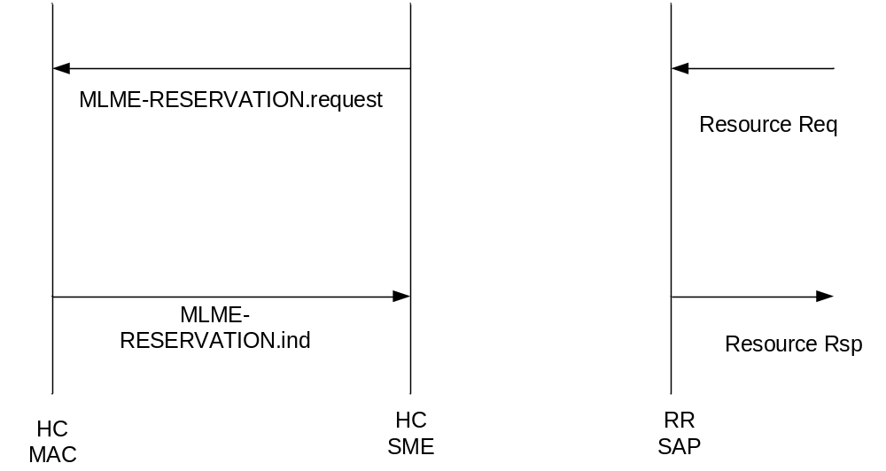
Figure 31 MLME-Reservation Request

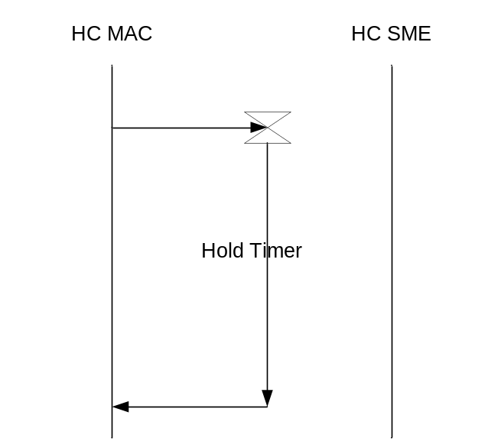
Figure 32 Traffic Stream Cleanup on Reservation Timeout

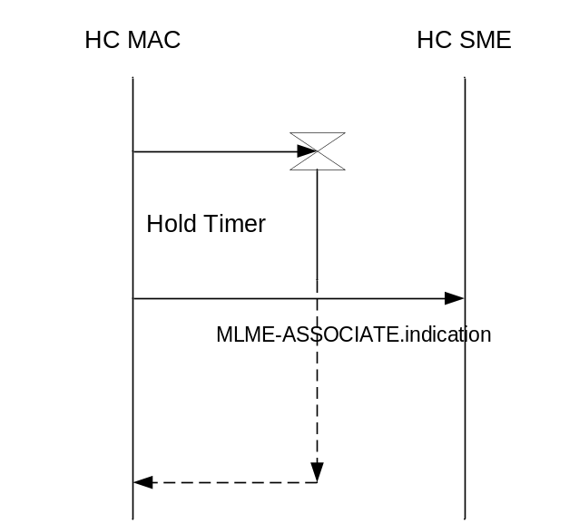
Figure 33 TS Active on successful Transition

RIC Usage for Pre-reservation

Constructing a RIC for Request
To reserve resources the station must create a RIC and insert it in the appropriate action message. The action message is then sent to the Current AP in case of over-the-DS request or to the target AP in case of over-the-air request. A RIC construction could be done if the resource reservation is to be done at the time of (re)-association.

- For constructing the RIC, the STA needs to consider the set of resources that the STA requires at the next AP. This set will structure the resource entities, such as TSPEC IEs, to be placed in the RIC, within RDIEs.
- Each RDIE may contain one or more individual resource entities, such as TSPECS. The RDIE mandatory bit, when set to 1, indicates that only one of the TSPECs within the same RDIE must be allocated for the resource reservation to be successful. The TSTA may not be able to transition when it’s RDIEs with mandatory bit set to 1 are not accepted.
- When multiple resource entities, like TSPECs, are inserted within the same RDIE, then this indicates that a logical “OR” realationship exists between those resource entities (TSPECs) within the same RDIE. Only one of these TSPECs, within an RDIE, need to be accepted.
- The RIC construction can be used in a resource request,and in (re)-association request messages.

RIC processing by the target AP
In case the RIC appears in a Resource Request, the AP shall attempt to allocate or check for allocatibility of one resource for each RDIE in the RIC in the order appearing in the RIC. The behaviour of the AP is described below:
- Select next RDIE (if none finish)
- Select first TSPEC after RDIE
- Check for allocatability/Attempt to allocate TS using TSPEC
- If succeeds go to step 1
- If fails -> is there another TSPEC for this RDIE?
- If yes, select next TSPEC and go to line 3
- If no, check state of Mandatory bit
- if clear go to line 1
- if set finish.
The AP keeps a list of which resources succeed and which fail to construct response message. If a mandatory resource fails, the AP need not process RDIEs that follow but may choose to do so in order to provide suggestions to the TSTA. If the request fails, no resources are actually allocated.
In case the RIC appeared in the Re-association message, before applying the above procedure, the AP needs to check if the resources have been previously allocated by a resource request.
This is possible by checking the sequence number in the RD IEs.

Interpreting RIC in the response message

The AP replies to the STA request with a response RIC where the RR IE identifier matches the request. The response RIC comprises the RRIE and one RDIE for each resource that the AP has assigned or attempted to assign. The RDIEs shall be in the same order as the request and include the original RIC_DATA sequence numbers. All RD IEs processed by the AP must be present. The “confirm” bit in the RDIE shall be set according to the result of the allocation request as follows:
Confirm = ‘1’ indicates that the resource has been allocated or could have been allocated. The RD IE will also be followed by TSPECs that got accepted.
Confirm = ‘0’ indicates that the resource could not be allocated. In this case the AP may optionally include a single TSPEC following the RDIE indicating a suggested TSPEC that could have been allocated. The TSPEC count field shall be set to ‘0’ or ‘1’ depending whether the suggested TSPEC is attached.
Absence of a RD IE in the response will indicate that the RD IE and related TSPECs were not considered by the AP.

Layer Management

MLME SAP Interface for Resource Reservation

MLME-Reservation.request

Function
This primitive is used to enact the security and QoS reservation method with a specified peer MAC entity.

Semantics of the service primitive
The primitive parameters are as follows:
MLME-Reservation.request (
PeerMACAddress,
Message Sequence Number,
Snonce,
Transition IE content,
RSN IE content,
Anonce,
Challenge,
ReservationItems,
MIC
)

Name | Type | Valid Range | Description
PeerMACAddress | MACAddress | Any valid individual MAC address | Specifies the MAC address of AP that is the intended immediate recipient of the reservation request.
Message Sequence Number | 8-bit unsigned integer | 1 or 3 | This value indicates which message in the reservation request protocol is to be generated.
Snonce | 64-bit unsigned integer | Any value | This is the nonce provided by the STA to be used in the key derivation.
Transition IE content
RSN IE content
Anonce | 64-bit unsigned integer | Any value | This is the nonce provided by the AP in message 2 to be used in the key derivation.
Challenge |  |  | This parameter is present only message 3.
ReservationItems |  |  | This parameter is present only message 3.
MIC |  |  | Message integrity check value computed on the content of the message. This parameter is present only in message 3.

When generated
This primitive is generated by the SME at a non-AP STA to send either the first or third frames of the reservation handshake.

Effect of receipt
Upon receipt of this primitive, the MLME constructs the appropriate authentication frame and causes it to be transmitted to the PeerMACAddress.

MLME-Reservation.indicate

Function
This primitive is used to enact the security and QoS reservation method with a specified peer MAC entity.

Semantics of the service primitive
The primitive parameters are as follows:
MLME-Reservation.indicate (
PeerMACAddress,
Message Sequence Number,
Snonce,
Transition IE content,
RSN IE content,
Anonce,
Challenge,
ReservationItems,
MIC
)

Name | Type | Valid Range | Description
PeerMACAddress | MACAddress | Any valid individual MAC address | Specifies the MAC address of the non-AP STA that is the source of the reservation request.
Message Sequence Number | 8-bit unsigned integer | 1 or 3 | This value indicates which message in the reservation request protocol is to be generated.
Snonce | 64-bit unsigned integer | Any value | This is the nonce provided by the STA to be used in the key derivation. This parameter is present only in message 1.
Transition IE content |  |  | This parameter is present only in message 1.
RSN IE content |  |  | This parameter is present only in message 1.
Anonce | 64-bit unsigned integer | Any value | This is the nonce provided by the AP in message 2 to be used in the key derivation.
Challenge |  |  | This parameter is present only message 3.
ReservationItems |  |  | This parameter is present only message 3.
MIC |  |  | Message integrity check value computed on the content of the message. This parameter is present only in message 3.

When generated
This primitive is generated by the MLME at an AP to indicate either the first or third frames of the reservation handshake has been received.

Effect of receipt
Upon receipt of this primitive, the SME examines the Transition IE and RSN IE contents and responds to the PeerMACAddress using the MLME-Reservation.response primitive.

MLME-Reservation.response

Function
This primitive is used to enact the security and QoS reservation method with a specified peer MAC entity.

Semantics of the service primitive
The primitive parameters are as follows:
MLME-Reservation.response (
PeerMACAddress,
Message Sequence Number,
Anonce,
Transition IE content,
RSN IE content,
KeyLifetime,
ReservationResponses,
MIC
)

Name | Type | Valid Range | Description
PeerMACAddress | MACAddress | Any valid individual MAC address | Specifies the MAC address of the non-AP STA immediate intended recipient of the reservation response.
Message Sequence Number | 8-bit unsigned integer | 2 or 4 | This value indicates which message in the reservation request protocol is to be generated.
Anonce | 64-bit unsigned integer | Any value | This is the nonce provided by the AP to be used in the key derivation. This parameter is present only in message 2.
Transition IE content |  |  | This parameter is present only in message 2.
RSN IE content |  |  | This parameter is present only in message 2.
KeyLifetime |  |  | This parameter is present only in message 2.
ReservationResponses |  |  | This parameter is present only in message 4.
ReassociationDeadline | 16-bit unsigned integer |  | The value of this parameter is the number of milliseconds before which the STA must initiate the reassociation with the AP, in order to expect that the reserved resources are still available. This parameter is present only in message 4.
MIC |  |  | Message integrity check value of the content of the message.

When generated
This primitive is generated by the SME at an AP to cause the transmission of either the second or fourth frame in the reservation handshake.

Effect of receipt
Upon receipt of this primitive, the MLME constructs the appropriate authentication frame and causes it to be transmitted to the PeerMACAddress. When the Message Sequence Number is 4, the AP shall reserve the bandwidth committed in the reservation responses for the number of seconds

MLME-Reservation.confirm

Function
This primitive is used to enact the security and QoS reservation method with a specified peer MAC entity.

Semantics of the service primitive
The primitive parameters are as follows:
MLME-Reservation.confirm (
PeerMACAddress,
Message Sequence Number,
Anonce,
Transition IE content,
RSN IE content,
KeyLifetime,
ReservationResponses,
MIC
)

Name | Type | Valid Range | Description
PeerMACAddress | MACAddress | Any valid individual MAC address | Specifies the MAC address of the non-AP STA immediate intended recipient of the reservation response.
Message Sequence Number | 8-bit unsigned integer | 2 or 4 | This value indicates which message in the reservation request protocol is to be generated.
Anonce | 64-bit unsigned integer | Any value | This is the nonce provided by the AP to be used in the key derivation. This parameter is present only in message 2.
Transition IE content |  |  | This parameter is present only in message 2.
RSN IE content |  |  | This parameter is present only in message 2.
KeyLifetime | 32-bit unsigned integer |  | This parameter is present only in message 2.
ReservationResponses |  |  | This parameter is present only in message 4.
ReassociationDeadline | 16-bit unsigned integer |  | The value of this parameter is the number of milliseconds before which the STA must initiate the reassociation with the AP, in order to expect that the reserved resources are still available. This parameter is present only in message 4.
MIC |  |  | Message integrity check value of the content of the message.

When generated
This primitive is generated by the MLME on receipt of either the second or fourth frame in the reservation handshake.

Effect of receipt
Upon receipt of this primitive, the SME examines the content of the message and either responds to the PeerMACAddress with the next message in the reservation sequence or completes its processing of the reservation request.

Updates to MLME-Reassociate

Change 10.3.7.1.2 as follows:

The primitive parameters are as follows:
MLME-Reassociate.request (
NewAPAddress,
ReassociateFailureTimeout,
CapabilityInformation,
ListenInterval,
SupportedChannels,
Snonce,
Anonce,
Transition IE content,
RSN IE content,
KeyLifetime,
ReservationItems,
MIC
)

Add the following rows to the table in 10.3.7.1.2:

Snonce | 64-bit unsigned integer | Any value | This is the nonce provided by the STA to be used in the key derivation.
Anonce | 64-bit unsigned integer | Any value | This is the nonce provided by the AP to be used in the key derivation.
Transition IE content
RSN IE content
KeyLifetime | 32-bit unsigned integer
ReservationResponses
ReassociationDeadline | 16-bit unsigned integer |  | The value of this parameter is the number of milliseconds before which the STA must initiate the reassociation with the AP, in order to expect that the reserved resources are still available.
MIC |  |  | Message integrity check value of the content of the message.

Change 10.3.7.3.2 as follows:

The primitive parameters are as follows:
MLME-Reassociate.indicate (
PeerTSTAAddress,
CurrentAPAddress,
CapabilityInformation,
ListenInterval,
SSID,
SupportedChannels,
Snonce,
Anonce,
Transition IE content,
RSN IE content,
KeyLifetime,
ReservationItems,
MIC
)

Add the following rows to the table in 10.3.7.3.2:

Snonce | 64-bit unsigned integer | Any value | This is the nonce provided by the STA to be used in the key derivation.
Anonce | 64-bit unsigned integer | Any value | This is the nonce provided by the AP to be used in the key derivation.
Transition IE content
RSN IE content
KeyLifetime | 32-bit unsigned integer
ReservationResponses
ReassociationDeadline | 16-bit unsigned integer |  | The value of this parameter is the number of milliseconds before which the STA must initiate the reassociation with the AP, in order to expect that the reserved resources are still available.
MIC |  |  | Message integrity check value of the content of the message.

Change 10.3.7.4.2 as follows:

The primitive parameters are as follows:
MLME-Reassociate.response (
PeerTSTAAddress,
ResultCode,
CapabilityInformation,
AssociationID,
Transition IE content,
ReservationResponses,
MIC
)

Add the following rows to the table in 10.3.7.4.2:

Transition IE content
ReservationResponses
MIC |  |  | Message integrity check value of the content of the message.

Change 10.3.7.2.2 as follows:

The primitive parameters are as follows:
MLME-Reassociate.confirm (
ResultCode,
CapabilityInformation,
SupportedRates,
AssociationID,
Transition IE content,
ReservationResponses,
MIC
)

Add the following rows to the table in 10.3.7.2.2:

Transition IE content
ReservationResponses
MIC |  |  | Message integrity check value of the content of the message.

Broker Function

A broker function in the TTAP is defined to facilitate policy enforcement and reservation request response co-ordination. The Broker Function is only invoked at the Current TTAP when an over-the-DS reservation request is to be performed. Following are the tasks performed by a Broker function:

- At the minimum, the BF shall re-format the reservation request from the SME for consumption by the RRSAP. Similarly, it shall be able to re-format the response from the RRSAP to send it to the SME.
- A BF may choose to apply any policy dependent processing on the reservation request before forwarding it to the RRSAP. A BF may, similarly choose to apply any policy dependent processing on the resource response before forwarding it to the SME..
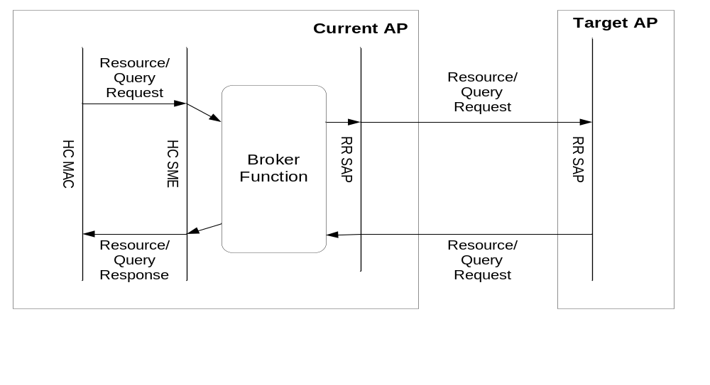
Figure 34 Broker Function for Over-the-DS Communication

Security

While the use of currently specified mechanisms such as pre-authentication can facilitate a BSS Transition, the implication is that the TSTA must have established a fresh PMK with each AP prior to association. The imposition of establishing a PMK by means of a full IEEE 802.1X EAP authentication can often be a time expensive operation that would prohibit a FAST BSS transition.

This section describes a new key hierarchy and its supporting architecture that enables Fast BSS transitions while obviating the need to have the STA (and each AP it transitions to) execute multiple IEEE 802.1X EAP authentications. Note however that while this new key hierarchy enables the optimal BSS transition, to ensure backward compatibility, TGr (this proposal) also supports all of the AKMs as defined by IEEE 802.11i.

Overview

To accommodate different 802.11 based network topologies, a four level key hierarchy is introduced to ensure key separation between each potential entity, called key holder, which are the authorized agents to hold the keying material. Multi-layer key hierarchy expedites the distribution of keys between the network entities prior to, or, during a transition.

As shown in Figure 35, each entity holding a key is identified by a 16 octet identifier, with the first level of the hierarchy (R0KH-ID) generating the PMK-R0 from either the PSK or from the resulting AAA-Key (per RFC 3748) from a successful 802.1X EAP Authentication between the AS and the SPA.

The lifetime of the keys is bound to the lifetime of the PSK or AAA-Key. For example, the RADIUS protocol communicates key lifetime through the Session-Timeout attribute. It is important to note that any keys derived from PMK-R0 cannot have a lifetime that is greater than its parent.

The TGr key hierarchy derives its keys using a new Key Derivation Function (KDF) as defined in Section 1.2.1 with separate labels to further distinguish derivations. Each level of the hierarchy derives keys for the level below it. The distribution of keys within the PMK key holders is outside the scope of the TGr PAR and thus is not discussed in this document. However, to ensure security, this new key hierarchy requires that keys only be distributed down the key hierarchy using a secure transport protocol.

R0 Key Holder
R0KH-ID
R1 Key Holder
R1KH-ID_{A}
R1 Key Holder
R1KH-ID_{B}
R2 Key Holder
R2KH-ID_{C}
R2 Key Holder
R2KH-ID_{D}
R2 Key Holder
R2KH-ID_{E}
R2 Key Holder
R2KH-ID_{F}
Authentication Server
(802.1X Authentication only)
BSSID_{G}
BSSID_{H}
BSSID_{I}
BSSID_{J}
AAA-Key or PSK
PMK-R1_{A}
PMK-R1_{B}
PMK-R2_{C}
PMK-R2_{D}
PMK-R2_{E}
PMK-R2_{F}
PTK_{G}
PTK_{H}
PTK_{I}
PTK_{J}
PMK-R0
Figure 35 TGr Key Hierarchy

As different entities, whether physical or logical, may hold keying material used to derive PTKs, the four level key heirarchy is enforced to ensure that compromise of such keying material is isolated to only that branch of the hierarchy. For example, the AAA server on which the top level key is established will be able to derive the keys used by every AP (in the hierarchy) and have the knowledge to decrypt any session on any AP. Thus, if the AAA server is compromised, then every key in the hierarchy is compromised and their resulting sessions must be deleted.

However, if the third level (R2KH in Figure 35) is compromised, only its corresponding key PMK-R2 and the keys derived from that PMK-R2 are compromised; only the sessions on APs using the keys derived from that PMK-R2 are compromised and must be deleted. Furthermore, since the key hierarchy lacks freshness, they must never be derived again from higher layer keys. For ease of implementation, APs may delete the higher layer keys to simplify its session states.

The mechanisms for ensuring keys are deleted and not derived again after a compromise in the key hierarchy is outside the scope of the TGr PAR and thus is not discussed in this document. However, to ensure that keys are not deleted without warrant, there should be some mechanism to ensure authorization for key distribution as well as key deletion.

Key Hierarchy

As shown in Figure 35, the TGr key hierarchy consists of four levels whose keys are derived using a new KDF described in Section 1.2.1. The key derivation hierarchy is shown in figure below.:
- PMK-R0 – the top level of the TGr key hierarchy; this key is derived as a function of the MSK and SSID and stored by the PMK-R0 key holder, R0-KH. This key is mutually derived by the SPA and the R0-KH and named by the SSID, SPA and R0-KH.

- PMK-R1 – the first level of the key hierarchy; this key is mutually derived by the SPA and the R1 Key holder, R1-KH. This key is named by the SPA, R0-KH and the R1-KH.

- PMK-R2 – the second level of the key hierarchy; this is mutually derived by the SPA and the R2 key holder, R2-KH. This key is named by the SPA, R0-KH, R1-KH and R2-KH.

- PTK – the last level of the key hierarchy that defines the 802.11 and 802.1X protection keys. The PTK is mutually derived by the SPA and the TTAP. This key is named by SNonce, ANonce, SPA and TTAP.

While TGr defines a four level key hierarchy; the last level ultimately results in a PTK to be consumed in the same manner as defined by 802.11i.

Authentication Server
PMK-R0 Key Holder
(R0KH-ID)
PMK-R1 Key Holder
(R1KH-ID)
PMK-R2 Key Holder
(R2KH-ID)
PTK
(held by AP & STA)
PMK-R0 = KDF-256 (MSK, “R0 Key Derivation” || SSID || SPA)
PMK-R1 = KDF-256( PMK-R0, “R1 Key Derivation” || R0KH-ID ||
R1KH-ID || SPA)

PMK-R2 = KDF-256( PMK-R1, “R2 Key Derivation” || R0KH-ID ||
R1KH-ID || R2KH-ID || AA || SPA)

PTK = KDF-XXX( PMK-R2, “PTKey derivation” || SNonce ||
ANonce || R0KH-ID || R1KH-ID || R2KH-ID ||
SPA || AA)

Figure 36 TGr Key Derivation Hierarchy

KDF
A new key derivation function is introduced to address sliding parameter vulnerabilities existing in the 802.11i PRF. The FT key derivation function is a variant of the 802.11i key derivation function and defined as follows:

Algorithm kdf

Output = KDF-Length( K, label, Context) where
Input: K, a 256 bit key derivation key
label, a string identifying the purpose of the keys derived using this KDF
Context, a bit string that provides context to identify the derived key
Length, the length of the derived key in bits
Output: a Length-bit derived key

result = “”
iterations = ⎡(Length+159)/160⎤
do i = 1 to iterations
result = result || HMAC-SHA1(K, i || label || 0x00 || Context || Length)
od
return first Length bits of result and securely delete all unused bits

In this algorithm, i and Length are encoded as 16 bit unsigned integers, represented using the bit ordering conventions of Clause 7.1.1.

PMK-R0
To ensure policy consistency in both security and QoS, the TSTA must roam across BSSID’s that retain the same SSID, security policy and similar QoS capabilities as the BSSID the TSTA is currently associtated with. Thus, the top level TGr Key Hierarchy key, PMK-R0 binds the SPA, top level key holder (R0KH-ID) and SSID with the keying material resulting from the negotiated AKM (e.g. the AAA-Key for 802.1X EAP authentication or PSK). The PMK-R0 is the top level 256 bit keying material used to derive the first level (PMK-R1s):

PMK-R0 = KDF-256(MSK, “R0 Key Derivation”, SSID || SPA)

The PMK-R0 is referenced and named as follows:

R0Name = SHA-256(PMK-R0 || “R0 Key Name” || SSID || R0KH-ID || SPA)

The entity that stores this key is typically the NAS that is identified by a 16 octet string referred to as the R0KH-ID. The R0KH-ID must be advertised by the TTAP in the beacons and probe responses.

Informative Note: the R0KH-ID may also be advertised by TGk but its definition for this is out of scope for this specification.

PMK-R1
The second level TGr Key Hierarchy, PMK-R1 is a 256 bit key used to derive the second level keys (PMK-R2). The PMK-R1 binds the SPA, top and second level key holders:

PMK-R1 = KDF-256( PMK-R0, “R1 Key Derivation”, R0KH-ID || R1KH-ID || SPA)

The PMK-R1 is referenced and named as follows:

R1Name = SHA-256(R0Name || R0KH-ID || R1KH-ID || SPA)

This level enables nework topologies where a device is connected to a NAS and to one or many APs and provides the facility of cacheing TSTA’s keys. The entity that stores this key is identified by a 16 octet string referred to as the R1KH-ID. The R1KH-ID must be advertised by the TTAP in the beacons and probe responses.

Informative Note: the R1KH-ID may also be advertised by TGk but its definition for this is out of scope for this specification.

PMK-R2
The second level TGr Key Hierarchy, PMK-R2 is a 256 bit key used to derive the PTK. The PMK-R2 binds the SPA, top, second and third level key holders:

PMK-R2 = KDF-256( PMK-R1, “R2 Key Derivation”, R0KH-ID || R1KH-ID || R2KH-ID || AA || SPA)

The PMK-R2 is referenced and named as follows:

R2Name = SHA-256(R0Name || R0KH-ID || R1KH-ID || R2KH-ID || AA || SPA)

The entity that stores this key is the TTAP’s 802.1X Authenticator and is identified by a 16 octet string referred to as the R2KH-ID. The R2KH-ID must be advertised by the TTAP in the beacons and probe responses.

Informative Note: the R2KH-ID may also be advertised by TGk but its definition for this is out of scope for this specification.

PMK Distribution Within a Security Mobility Domain
A mechanism has been defined for caching and distributing PMKs, using the above described logical key hierarchy. A TSTA first acquires PMK-R0 keys for use in fast transitioning ("first contact") via the SD of the AP with which it associated. This SD is part of an SMD, and this SMD may contain additional SDs. A TSTA may transition to any of the SDs within a SMD. The R1 Key Holders of the other SDs acquire PMK-R1 from the R0 Key Holder in the original SD.

This logical hierarchy is illustrated in figure below.

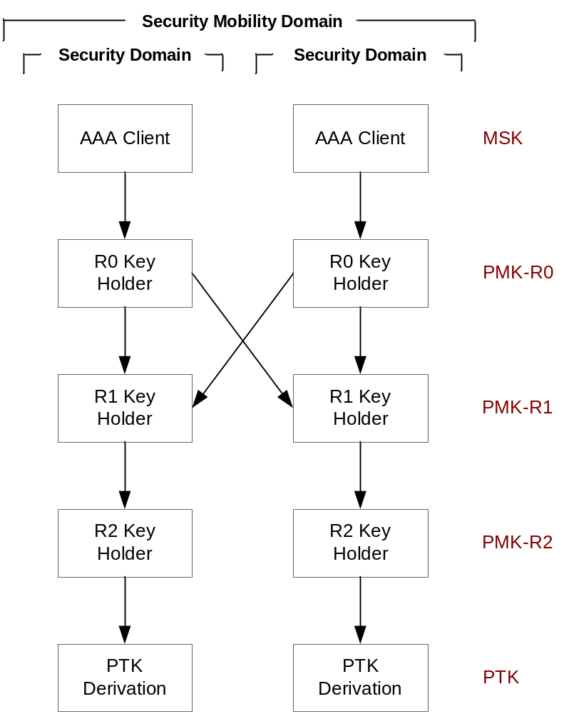
Figure 37: Key Distribution within Security Mobility Domain

When the 802.1X AKM is used to establish keys, the R0 Key Holder acquires PMK-R0 from AAA Client, which may be co-located with the R0 Key Holder or may be a separate device. When Pre-Shared Keys are used, the AAA Client is omitted and the R0 Key Holder uses an alternate means of acquiring PMK-R0 as a derivation of the PSK.

Each R0 Key Holder is responsible for deriving PMK-R1 and transmitting it to the appropriate R1 Key Holder in the SD with which the station is associated. This may be the SD of which it is a member, or it may be a different SD.

Each R1 Key Holder is responsible for deriving PMK-R2 and transmitting it to the appropriate R2 Key Holder in its own SD.

Each R2 Key Holder is responsible for conducting the negotiation with the station to derive the PTK.

PTK
The fourth level of the key hierarchy is the PTK. This key is mutually derived by the SPA and the TTAP with the key length being a function of the negotiated cipher suites as defined by 802.11i. Using the KDF construction defined in Section 1.2.1, the PTK derivation is as follows:

PTK = KDF-PTKLen(PMK-R2, “PTK Key derivation”, SNonce || ANonce ||
R0KH-ID || R1KH-ID || R2KH-ID || AA || SPA)

where
- KDF-PTKLen is the KDF function as defined in Section 1.2.1 used to generate a PTK of length PTKLen.
- PMK-R1 is the key that is shared between the SPA and the AA
- “PTK Key derivation” is the literal string consisting of the sequence of letters ‘P’, ‘T’, ‘K’, ‘ ‘, ‘K’, ‘e’,‘y’,‘ ’, ‘d’, ‘e’, ‘r’, ‘i’, ‘v’, ‘a’, ‘t’, ‘i’, ‘o’, and ‘n’ (no null terminator).
- SNonce is a 256 bit random bit string contributed by the SPA
- ANonce is a 256 bit random string contributed by the AA
- SPA is the STA MAC address
- AA is the AP’s MAC Address (BSSID).
- PTKlen is the total number of bits to derive, e.g. number of bits of the PTK. The length is dependent on the negotiated cipher suites as defined by 802.11i

Fast BSS Transition 802.1X EAPOL-Key frame
Fast BSS Transition 802.1X EAPOL-Key frames are used to exchange and protect selected information between TSTA’s supplicants and TTAP’s Authenticators. These EAPOL-Key frames follow the same format and convention as that defined by Clause 8.5.2 of 802.11i.

The following notation is used by this specification:

EAPOL-Key-FT(S, M, A, I, K, KeyRSC, ANonce/Snonce, MIC, RSNIE, GTK[N], TSIE, KeyLifetime)

where

S means the initial key exchange is complete. This is the Secure bit of the Key Information field in 802.11i.

M means the MIC is available in the message. This is the Key MIC bit of the Key Information field in 802.11i.

A means a response is required to this message. This is used when the receiver should respond to this message. This is the Key Ack bit of the Key Information field in 802.11i.

I is the Install bit: Install/Not install for the pairwise key. This is the Install bit of the Key Information field in 802.11i.

K is the key type: P (Pairwise), G (Group/STAKey). This is the Key Type bit of the Key Information field in 802.11i.

KeyRSC is the key RSC. This is the Key RSC field in 802.11i.

ANonce/Snonce is the Authenticator/Supplicant nonce. This is the Key Nonce field in 802.11i.

MIC is the integrity check, which is generated using the KCK. This is the Key MIC field in 802.11i.

RSNIE is the RSN information element. This is in the 802.11i Key Data field only on the first contact 4-way handshake.

GTK is the encapsulated GTK. This is in the 802.11i Key Data field.

N is the key identifier, which specifies which index should be used for this GTK.

TSIE This is in the 802.11i Key Data field only on the first contact 4-way handshake.

KeyLifetime is a 4octet value that defines the lifetime the FT key hierarchy. It is always present in the response messages transmitted from the TTAP to the TSTA. When this field is required, this value shall be the first value in the 802.11i KeyData field.

These frames are referred to as the FT EAPOL-Key frames as they convey more information, such as the KeyLifetime that is not currently conveyed in 802.11i. Furthermore, the MIC field may now protect data that is conveyed outside of the EAPOL-Key frame.

Annex Informative Section

Example Deployments using multiple SDs in an SMD
This logical hierarchy key hierarchy may be physically realized in a variety of ways. Some examples are provided below.

Controller Architecture
A centralized Controller that manages multiple APs may include the AAA Client, R0 Key Holder and R1 Key Holder.

Each AP managed by the Controller may be an R2 Key Holder. Alternatively, if the Controller is also the authenticator for the purpose of PTK derivation, the Controller will be the R2 Key Holder for each of its APs, and transmit the PTK to the AP, which serves as Data Termination point. It is also possible for Data Termination to be aggregated in the Controller, with the AP transmitting encrypted data between station and Controller.

Each Controller and its associated APs thus constitute an SD, and multiple Controllers may be associated with each other to form an SMD. When a station transitions to an AP managed by a different Controller, the new Controller acquires PMK-R1 from the Controller with which the station first established keys.

Standalone AP Architecture
A deployment may comprise multiple APs that are not managed by central Controllers. In this case, each AP comprises the AAA Client and R0/R1/R2 Key Holders.

Each AP constitutes an SD, and multiple APs may be associated with each other to form an SMD. When a station transitions to a new AP, the new AP acquires PMK-R1 from the AP with which the station first established keys.

Key Holder and SMD Naming

Each AP advertises the following names in its beacon and/or probe response:
- SMD-ID
- R0KH-ID
- R1KH-ID
- R2KH-ID

To ensure global uniqueness, the first three octets of an ID must be set to an Organizationally Unique Identifier (OUI). The remainder of the binary sequence is managed by the vendor named in the OUI as its own private namespace, within which it must guarantee uniqueness.

One option for selecting an ID is the MAC address of an interface of the device, zero-filled to 16 octets. Another option is to append 13 random octets to the OUI.

Typically, R2KH-ID might be set to the BSSID of the AP; however, this is not a requirement and there may be architectures in which R2KH-ID and BSSID are different values.

For key derivation and key naming purposes, R2KH-ID and R1KH-ID are always the names of the R2 and R1 Key Holders in the current SD which with the station is associated, and R0KH-ID is the name of the R0 Key Holder of the original SD in which the security association was established. Thus, R0KH-ID may or may not be the name of the R0 Key Holder of the current SD with which the station is associated.

Broker Function and Policies

A TTAP may choose to incorporate variety of policies in the Broker function. This provides a vendor some flexibility and control over the behavior it wants to mete to the resource reservation requests originating in its network. As mentioned earlier, however, a BF shall at least be able to relay the request to its local RRSAP and receive the responses from the RRSAP.

Over and above the minimal functionality a TTAP vendor may choose to impose certain restrictions and/or preferences by injecting some policy processing in the Broker Function.
Examples of this include:
- A BF may choose to limit the number of resource request/queries per STA..
- A BF may choose to spoof the over-the-DS resource allocation if it has knowledge of the overall system and can make decisions on behalf of the target TTAP.
- A BF may choose to introduce a bias in the responses, for various reasons like load balancing etc.
A BF may want to check for the mobility domain of the target APs before sending out request to the APs. The BF may reject one or more request if it has enough knowledge of the mobility domain to which the target APs belong

Transition Mechanism during Voice Flow

The figure below depicts a scenario where the FT proposal could be used. We assume that a 802.11 enabled station had associated with AP1.

- It orignites a voice call after reserverving air resources by using 802.11e enhancements (ADDTS etc ).
- The voice call singaling and the RTP path setup occurs while the phone is associated with AP1.
- During the voice-call the phone tries to “roam”.
- It finds that AP2 is a potential AP to roam to.
- It triggers a resource reservation mechanism.
- A FT association is initiated to roam to the new AP2
- The phone now connects to the back-end via AP2.

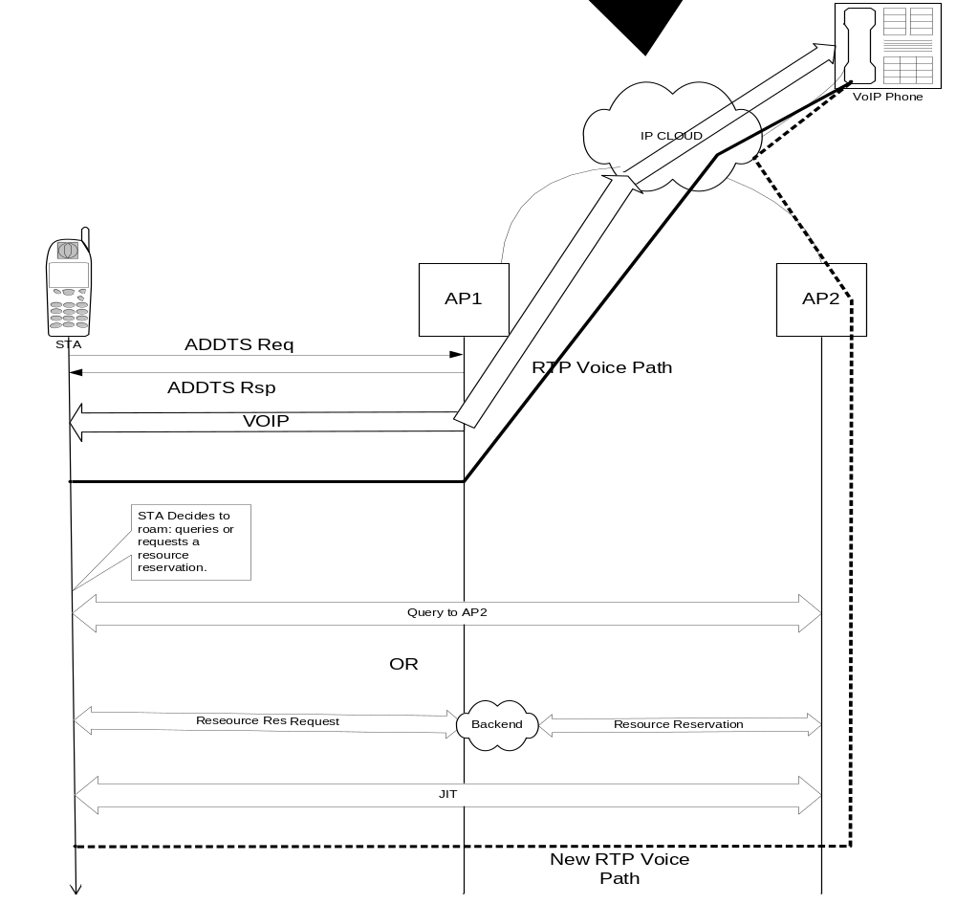
Figure 38 Transition Mechanism in a Voice Call Flow

