CID 171
Clarified this is not VR but rather the wearable display which have the same side effect as VR causing sickness. Wearable display with some kind of Augmented Reality. Are these for worker instruction?
Display in the glass which display the place of the error. When the head is moved the scene in the display also moves to update the scene and information displayed. This will cause sickness feeling if delay is slower than 10ms as per the VR presentation in March meeting.
We have already for worker instruction. Suggest to add work instruction with wearable device.
Add another red box called wearable devices with two applications worker instructions and xxx..

<Figure 9>

Option #1
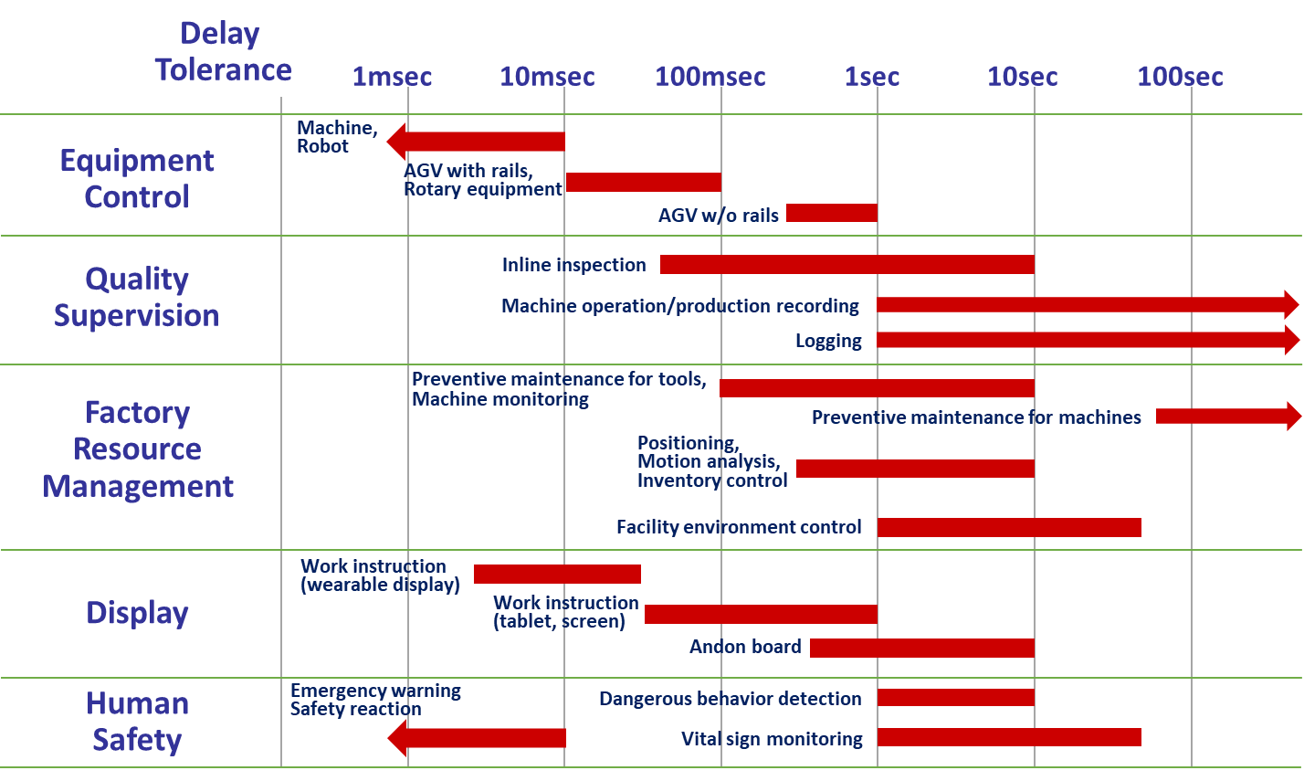

Option #2
