Comments to Figure 1.
CID 22 Replace the footnote (1 http://www.soumu.go.jp/main_content/000469037.pdf) with a proper citation.
CID 23 The graph shows a specific situation in a dedicated industry as the number of machines up to 5 years is 18.6% and between 5 and 10 is 24%. This is an extraordinary situation do not reflect the typical figure with more machines in earlier stages than in later stages.
CID 24 the years overlap - it is not clear which segment includes which machine age exactly
CID 25 The reference point to a japanese document
CID 26 There are different types of production machines - complex machines are not so old as estimated here

Within factory installations, sensors are attached to machines for the purpose of monitoring operations and preventive maintenance. According to a survey by Japan's Ministry of Economy, Trade and Industry , the lifetime of production machines is generally long and about 10.9% of them have been used for more than 30 years, as shown in Figure 1. In many cases, sensors usually continue to be used for long time once they have been introduced, resulting in coexistence of sensors and their communication interfaces in different generations as well as with existing machines.
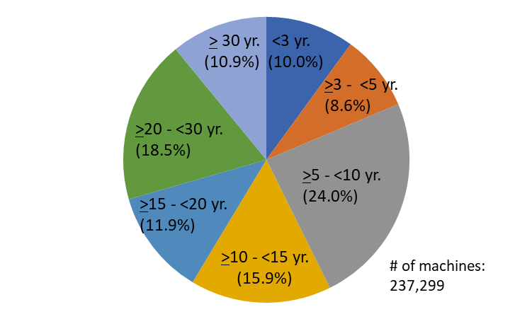
Figure 1 Share of production machines by age

Comments to “Scope & Purpose”
CID 31 Context of "Scope" seems to be mixed up with purpose.
CID 41 Scope needs to be edited for grammar and clarity.
CID 42 Purpose needs to be edited for grammar and clarity.

Scope
The scope of this report is use cases and communication requirements for wired and wireless bridged networks taking into consideration dense use of wireless devices and its operation in factory environment. Gap analysis from existing IEEE 802 standards and necessary technology enhancement are also covered in view of time-sensitive nature for the future.

Purpose
The purpose of this report is to understand an overview of issues and challenges in managing a reliable and time-sensitive connectivity in “Flexible Factory” scenarios where many and various equipment and devices coexist and attached to the wired network via wireless connections. The report also discusses technical analyses of the desired features and functions in wired and wireless IEEE 802 technologies for managing requirements in E2E network connectivity which can be used in an IEEE 802 standard solution based on time critical requirements for integrated wired and wireless connectivity within the factory environment.

Data were from a questionnaire survey for Japanese 1,033 factories by Ministry of Economy, Trade and Industry of Japan in 2013. Total number of machines was 237,299 in which grinders (12.5%), industrial robots (9.3%), automated assembly machines (8.8%), welding/fusing machines (8.7%), lathe machines (7.9%), press machines (6.7%), machining centers (5.5%), and others were investigated. http://warp.da.ndl.go.jp/info:ndljp/pid/10383604/www.meti.go.jp/press/2013/05/20130531001/20130531001-2.pdf

