Propose Revision of FFIOT Section of ‘Factory communication network environment’
Date: 2019-02-06
Author(s):
Name | Affiliation | Phone | email
Hao Wang | Fujitsu |  | wangh@cn.fujitsu.com

Abstract

This is a contribution to the IEEE 802 Network Enhancements for the Next Decade Industry Connections Activity (Nendica). It regards the FFIOT Work Item and comment resolution regarding the Call for Comments on the FFIOT Nendica Draft Report.

The contribution proposes revision of the section of Factory communication network environment. It is proposed for initial discussion at the Nendica conference call of 7 February 2019.

This document intends to address the following comments which all concern Figure 2 and surrounding texts.
- Comment 55: Page 3, line 16, “need more explanation about future, legacy and new machines integrated situation”
- Comment 83: Page 3, line 16, “The use of machine local management of communication is important for set up of machines. Thus, this sentence is not true for a feasible approach”

Propose Revision of the section ‘Factory communication network environment’

Factory communication network environment
Trends to introduce Internet-of-Thing (IoT) devices, such as sensors and cameras, in factories are accelerated by strong demand for improving productivity under the constraints of pressure for cost reduction. Digitalization of the factories as well as connection of information on production process and supply chain management within a factory and across factories becomes important. There is no doubt that factory communication networks will be changing for the next decade.
Figure 2 shows an example of network for a vehicle assembly line in factory today. The industrial control systems are extensively applied for industrial process control and operation. Such systems can range from a few modular panel-mounted controllers to thousands of field connections, as being the universal means of remote access to the enormous data provided by e.g. sensors, actuators, motors deployed in the field. The larger systems are usually implemented by Distributed Control Systems (DCS) or Supervisory Control and Data Acquisition (SCADA) systems, which manages Programmable Logic Controller (PLC) in the field. The entities labelled as ‘App x’ illustrate several system applications, e.g., preventive maintenance, management of materials and products, monitoring of movements and machine monitors, are supported in the factory network.
The factory network infrastructure primarily concerned with the communication between and within these components and systems. One of the essential differences between factory and commercial networks is that the physical devices connecting to the network are used to control and monitor real-world actions and conditions. This has resulted in an emphasis on a different set of Quality of Service (QoS).
Because of performance and other advantages, Ethernet has emerged as the dominant standard for the physical layer. Unlike serial protocols such as fieldbus, multiple higher layer protocols can run on the same Ethernet physical layer. It is fairly easy to interconnect several devices such as PLCs, HMI (Human Machine Interface), etc, remaining in high speed communication. Plus the deterministic features introduced by TSN, Ethernet are now taking over more shares at the high end markets.
But, much of the cost of installation of wired networks is for the wire itself. Installation of wires in a factory environment is costly. Future industrial factory networks are expecting to use more wireless to eliminate the installation cost, as well as to enhance the flexibility. By utilizing wireless communications, it is possible to collect useful information from IoT sensors, to flexibly allocate equipment such as cameras, and to analyze the status of humans and machines. It is an essential element that enables flexible layout of machines and order of manufacturing processes to adapt to variable-type, variable-volume production and mass customization.

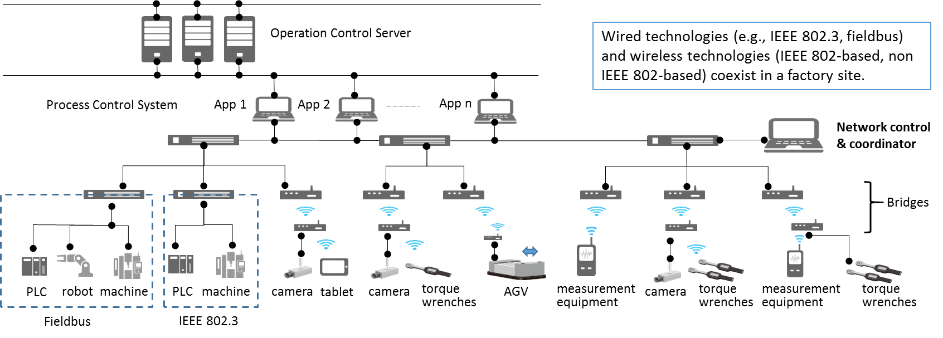
Figure 2 Example of network topology for a vehicle assembly line

The ability to transmit and receive data over a wireless link is not always going to work with the same degree of certainty as a wired link. More effort will be required for wireless communication because of its limited and shared radio resources and the sensitive nature of the environment in which it will operate in.
In order to configure, coordinate and maintain various QoS requirements end-to-end (E2E) over the heterogeneous network integrating wired and wireless interfaces, as the one in Figure 2, the network control and coordinator is required. The successful integration of wired and wireless systems is indispensable.

https://www.ffp-a.org/news/index.html

