CID245：Instead of a feedback line from PFC Receiver to Queuing management, there should be one feedback line from PFC Receiver to Transmission selection.

Correction as follows:

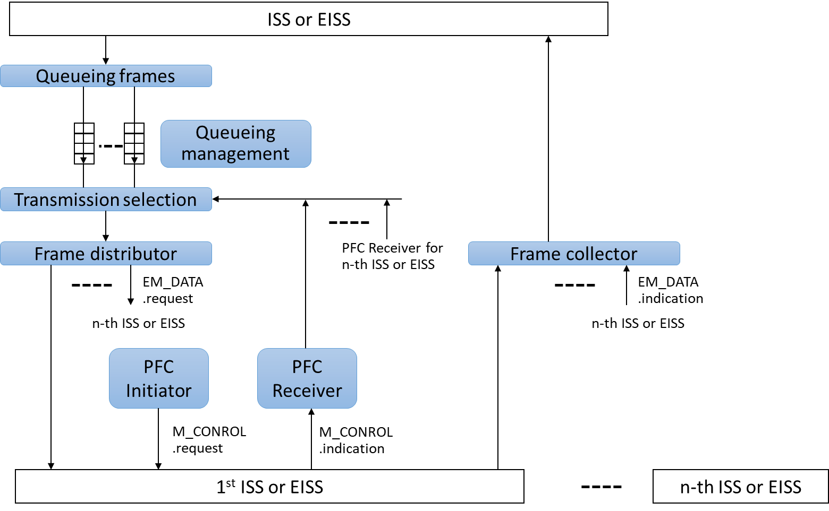
Figure 20 PFC aware system queue functions with Link Aggregation
(Rewritten Figure 36-4 in Std. 802.1Q-2014)

