Communication requirements
Figure 10 shows representative wireless applications with corresponding classifications (1)-(13) inform Table 1 and their wireless communication features. Values of data size, data generation rate, node density, and so forth are different for different systems in factories, and according to the required functions of the systems. They use different wireless frequency bands and wireless standards. High frequency bands such as 60 GHz band are expected to be effective for systems with relatively large data volume requirements (image inspection equipment, etc.). 5 GHz band and 2.4 GHz band are being used for systems with medium requirements of data sizes and data generation rate, such as distributing control programs and control of mobile equipment. Relatively low wireless frequency bands such as Sub-1 GHz are being used for applications with low power requirements (such as environmental sensing).

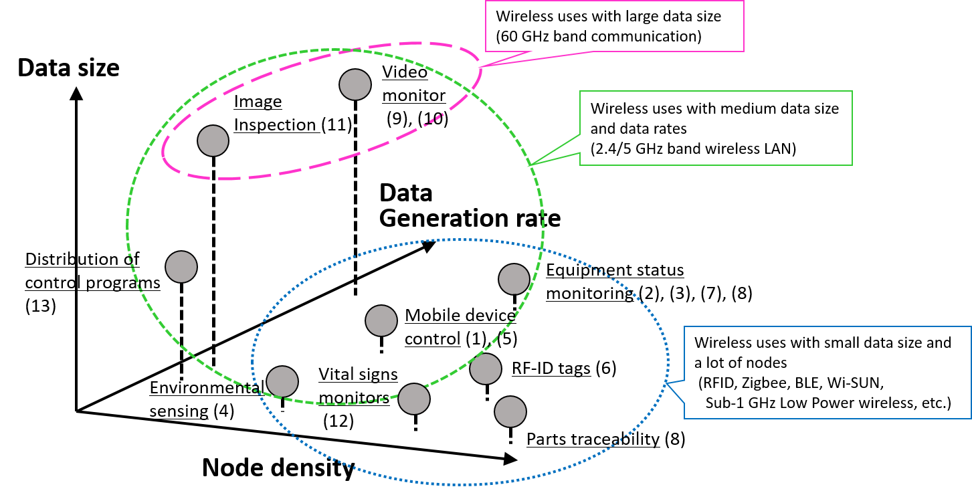
Figure 10 Representative wireless applications with corresponding classifications (1)-(13) from Table 1 and their wireless communication features

Usage scenarios example: Mechanical assembly site
A wireless usage scene at a mechanical assembly site is shown in Figure 13 as an example in automotive plant. In a mechanical assembly plant, the benefit of wireless communications is expected where management of building systems for collection and analysis of data for quality management and traceability, and management of operations, such as Automated Guided Vehicles (AGV) for transport of components.

Wireless communication is used to send data to servers - inspection data from large numbers of workbenches, operation sequences in Programmable Logic Controllers (PLC) used for machine control, error information and environmental information. Also, work tools such as torque-wrenches, acquire and send to servers data such as the number of wrench operations and the success of the operations, and even time series data such as vibration and torque waveforms. As ISO 9001 specifies the mandatory recording of inspection data, it requires the reliable collection of data, although strict requirements are not imposed on communication latency. Hence when transmitting data, it is necessary to check radio usage in the neighborhood, and use available frequency bands and time slots (transmission times) according to the requirements such as number of machines, transmitted data volume and necessity of real-time response.

In the case of production management display (such as an “Andon” display board), in coordination with the above information, wireless communication is used to send data for real-time display of production status information, such as production schedule, production progress and production line operation status.

In the case of AGV with autonomous driving ability, the AGV itself will be able to control its current position and path. Each AGV will be sent a command “go from position A to position B” from a parent device (fixed device) and the AGV will move accordingly. As an AGV may move over a wide area in a factory, it is possible that in some locations the quality of wireless communication will degrade due to physical obstruction by facilities and manufacturing machine tools. Hence, it is necessary to consider the radio propagation environment when deciding where to place wireless access points and to consider the use of multi-hop networks. The number of mobile vehicles used in factories is continuing to increase, and the related issues of the radio environment will require more consideration in the future.

In a modern automotive plant, the welding or painting process is usually located adjacent to the mechanical assembly. As such, IoT devices such as temperature, humidity and particle sensors are used for environmental monitoring in places such as paint-shops or clean-booths as shown in Figure 13. Wireless communication is used for collecting sensor information remotely at any time from outside the rooms where the sensors are installed without requiring reconstruction work. The sensors transmit collected environmental information to an upper layer server at periodic time intervals. It is required that no data loss occurs. As such, communication routes can be checked when necessary at times of trouble, and relay devices can be installed where radio signal reception is weak without complex expert knowhow.

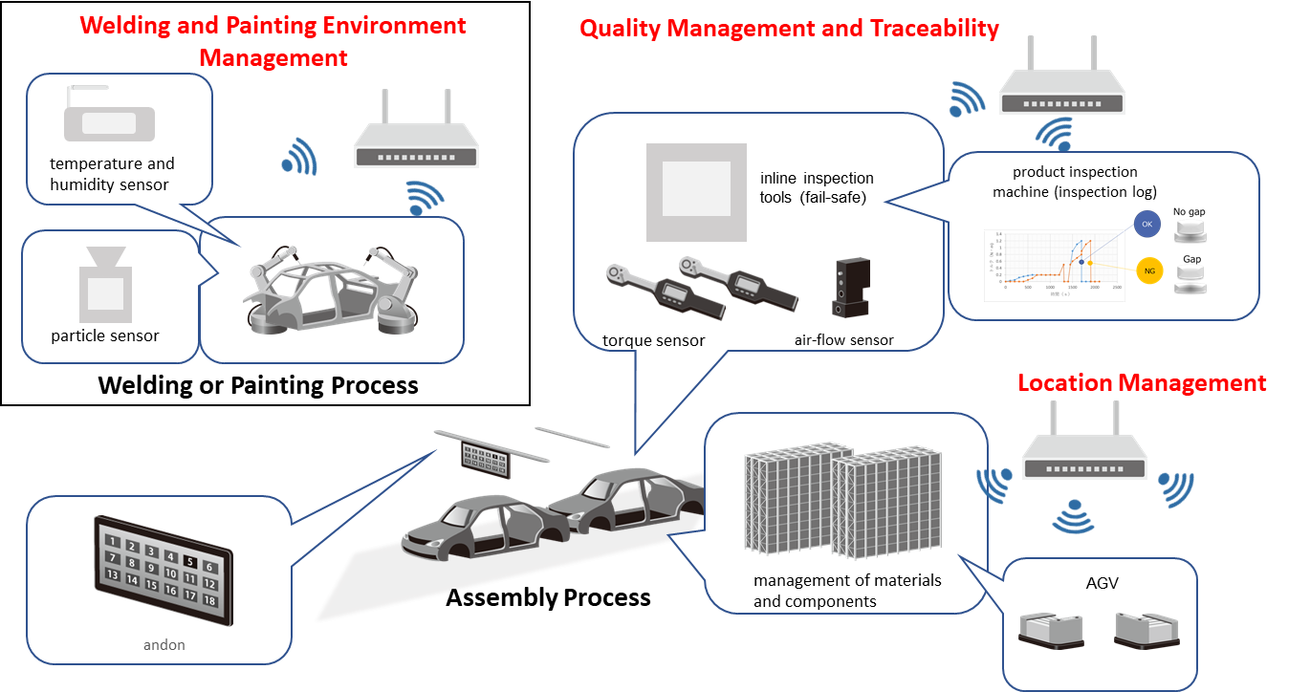
Figure 13 Usage scene example: Mechanical assembly site (automotive plant)

Lower-frequency radio waves propagate better than higher-frequency. It achieves better range, lower transmitting power, resulting in low power consumption. Environmental sensing which requires long life battery operation is a good example of low power applications. Lower-frequency band like Sub-1 GHz has become de fact standard for such applications." References: Sub-1 GHz long-range communication and smartphone connection for IoT applications http://www.ti.com/lit/wp/swry026/swry026.pdf, Sub-1GHz Radio The Best Solution for the Internet of Things? http://www.lprs.co.uk/about-us/news-and-events/rf-articles/sub1ghz-radio-solution-for-iot.html

