Wired/Wireless Use Cases and Communicatixon Requirements for Flexible Factories IoT Bridged Networkx

Radio Environment within Factories
Wireless commutations are not always difficult everywhere in factories. However, we have to consider that some applications require high-reliable, low-latency and low-jitter data transmission compared with other application in other places like offices and homes in general. Furthermore, the measurement results show that some factories are facing difficulties due to (a) severe environment for wireless communications, and/or (b) existence of uncoordinated and independent systems in the same space.

(a) The Severe Environment for Wireless Communications
There are two sources of impairment to radio signal within the factory environment that cause unpredictable variations to channel capacity, namely:
- Fluctuation of signal strength
- Electromagnetic interference
Followings are examples of such impairments observed within the factory environment.
Example of Fluctuation of signal Strength:
The layout of the environment for which measurements are made is shown in the Figure 3 below. Master and slave transceivers were located and there was no blockage by a vehicle, human body and any other objects in the line between the master and slave transceivers during measurement.
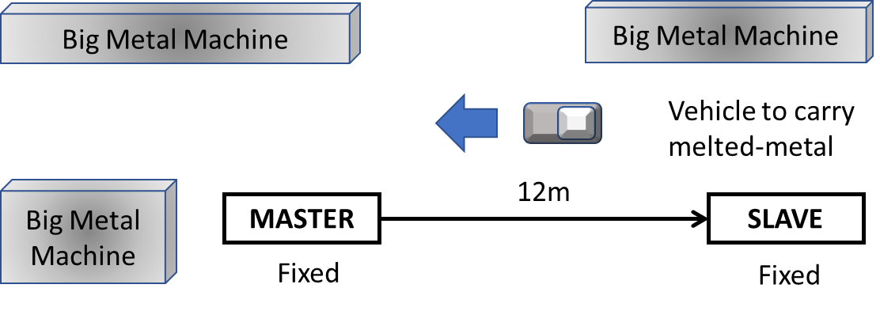
Figure 3 Layout in factory for which measurement of RSSI is recorded
The observed RSSI measurement for this layout is shown in Figure 4 below. The packet with 54Byte was sent at each sequential(Seq) number with 10-msec separation at a data rate of 6Mbps.
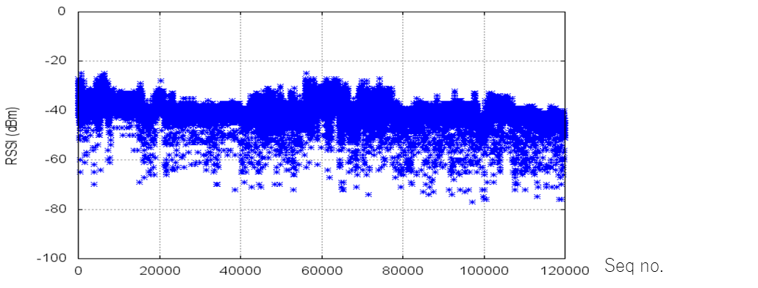
Figure 4 RSSI Fluctuation in Factory
This fluctuation in RSSI may be due to motions of materials, parts, products and carriers in closed space, with multi-path reflections as indicated in the NIST report on “Guide to Industrial Wireless Systems Deployments."
Example of Noises:
While carrying radio measurement within the factory environment considerable noise signals were observed within the 920MHz band. This is shown in Figure 5. The source of the noise was confirmed to be Automated Guided Vehicles (AGVs) with heavy load when it stopped.

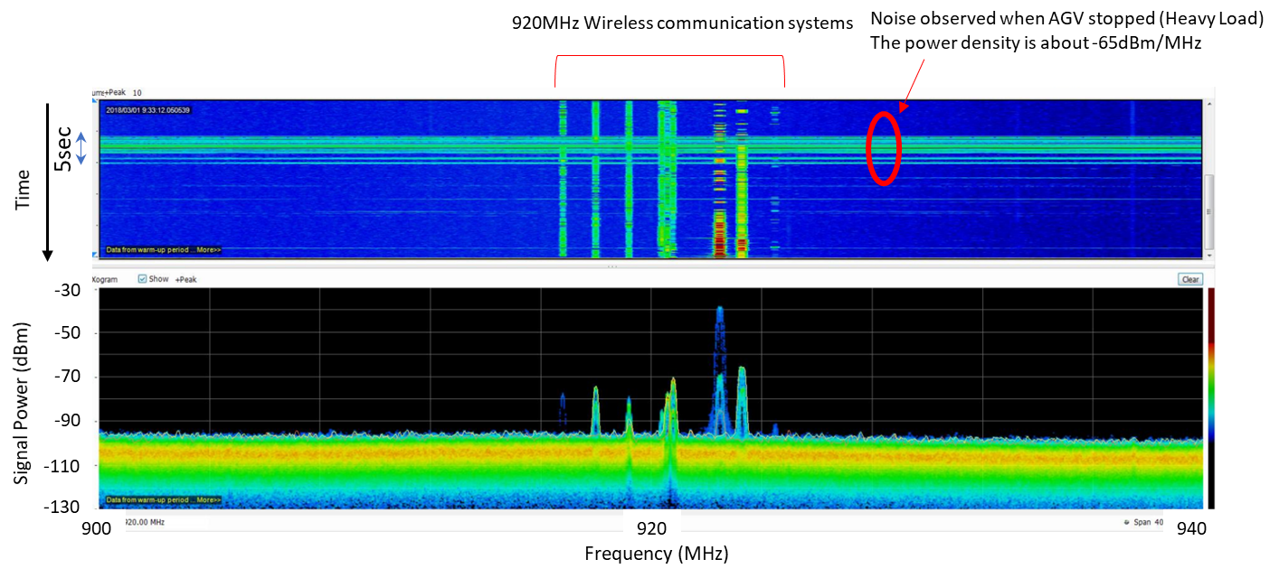

Figure 5 Measured noise spectral density within 920MHz band

The observed noise power was -65dBm/MHz which were above the receiving sensitivity for the 920MHz wireless systems. In the under 1 GHz band, the noise appears to cause problems for the communication with sensing systems using 920MHz band wireless communications.
The source of the noises is attributed to some kinds of manufacturing machines that are causing interference for wireless communications.

(b) Uncoordinated and Independent Systems
This issue within the factory environment is attributed to the progressive nature which leads to stepped approach of addition and installation of machines and equipment in the factory and due to coexistence of heterogeneous and legacy devices/systems used within the factory.
(Withdraw Figure 6 and associated text)

When considering the coexistence of uncoordinated wireless systems, we observe the problem of interference between the legacy wireless communications used by some machinery in the factory with the new systems using Wi-Fi. In a certain factory, there are many troubles of manufacturing systems after introduction of new system using Wi-Fi in their site. The cause of this trouble is that two manufacturing systems using wi-fi and legacy system using original communication protocol are interference each other. Currently there is only one way to avoid this problem that to assign two separate frequencies for two systems.
Figure 7 shows wireless signals observed in the existing factory site where two systems are coexist. The legacy system occupies one Wi-Fi channel even its frequency spectrum is narrow. However, there are only three Wi-Fi channels that they can use without interference in the 2.4GHz unsilenced band. Because there is no common scheme for collision avoidance among different communication protocols, an independent channel should be assigned to each system for stable factory operation. This constrains the number of wireless systems with different communication protocols to accommodate in the same frequency band and in the same site..
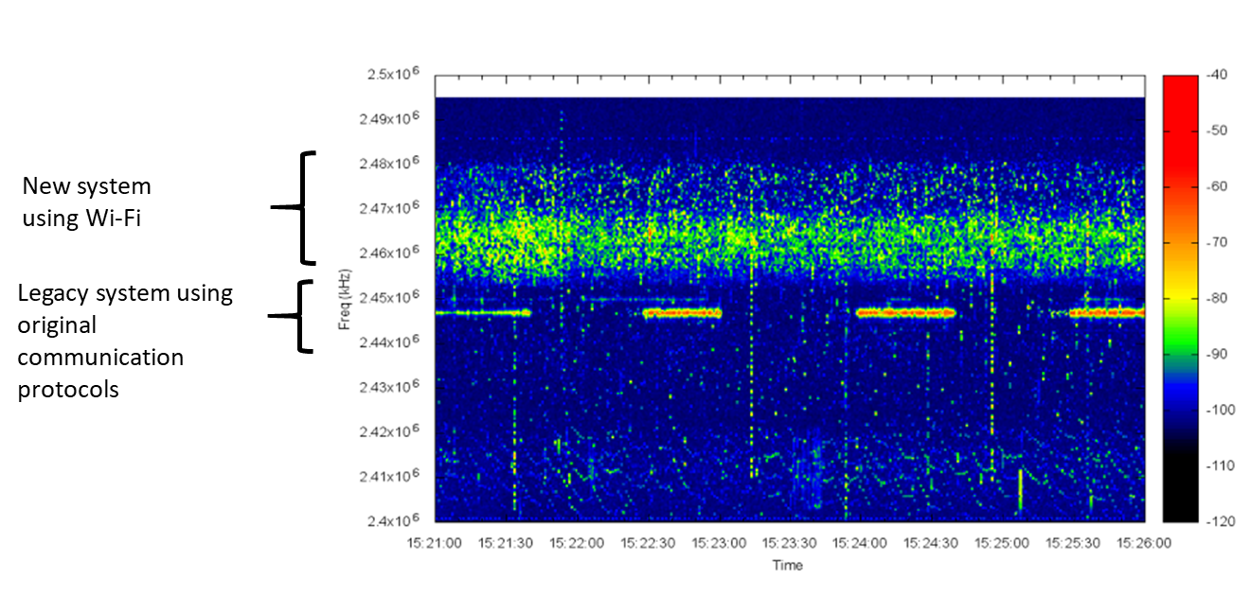
Figure 7 Wireless signals with coexistence of different wireless technologies. The vertical and horizontal-axes show frequency (Hz) and time, and color shows signal strength (dBm) in a bar on the right hand side..

(Withdraw Figure 8 and associated text)

