[Wired/Wireless Use Cases and Communication Requirements for Flexible Factories IoT Bridged Network]
IEEE-SA Industry Connections Report
IEEE | 3 Park Avenue | New York, NY 10016-5997 | USA

Wired/Wireless Use Cases and Communication Requirements for Flexible Factories IoT Bridged Network
Author [TBD]
and any other important
authoring details
Trademarks and Disclaimers
IEEE believes the information in this publication is accurate as of its publication date; such information is subject to change without notice. IEEE is not responsible for any inadvertent errors.

The Institute of Electrical and Electronics Engineers, Inc.
3 Park Avenue, New York, NY 10016-5997, USA

Copyright © 20xx by The Institute of Electrical and Electronics Engineers, Inc.
All rights reserved. Published Month 20xx. Printed in the United States of America.

IEEE is a registered trademark in the U. S. Patent & Trademark Office, owned by The Institute of Electrical and Electronics Engineers, Incorporated.

PDF: ISBN 978-0-7381-xxxx-x STDVxxxxx
Print: ISBN 978-0-7381-xxxx-x STDPDVxxxxx

IEEE prohibits discrimination, harassment, and bullying. For more information, visit http://www.ieee.org/web/aboutus/whatis/policies/p9-26.html.

No part of this publication may be reproduced in any form, in an electronic retrieval system, or otherwise, without the prior written permission of the publisher.

To order IEEE Press Publications, call 1-800-678-IEEE.
Find IEEE standards and standards-related product listings at: http://standards.ieee.org

Notice and Disclaimer of Liability
Concerning the Use of IEEE-SA Industry Connections Documents
This IEEE Standards Association (“IEEE-SA”) Industry Connections publication (“Work”) is not a consensus standard document. Specifically, this document is NOT AN IEEE STANDARD. Information contained in this Work has been created by, or obtained from, sources believed to be reliable, and reviewed by members of the IEEE-SA Industry Connections activity that produced this Work. IEEE and the IEEE-SA Industry Connections activity members expressly disclaim all warranties (express, implied, and statutory) related to this Work, including, but not limited to, the warranties of: merchantability; fitness for a particular purpose; non-infringement; quality, accuracy, effectiveness, currency, or completeness of the Work or content within the Work. In addition, IEEE and the IEEE-SA Industry Connections activity members disclaim any and all conditions relating to: results; and workmanlike effort. This IEEE-SA Industry Connections document is supplied “AS IS” and “WITH ALL FAULTS.”

Although the IEEE-SA Industry Connections activity members who have created this Work believe that the information and guidance given in this Work serve as an enhancement to users, all persons must rely upon their own skill and judgment when making use of it. IN NO EVENT SHALL IEEE OR IEEE-SA INDUSTRY CONNECTIONS ACTIVITY MEMBERS BE LIABLE FOR ANY ERRORS OR OMISSIONS OR DIRECT, INDIRECT, INCIDENTAL, SPECIAL, EXEMPLARY, OR CONSEQUENTIAL DAMAGES (INCLUDING, BUT NOT LIMITED TO: PROCUREMENT OF SUBSTITUTE GOODS OR SERVICES; LOSS OF USE, DATA, OR PROFITS; OR BUSINESS INTERRUPTION) HOWEVER CAUSED AND ON ANY THEORY OF LIABILITY, WHETHER IN CONTRACT, STRICT LIABILITY, OR TORT (INCLUDING NEGLIGENCE OR OTHERWISE) ARISING IN ANY WAY OUT OF THE USE OF THIS WORK, EVEN IF ADVISED OF THE POSSIBILITY OF SUCH DAMAGE AND REGARDLESS OF WHETHER SUCH DAMAGE WAS FORESEEABLE.

Further, information contained in this Work may be protected by intellectual property rights held by third parties or organizations, and the use of this information may require the user to negotiate with any such rights holders in order to legally acquire the rights to do so, and such rights holders may refuse to grant such rights. Attention is also called to the possibility that implementation of any or all of this Work may require use of subject matter covered by patent rights. By publication of this Work, no position is taken by the IEEE with respect to the existence or validity of any patent rights in connection therewith. The IEEE is not responsible for identifying patent rights for which a license may be required, or for conducting inquiries into the legal validity or scope of patents claims. Users are expressly advised that determination of the validity of any patent rights, and the risk of infringement of such rights, is entirely their own responsibility. No commitment to grant licenses under patent rights on a reasonable or non-discriminatory basis has been sought or received from any rights holder. The policies and procedures under which this document was created can be viewed at http://standards.ieee.org/about/sasb/iccom/.

This Work is published with the understanding that IEEE and the IEEE-SA Industry Connections activity members are supplying information through this Work, not attempting to render engineering or other professional services. If such services are required, the assistance of an appropriate professional should be sought. IEEE is not responsible for the statements and opinions advanced in this Work.

Contents
Introduction (Level one heading appear in a darker blue) 1
History and values (example of Heading 2) 1
Another example of Heading 2 1
Heading 3 example 1
Heading 3 example 1
Conclusions 1
Citations 1

Wired/Wireless Use Cases and Communication Requirements for Flexible Factories IoT Bridged Network

Introduction (Level one heading appear in a darker blue)

Communication used in factories has until now been mainly wired communication, which has been preferred for its reliability. However, in recent years the shorter times of product development cycles demands greater flexibility in the layout of machines and sequence of processes,, and there are increasing expectations for the use of radio links amongst of the sensors and machines used in the manufacturing and factory processes.
This report is developed under the IEEE 802 Network Enhancements for Next Decade Industry Connections Activity (NEND-ICA). It addresses the integration and bridged wired and wireless IoT communications in the factory environment. The report includes use cases and requirements within the factory wireless environment. It presents problems and challenges observed within the factory and reports on feasibility of some possible solutions for overcoming these issues. Areas that may benefit from standardization are highlighted.

Roger thinks the following text should be removed out of the introduction. I can agree with that. But the rest the text “Material supporting the development …” can be maintained as it is one of the key scope of NEND and it is one of the key objectives of this report. If necessary we can edit to make general and not to pre-judge the outcome. As such deleted the target WG for the new PAR.

[leading towards a proposal to initiate new standards development makes the case for a new project. Material supporting the development of a new PAR is included in this report. ]
The report analyses the factories environments considering its foreseen evolution that includes dense radio devices utilization. It summarizes wireless use cases and their communication requirements which are obtained based on information gathered from literature and factories survey.
The report then presents an underlying End to End network architecture which encompasses the operation and control of the various services in the factory network according to their dynamic QoS requirements. It analyses the applicable standards and features in wired and wireless IEEE 802 technologies for managing requirements in End-to-End (E2E) network connectivity and TSN profiling for converged wired and wireless connectivity in factory environment.

[Old Overview duplicate with the above text and needs to be converged:
Communication used in factories has until now been mainly wired communication, which has been preferred for its reliability. However, in recent years the shorter times of product development cycles demands greater flexibility in the layout of machines and line construction, and there are increasing expectations for the use of wireless communications.
The report addresses the converged and bridged wired and wireless Internet of Things (IoT) communications in the factory environment. It analyses factory environment considering its foreseen evolution that includes dense radio devices utilization. It gives summary of use cases and requirements within the factory wireless environment which are obtained based on information gathered from literature and factories survey. It presents problems and challenges observed within the factory’s network and reports on feasibility for overcoming these issues leading towards potential project(s) for new standard(s) development. ]

Scope
The scope of this report is to capture current and future network requirements taking into consideration dense use of radio devices and its operation in factory environment. The report presents analysis of issues and challenges identified in maintaining reliable and time sensitive/constraint deliverable of control messages and data traffic across wired and wireless bridged network within the identified factory environment. Also to present analysis of applicable standards and features in wired and wireless IEEE802 technologies for managing requirements in E2E network connectivity.

Roger questioned the use of “bridged” network. The use of bridges in the factory network is quite common since multiple LAN wired and wireless with different segments which are generally bridged. Updated figure 3-1 that shows bridges used within the factory network

Purpose
The purpose of this report is to present an overview of issues and challenges in managing a reliable and time sensitive connectivity in E2E wired and wireless network characterized by dense radio devices installation and noisy factory environment. The report will also present technical analyses of the applicable features and functions in wired and wireless IEEE802 technologies for managing requirements in E2E network connectivity which can be used in an IEEE 802 standard solution based on TSN profiling for converged wired and wireless connectivity within the factory environment.

Definitions

Factory Overview and Operation environment

Factory communication network environment
Recent trends to introduce IoT devices, such as sensors and cameras in the factories are accelerated by strong demand for improving productivity under the constraints of decreasing works in aging population society and pressure for cost reduction. Digitalization of the factories as well as connection of information on production process and supply chain management within a factory and across factories becomes important. It is no doubt that commutation networks will be changing in factories for the next decade.
There are several system applications, e.g., preventive maintenance, management of materials and products, monitoring of movements and machine monitors which are integrated in the network. Future industrial network for a factory may consist of wired and wireless bridges for such systems above. The successful integration of wired and wireless systems is indispensable and more efforts will be required for wireless communication because of its narrow bandwidth and sensitive nature of environment. A multi layers network architecture is required in order to configure, coordinate radio technologies coexistence and manage the end to end flows and streams as illustrated in the following Figure 1.
Need to insert here a figure for the factory multi layers network architecture taken from one of the presentations made earlier in IEEE802.1 illustration E2E flow management and coordination of radio technologies used within the factor.
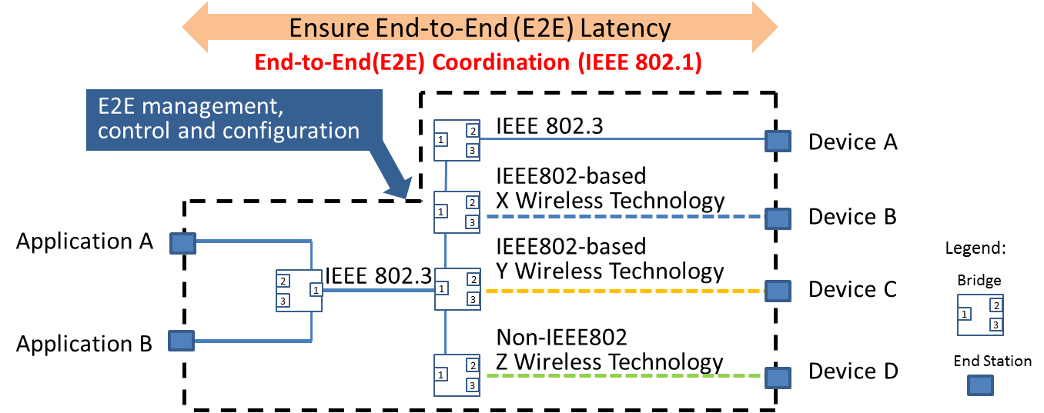
Figure 1 Example of Network Topology in Factory Environment

End-to-End (E2E) network topology for a factory today is configured by combination of wired LAN, such as 802.3, IEEE802-based and non-IEEE802 wireless technologies.
In order for factory IoT system to work well, a higher layer End to End coordination system is needed to configure, manage, and control data frames/streams that are transported in a mix of different technologies with varying QoS performance and attributes.

Traditionally, wireless communications have not been popular in the manufacturing field. There are still many stand-alone machines managed manually by skilled workers. Advanced factories, on the other hand, have been using communication networks called fieldbus, a type of wireline network. One of the reasons wireless commutations have not been used extensively in factories is because there are doubts about their stability and reliability. Technology developments as well as standardization are keys to success for wireless utilization. If these efforts are proven successful, wireless use for IoT connectivity in factory will increase resulting in more flexibility in the manufacturing process and improved productivity within the factory environment.
Note from the review during OmniRAN meeting in Geneva January 2018:
A figure or text explaining the need in the current network configuration used within typical factory and how the expansion of radio LAN or radio nodes within the wired network will require maintaining certain QoS requirements in the radio domain. It should also show the enhancement by introducing TSN functionality into the factory network.
One of the main considerations within the factory network is the need for the provisioning of QoS for large number of M2M type of data generated from many sensors at the same time with different priority-classes. These data types are periodic in nature and have relatively short packet size.
When the factory network is extended over radio, some incompatibility in QoS provisioning between wired and wireless segments become apparent. The first is due to dynamic variations in the available bandwidth (capacity and throughput) over the radio segment as results of the non-deterministic noise/interference, distortions and fading. These dynamic variations cause congestion not just because overloading of the data streams but also because of the wireless link quality deterioration. Under such conditions, the current protocols may not function properly.
Therefore, for the successful factory automation with high degree of flexibility, dynamic management and control of end-to-end streams/frames across mixed wired and wireless links required some kind of coordination at the higher layer is necessary as illustrated in Figure 1 above.
Impact of applying QoS and Time Synchronizations functions and protocols to heterogeneous factory network with mixed wired and wireless links in factory network is further analyzed in section 6 with potential and possible solutions discussed. But first, details of the environment and cause of impairments and distortions to radio signals within the factory environment are presented next.

Radio Environment within Factor
It is true that wireless commutations are not always difficult everywhere in factories. However, we have to consider that some applications require high-reliable, low-latency and low-jitter data transmission compared with other application in other places like offices and homes in general. Furthermore, the measurement results have revealed that some factories are facing difficulties coming from (a) severe environment for wireless communications, and/or (b) existence of uncoordinated and independent systems in the same space.
(a) The Severe Environment for Wireless Communications
There are two source of impairment to radio signal within the factory environment that cause unpredictable variations to channel capacity, namely:
- Fluctuation of signal strength
- Noises
As follows are examples of such impairments observed within the factory environment.
Example of Fluctuation of signal Strength:
TA layout of the environment for which measurements are made is shown in the figure below. Master and slave transceivers were located in LOS condition and there was no blockage during measurement.
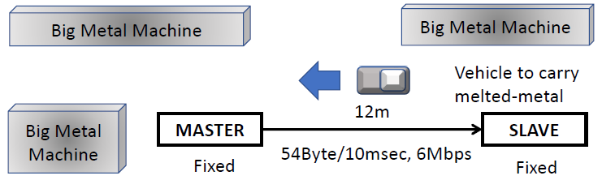
Figure 2 Layout in factory for which measurement of RSSI is recorded

The observed RSSI measurement in LOS condition is shown in figure 3 below.
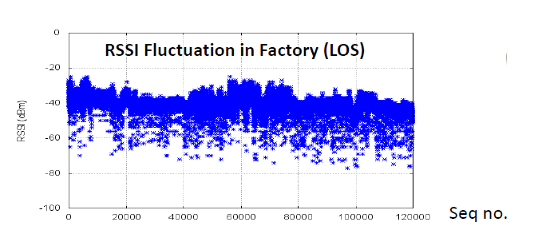
Figure 3 RSSI Fluctuation in Factory (LOS)

This fluctuation in RSSI is due to motions of materials, parts, products and carriers in closed space.
Example of Noises:
While carrying radio measurement within the factory environment strong noise signals were observed within the 1.9 GHz band and the 2.4 GHz band. These are shown in Figure 4.

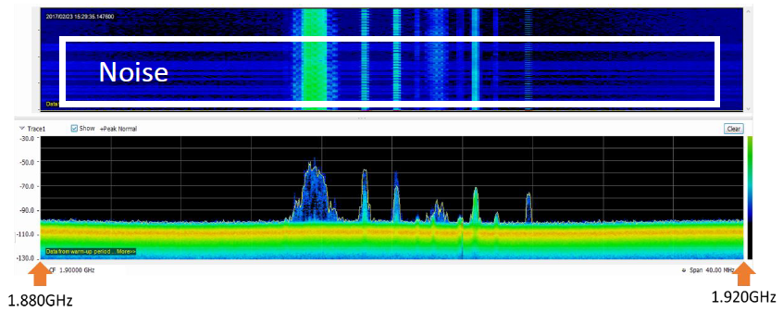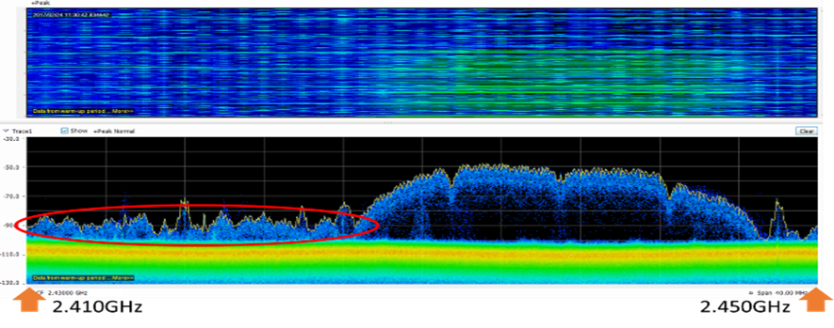

- 1.9 GHz band (b) 2.4GHz band

Figure 4 Measured noise spectral density within
(a) 1.9 GHz band and (b) 2.4 GHz band

In the 1.9 GHz band, the noise appears to cause problems for the communication with particular machines as well as problem for using the 1.9GHz band for internal telephone system.
The source of these noises is attributed to some kinds of manufacturing machines that are causing interference for wireless communications.
(b) Uncoordinated and Independent Systems
This issue within the factory environment is attributed to the progressive nature which leads to stepped approach of addition and installation of machines and equipment in the factory and due to coexistence of heterogeneous and legacy devices/systems used within the factory.
An example of using wireless technology in the factory is shown in Figure 5.
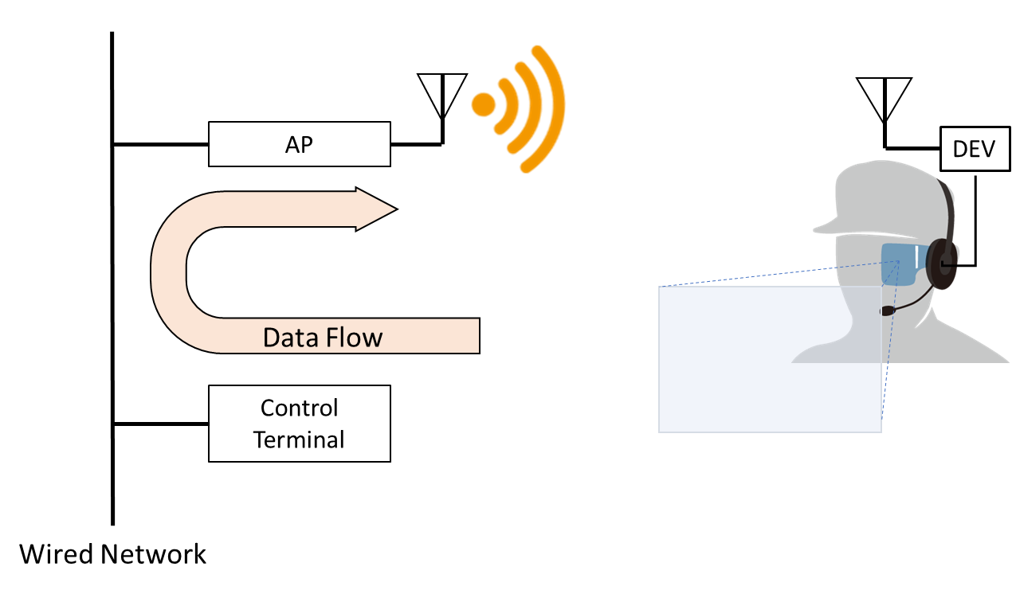
Figure 5 video monitor application as an example of using wireless technology

In this example it illustrates an application in which the data flow across the wired network and bridged across to the wireless domain. In this application there are QoS requirements and latency constraints for both the video signal and the control signal. Potential problem is a bottleneck for which delay or uncoordinated signal flow may occur due to disturbance and/or degradation in the radio signal.
When considering the coexistence of uncoordinated wireless systems, we observe the problem of interference between the legacy wireless communications used by some machinery in the factory with the new systems using Wi-Fi. The overlapping of signal causing potential interference is illustrated in Figure 6.
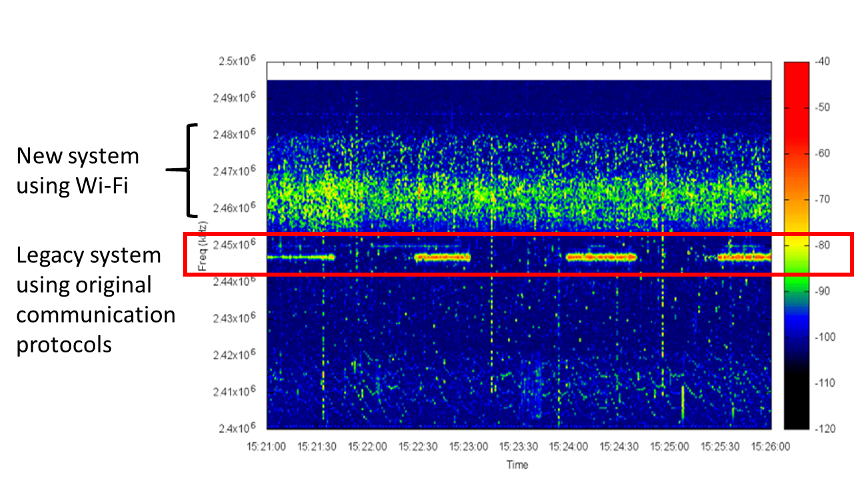
Figure 6 Coexistence of different wireless technologies

Some of the problems observe relates to the packet delivery delay. Figure 7 shows packet loss and packet delivery delay with different interference level. The packet latency increased from 8ms in case of no interference to around 2 second in the presence interference due to lack of coordination amongst the used wireless systems used in the factory.
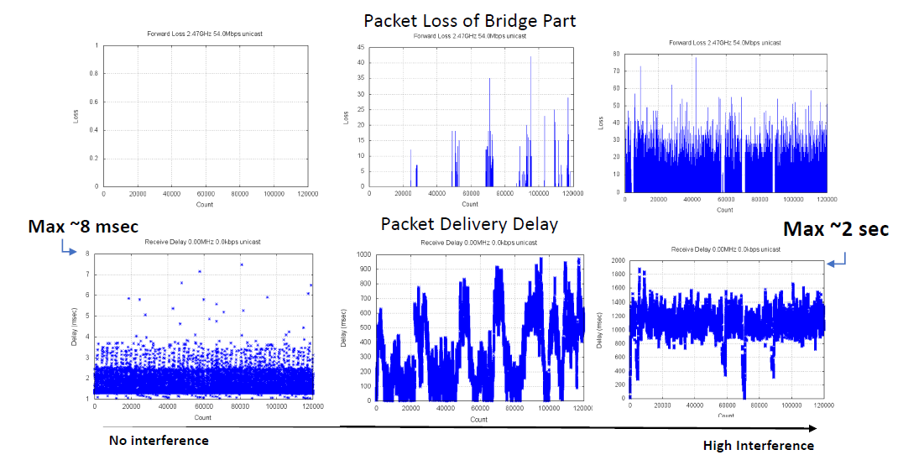
Figure 7 Impact of interference on latency in uncoordinated wireless systems

In this document, wireless applications and communication requirements are described to understand what shall be improved and enhanced for successful convergence of wired and wireless systems.

Wireless applications and communication requirements

Scope of wireless applications in factory
The wireless applications considered in this clause illustrate the use of wireless systems that are currently used –or will be used soon - in factories and factory related facilities. The applications correspond to wireless systems that are installed for specific purpose.
For example, wireless systems shown in Figure 8, there are individual systems (within the dotted lines) introduced for specific purposes such as “Collecting Management Information”, and a wireless network consisting of multiple such wireless systems and transmitting information aggregated by them. In this case, each individual system corresponds to a wireless application and described in following sub sections, but not the whole wireless network. That is, each wireless segment is considered as a separate application.

Section 5 considers actual factory sites with large needs for wireless communication and describes usage scenarios where multiple wireless applications coexist.

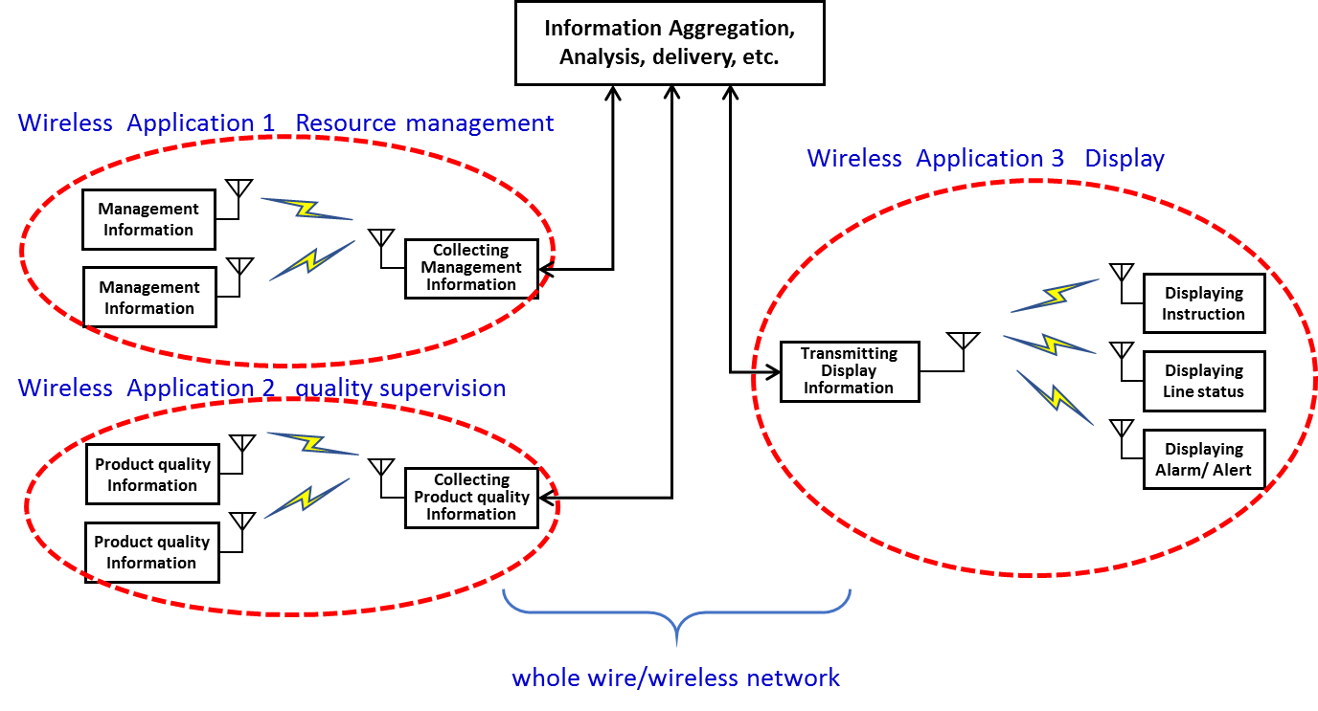
Figure 8 Scope of wireless applications in factory

Wireless applications
In our usage survey of wireless communication in factories, we collected various applications. We classified them according to their purposes, and organized their communication requirements. List of collected wireless applications are shown in Table 1. They were divided into six categories (equipment control, quality supervision, resource management, display, Human safety, and others) and then subdivided into thirteen [three] classifications according to their corresponding purposes.

Table 1 Wireless applications

Category | Description | Classification according to the purpose
Equipment Control | sending commands to mobile vehicles, production equipment | - Controlling, operating and commanding of production equipment, auxiliary equipment
Quality Supervision | collecting information related to products and states of machines during production | - Checking that products are being produced with correct precision  - Checking that production is proceeding with correct procedure and status
Factory Resource Management | collecting information about whether production is proceeding under proper environmental conditions, and whether personnel and things contributing to productivity enhancement are being managed appropriately | - Checking that the production environment is being appropriately managed  - Monitoring movement of people and things  - Checking the management status of equipment and materials (stock)  - Checking that the production equipment is being maintained  - Appropriate recording of work and production status
Display | For workers, receiving necessary support information, for managers, monitoring the production process and production status | - Providing appropriate work support  - Visually display whether the process is proceeding without congestion or delay  - Visually display the production status
Human Safety | collecting information about dangers to workers | - Ensuring the safety of workers
Other | Communication infrastructure with non-specific purposes | - Cases other than the above

communication requirements
[The communication requirements of each wireless applications are shown as the following parameters - mobility, number of terminals in the factory, density of terminals, average number of terminals influencing at a location, transmission data size, regularity of communications, communication frequency, delivery time tolerance, tolerance jitter, communication range, wireless terminal (master station) height, wireless terminal (sub-station) height, communication standard, frequency band and network topology.]
Figure 9 shows representative wireless applications and their features of wireless communication. Values of data size, data generation rate, number of wireless nodes, and so forth are different for different systems in factories, and according to the required functions of the systems, they use different wireless frequency bands and wireless standards. High frequency bands such as 60 GHz band are expected to be effective for systems with relatively large data volume requirements (image inspection equipment, etc.), 5 GHz band and 2.4 GHz band are being used for systems with medium requirements of data sizes and data generation rate, such as distributing control programs and control of mobile equipment, and relatively low wireless frequency bands such as 920 MHz band are being used for applications with low power requirements (such as environmental sensing).

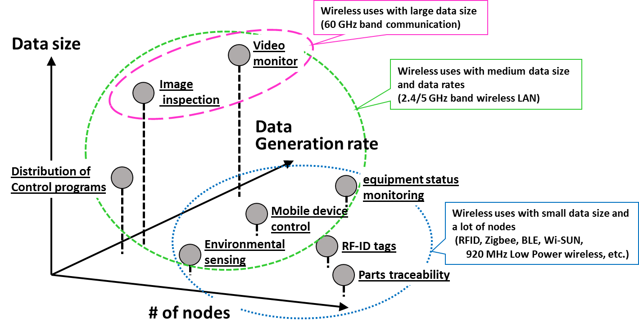
Figure 9 Representative wireless applications and their features of wireless communication

Figure 10 shows the permissible delay for representative wireless applications. There are wireless applications, such as robot control and urgent announcements, for which the urgency and accuracy of information arrival timing requires less than one millisecond latency. On the other hand, particularly in the categories of quality (inline inspection, etc.) and management (preventive maintenance, etc.), there are many wireless applications that tolerate latencies larger than hundred milliseconds.

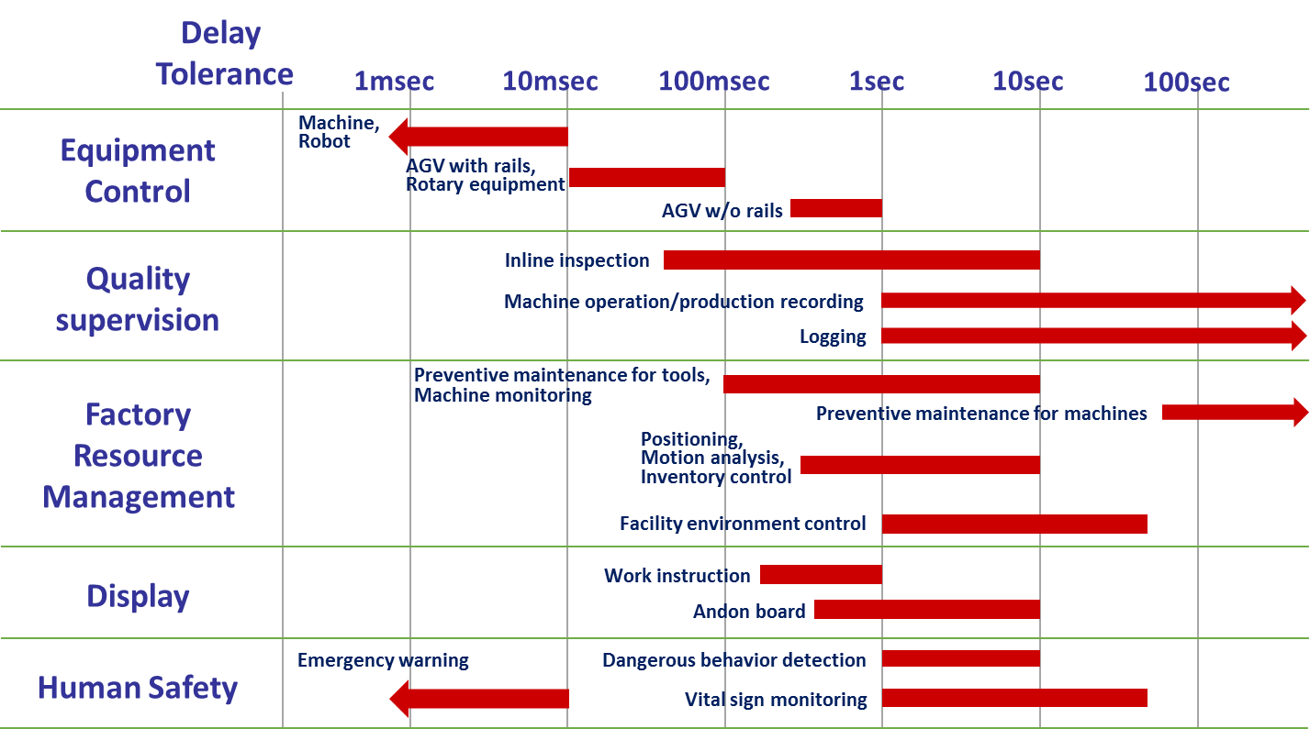
Figure 10 Permissible latencies of representative wireless applications

Details of wireless application and communication requirements

Communication requirements for the thirteen classifications of three selected wireless applications are organized in Table 2 to 14.
Each table contains further detailed purpose of the wireless application, corresponding information, and the communication requirements of transmitted data size, communication rate, and delivery time tolerance.
Table 2 below shows an example of “List of wireless applications and communication requirements”. More will be added later…
Table 2 classification (2) Checking that products are being produced with correct precision
 | Category | Purpose | corresponding Information | Data Size (bytes) | Communication Rate | Delivery Tolerance time
1 | Quality Supervision | size inspection by line camera (line sensor) | size measurements | 30K | once per sec. | 5 sec.
2 | Quality Supervision | detect defect state | defect information (video) | 500 | one per 100 millisecond. | 500 millisecond.
3 | Quality Supervision | detect incorrect operation | anomalous behavior due to adding impurities | 1M | once per sec. | 10 sec.

Additional tables 3 to 14 will be added here after confirming the format and contents of classifications for the selected applications.

Factory Usage scenarios

Usage scenarios example: Metal processing site

Usage scenarios example: Mechanical assembly site

Usage scenarios example: Elevated and high temperature work site

Usage scenarios example: Logistics warehouse site

Factory End to End Network architecture

Concept of architecture

Preliminary and partial material inserted here (i.e. provisionally). More is needed. But check first on the intended contents of this section.

QoS management of frames/streams across their paths is important in the automation of factories. There are several functions and protocols within existing IEEE802 standards that maybe used effectively for the provision of QoS and priority control over bridged network. Example of such functions are given as follows.
- Stream Reservation Protocol (SRP)/Multiple Stream Reservation Protocol (MSRP). [802.1Qat]
- Forwarding and Queuing for Time-Sensitive Streams (FQTSS) [802.1Qav]
- Generalized Precision Time Protocol (gPTP)[802.1AS]
- Priority-based Flow Control (PFC) [802.1Qbb]
- Congestion Notification (CN) [802.1Qbb]
- Enhanced Transmission Selection (ETS) [802.1Qaz]
- Access Categories (ACs) for priority in EDCA [802.11e]
- Quality-of-service Management Frame (QMF) [802.11ae]

As an example, the Priority-based Flow Control（PFC）in the congestion notification protocols of IEEE802.1Qbb creates eight separate virtual links on the physical link. It enables pause based on user priorities or classes of service as illustrated in Figure 11 below.
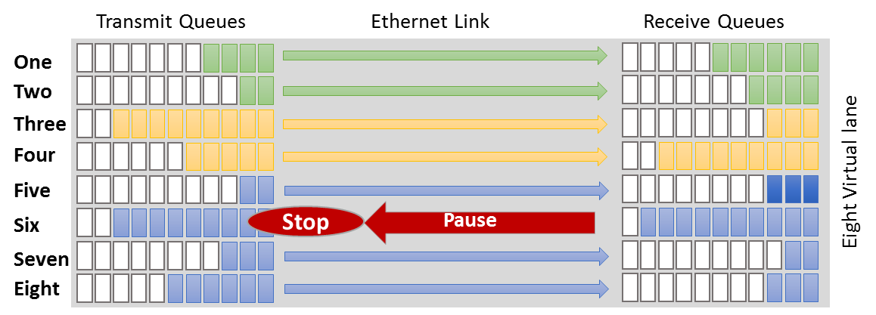
Figure 11 Example of operation of the PFC function
By considering the PFC operation under multi-hop links with some bandwidth fluctuation over say a deteriorated wireless link, then PFC may fail as per the example illustrated in Figure 12 below.
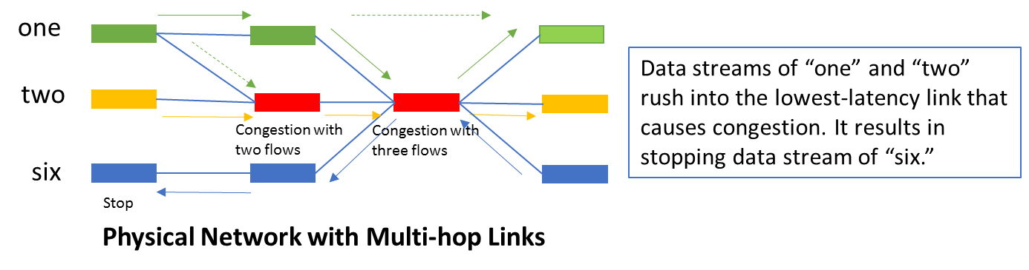
Figure 12 Impact of PFC function over multi-hop links with fluctuating bandwidth
In the example of Figure 12, Data streams rush into the physical link with the lowest latency regardless of actual bandwidth at that time. This may cause unnecessary stopping/interruption, in this case stream six suffers extensive delay, unless dynamic load balance is applied across physical links. However, dynamic load balancing is not supported so far for wireless links with narrow and fluctuating bandwidth

Expectation for Enhancement of existing IEEE 802 functions

New Project description and proposal

Conclusions
More body text. More body text. More body text. More body text. More body text. More body text.

Citations
- “IEEE 802 recommendations on IEEE 802 related Smart Grid standards”, https://mentor.ieee.org/802.24/dcn/12/24-12-0033-04-0000-package-of-802-smart-grid-standards.docx
- NISTRIR 7761 V2, Guidelines for Accessing Wireless Standards for Smart Grid Applications.

Physical objects such as materials and equipment related to production are called “things”

