|  |  |  |
| --- | --- | --- |
| Project | IEEE 802 Wireless Interim Opening Plenary May 2025 | |
| Title | Meeting Minutes for May 12th, 2025 | |
| Date Submitted | May 27th, 2025 | |
| Source | Stephen McCann  Huawei Technologies Co., Ltd | E-mail: stephen.mccann@ieee.org |
| Re: | Meeting Minutes | |
| Abstract |  | |
| Purpose | Maintain Meeting Record | |
| Notice | This document is offered as a basis for discussion and is not binding on the contributing individual(s) or organization(s). The material in this document is subject to change in form and content after further study. The contributor(s) reserve(s) the right to add, amend or withdraw material contained herein. | |
| Release | The contributor acknowledges and accepts that this contribution becomes the property of IEEE and may be made publicly available by IEEE 802. | |

**Abbreviations:**

A: Answer

C: Comment

Q: Question

**IEEE 802 Wireless Interim Session - Joint Opening Plenary #124**

**May 2025**

**Monday May 12th, 2025, 08:00 Central European Summer Time (CEST)**

1. **Call to order**: Meeting called to order at 08:00 CEST

* **Chair**: Dorothy Stanley
* **Recording Secretary**: Stephen McCann
* Please remember to join this meeting using Webex on the IEEE 802 calendar page: <https://www.ieee802.org/802tele_calendar.html>.
* There are the following IEEE staff present:
  1. Christy Bahn, Senior Program Manager.
* Attendance is in Annex A of this document.

1. **Review and approve agenda**

* <https://mentor.ieee.org/802-ec/dcn/25/ec-25-0099-00-WCSG-2025-may-wireless-interim-opening-plenary-agenda.xlsx>
* **Move to approve the agenda in document ec-25-0099r0.**
* Moved: Ben Rolfe, Second: Tuncer Baykas
* No objection to approving by unanimous consent.
* Please visit the document server: <https://mentor.ieee.org/802-ec/documents> to obtain documents for this meeting.
* **Policy and Procedure reminders**
* <http://ieee802.org/sapolicies.shtml>
* The chair read out the relevant policies and procedures, including the copyright policy.
* No statements were made.
* **Minutes from the last meeting January 2025**:
* <https://mentor.ieee.org/802-ec/dcn/25/ec-25-0009-01-WCSG-minutes-2025-01-wireless-interim-opening-plenary.docx>
* No actions from these minutes.
* Consent agenda item. Approved with approval of agenda.

1. **Venue Information and Treasury Status**

**Venue Information:**

* <https://mentor.ieee.org/802-ec/dcn/25/ec-25-0106-00-WCSG-things-to-know-2025-may-802w-interim-warsaw.pptx>
* This presentation gives you information about the venue this session.
* There will be some 802.11 newcomer training today at 10:30 in room Baltic III of the hotel.
* Please remember to pay the registration fee to attend this session.
* There is an app(lication) for this week’s meetings provided by “Event App by EventsAir”.
* Network access is provided by Linespeed and there are 2 networks for this session, WPA2 and WPA3 that should ease any connection issues for older devices.
* Breakfast is in the hotel restaurant, if you are staying the venue hotel. Beverages are served in the foyers during the morning and afternoon break.
* If you wish to use a room for your lunch, please tidy your plates to keep the rooms clear for the afternoon meetings.
* On Wednesday there is a social at the “Concept 13 Restaurant” that is about 1 km away from the hotel. At 6.30pm there will be a guide that will take a tour from this hotel to the venue. At the venue you need to go to the top floor. The social is now sold out, so there are no spare places at the moment.
* Please remember to wear your badge and this is also required for the social.
* No questions.

**Treasury Report:**

* <https://mentor.ieee.org/802-ec/dcn/25/ec-25-0001-05-WCSG-wireless-treasurer-report-2025.pptx>
* The figures in this document are correct to April 1st, 2025.
* The treasury is fine at the moment.
* Thank you to Hiroshi Mano for negotiating some extra funds for the Kobe meeting (January 2025).
* For this May session, there will be a deficit of about $90,000.
* The registration page for the September 2025 session will open on June 2nd 2025.
* Slides #18 and #19 shows the current list of deadbeats.
* No questions.

1. **Reports from WG and SC Chairs**

* **802.11 (Wireless Local Area Network – WLAN)**
  + <https://mentor.ieee.org/802.11/dcn/25/11-25-0594-01-0000-2025-may-working-group-chair-opening-report.pptx>
  + Robert Stacey presented a summary of recent 802.11 activities.
* Slide #12 shows the past 802.11 projects.
* TGbr is a new group looking at Enhanced Light Communications (ELC).
* There is also a new Post Quantum Cryptography (PQC) PAR study group which should have a draft PAR ready by the end of the session.
* IEEE 802.11-2024 was published on April 28th 2025.
* Slide #17 shows the current 802.11 sub-groups.
* There are currently 677 voters in 802.11.
* No questions.
* **802.15 (Wireless Specialty Networks)**
* <https://mentor.ieee.org/802.15/dcn/25/15-25-0168-04-0000-may-2025-802-15-opening-report.pptx>
* Phil Beecher presented the document.
* Slide #3 shows the various 802.15 groups and activities.
* Some of the sub groups are not meeting this session.
* There have been 5 ballots since the March plenary.
* There are 129 voting members at the moment.
* Slide #13 is a summary of the Terahertz demonstrations from the January 2025 session in Kobe, Japan. This was attended by many SMEs from Japan. It was regarded as a very useful and valuable event.
* Chair: If you have any topics that could be included in a future interim we can try to accommodate them.
* No questions.
* **802.18 (Radio Regulatory Technical Advisory Group)**
* <https://mentor.ieee.org/802.18/dcn/25/18-25-0029-00-0000-2025-may-rr-tag-chair-opening-report.pptx>
* Edward Au presented the document summarizing the latest activities in the working group.
* There will be a representative from the UK OfCom who will give a presentation this session. The topic is regarding Wi-Fi in the 6 GHz band and will be on Tuesday AM2. It will also cover the Wi-Fi Alliance Passpoint and Wireless Broadband Alliance Open Roaming programs.
* There are 68 voters at the moment.
* No questions.
* **802.19 (Coexistence)**
* <https://mentor.ieee.org/802.19/dcn/25/19-25-0026-01-0000-may-2025-opening-report.pptx>
* Presented by Tuncer Baykas.
* There are 53 voters.
* There have been 2 ballots since the March 2025 session.
* Task group 802.19.3a will meet this session addressing issues between 802.11-2020 and 802.15.4 sub 1 GHz standards.
* Slide #20 highlights some IEEE 802 publicity items.
* Chair: There is also an active IEEE 802 LinkedIn page that you may want to look at.
* No questions.
* **802.24 (Vertical Applications)**
* Tim Godfrey presented a summary of the working group.
* There are 21 voting members.
* The main activity this session is to continue working on the various white papers and to discuss potential new white paper topics.
* The white paper about vehicle charging infrastructure communication is almost complete.
* No questions.

1. **Discussion Topics**

* None.

1. **Announcements**

* Chair: We would like to thank Hironori Washizaki for hosting a presentation following the January 2025 session in Kobe, Japan. Also see <https://www.computer.org/profiles/hironori-washizaki> for more information.
* Nominations for IEEE SA awards are now open and close at the end of July 2025. Please note that there are several opportunities, such as the Medallion Award:
* <https://standards.ieee.org/about/awards/nominate/>.
* The IEEE SA also has a call for candidates for governance and closes on June 1st:
* <https://standards.ieee.org/wp-content/uploads/import/governance/call-for-candidates-governance.pdf>
* And this link is also useful: <https://standards.ieee.org/about/governance/>
* Finally there are upcoming IEEE annual elections, which will commence in July 2025, indicated by this link:
* <https://www.ieee.org/about/corporate/election/candidates.html?mkt_tok=NzU2LUdQSC04OTkAAAGaLDH9pCD2l56wUbVW4FPZkPVFs0UHFftyE2T6cNUr5tWdr28dIXTBBR5ufYNnnNmI9B8YXur967ocde7JZQdk-IbvCO_XDfBMYIPtA6tQGA8j>
* Chair: I think IEEE 802 members are very well represented in these IEEE SA activities.

1. **All Other Business**

* Chair: Within Webex, please remember to show your voting status using the following format: “[V] Dorothy Stanley, HPE”. This makes it easy for your colleagues and leadership to see your status when attending meetings.

1. **Adjourn**

* No objection to adjourning.
* Adjourned at 08:54 CEST.

**Annex A: Attendance & Affiliation**

| **Name** | **Affiliation** |
| --- | --- |
| Ansley, Carol | Cox Communications Inc. |
| Asterjadhi, Alfred | Qualcomm Incorporated |
| Au, Kwok Shum | Huawei Technologies Co., Ltd |
| Bahn, Christy | IEEE STAFF |
| Balaji, Rakesh | Synaptics |
| Bansal, Ankur | SAMSUNG |
| baron, stephane | Canon Research Centre France |
| Baykas, Tuncer | Self |
| BEECHER, PHILIP E | Wi-SUN Alliance |
| Bims, Harry | Bims Laboratories, Inc. |
| Carney, William | Sony Corporation |
| Carty, Clark | Juniper Networks, Inc. |
| Chang, Chen-Yi | MediaTek Inc. |
| Chaturvedi, Abhishek | Samsung Electronics |
| Chen, Junbin | TP-Link Systems Inc. |
| Chitrakar, Rojan | Huawei International Pte Ltd |
| Choi, Jin Seek | Professor Hanyang University |
| Costa, D.Nelson | HaiLa Technologies |
| Cui, Yaoshen | TP-Link Systems Inc. |
| da Silva, Claudio | Intel |
| Dezfouli, Behnam | Nokia |
| Ding, Qian | TP-Link |
| Dong, Xiandong | Xiaomi Communications Co., Ltd. |
| EMMELMANN, MARC | SELF |
| Erkucuk, Serhat | Ofinno |
| Fang, Yonggang | Mediatek |
| Fischer, Matthew | Broadcom Corporation |
| Fu, Qingwei | TP-Link Global Inc. |
| Fujimori, Yuki | Canon Research Centre France |
| Gaeremynck, Robbe | Ghent University; IMEC |
| Gee, Thomas | Qorvo |
| Genc, Eda | Nokia |
| Godfrey, Tim | Electric Power Research Institute, Inc. (EPRI) |
| Goto, Fumihide | DENSO |
| Gu, Junrong | Clourney Semiconductor |
| GUIGNARD, Romain | Canon Research Centre France |
| Halasz, David | Morse Micro |
| Halna du Fretay, Tristan | Canon Research Centre France |
| Hamilton, Mark | Ruckus/CommScope |
| Harkins, Daniel | Hewlett Packard Enterprise |
| Harrison, Edward | Anritsu Company |
| Helmy, Ahmed | Apple Inc. |
| Henry, Jerome | Cisco Systems, Inc. |
| Inohiza, Hirohiko | Canon |
| Ishihara, Susumu | Shizuoka University |
| Jee, Anand | SAMSUNG ELECTRONICS |
| Jeffries, Timothy | Futurewei Technologies |
| Johnsson, Kerstin | Nokia |
| Jungnickel, Volker | Fraunhofer Heinrich Hertz Institute |
| Kalyankar, Shravan | Huawei Technologies Co., Ltd |
| Kamel, Mahmoud | InterDigital, Inc. |
| Karthik, S. G. | SAMSUNG ELECTRONICS |
| KERGOURLAY, Gerald | Canon Research Centre France |
| Kim, Youhan | Qualcomm Incorporated |
| Kitazawa, Shoichi | Muroran IT |
| Kivinen, Tero | Wi-SUN Alliance |
| Klein, Arik | Huawei Technologies Co., Ltd |
| Koundourakis, Michail | Samsung Cambridge Solution Centre |
| Krischer, Mark | Cisco Systems, Inc. |
| Krishnamoorthy, Aravindh | University of Cambridge |
| Lalam, Massinissa | SAGEMCOM BROADBAND SAS |
| Levy, Joseph | InterDigital, Inc. |
| Li, Hao | TP-LINK Systems Inc. |
| Li, Haozheng | TP-Link System Inc. |
| Li, Jialing | Qualcomm Incorporated |
| Li, Weiyi | Spreadtrum Communications USA, Inc. |
| Liubogoshchev, Mikhail | Nokia |
| Lorgeoux, Mikael | Canon Research Centre France |
| Lungu, Alexandru | SAMSUNG ELECTRONICS |
| Martinez Vazquez, Marcos | MaxLinear Inc |
| Max, Sebastian | Ericsson AB |
| McCann, Stephen | Huawei Technologies Co., Ltd |
| Mohamed Hassan Salem, Nedime Pelin | Cisco Systems, Inc. |
| Nezou, Patrice | Canon Research Centre France |
| Nogami, Toshizo | SHARP CORPORATION |
| Nomura, Tetsuya | DENSO TEN LIMITED |
| Okumoto, Yusuke | Advanced Telecommunications Research Institute International (ATR) |
| Pare, Thomas | MediaTek Inc. |
| Patwardhan, Gaurav | Hewlett Packard Enterprise |
| Perez, Javier | Ofinno |
| Petrick, Albert | Jones-Petrick and Associates |
| Pettersson, Charlie | Ericsson AB |
| Portier, Fabrice | Silicon Laboratories |
| Prabhakaran, Dinakar | Broadcom Corporation |
| Qi, Yinan | Guangdong OPPO Mobile Telecommunications Corp.,Ltd |
| Ralle, Helene | Orange |
| Rezk, Meriam | Qualcomm Technologies Inc. |
| Rich, Ken | Hewlett Packard Enterprise |
| Riegel, Maximilian | IEEE member / Self Employed |
| Robert, Joerg | FAU Erlangen-Nuernberg |
| Rosdahl, Jon | Qualcomm Incorporated |
| Sahyoun, Walaa | Canon Research Centre France |
| Sakamoto, Ryunosuke | Sharp Corporation |
| Sand, Stephan | German Aerospace Center (DLR) |
| Schindler, Daniel | BSH Hausgerate GmbH; Robert Bosch GmbH |
| Sevin, Julien | Canon Research Centre France |
| Shatil, Ohad | Zebra Technologies |
| Sherlock, Ian | Texas Instruments Inc. |
| shi, shuyu | TP-Link |
| Shirakawa, Atsushi | SHARP CORPORATION |
| Shukai, Wang | southwest jiaotong university |
| Stacey, Robert | Intel |
| Stanley, Dorothy | Hewlett Packard Enterprise |
| Strickland, Stuart | Hewlett Packard Enterprise |
| Strobel, Rainer | Maxlinear |
| Stuebing, Gary | Cisco Systems, Inc. |
| Sumi, Takenori | Mitsubishi Electric Corporation |
| Sun, Baoyu | Espressif Systems Co., Ltd |
| Sun, Li-Hsiang | Mediatek Inc |
| Sundman, Dennis | Ericsson AB |
| SUZUKI, Shuntaro | Yamaha Corporation |
| Tomoyuki, Takada | Canon |
| Tsujimaru, Yuki | Canon |
| Uno, Masanori | e-trees.Japan,inc |
| Urabe, Yoshio | Panasonic Holdings Corporation |
| Varshney, Prabodh | Nokia |
| Verma, Lochan | Apple Inc. |
| VIGER, Pascal | Canon Research Centre France |
| Wee, Gaius | Panasonic Holdings Corporation |
| Wicaksana, Harya | Espressif Systems Co., Ltd. |
| Xiao, Tong | Xiaomi Communications Co., Ltd. |
| Xu, Yanchao | Amlogic |
| Yang, Lin | Qualcomm Incorporated |
| Yang, Yunpeng | TP-LINK SYSTEMS INC |
| Yano, Kazuto | Advanced Telecommunications Research Institute International (ATR) |
| Yee, Peter | NSA-CSD |
| Yoshikawa, Yuki | Canon Inc. |
| Yu, Chinghwa | Amlogic |
| Zhong, Ke | Ruijie Networks Co.,Ltd. |
| Zhou, Lei | H3C Technologies Co., Limited |
| Zhu, Yu | TP-Link Systems Inc. |
| Zimmer, Ethan | Cisco Systems |

**Annex B: Attendees by Country**

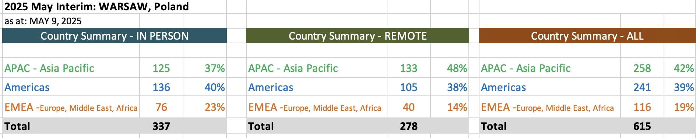

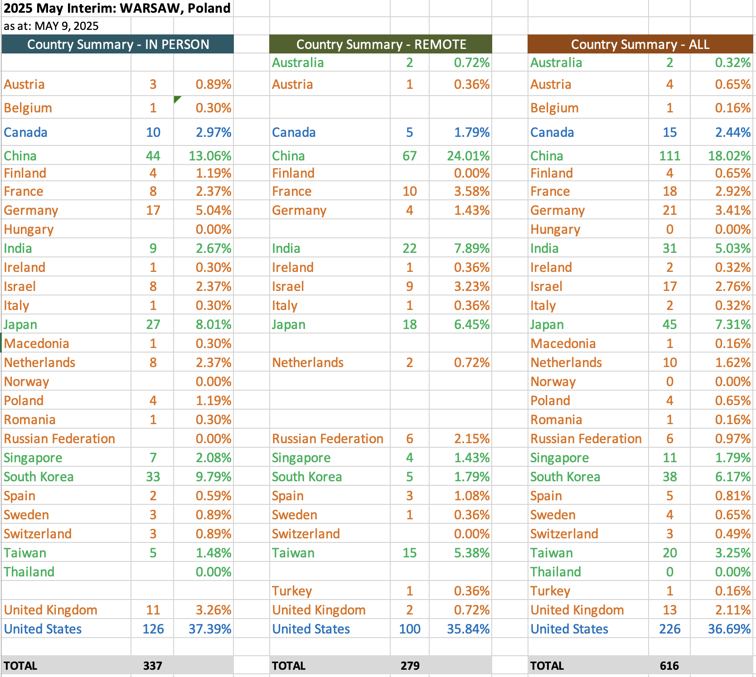

End of Document