IEEE P802.11
Wireless LANs
Wireless Chairs Meeting Agenda 2023-09-10 Meeting
Date: 2023-09-10
Author(s):
Name | Affiliation | Address | Phone | email
Dorothy Stanley | Hewlett Packard Enterprise | 3333 Scott Blvd  Santa Clara, CA 95054 | +1 630-363-1389 | dstanley@ieee.org
Jon Rosdahl | Qualcomm Incorporated, Inc. | 10871 N 5750 W  Highland, UT 84003 | +1-801-492-4023 | Jrosdahl @ ieee . org
Abstract
Agenda for Wireless Chairs Standing Committee Meeting on 2023-09-10.

See the instructions in the meeting teleconference information at
https://www.ieee802.org/802tele_calendar.html .

Wireless Chairs Standing Committee Meeting Agenda- 2023-09-10.

This meeting is being held in person and via teleconference, see https://www.ieee802.org/802tele_calendar.html

- Call to order – Jon Rosdahl (Appointed by 802 Chair to be acting 802WCSC chair).
- Policy and Procedure reminders, see http://ieee802.org/sapolicies.shtml for Patent, Participation and Copyright slides. Also see the Wireless Chairs Standing Committee Operations Manual.
- Attendance
- Review and approve agenda (ec-23-0157-00-WCSG)
  - Motion: Approve the agenda in ec-23-0120r0:
    - M: Stephen MCCAAN S: Ben ROLFE
    - Result: No Objection – Motion passes.

  - Consider 2023-07-09 teleconference minutes, see https://mentor.ieee.org/802-ec/dcn/23/ec-23-0147-01-WCSG-minutes-july-9-2023.docx
    - Actions arising out of the minutes.
      - none
    - Motion: Approve the July 2023 WCSC meeting minutes in ec-23-0147-01;
      - M: Stephen MCCANN S: Robert STACEY
      - Result: No Objection – Motion passes.

- 802.18 report –Edward Au/ Al Petrick
- 802.19 report – Steve Shellhammer/Tuncer Baykas
- 802.24 report – Tim Godfrey/Ben Rolfe
- 802.15 Report - Clint Powell
  - tool progress update –
  - Update on the work previously funded by the WSCS treasury.
- 802.11 report – Robert Stacey (acting 802.11 chair)

- September 2023 Session information –Jon Rosdahl
  - September 2023 registration status and review of venue information.
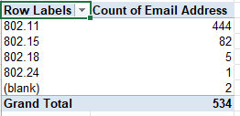
  - November 2023 and any prior meeting registration updates.
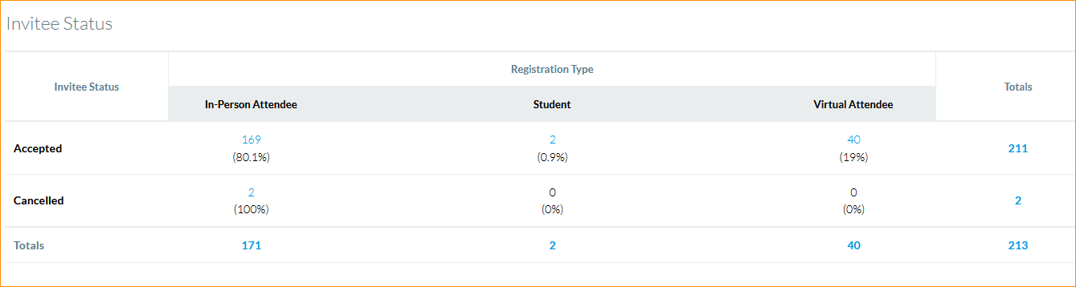

- Future Wireless Interim Sessions: review and update status, see https://mentor.ieee.org/802-ec/dcn/22/ec-23-0001. Meeting planning: 3-year cycle plan:

  - September 10-15, 2023, Atlanta Buckhead mixed mode –
  - Jan 14-19, 2024 – Panama Hilton - Contract executed, in repository. Site visit planned for August 2023 (Jon R) and Oct 2023 (MTG Events and LineSpeed).
  - May 12-17, 2024 – Planned reschedule of 2022-05 Marriott Warsaw. Contract revision in development, end July target still pending.
  - Sept 8-13, 2024, Hilton Waikoloa Village – Contract executed, in repository
  - January 2025 – Potential Asia venue – likely Kobe, TBC. Hiroshi Mano completed site visit; contract under development, working to obtain MICE support.
    - Site visit for MTG Events/Linespeed/Venue Manager -Dec 18-19, 2023.
  - May 2025 – Planned Asia/Europe venue; RFP was sent Aug 2023. Included in RFP.
  - Sept 14-19, 2025 - Hilton Waikoloa Village – Contract executed, in repository
  - January 2026 - RFP
  - May 2026 - RFP
  - Sept 13-18, 2026 Hilton Waikoloa Village – Contract executed, in repository

- Financial report
  - Treasury report from Ben Rolfe/Jon Rosdahl, see https://mentor.ieee.org/802-ec/dcn/23/ec-23-0003

- September 2023 session
  - Registration fee required.
  - Meeting Fee Waiver/Subject Matter Expert
    - Alex Roytblat, Wi-Fi Alliance – 802.18 (Thurs)
    - Pedro Riviera, University of Ottawa (802.11 (WNG))
    - Melike Erol-Kantarci, University of Ottawa (802.11 (WNG))
  - Wireless Interim Opening meeting September 10th at 8AM Local Eastern time, 1 hour.
    - Status reports on each WG/TAG.
    - Q&A time on WG/TAG topics, general topics.
    - See draft agenda in https://mentor.ieee.org/802-ec/dcn/23/ec-23-0158-00-WCSG-2023-september-wireless-interim-opening-plenary-agenda.xlsx
  - Each WG/TAG Chair has announced that their session is a Credited Interim or not.
  - Any other items re: September 2023 Interim session
- AoB – WCSC meeting cadence:
  - 2023-09-10 – Sunday 4PM in Atlanta 1.5 hours
  - 2023-10-11 – Wednesday teleconference 1.5 hours
  - 2023-11-12 – Sunday 4PM in Honolulu 1.5 hours
- Adjourn
- Topics planned for future WCSC meetings:
  - TBD

References:

