Possible 802 Sponsorship for IEEE Milestone Recognition of FCC Creation of Unlicensed ISM Bands
The IEEE Milestones program, https://ethw.org/Milestones:IEEE_Milestones_Program, honors significant technical achievements in all areas associated with IEEE. It is a program of the IEEE History Committee, administered through the IEEE History Center. Milestones recognize the technological innovation and excellence for the benefit of humanity found in unique products, services, seminal papers and patents. Milestones are proposed by any IEEE member, and are sponsored by an IEEE Organizational Unit (OU)—such as an IEEE section, society, chapter or student branch. In 2019 the program approved a plaque that was dedicated in Nieuwegein, a suburb of Utrecht, The Netherlands where an NCR team developed WaveLAN, the precursor of 802.11b .

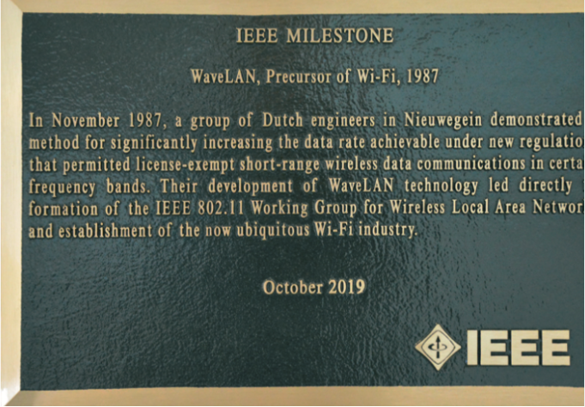

FCC’s Docket 81-413 decision, Report &Order, https://archives.federalregister.gov/issue_slice/1985/6/18/25234-25241.pdf#page=6 @p. 25234, will have its 40th anniversary on May 9, 2025. This decision created a new approach to spectrum policy that was subsequently replicated around the world. While unlicensed spectrum had existed in the US since the late 1930s, the previous provisions for unlicensed bands were all for power much less than 1W and had very narrow restrictions on uses that were permitted, e.g. cordless telephones or opening doors. The 81-413 decision created a 1W provision for unrestricted uses. It permitted and stimulated the development of W-Fi, Bluetooth and several lesser known RLAN systems such as ZigBee.
While FCC’s unlicensed Part 15 existed prior to this, a review of historic Part 15 rules confirms that they were all limited pre-1985 to powers much less than 1 W, only addressed very specific uses, and a multiyear rulemaking was needed every time a new usage was considered.
A key “secret sauce” in the 1985 decision is what is now called “permissionless innovation”. The 2022 CTA report "UNLICENSED SPECTRUM AND THE U.S. ECONOMY -Quantifying the Market Size and Diversity of Unlicensed Devices, https://shop.cta.tech/products/unlicensed-spectrum-and-the-us-economy-quantifying-the-market-size-and-diversity-of-unlicensed-devices, states "estimates that permissionless spectrum generates $95.8 billion per year in incremental sales value (ISV) at retail” and most of these devices use unlicensed ISM band spectrum or expansion thereof.” (emphasis added) “Permissionless spectrum here means spectrum that can be used by the equipment purchaser without any individual request to a government or a licensed radio system operator such as a cellular carrier. It also means that the equipment development had complete flexibility with respect to the functionality of the equipment and is only subject to regulations on electromagnetic compatibility/EMC and RF safety. Thus, the originality developers of Wi-Fi and Bluetooth did not have to ask any government permission to use spectrum for functionality that had not previously existed and such systems were allowed evolve subject only to EMC and RF safety limitations. This resulted in rapid technical innovation over the years with minimal governmental involvement. When the 81-413 decision was adopted 1985 there was little interest in Ethernet in nontechnical workplaces or in homes but as such interest developed in the next few years the RLAN pioneers had immediate access ot the marketplace without seeking government permission on the nature of their technology
The 81-413 decision was adopted at the then FCC location at 1919 M St. NW, Washington DC. That building still exists although it had major modifications in 2019 when FCC moved to another location. The Milestone rules, https://ieeemilestones.ethw.org/Milestone_Guidelines_and_How_to_Propose_a_Milestone permit the plaque to be located where the events happened but could also be nearby if that isn’t feasible. (The WaveLAN plaque is in the city library in Nieuwegein because the actual building has different tenants now and was not interested in the plaque.) If the current owners of the 1919 M St. location are unwilling to host the plaque, there are 2 neighborhood parks nearby that are possible locations.
Any IEEE organizational unit -- e.g. a Section, Society, Chapter, or Student Branch may sponsor the milestone proposal. Sponsorship has three aspects: 1) Payment for the cost of the plaque(s), 2) Arranging the dedication ceremony, and 3) agreeing to monitor the plaque and to let IEEE History Center staff know in case the plaque needs to be moved, is no longer secure, etc. Number 3 must be done by the IEEE Section(s) in which the plaque(s) is located, but aspects 1 and 2 can be done by any IEEE Organizational Unit, and they need not be the same one. The plaque(s) remains the property of the IEEE Section in which it is located. A letter from the Section Chair specifically stating that the Section will monitor the plaque and (if applicable, pay for the plaque and arrange the dedication) must be submitted with the proposal. If an IEEE organizational unit other than the Section will be paying for the plaque(s), a letter/email from the Chair or President of that IEEE organizational unit must also be submitted with the proposal. The local IEEE section is the IEEE Washington Section, https://r2.ieee.org/washington/, and would probably be more receptive if 802 could arrange for the cost of the plaque – about $1k – and cooperate in the dedication ceremony and associated costs.

