802 Restructuring ad hoc meeting notes
16 February 13:00-14:00 ET
Recorded by: Paul Nikolich

Nikolich chaired the meeting, called to order at 1:03 ET. Participants noted in the below table.

Meeting Date | 15 Dec | 19 Jan | 16 Feb | 16 Mar | 20 Apr | 18 May | 22 Jun | 20 Jul | 17 Aug | 21 Sep | 19 Oct | 16 Nov | 21 Dec
Ad hoc Members
Paul Nikolich, Chair | X | X | X
James Gilb, Vice Chair 1 | X | X | X
Roger Marks, Vice Chair 2 | X | X
Jon Rosdahl, Exec Secy | X | X | X
John D’Ambrosia, Rec Secy | X
George Zimmerman, Treas | X |  | X
Clint Chaplin, Emeritus | X | X | X
Geoff Thompson, Emeritus | X | X | X
Glenn Parsons, dot01 Ch | X | X | X
Jessy Rouyer, dot01 alt | X | X
David Law, dot03 Ch | X | X | X
Adam Healy, dot03 alt | X | X | X
Dorothy Stanley, dot11 Ch
Robert Stacey, dot11 alt | X
Pat Kinney, dot15 Ch
Rick Alfvin, dot15 alt | X
Jay Holcomb, dot18 Ch | X | X | X
Stuart Kerry, dot18 alt |  | X | X
Steve Shellhammer, dot19 Ch | X | X | X
Tuncer Baykas, dot19 alt | X |  | X
Tim Godfrey, dot24 Ch | X | X
Ben Rolfe, dot24 Ch | X |  | X
Subir Das, dot21 HiberCh  Bruce Kraemer  Nada Golmie | X | X
Apruva Mody, dot22 HiberCh |  |  | X
Andrew Myles, 802/JTC1 Ch |  |  | X
Observers
Bob Grow, ex dot03 Ch |  | X
Bruce Kraemer, ex dot11 Ch | X
R. Canchi, ex dot20 Ch | X
Peter Jones, dot03 | X
Joseph Levy, dot11 | X
Carl Kain, dot18 | X
Jodi Haasz, IEEE staff | X | X
J. Goldberg, IEEE staff |  | X
Dawn Slykhouse, FtF staff |  |  | X
Lisa Ronmark, FtF staff |  |  | X

Nikolich presented slide deck
https://mentor.ieee.org/802-ec/dcn/21/ec-21-0030-00-00EC-16feb2021-802-restructuring-ad-hoc-slide-dec.pptx

Nikolich reviewed the agenda:
- Discuss, refine and agree on the scope of the ad hoc:
  - Discuss proposed 802 Scope by Roger and Geoff (~10 min)
  - Discuss areas of focus, assign individuals to follow up (~15 min)
  - Discuss hybrid meeting possibility, assign follow up to sub ad hoc (~15 min)
  - Consider the pros and cons of various restructuring options (postpone to later meeting(s))
- Proposed deliverable:
  - a well vetted and socialized recommendation for EC consideration within 12 months
- Monthly meeting reminder: (1 min)
default -- 13:00-14:00 ET 3rd Tuesday of each month in 2021
15Dec20, 19Jan, 16Feb, 16Mar, 20Apr, 18May, 15Jun, 20Jul, 17Aug, 21Sep, 19Oct, 16Nov, 21Dec
- Review action items, draft agenda for next meeting (~5 min)

No comments, the agenda is approved.

a.1) Nikolich reviewed the proposed 802 Scope by Roger and Geoff l. See following slide.
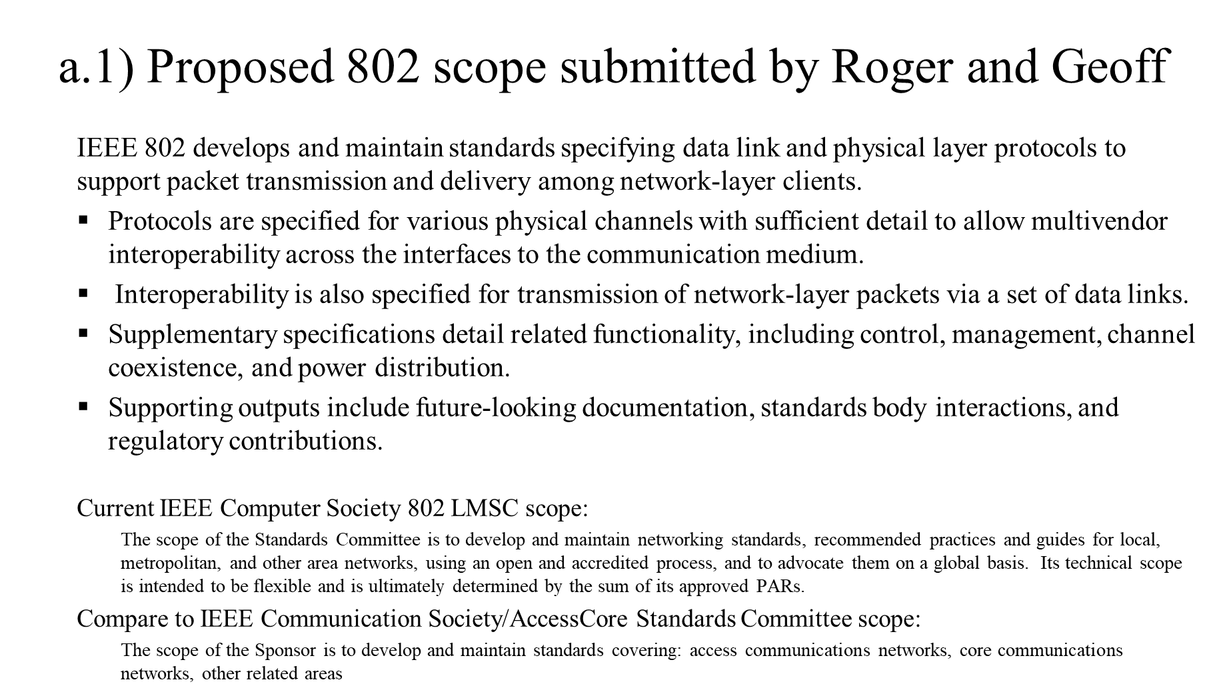

Nikolich asked for input from the ad hoc regarding additional proposed 802 scope. After discussion, consensus of the group was to keep the scope as currently defined in the 802 P&P (i.e., broad).

It was agreed the proposed scope is better categorized as a mission/purpose statement. This mission/purposed statement should be captured in the 802 Chair’s Guideline, with the direction that it be made publicly visible (e.g., on the www.ieee802.org home page).

Action Item: Nikolich to draft 802 Mission/Purpose Chair’s Guideline.

a.2) Nikolich reviewed the ‘areas of focus’ proposed by Steve Shellhammer, Paul Nikolich and Roger Marks. See following slide.
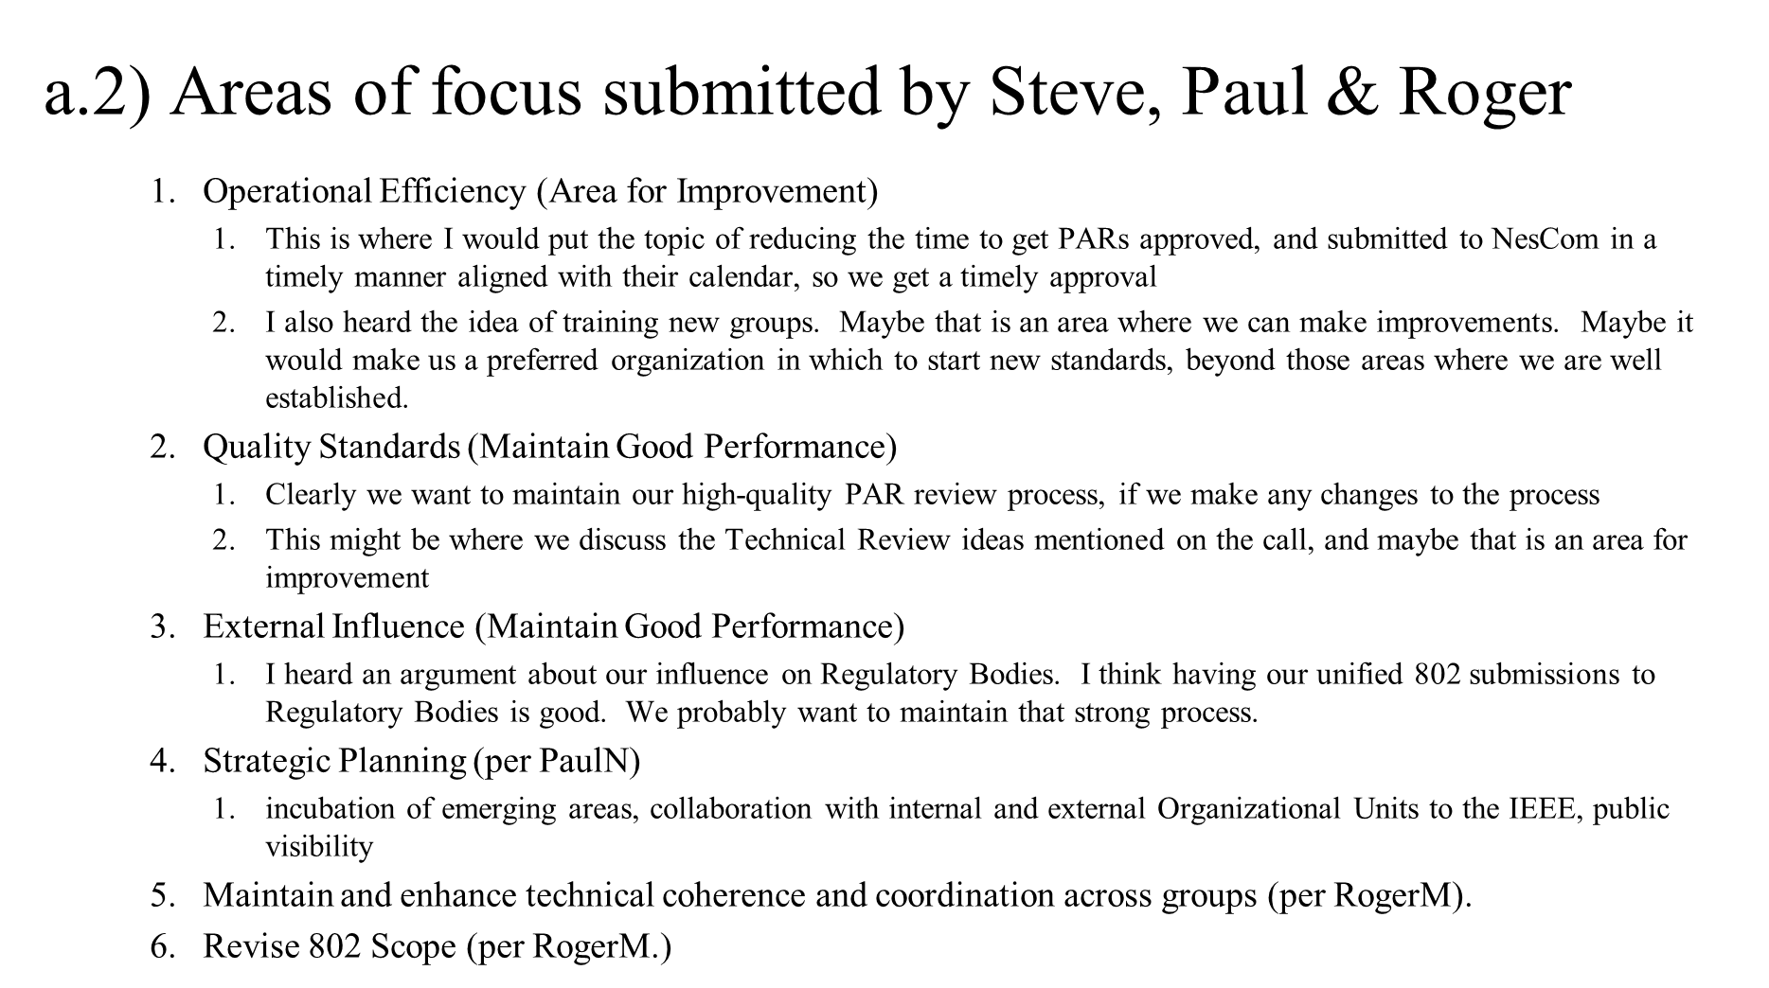
Andrew observed definitions of “the problem to be solved” are needed for the above items. Nikolich asked participants to volunteers to act as mentors for each item to define the problem and lead off-line discussions with their colleagues prior to the next ad hoc meeting. The following assignments were made:
1. Operational Efficiency – BenR,
2. Quality Standards -- GeoffT and ApurvaM on item (after off-line consultation with Nikolich),
3. External Influence – Open,
4. Strategic Planning – PaulN,
5. Technical Coherence – GlennP,
6. 802 Scope – RogerM (completed as per a.1 above)

Action Items: Mentors to lead and complete discussion on developing a ‘problem statement for each ‘area of focus’ item prior to the next meeting.

a.3) Nikolich lead discussion hybrid meeting possibilities. See following slide:
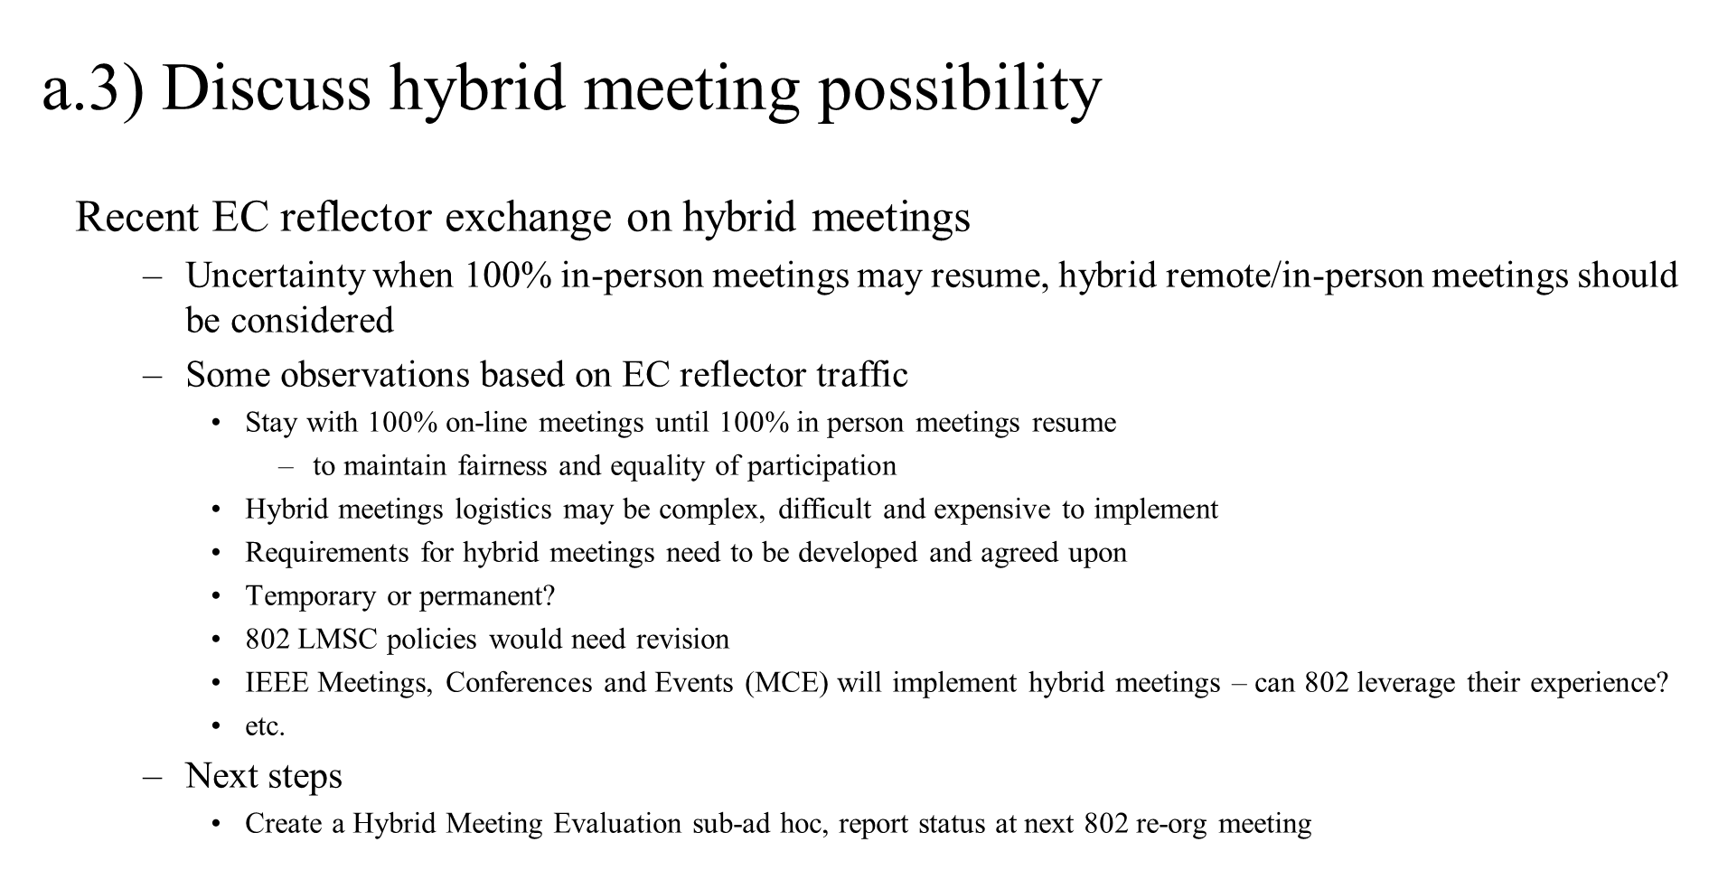
Andrew presented a Thoughts on Meeting Modes slide from https://mentor.ieee.org/802-ec/dcn/21/ec-21-0031-00-00EC-thoughts-on-meeting-modes.pptx :
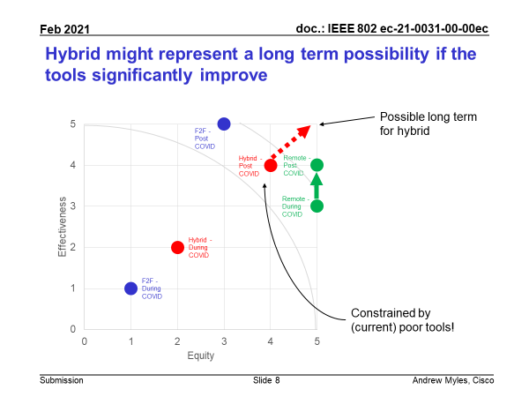
Opinions ranged from strongly against to mildly supportive of hybrid meetings possibilities, however, too many unknowns and uncertainties exists at the moment, no clear consensus developed. It was agreed to form a Hybrid Meeting Evaluation sub-ad hoc to be chaired by JonR. Jon will report status at the next 802 restructuring ad hoc meeting.

Nikolich began meeting wrap up; the next meeting, scheduled for 1-2pm ET Tuesday 16 March 2021.

Action Items
1. Nikolich to draft 802 Mission/Purpose Chair’s Guideline.
2. Ben, Geoff, Apurva, Paul and Glenn to lead and complete discussions on developing a ‘problem statement for each ‘area of focus’ item in (a.2) above prior to the next meeting.
3. JonR to lead Hybrid Meeting Evaluation sub-ad hoc and report status at next meeting.

Draft agenda for 16 March 2021 meeting
1. Follow up on above action items.

Having reached the end of the agenda, meeting adjourned at 2:09 pm ET.

