802 Restructuring ad hoc meeting notes
19 January 13:00-14:00 ET
Recorded by: Paul Nikolich and Jonathan Goldberg

Notes (combined effort, Goldberg, Nikolich):

Nikolich chaired the meeting, called to order at 1:00 ET. Participants noted in the below table.

Meeting Date | 15 Dec | 19 Jan | 16 Feb | 16 Mar | 20 Apr | 18 May | 22 Jun | 20 Jul | 17 Aug | 21 Sep | 19 Oct | 16 Nov | 21 Dec
Ad hoc Members
Paul Nikolich, Chair | X | X
James Gilb, Vice Chair 1 | X | X
Roger Marks, Vice Chair 2 | X | X
Jon Rosdahl, Exec Secy | X | X
John D’Ambrosia, Rec Secy | X
George Zimmerman, Treas | X
Clint Chaplin, Emeritus | X | X
Geoff Thompson, Emeritus | X | X
Glenn Parsons, dot01 Ch | X | X
Jessy Rouyer, dot01 alt | X | X
David Law, dot03 Ch | X | X
Adam Healy, dot03 alt | X | X
Dorothy Stanley, dot11 Ch
Robert Stacey, dot11 alt | X
Pat Kinney, dot15 Ch
Rick Alfvin, dot15 alt | X
Jay Holcomb, dot18 Ch | X | X
Stuart Kerry, dot18 alt |  | X
Steve Shellhammer, dot19 Ch | X | X
Tuncer Baykas, dot19 alt | X
Tim Godfrey, dot24 Ch | X | X
Ben Rolfe, dot24 Ch | X
Subir Das, dot21 HiberCh  Bruce Kraemer  Nada Golmie | X | X
Apruva Mody, dot22 HiberCh
Observers
Bob Grow, ex dot03 Ch |  | X
Bruce Kraemer, ex dot11 Ch | X
R. Canchi, ex dot20 Ch | X
Peter Jones, dot03 | X
Joseph Levy, dot11 | X
Carl Kain, dot18 | X
Jodi Haasz, IEEE staff | X | X
J. Goldberg, IEEE staff |  | X

Nikolich presented slide deck https://mentor.ieee.org/802-ec/dcn/21/ec-21-0010-00-00EC-19jan21-802-restructuring-ad-hoc-mtg.pptx

Nikolich reviewed the agenda:
- Discuss, refine and agree on the scope of the ad hoc:
  - Specify what problem(s) we are trying to solve focus for this meeting
  - consider the pros and cons of various restructuring options
- Discuss the proposed deliverable:
  - a well vetted and socialized recommendation for EC consideration within 12 months
- Monthly meeting reminder:
default -- 13:00-14:00 ET 3rd Tuesday of each month in 2021
19Jan, 16Feb, 16Mar, 20Apr, 18May, 15Jun, 20Jul, 17Aug, 21Sep, 19Oct, 16Nov, 21Dec
- Review action items, draft agenda for our next meeting

Nikolich reviewed the ‘areas of focus’ proposed by Steve Shellhammer and Paul Nikolich via email. See following slide.
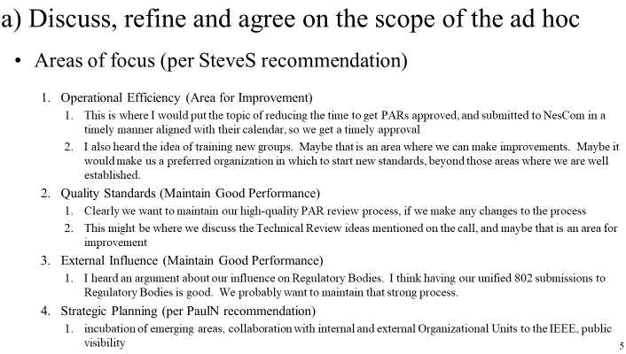

Nikolich asked for input from the ad hoc regarding additional ‘areas of focus’. Roger Marks suggested two additions (technical coherence and 802 scope), see following slides

Nikolich asked the ad hoc participants to brainstorm on possible 802 scope clarifications, following is an attempt to capture all the suggestions:

- Develop clear and technical scope for 802 overall
  - Better definition of technical subjects within scope of 802, need additional criteria and boundaries
- Should general 802 and WG scopes or criteria be better defined before the restructuring is completed?
  - Do the working groups need a specific scope?
  - Current structure based on current industry requirements, evolved naturally without strong restrictions that may inhibit progress and be counterproductive to market needs
  - Scope(s) should be narrower, currently very broad but not too narrow as to restrict progress and innovation
  - Currently accepted Distinct Identity in CSD are very weak and cause some confusion
- Possible technical scope bounds
  - OSI below layer 3 (only layer 1 and 2) plus interface to higher layers (eg close integration and cooperation with IETF)
  - Single hop / multi hop / guarantee bridging across 802?
  - Data communications standards
  - Packet-oriented
  - Operation over license-exempt and licensed spectrum
  - Review other relevant SDO scopes for insight
    - JTC1 scope: SC6 works in the field of telecommunications… (link)
    - Develop standards for SC6 Adoption while implementing international cooperative development (eg within scope of SC6)
  - Support DC power delivery over copper data cabling (Provision of power of selected PHY types? ICT cabling? PDCC ad hoc)
  - Media types: copper, optical fiber, wireless, RF and optical, organic material, etc
  - Keep the scope simple: Specifying technologies that support the function of data communications and layer 1 and 2 networking (free of the legacy constraints of telephone infrastructure)
  - Describe core mission rather than new scope? WGs can define their scope within the mission statement
  - A description of all the work in 802 has public visibility utility as it would attract participants. This more of a marketing statement
  - State 802’s core mission. WGs articulate how they are within the core mission

Nikolich began meeting wrap up; review of action items and agree on a draft agenda for the next meeting, scheduled for 1-2pm ET Tuesday 16 February 2021.

Action Items
1. Geoff Thompson and Roger Marks to draft an 802 Core Mission Statement for circulation on the 802 EC reflector not later than 29 January 2021
2. ad hoc participants to discuss (1) above via EC reflector in preparation for the 16 February ad hoc meeting.

Draft agenda for 16 February 2021 meeting
1. Discuss, debate and agree on an 802 Core Mission Statement

Having reached the end of the agenda, meeting adjourned at 1:59pm ET.

