Wireless Chairs Committee
Joint 11/15 Executive Committee

Project | Wireless Chairs Committee
Title | 2018 Waikoloa 11ax Coex comment status
Date Submitted | September 9, 2018
Source | Dorothy Stanley  HP Enterprise | Tel: 630-363-1389  E-mail: dstanley@ieee.org
Re: | P802.11ax Coexistence assurance document comment status
Abstract
Purpose | Status Report – IEEE 802.11ax coexistence comment resolution
Notice | This document has been prepared to assist the Wireless Chairs Committee (WCC) and the Joint 11/15 Executive Committee. It is offered as a basis for discussion and is not binding on the contributing individual(s) or organization(s). The material in this document is subject to change in form and content after further study. The contributor(s) reserve(s) the right to add, amend or withdraw material contained herein.
Release | The contributor acknowledges and accepts that this contribution becomes the property of IEEE and may be made publicly available by IEEE 802.

Status Report

Events 2018 May to July

- 2018-0 802.19 ballot of P802.11ax Coexistence Assurance document (see results reported in 19-18-0049r1) did not achieve 75% - result was 16-6-0 (72.7%)
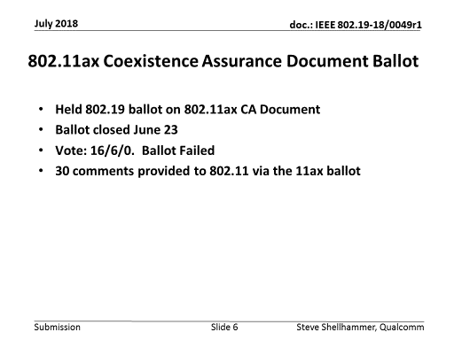

- All received P802.11ax D3.0 & Coexistence document comments are available here: https://mentor.ieee.org/802.11/dcn/18/11-18-1123-04-00ax-comments-on-tgax-d3-0.xlsx
- Comment resolutions are under discussion

Events 2018 July - September

- Comment resolutions for comments received on the coexistence assurance document are under discussion in 802.11 TGax
- A proposed set of resolutions is available, see https://mentor.ieee.org/802.11/dcn/18/11-18-1532-00-00ax-tgax-coexistence-assurance-document-comments.docx
- An updated revision of the coexistence assurance document is here: https://mentor.ieee.org/802.11/dcn/16/11-16-1348-04-00ax-coexistence-assurance.docx
- Further discussion in Waikoloa – to be announced

Planned events September 2018 – November 2018

- Continue discussion on comment resolutions, per received submissions
- Target: P802.11ax D4.0 Recirculation letter ballot, and ballot on revised coex document out of the November 2018 meeting

WCSG Discussion topic

- Observation on the discussions to date: Differing views among members on Coexistence assurance document requirements
  - View A: Coex document describes current situation. Simulations optional. Solutions optional.
  - View B: Coex document describes current situation, with simulations mandatory, solutions mandatory
- 802 LMSC Operations Manual, Section 13: Procedure for coexistence assurance
  - If indicated in the five criteria, the wireless WG shall produce a coexistence assurance (CA) document in the process of preparing for WG letter ballot and Sponsor ballot. The CA document shall accompany the draft on all wireless WG letter ballots.
  - The CA document shall address coexistence with all relevant approved IEEE 802 LMSC wireless standards specifying devices for unlicensed operation. The WG should consider other specifications in their identified target band(s) in the CA document.
  - The IEEE 802.19 WG shall have one vote in WG letter ballots that include CA documents. As part of its ballot comments, the IEEE 802.19 WG will verify the CA methodology was applied appropriately and reported correctly.
  - The ballot group makes the determination on whether the coexistence necessary for the standard or amendment has been met.
  - A representative of the IEEE 802.19 WG should vote in all wireless Sponsor ballots that are in the scope of the IEEE 802.19 coexistence WG.
- 802.11 Chair understanding
  - View A is the accurate understanding

