Project | Human Factor for Immersive Content Working Group  < https://sagroups.ieee.org/3079/ >
Title | Framework for Privacy Protection through Identifiability Management in Avatar Interaction
DCN | 3079-23-0064-01-0003
Date Submitted | October 17, 2023
Source(s) | Jun Young Kwak, weekendmeta@gmail.com (HSU)  HyunDuck Shin, henry@hansung.ac.kr (HSU)  Seung Wook Lee tajinet@etri.re.kr (ETRI)  Beom-Ryeol Lee, lbr@etri.re.kr(ETRI)
Re: | IEEE 3079 Session #28 Plenary Meeting in Tokyo, Japan
Abstract | A framework ensuring privacy in avatar interactions by managing identifiability.
Purpose | To start discussion on purpose of the IEEE P3079.3 standard
Notice | This document has been prepared to assist the IEEE 3079 Working Group. It is offered as a basis for discuqssion and is not binding on the contributing individual(s) or organization(s). The material in this document is subject to change in form and content after further study. The contributor(s) reserve(s) the right to add, amend or withdraw material contained herein.
Release | The contributor grants a free, irrevocable license to the IEEE to incorporate material contained in this contribution, and any modifications thereof, in the creation of an IEEE Standards publication; to copyright in the IEEE’s name any IEEE Standards publication even though it may include portions of this contribution; and at the IEEE’s sole discretion to permit others to reproduce in whole or in part the resulting IEEE Standards publication. The contributor also acknowledges and accepts that IEEE 3079 may make this contribution public.
Patent Policy | The contributor is familiar with IEEE patent policy, as stated in Section 6 of the IEEE-SA Standards Board bylaws <http://standards.ieee.org/guides/bylaws/sect6-7.html#6> and in Understanding Patent Issues During IEEE Standards Development http://standards.ieee.org/board/pat/faq.pdf

Functional Description
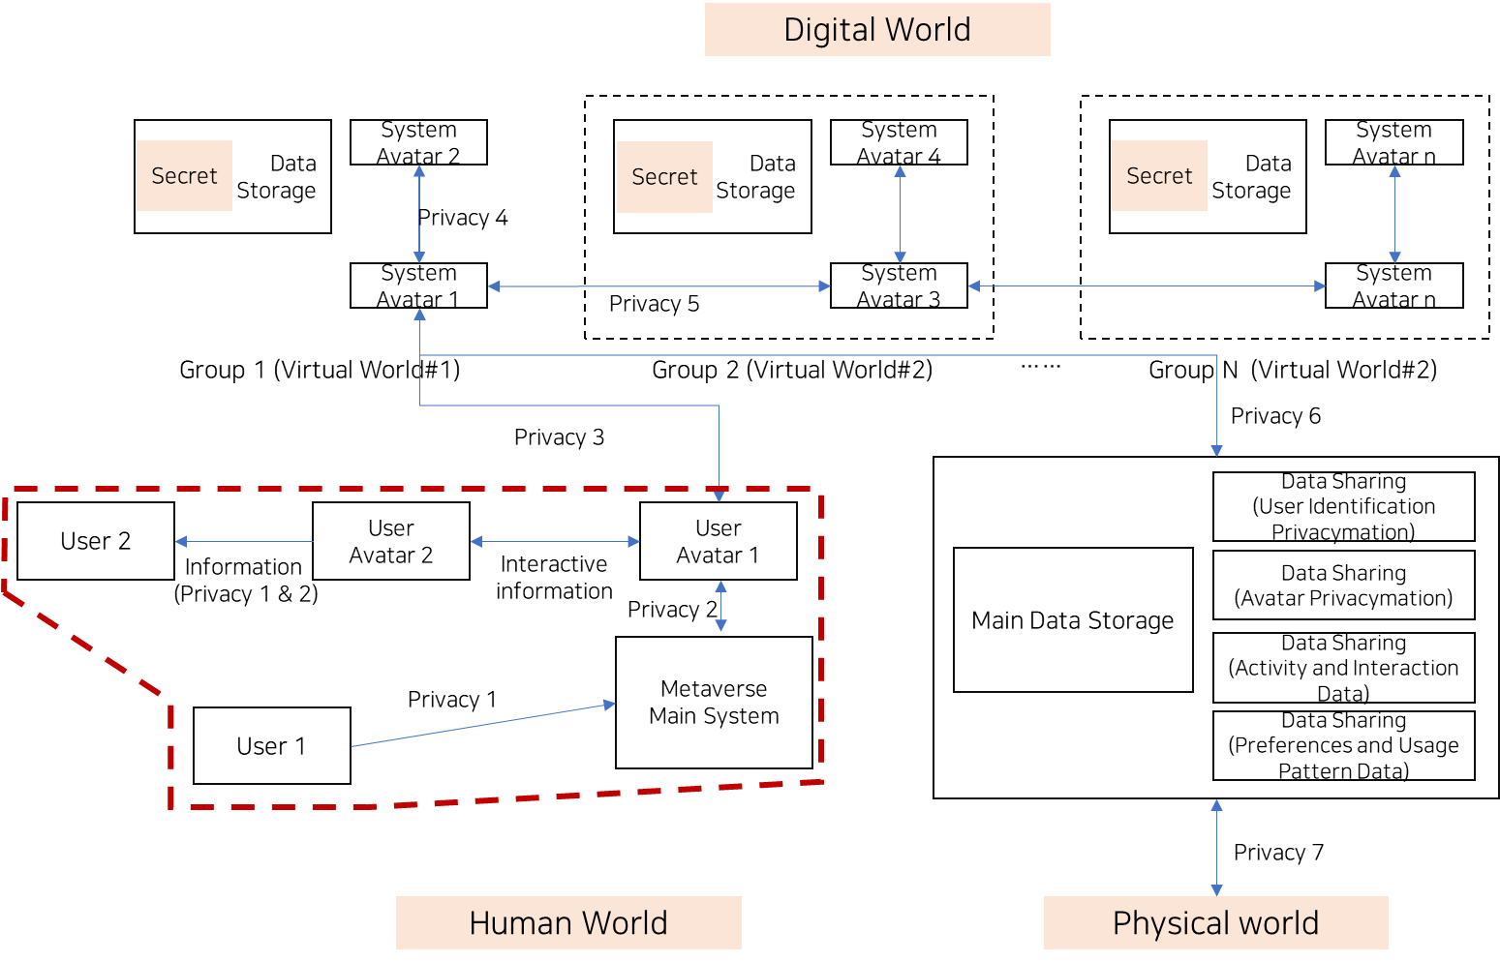
This standard aims to protect and manage identifiable personal information generated through interactions with User 1's User Avatar in metaverse environments.
A User Avatar refers to a digital character representing the user in a digital environment, designed to reflect the user's tendencies and identity.
"Identifiable personal information" encompasses all data directly associated with User 1, or all data that can infer User 1 through the behaviors and patterns of User Avatar 1.
This standard stipulates the principles and methods for the collection, storage, processing, sharing, and deletion of personal information arising from interactions with User 1's User Avatar.
The scope of information includes the physical characteristics, behavior patterns, tendencies, preferences, opinions, and emotions of User 1's User Avatar.
This standard focuses on preventing User 2 from identifying User 1 through User 1's User Avatar, ensuring User 1's privacy and self-determination rights.
If User 2 can identify User 1 through User 1's User Avatar, it can lead to issues of personal information leakage, privacy infringement, and limitations on self-determination rights of User 1.
This standard defines how to categorize and group the information generated by the user and User Avatar, and stipulates how to provide and delete such information.
This standard is based on the classification of user and avatar information and the principles of secure collection, storage, sharing, and deletion.

Information Exchange and Interaction Scenarios
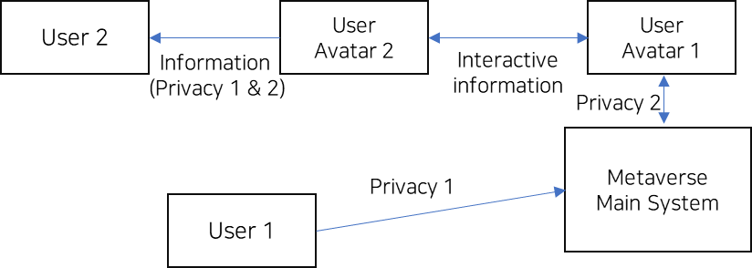
- Privacy 1 (User - Metaverse Main System): This relationship represents the information exchange between the user and the main system of the metaverse. The user provides necessary information to the main system when logging in or initiating activities in the metaverse, and the main system conveys information about the status of the metaverse, notifications, updates, etc., to the user.
- Privacy 2 (Metaverse Main System - User Avatar): The main system of the metaverse provides information such as environment settings, preferences, and activity history to the user avatar. The user avatar acts and reacts within the metaverse based on this information.
- Interactive Information (User Avatar 1 – User Avatar 2): Within the metaverse, information is shared between avatars based on their interactions. These interactions involve linguistic and non-linguistic information, which can be analyzed in quantitative and qualitative terms.
- Privacy Information 1 & 2 (User Avatar 2 – User 2): User 2 can obtain information about User 1 through User Avatar 2. In this scenario, there is a possibility for User 2 to access User 1's personal information.

Definition of Avatar
Avatar serves as a digital representative of the user, embodying the user's presence and actions within a digital environment. Avatar can reflect the user's actual appearance, characteristics, or desired portrayal, and serve as a medium for the user's interactions, expressions, and communications.
- Representation: Avatar can be personalized to reflect the user’s physical characteristics, tendencies, and preferences.
- Interaction: Engage with other user avatars or system avatars, communicating and participating in the virtual world.
- Control: Directly adjusted by the user, reflecting the user’s intentions and actions.

Avatar Types
- Realistic Avatars: Realistic avatars are designed to resemble the user's actual appearance, enhancing the connection between the real world and the digital realm.
- Stylized Avatars: Stylized avatars display non-realistic design elements to express the user’s individuality. With creative and unique designs, these avatars highlight the user’s personality.
- Abstract Avatars: Abstract avatars are composed of unreal elements such as symbols, colors, or geometric shapes. These avatars may not reflect the user’s identity directly.

Avatar Role
- Avatars act as proxies for users, facilitating interactions within a digital environment. Serving as a medium for the user’s communications, expressions, and interactions, avatars indicate the user’s presence in the digital world.
- Avatars can offer a neutral appearance that allows for unbiased opinions and participation in social consensus. For example, in scenarios such as debates, group therapy, or jury participation in a court setting, the neutral appearance of avatars demonstrates the social impact in the metaverse.

Objective
- Privacy Protection: It is essential to protect users' personal information and activities in the metaverse environment. Thus, one of the primary objectives of this project is to clarify the information exchange processes between users and the system, as well as among users. Through this, the project aims to protect users' privacy, make the information exchange processes within the metaverse transparent, and provide better security and transparency to users.
- Understanding Interactions: It is crucial to have a deep understanding of the interaction mechanisms between users and the system, and among users within the metaverse. Such understanding can contribute to providing a better user experience and improving the metaverse environment. By analyzing the operation and flow of interactions, it is possible to enhance user engagement, identify issues, and improve the usability and efficiency of the metaverse environment.

Project Necessity
In digital domains, especially the emerging metaverse environments, a substantial amount of data is generated through interactions between users and their digital representatives, user avatars. Within this data, there are portions containing personal information. Additionally, with technological advancements, the identification and misuse of personal information are becoming increasingly serious issues.
- Standardization: For the development of the metaverse, standardization concerning information exchange methods and privacy is necessary. This project highlights the need to establish standards regarding information exchange processes and privacy issues within metaverse environments.
- Privacy Protection: When users immerse themselves in the metaverse environment, the distinction between personal identity and digital identity becomes blurred. This standard aims to establish clear boundaries for protecting identifiable personal information, thereby preserving user privacy.
- Transparency and Control: This standard proposes a framework for the collection, storage, processing, sharing, and deletion of personal information, fostering transparency and restoring control over digital interactions to users.
- Security Enhancement: By preventing unauthorized identification and access to personal information, this standard strengthens security within the metaverse, creating a safe space for users to interact and engage.
- Legal and Ethical Compliance: Establishing this standard aids in aligning metaverse platforms with existing and future legal and ethical requirements regarding data protection and privacy.

Stakeholders of the Standard
- Users: Users are at the core of this standard and primarily strive to protect their privacy and personal information. They stand to benefit from enhanced security and control over digital interactions.
- Metaverse Platform Providers: These entities have a stake in providing a safe and transparent platform to users. By adhering to this standard, they can not only enhance user trust but also mitigate legal liabilities.
- Government and Regulatory Bodies: Governments and regulatory agencies become stakeholders as they bear the responsibility to ensure digital platforms comply with data protection laws and ethical practices.

‘Interactive Information’ Classification (Linguistic Patterns and Non-linguistic Patterns)
Classification Level 1 | Level 2 | Level 3
Linguistic Patterns | Communication Style | Language Usage: Language choice, tone, speech style, emphasis, etc.  Conversation Style: Flow of conversation, response time, choice of conversation topics, etc.
 | Avatar's Opinions and Emotions | Political Opinions: Party preference, policy stance, election participation, social movement involvement, etc.  Social Opinions: Awareness of social issues, ethics and values, social responsibility, cultural and diversity awareness, etc.
Non-linguistic Patterns | Avatar's Physical Features and Preferences | Direct Modifications: Hairstyle and color, special symbols or tattoos, etc.  Avatar's Wearables: Style of clothing, accessories, shoes, etc.  Preferences Manifested: Music genre, art style, environmental design, choice of locations, etc.
 | Behavioral Patterns | Movements: Walking style, running pattern, dancing style, gestures, etc.  Non-verbal Communication: Body language and facial expressions, non-verbal signals, etc.  Interactions: Interactions with other avatars, interactions with the environment, behavior in groups, user-defined interactions, etc.
 | Avatar's Emotional Expressions | Emotional Expressions: Ways of expressing happiness, sadness, anger, fear, surprise, love, intimacy, etc.

Classification as Linguistic Patterns:
- Linguistic patterns refer to the characteristics related to a user's language usage.
- For instance, this includes tone, speech style, emphasis, and language choice.
- These patterns can reflect a user's education level, cultural background, emotional state, etc. For example, if a user employs a formal tone, it may suggest a higher level of education or an authoritative profession, while the choice of a specific language may indicate interest or affiliation with a particular culture or group.
- Such linguistic patterns can be included in the data generated and shared by avatars, and this data can be analyzed or processed by other entities. This might lead to predictions or manipulations of the user's behavioral patterns, preferences, tastes, etc., requiring caution from a personal information protection standpoint.

Classification as Non-linguistic Patterns:
- Non-linguistic patterns refer to the characteristics related to a user's non-verbal signals.
- Examples include gestures, facial expressions, eye contact, posture, and spatial distance.
- These patterns can reflect a user's emotional state, intentions, personality, etc. For instance, if a user exhibits a smiling expression, it might indicate a good mood or an intent to interact amicably, while engaging in conversation at a close distance with another avatar might suggest a higher level of intimacy or interest.
- Such non-linguistic patterns can also be included in the data generated and shared by avatars, and can be analyzed or processed by other entities. This might lead to understanding or manipulation of the user's emotional state, intentions, personality, etc., requiring caution from a personal information protection standpoint.

‘Interactive Information’ Classification (Choice, Externally Visible Behavior, Unrevealed Attitude))
Classification Level 1 | Level 2 | Level 3
Avatar's Physical Features and Preferences (User Choice) | Things That Require Direct Modification (Elements forming the basic appearance of the avatar, which the user has to select and change directly.) | □ Hairstyle and Color:  ・Style: Choices among various styles such as short, long, curly, straight, etc.  ・Color: Choices of hair color such as blonde, brunette, red, black, etc.  ・Accessories: Choices of hair accessories like headbands, hats, hairpins, etc.  □ Special Symbols or Tattoos:  ・Tattoo Design: Choices of tattoo design such as specific symbols, letters, images, etc.  ・Location: Choice of body part of the avatar where the tattoo will be applied.  ・Color and Size: Adjusting the color and size of the tattoo.
 | Things The Avatar Can Choose to Wear (Physical features that the avatar can choose and wear based on user preferences.) | ・Clothing Style: Choices among casual, business, traditional attire, etc.  ・Accessories: Choices of accessories to wear like necklaces, watches, glasses, etc.  ・Footwear: Choices among sneakers, shoes, sandals, etc.
 | Things That Can Be Indicatively Displayed (Features displayed based on user preferences and environment in an indirect manner.) | ・Music Genre: Choices of preferred music genres like classical, jazz, pop, rock, etc.  ・Art Style: Choices of preferred art styles like modern art, classical art, abstract art, etc.  ・Environment Design: Design and decoration of avatar's home, room, workspace, etc.  ・Place Selection: Spaces, places, environments preferentially selected by the avatar.
Behavior Pattern (Externally visible active behavior) | Movement | ・Walking Style: Walking speed, posture, stride, etc.  ・Running Pattern: Running method, speed, posture, etc. ・Dancing Style: Types of dance, rhythm sense, expression of movements, etc.  ・Gesture: Usage patterns of specific gestures or body movements.
 | Communication Style | ・Language Usage: Language choice, tone, manner of speech, accent, etc.  ・Body Language and Facial Expressions: Body movements and facial expressions representing specific emotions or intentions.  ・Non-verbal Communication: Eye contact, posture, proximity, etc.  ・Conversation Style: Flow of conversation, response time, choice of conversation topics, etc.
 | Interaction | ・Interaction with Other Avatars: Styles of interaction such as intimacy, cooperativeness, competitiveness, etc.  ・Interaction with the Environment: Ways of interacting with objects or elements within the virtual environment.  ・Behavior within Groups: Behavior and role distribution within a group of multiple avatars.  ・User-Defined Interaction: Special interaction patterns defined by the user.
Avatar's Opinions & Emotions (Attitudes inferred through interactions, though not directly visible) | Political Opinions | ・Party Preference: Preference and support for specific parties or politicians.  ・Policy Stance: Positions on various policy issues such as economy, education, healthcare, environment, etc.  ・Election Participation: Interest and willingness to participate in elections, voting behavior, etc.  ・Social Movement Participation: Support and participation in specific social movements or campaigns.
 | Social Opinions | ・Social Issue Awareness: Awareness and views on social issues such as poverty, discrimination, educational inequality, etc.  ・Ethics & Value System: Morals, ethics, religious beliefs, etc.  ・Social Responsibility: Sense of responsibility and willingness to engage in community, environmental, human rights issues, etc.  ・Cultural & Diversity Awareness: Awareness and respect for various cultures, races, genders, etc.
 | Emotional Expression | ・Expression of Joy: Reactions to positive events or experiences, ways of expressing laughter and smiles.  ・Expression of Sadness: Reactions to negative events or experiences, ways of expressing depression and tears.  ・Expression of Anger: Gestures, language, facial expressions used to convey irritation and anger.  ・Expression of Fear & Surprise: Ways of expressing surprise, fear, shock, etc.  ・Expression of Love & Intimacy: Ways of expressing affection, closeness, compassion, etc.

‘Interactive Information’ Classification (Quantitative Attributes and Qualitative Attributes.)
 | Quantitative Aspects  (Verifiable through log files) | Qualitative Aspects  (Not verifiable through log files)
Avatar's Appearance and Preferences | ・Hairstyle and Color: Chosen style, color, type, and quantity of accessories.  ・Special Symbols or Tattoos: Chosen tattoo design, location, color, size.  ・Clothing Style: Chosen clothing style, types, and quantity of accessories and shoes. | ・Music Genre, Art Style, Environmental Design: These preferences and tastes are hard to express in objective numerical terms.
Behavioral Patterns | ・Movements: Speed, posture, stride, rhythm sense, expression of actions in walking, running, dancing, gestures.  ・Communication Style: Used language, tone, speech style, emphasis, types, and frequency of body language and non-verbal signals.  ・Interactions: Types of interactions (closeness, cooperativeness, competitiveness), ways of interacting with the environment, behavior and role distribution within groups, types and frequency of user-defined interactions. | ・Conversation Style: Flow of conversation, reaction time, choice of conversation topics are hard to represent numerically.
Avatar's Opinions and Emotions |  | ・Political Opinions, Social Opinions, Ethics & Value System, Social Responsibility, Cultural & Diversity Awareness: These opinions and awareness are subjective and hard to express numerically.  ・Emotional Expression: Expression of joy, sadness, anger, fear, surprise, love, intimacy are hard to express in objective numerical terms.

Classification of Avatar Behavior and Attributes into Quantitative and Qualitative Aspect
- Quantitative Aspects: These pertain to the elements verifiable via log files, encompassing features that can be measured or quantified, such as avatar appearance, clothing choices, and accessory selections. For instance, the choices of clothing by the avatar, the accessories worn, and the tattoos chosen can all be verified through log files.
- Qualitative Aspects: These pertain to the elements difficult to verify through log files, encompassing subjective features or those difficult to express numerically such as avatar preferences, behavior patterns, opinions, and emotions. For example, the avatar's music genre preferences, art style preferences, interaction styles, and political opinions would be difficult or impossible to verify through log files.

Proposed Area Images and Schematics
