Project | Human Factor for Immersive Content  <http://sites.ieee.org/sagroups-3079/ >
Title | Evaluation framework for user’s QoI on the XR content
DCN | 3079-21-0084-00-0002
Date Submitted | October 02, 2021
Source(s) | Beom-Ryeol Lee lbr@etri.re.kr (ETRI)  Yongho Lee jason0720@etri.re.kr (ETRI)  Jung-Chul Park jucpark@etri.re..kr (ETRI)  Wookho Son whson@etri.re.kr (ETRI)
Re:
Abstract | This document is for evaluating the quality of interaction of a single user who experiences extended reality content, and includes a quality measurement method and an integrated framework for evaluating the quality of interaction of multiple users in service experience environment with an extended reality content where users participate in face-to-faced and/or non-faced styles.
Purpose | The purpose of this document is to provide a method for evaluating the quality of the interaction results of users who experience services such as extended reality content.
Notice | This document is offered as a basis for discussion and is not binding on the contributing individual(s) or organization(s). The material in this document is subject to change in form and content after further study. The contributor(s) reserve(s) the right to add, amend or withdraw material contained herein.
Release | The contributor grants a free, irrevocable license to the IEEE to incorporate material contained in this contribution, and any modifications thereof, in the creation of an IEEE Standards publication; to copyright in the IEEE’s name any IEEE Standards publication even though it may include portions of this contribution; and at the IEEE’s sole discretion to permit others to reproduce in whole or in part the resulting IEEE Standards publication. The contributor also acknowledges and accepts that IEEE 3079 may make this contribution public.
Patent Policy | The contributor is familiar with IEEE patent policy, as stated in Section 6 of the IEEE-SA Standards Board bylaws <http://standards.ieee.org/guides/bylaws/sect6-7.html#6> and in Understanding Patent Issues During IEEE Standards Development http://standards.ieee.org/board/pat/faq.pdf

Evaluation framework for user’s QoI on the XR content

1. Overview
This document is for evaluating the quality of interaction of a single user who experiences extended reality content, and includes a quality measurement method and an integrated framework for evaluating the quality of interaction of multiple users in service experience environment with an extended reality content where users participate in face-to-faced and/or non-faced styles.

2. Scope
The document includes a framework for evaluating the user’s experience quality of the interaction result in the process of confirming the interaction results. Extended reality content users are manipulating virtual and real objects on the extended reality space through a user interaction interface by a single and/or multiple user in an operational environment of extended reality content.

3. Terminology
3.1. Quality of Interaction
an objectified value which displays a level where the interaction result of the user coincides with the intention of the user when the user manipulating virtual objects on the extended reality space through the interaction interface presented in the content
3.2. Multiple User
In the environment where the extended reality content service is carried out, a substantial number of subjects directly drive, participate and experience the extended reality content
3.3. XR space
The content operational space that users who experience XR content are exposed to, and a space to experience temporal spatial change of content display image, and is expressed same as VR or AR space.
3.4. Evaluation Framework
a tool systematizing the quality evaluation method of the user interaction experience and the criteria for the evaluation method as to how much the responding result can be objectified to the input intention of the user about the interaction input of the extended reality content experiencing by users

4. Abbreviations
VR | Virtual Reality
AR | Augmented Reality
MR | Mixed Reality
XR | eXtended Reality
ML | Machine Learning
QoI | Quality of Interaction
UI | User Interface

5. Evaluation framework for QoI

5.1. Introduction
Evaluation framework deals with the content operational environment from the viewpoint of a user who interacts on the XR content including virtual/augmented/mixed reality content. The interaction input of the user is processed according to the UI implemented in the content, and the systematic evaluation method for the interaction satisfaction is presented through how much the user's interaction intention is reflected on the XR content space.
By presenting the framework for the evaluation about the interaction quality of the XR content user it can utilize as the user experience quality standard for XR content, the content use safety spec, the content quality evaluation standard and the content rating and classification standard etc.
The user interaction is carried out in the XR space during the XR content service operation according to the intention of the user. The interaction quality is evaluated with the satisfaction level for reflecting the interaction result. The interaction of the user brings about the temporal and spatial changes of the XR space.
The evaluation framework about the interaction quality of the XR content about single user is progressed as the next step: extracting the features of the XR content from the content operational environment; performing the modeling for the user experience quality evaluation about the interaction within the XR space and the content environment characteristic; enforcing the user evaluation about the referenced XR content for the interaction quality measurement; predicting quality level user interaction using the correlation between the extracted content environment characteristics and the interaction quality level of a specific user through the reference content through machine learning scheme.
The evaluation framework for the interaction quality of XR content for multiple users is proceeded in a similar step to that of single user. The integrated experience quality will be evaluated according to the steps for the interaction of multiple users who participate in the XR content service face-to-face and/or non-face-to-face.

5.2. Evaluation of single user’s QoI

5.2.1. Structure of framework for a single user’s QoL
A single user experiences XR content services by executing XR content. In this process, a single user evaluates whether the reflection result of his or her interaction input is appropriately reflected according to the user's interaction intention in the XR space. The level of reflection of these interaction inputs can be evaluated as interaction quality satisfaction. The framework processes how to measure and evaluate this level of QoI. (Figure 5-1) showed the structure of evaluation framework for single user’s QoI on the XR content. The evaluation framework explains how to measure and evaluate the quality of interaction of a single user while operating XR content. There are four steps for evaluating QoI: the first step is extracting step of the operating environment features of XR content, the 2nd is modeling step of the operating environment featuress of XR content, the 3rd is evaluating step for the referenced XR content, and the last is the correlation evaluation step of user QoI.

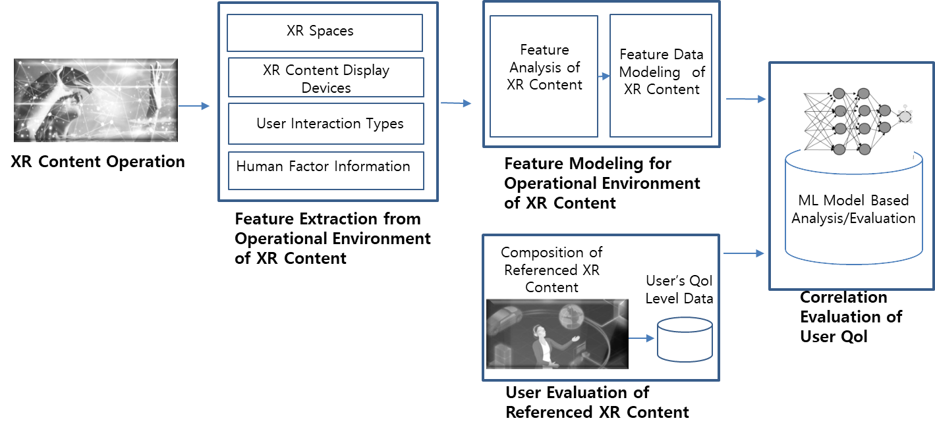
(그림 5-1) Structure of evaluation framework for single user’s QoI on the XR content

5.2.2. Evaluation procedure of a single user QoI

5.2.2.1. Feature extraction for operational environment of XR content
In the step of extracting the features of the operating environment of the XR content, it’s extracted feature elements that affect the user's interaction. These elements affect the user's interaction in the process of experiencing the XR content being operated.
These elements represent the features of the operating environment in the XR space. Features that may affect user interaction can be divided into the following three parts. These are XR content and environmental information, user interaction information, and user human factor-related information. (Figure 5-2) showed the XR content feature Information for XR content operational environment. As shown in (Figure 5-2), the operating environment information part may consist of AR/VR/MR content information, XR content operational environment map, and XR content operational device information. The user interaction information part may consist of hand gesture information, interaction user interaction interface, and interaction context information. The user human factor information part may include eye tracking information, user posture information, user emotion information, and bio-signal measurement information.

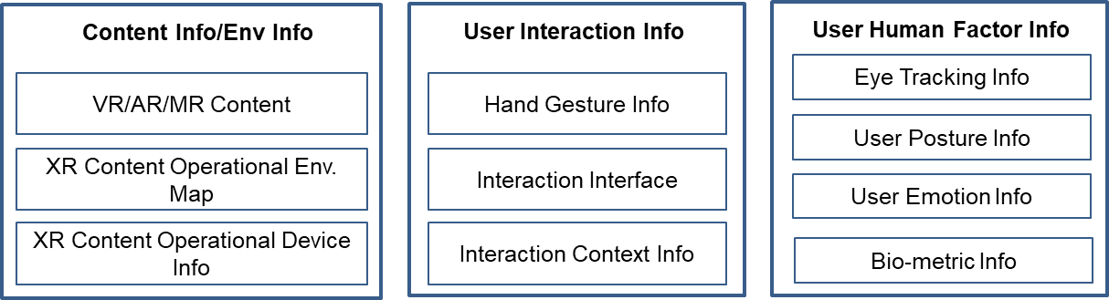
(그림 5-2) XR content feature Information for XR content operational environment

5.2.2.2. Feature data modeling for operational environment of XR content
In the modeling step of the operating environment features of XR content, it’s analyzed feature information on the XR content and the XR content operating environment. By applying this analysis result, it is transferred to the step of modeling the XR content feature data. (Figure 5-3) showed the feature data analysis of XR content for XR feature modeling. The feature data analysis can be divided into the following three parts. These parts are XR content information analysis data, eye tracking information analysis data, and user human emotion information data. XR content information analysis data part may include complexity information on the XR space of the XR content, content image depth-map information, optical flow information of the XR content image, and spatial frequency distribution information of the XR content image. Eye tracking information analysis data part may include foveation information, saccade information, saliency sensing information, and eye fixation information. User emotion information analysis data part may include face detection information, user emotion information, and user attention information.

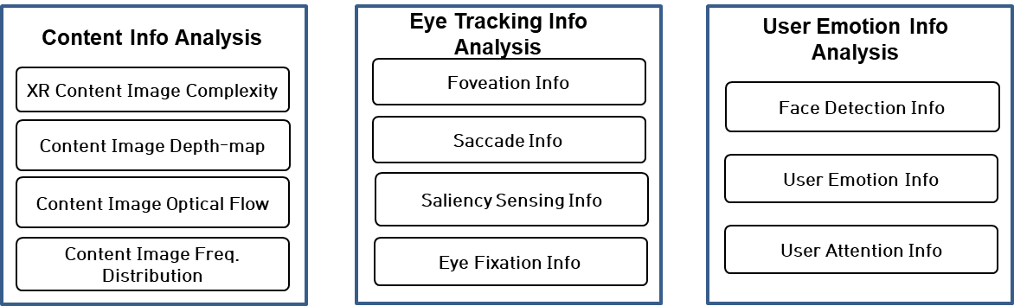
(그림 5-3) Feature data analysis of XR content for XR feature modeling

(Figure 5-4) presented feature data modeling process for XR content feature information. In order to evaluate the user's interaction quality for XR content, it should precede content image recognition modeling process and face/bio-metric information recognition modeling process before the ongoing integrated recognition modeling process. In the content image recognition modeling stage, it should be used XR content image recognition information, XR content image depth-map recognition information, and user interaction recognition information. In the user's face/bio-metric information recognition modeling stage, it might be included user’s bio-metric information-based emotion data, user’s face information-based emotion data, user movement intensity data, and user interaction accuracy data. In the integrated recognition modeling stage, it’s utilized a few information of user interaction intensity, XR content image visual attention, user emotion synchronization data, and user fatigue and presence level.

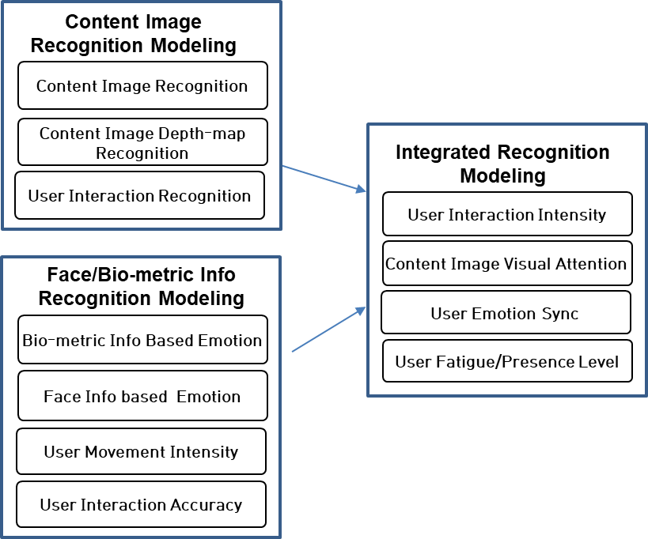
(Figure 5-4) Feature data modeling for XR content feature information

5.2.2.3. User’s evaluation of referenced XR content
In the user’s evaluation step for referenced XR content, it should be obtained first user’s interaction evaluation result data used as a criterion for user’s QoI. What should be possible is the appropriate extraction of XR content features and XR content operating environment features information that can affect the user's QoI. The first thing to do for feature information extraction is to design XR space composition and user test procedures for referenced XR content. By applying the test procedure, user’s QoI evaluation data is obtained in advance for user’s interaction satisfaction on the referenced XR space..

5.2.2.4. ML based correlation evaluation of user’s QoI
In the machine learning-based user's QoI correlation evaluation stage, the operating environment features modeling data of XR content are used to evaluate the user's QoI. In addition, user evaluation information on referenced XR content will be used. In order to evaluate the correlation of the user experienced QoI, a machine learning algorithm is applied by inputting operating environment information of XR content and actual QoI information of the user. Through these procedures, a correlation map for user’s QoI is constructed. (Figure 5-5) presented procedure for ML data model-based user’s QoI measuring of XR content. In the method of applying the machine learning data model, it was divided to the learning stage and the prediction stage. In the learning stage, XR content feature information is extracted from XR content and operating environment information, and user’s QoI correlation map is created through analysis and XR content operating feature modeling process. In the prediction stage, the user’s QoI correlation map generated in the learning stage is used to generate a QoI prediction value for active XR content through the user’s QoI prediction model.

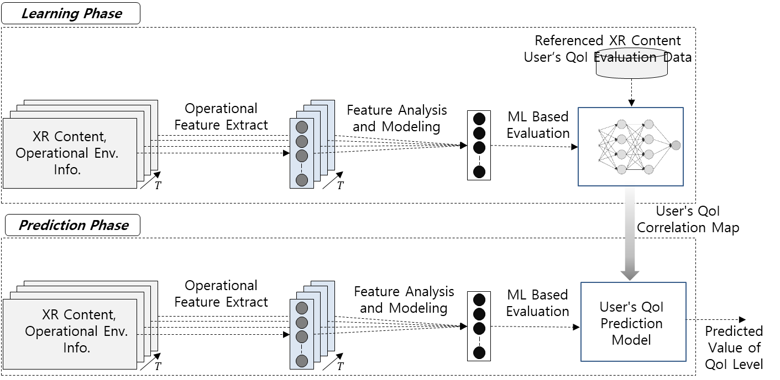
(Figure 5-5) Procedure for ML data model based user’s QoI measuring of XR content

5.3. Evaluation of multiple user’s QoI

5.3.1. Structure of framework for multiple user’s QoI
In the process of multiple users participating in the XR content service experience, each interaction input of multiple users is processed. What is evaluated here is the level of whether the reflection result in the XR space is appropriately reflected according to the interaction intention of multiple users. This evaluation result is viewed as multi-user interaction quality satisfaction. In this way, a method of measuring and evaluating the QoI of multiple users is processed. (Figure 5-6) showed structure of evaluation framework of multiple user’s QoI on the XR content. As shown in (Figure 5-6), the following four steps should be performed for evaluating the QoI of multiple users participating in the XR content service experience: the step of extracting the features of each user's XR content and operating environment from the multi-user XR content operating environment, the step of analyzing the features of the operating environment of the XR content for each of the multiple users and performing the modeling of the operating features, the step of performing multi-user evaluation on referenced XR content, the stage of evaluating the correlation of integrated QoI to multi-user interaction. The QoI evaluation framework between a single user and multiple users differ in the scale of users participating in the XR content service experience. Another difference is that each user has to go through a process of extracting XR content operating feature information. In addition, there is a difference in the method of applying a multidimensional machine learning data model to the modeling data of the features of the XR content operating environment for each user. An integrated process for user-specific QoI evaluation data is also performed in the multi-user evaluation stage for referenced XR content.

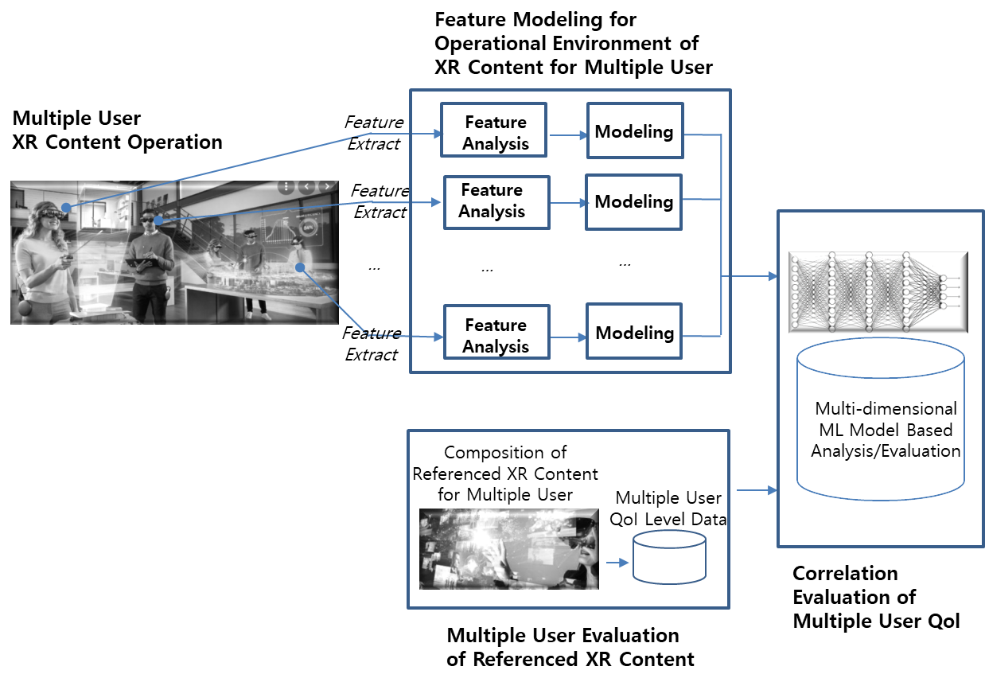
(Figure 5-6) Structure of evaluation framework of multiple user’s QoI on the XR content

5.3.2. Evaluation procedure of multiple user’s QoI

5.3.2.1. User-specific feature extraction for operational environment of XR content
The XR content feature information and XR content operating environment features are extracted for each user for multiple users experiencing XR content services in the feature extraction stage for the XR content operating environment in which multiple users participate. These features contribute to the user's QoI. In the step of extracting feature information on the XR content operating environment for multiple users, feature extraction information on the XR content operating environment described in section 5.2.2.1 (Feature extraction for operational environment of XR content for a single user’s QoI) is extracted for each user's interaction on the XR content.

5.3.2.2. User-specific feature data modeling for operational environment of XR content
Operating feature information for each XR content is analyzed in the feature modeling step for the XR content operating environment in which multiple users participate. The analysis process proceeds according to the operating feature experienced by each user for XR content services. Using this process, feature modeling data is calculated. In the environmental feature modeling step for the operating of XR content for multiple users, the operating environmental features modeling step of XR content mentioned in section 5.2.2.2 (Feature data modeling for operational environment of XR content for a single user’s QoI) is performed for each user of multiple users. The operating environment modeling data is generated for each user interaction on the XR content.

5.3.2.3. Multiple user’s evaluation of referenced XR content
The user-specific QoI evaluation data of referenced XR content for multiple users is generated and integrated in the multi-user evaluation stage of referenced XR content. In this stage, user’s QoI evaluation data of referenced XR content for a single user may be directly utilized.

5.3.2.4. Multi-dimensional ML based correlation evaluation of multiple user’s QoI
the operating environment features modeling data of each user's XR content are integrated in the multidimensional machine learning-based multi-user usage integrated QoI correlation evaluation stage. This is to reflect the results of interaction in the XR space experienced by each user for face-to-face/non-face-to-face multiple users participating in the XR content experience. A multidimensional machine learning algorithm is applied to utilize the operating environment feature modeling data for each user. In addition, an integrated QoI correlation evaluation is conducted appropriately for multiple users on the method of evaluating user’s QoI for XR content for individual users. This procedure leads to an integrated process for evaluating the correlation of additional user’s QoI.

6. Conclusions
In this proposal, a method of evaluating QoI for single users and multiple users was described. In order to evaluate the user's QoI, it is necessary to define and extract feature data of XR content operating environment. In addition, the extracted feature data is analyzed and feature modeling is performed. In the user’s QoI correlation analysis stage to which the machine learning data model is applied, the actual user’s QoI on the XR space is predicted based on the reference user’s QoI. Through this series of processes, framework criteria for evaluating the user's QoI are proposed. Using this evaluation framework, it will be possible to use it as a standard for the quality evaluation grading and rating of the XR content.

