Project | Human Factor for Immersive Content  <http://sites.ieee.org/sagroups-3079/ >
Title | The Automatic Calibration Procedure of the Device Coordinates Providing the Projection Mapping Content
DCN | 3079-21-0078-00-0002
Date Submitted | October 01, 2021
Source(s) | Sangkwon Peter Jeong ceo@joyfun.kr (JoyFun Inc.)  GookHwan Lee ghlee@joyfun.kr (JoyFun Inc.)  Jimmy Jang marketing@joyfun.kr (JoyFun Inc.)  HyeonWoo Nam hwnam@dongduk.ac.kr (Dongduk Women's Univ. )
Re:
Abstract | This document describes a procedure and a method for the automated calibration between two coordinate systems above.
Purpose | The purpose of this document is to  이 문서의 목적은 프로젝션 맵핑을 활용한 혼합현실 장치의 좌표계 자동 보정 절차를 표준에 반영하는 것이다.
Notice | This document is offered as a basis for discussion and is not binding on the contributing individual(s) or organization(s). The material in this document is subject to change in form and content after further study. The contributor(s) reserve(s) the right to add, amend or withdraw material contained herein.
Release | The contributor grants a free, irrevocable license to the IEEE to incorporate material contained in this contribution, and any modifications thereof, in the creation of an IEEE Standards publication; to copyright in the IEEE’s name any IEEE Standards publication even though it may include portions of this contribution; and at the IEEE’s sole discretion to permit others to reproduce in whole or in part the resulting IEEE Standards publication. The contributor also acknowledges and accepts that IEEE 3079 may make this contribution public.
Patent Policy | The contributor is familiar with IEEE patent policy, as stated in Section 6 of the IEEE-SA Standards Board bylaws <http://standards.ieee.org/guides/bylaws/sect6-7.html#6> and in Understanding Patent Issues During IEEE Standards Development http://standards.ieee.org/board/pat/faq.pdf

The Automatic Calibration Procedure of the Device Coordinates Providing the Projection Mapping Content

- Applied Area

When the relevant content is provided by a mixed reality content providing device using the RGB-D sensor, which is built into the beam projector, and depth camera, the beam projector displays the user interface, and the RGB-D sensor detects the user’s motion.
When installing the mixed reality content providing device, even if the coordinates are corrected manually, the coordinate system may be distorted due to external shock or vibration when using the device. Also, the coordinate system correction of the projection area of the beam projector and the recognition area of the RGB-D sensor should be able to be automatically corrected.

- Adjustment Procedure of Coordinate system

This chapter describes the procedure for adjusting the coordinate system of the RGB-D sensor built into the depth camera and the projection area of the beam projector.

  - Adjustment Environment of Coordinate system

When the relevant content is provided by a mixed reality content providing device using the RGB-D sensor, which is built into the beam projector, and depth camera, the beam projector displays the user interface, and the RGB-D sensor detects the user’s motion.
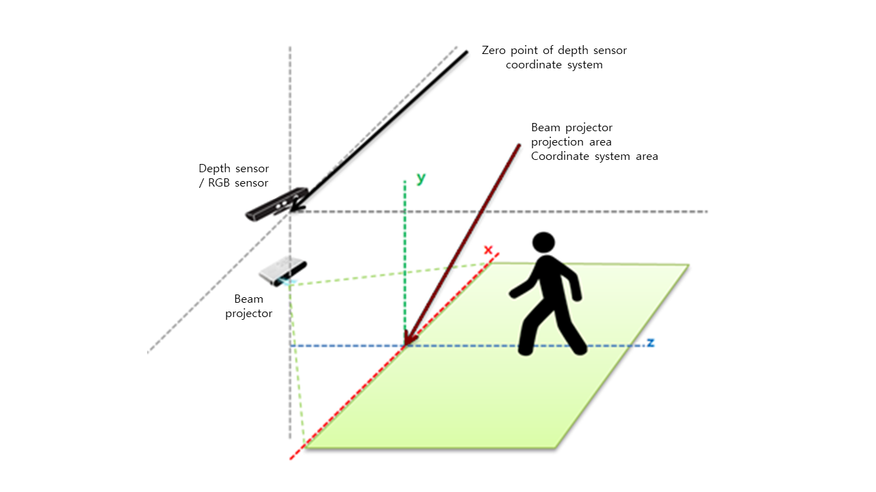
(Figure 2-1) Comparison of RGB-D sensor coordinate system and projection area coordinate system
Since the RGB-D sensor built into the beam projector and the depth camera is an independent device, an independent coordinate system exists as shown in the figure above, and related functions must be implemented by mapping these coordinate systems when implementing content.
Since the content development environment and the content operation and installation environment are different, the coordinates must be manually adjusted when installing the device.
Unlike the development environment, the distance between the beam projector and the floor may be different in the installation environment. Also the distance or direction between the RGB-D sensor and the beam projector may be different.
Even if such coordinate correction is manually performed when installing a mixed reality content providing device, this coordinate system may be distorted by external impact or vibrations when using the device.
In order to correct the distortion of the coordinate system, that is, to provide mixed reality content smoothly, the coordinate system adjustment of the projection area of the beam projector and the recognition area of the RGB-D sensor should be automatically performed.
The RGB-D sensor coordinate system and the coordinate system of the beam projector projection area are adjusted by the following procedure.
(Figure 2-2) Adjustment Procedure of Coordinate system
  - Adjustment Procedure

    - Project an image to be recognized using a beam projector
A beam projector included in the mixed reality content providing device projects an image of a specific color onto the area where the mixed reality content is to be provided.
Repeat the process below while changing this color to another color so that it can be distinguished from the color of the floor.

    - Image acquisition with RGB sensor

The image projected by the beam projector is acquired with the RGB sensor (RGB camera) included in the mixed reality content providing device.

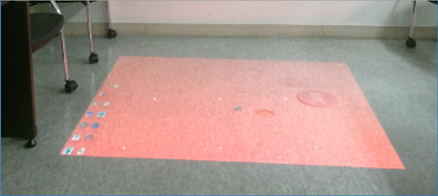
(Figure 2-3) Example screen acquired with RGB sensor

    - Image area Coordinate Recognition

From the image, which is acquired with RGB sensor, an image region of a specific color is found. And a coordinate information in the image of the region is acquired.

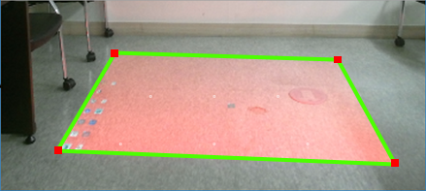
(Figure 2-4) Example screen detecting the area projected by the beam projector

As in the example screen, coordinate information of the four corners of the area projected by the beam projector is acquired.
The coordinate information of the four corners obtained in this way is converted into depth sensor coordinates using a coordinate mapping table between the depth sensor and the RGB sensor.

    - Coordinate adjustment compared to content reference coordinates

The coordinates of the RGB-D sensor and the beam projector projection area are corrected by comparing the depth sensor coordinates for the four corners of the area obtained by projecting with the beam projector in the above step with the reference coordinates applied when developing mixed reality content.

