Project | Human Factor for Immersive Content  <http://sites.ieee.org/sagroups-3079/ >
Title | Reference Model of Hardware System for Providing by Immersive Interactive Fitness Content
DCN | 3079-21-0077-00-0002
Date Submitted | October 01, 2021
Source(s) | Sangkwon Peter Jeong ceo@joyfun.kr (JoyFun Inc.)  GookHwan Lee ghlee@joyfun.kr (JoyFun Inc.)  Jimmy Jang marketing@joyfun.kr (JoyFun Inc.)  HyeonWoo Nam hwnam@dongduk.ac.kr (Dongduk Women's Univ. )
Re:
Abstract | This document synchronizes beam project and depth camera with gesture recognition. Through the data interlocking between them, This standard suggests conference model of hardware system for providing fitness content instructing and controlling user’s movement.
Purpose | The purpose of this document is to reflect the hardware reference model for the fitness system among immersive content in the standard.
Notice | This document is offered as a basis for discussion and is not binding on the contributing individual(s) or organization(s). The material in this document is subject to change in form and content after further study. The contributor(s) reserve(s) the right to add, amend or withdraw material contained herein.
Release | The contributor grants a free, irrevocable license to the IEEE to incorporate material contained in this contribution, and any modifications thereof, in the creation of an IEEE Standards publication; to copyright in the IEEE’s name any IEEE Standards publication even though it may include portions of this contribution; and at the IEEE’s sole discretion to permit others to reproduce in whole or in part the resulting IEEE Standards publication. The contributor also acknowledges and accepts that IEEE 3079 may make this contribution public.
Patent Policy | The contributor is familiar with IEEE patent policy, as stated in Section 6 of the IEEE-SA Standards Board bylaws <http://standards.ieee.org/guides/bylaws/sect6-7.html#6> and in Understanding Patent Issues During IEEE Standards Development http://standards.ieee.org/board/pat/faq.pdf
Reference Model of Hardware System for Providing by Immersive Interactive Fitness Content

- Introduction

The following presents an appropriate standard reference model by identifying the minimum configuration of each hardware device required to provide realistic interactive fitness content, and by confirming the role and performance system for each configuration. In order to draw interaction by extracting the shape of each joint from all the user’s movements and guiding it accurately in real-time, an effective service using a reference model, which is synchronized with the motion recognition unit using a depth camera, the monitor unit for motion guide, the projection unit to present points for main posture correction, and the system unit for organically control of mutual data in real-time, should be constructed.

- Constitution and Scope

This standard presents a hardware system reference model for providing realistic interactive fitness contents. The composition of this standard is as follows. It presents the hardware system reference model by clearly defining the character of construction modules such as projector unit, monitor unit, motion recognition unit, and system unit, which controls each driving unit, distributes and transmits data, and drives programmed fitness contents.

- Concept of Immersive Interactive Fitness Content

The immersive interactive content-based fitness system solves the temporal and spatial constraints, so that you can train your physical fitness anytime and anywhere. The hardware system reference model for realizing a fitness system based on realistic interactive content is constructed to maximize the exercise effect while the user feeling the sameness with reality in the augmented exercise space. This is done by showing an exercise program with a projector on the floor, which is the user’s exercise space, and when the user exercises according to the program, the motion recognition sensor detects it and displays it on the monitor.
In order to configure an augmented virtual fitness space using the immersive interactive content, it is necessary to display the fitness program written in the immersive interactive content onto the floor with a projector. In addition, it should be configured, so that the entire system can be organically interlocked with each other.
And its construction can be expressed as (Figure 3-1).

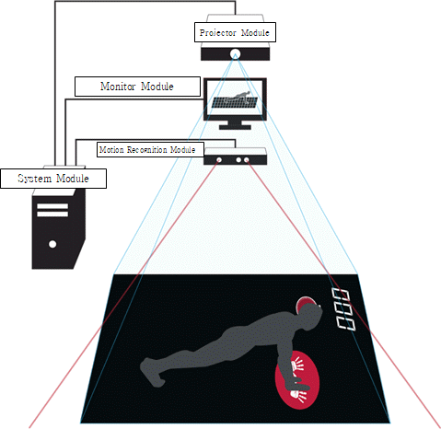
(Figure 3-1) Example of H/W system construction and configuration for providing immersive interactive fitness contents

- Construction of H/W System

To provide effective fitness contents, the hardware reference model for providing realistic interactive fitness contents is composed of a system unit, a projector unit, a monitor unit, and a motion recognition unit.
This reference model standard provides immersive interactive content that expands the experience and sensibility similar to the real thing by letting people to interact with objects or virtual objects, which is available from inducing human senses and cognition in the augmented virtual space. Through this, each module constituting the hardware system, that the exercise system based on realistic interactive content maximizing its effect should have, and the interface between each module are defined.
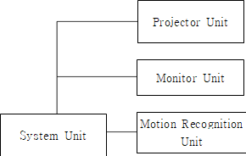
(Figure 4-1) H/W reference model for providing realistic interactive fitness content

  - Construction Module of H/W System

The hardware system for an exercise system based on realistic interactive fitness contents is composed of modules as shown in (Figure 4-2).
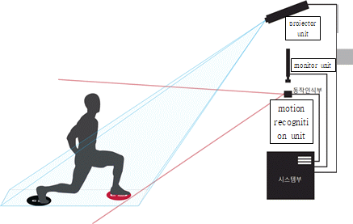
(Figure 6-2) Example of H/W construction to provide immersive interactive fitness content

    - System Unit

The system unit is a module that transmits data so that the projector unit, the monitor unit, and the motion recognition sensor unit can be organically interlocked with each other.

    - Projector Unit

The projector unit is a module that guides the user's motion or transmits an interaction interface image for the user to do fitness, and through this, the user's motion can be controlled.

    - Monitor Unit

The monitor unit is an information output module that serves to guide the user's motion or presents various information related to the exercise progress to the user. The difference from the projector unit is that it does not directly control the user's motion or provide an interactive interface.

    - Motion Recognition Unit

The motion recognition unit is a device module having a function to detect and track a user’s motion, such as a depth camera. Through this, it is detected how accurately the user expresses the fitness movement according to the interaction interface image presented by the projector unit.

  - Role and Operate structure of H/W Module

Each module constituting the hardware system for providing realistic interactive
fitness content has its own roles and performance system. In this regard, the roles and performance system for each component module are as follows.

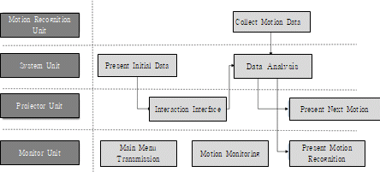
(Figure 4-3) The mutual role of hardware modules and their performance process

    - System Unit

The system unit serves as a terminal that receives and transmits data to and from the projector unit, monitor unit, and motion recognition sensor unit, and at the same time presents initial content data according to the initial data input by the administrator. In addition, it compares and analyzes the data input from the motion recognition unit and the motion suggested by the system, and outputs the corrective action to the monitor unit.

    - Projector Unit

By augmenting the image data received from the system unit on the user’s environment, the projector unit enables fitness in the exercise space. And through this, it suggests and controls the user’s action,

    - Monitor Unit

The monitor unit performs three roles by outputting the image data received from the system unit at the front.
First, it provides the interface that the user can communicate in, so that the fitness program can be smoothly proceeded. For this purpose, various UIs such as main menu transmission are presented.
Second, it guides the user in real-time the actions the user needs to take looking forward.
Third, by outputting the current motion state of the user received from the motion recognition unit, it helps the user to recognize his/her motion status and suggests how to correct the posture.

    - Motion Recognition Unit

The motion recognition unit recognizes the motion by detecting and tracking the motion of the user through the depth camera. The recognized data is transmitted to the system unit to analyze the user's motion and to transmit an appropriate image to the monitoring unit and the projector unit.
All information necessary to analyze the user's motion among various data transmitted from the motion recognition unit to the system unit is performed according to the contents defined in the software system reference model.

  - Interface within each H/W Module

The immersive interactive fitness content hardware system implements a more augmented virtual space through the projector unit, monitor unit, motion recognition unit, and system unit that analyzes and supports their synchronized motions, so that users can enjoy fitness programs there.
The realistic interactive fitness content guides the user's motion through the projector and outputs an augmented image in the user's exercise space. When the user takes a motion according to the exercise program, the motion recognition unit detects the user's motion and transmits it to the system unit. In addition, the system unit provides a fitness environment in which the user can feel the sameness with reality by synchronizing the movement of the fitness program with the user.
The exercise program, which is augmented in the user’s exercise space through the projector unit, is based on realistic interactive content, in which induces human senses and cognition by expanding realistic experiences and emotions, and letting people interact with objects or virtual objects. That is, the fitness program stores the sequence for the user's exercise motion, and the system unit outputs the stored sequence for the exercise motion of the program through the projector. The sequence can be stored in various forms such as a table form, an XML markup language, and a data structure. The stored program is interpreted by the system unit and output through the projector.
The motion recognition unit is composed of at least one camera, a depth camera, an infrared sensor, or a combination thereof to detect the user and the user's movement from the front. A plurality of the motion recognition sensors is installed around the user (front, back, left and right) to generate a multi-view image to recognize the user's motion. By transmitting the collected user, user's movement and spatial information to the system unit, it provides a livelier three-dimensional fitness interface optimized for the user and enables precise user motion recognition.
The monitor unit displays the following information or a combination thereof so that the user can check during or after exercise, so that the user can exercise in a more efficient environment: Exercise amount according to the user's movement, user information, exercise evaluation and result, calories burned, personal health information, own exercise content

    - Motion Recognition Unit and System Unit

The motion recognition unit collects motion data by analyzing the user's skeleton data and image data input through the depth camera, and transmits it to the system unit. The system unit analyzes the data received from the motion recognition unit and checks whether the user's motion matches the programmed data.

    - Projector Unit and System Unit

The projector unit projects the image transmitted from the system unit to a specific space. The system unit provides an interface for interacting with the user, and also a guide for the motion that the user needs to perform using the projector unit.

    - Monitor Unit and System Unit

Like the projector unit, the monitor unit outputs the image transmitted from the system unit. In particular, to make user monitor his/her motion, it outputs image data transmitted to the system unit from the depth camera of the motion recognition unit. And it also suggests corrective actions for errors compared to programmed actions.

    - Projector Unit and Monitor Unit

The projector unit and the monitor unit serve as a display for outputting image data from the system unit. Therefore, they are completely synchronized by the mutual system unit, and allow the user to proceed with a smooth fitness.

