Project | Human Factor for Immersive Content  <http://sites.ieee.org/sagroups-3079/ >
Title | Reference Model of Software System for Providing by Immersive Interactive Fitness Content
DCN | 3079-21-0076-00-0002
Date Submitted | October 01, 2021
Source(s) | Sangkwon Peter Jeong ceo@joyfun.kr (JoyFun Inc.)  GookHwan Lee ghlee@joyfun.kr (JoyFun Inc.)  Jimmy Jang marketing@joyfun.kr (JoyFun Inc.)  HyeonWoo Nam hwnam@dongduk.ac.kr (Dongduk Women's Univ. )
Re:
Abstract | This document synchronizes beam project and depth camera with gesture recognition. Through the data interlocking between them. This standard suggests conference model by defining role and interface of each module in software system for providing fitness content instructing and controlling user’s movement. .
Purpose | The purpose of this document is to reflect the software reference model for the fitness system among immersive content in the standard.
Notice | This document is offered as a basis for discussion and is not binding on the contributing individual(s) or organization(s). The material in this document is subject to change in form and content after further study. The contributor(s) reserve(s) the right to add, amend or withdraw material contained herein.
Release | The contributor grants a free, irrevocable license to the IEEE to incorporate material contained in this contribution, and any modifications thereof, in the creation of an IEEE Standards publication; to copyright in the IEEE’s name any IEEE Standards publication even though it may include portions of this contribution; and at the IEEE’s sole discretion to permit others to reproduce in whole or in part the resulting IEEE Standards publication. The contributor also acknowledges and accepts that IEEE 3079 may make this contribution public.
Patent Policy | The contributor is familiar with IEEE patent policy, as stated in Section 6 of the IEEE-SA Standards Board bylaws <http://standards.ieee.org/guides/bylaws/sect6-7.html#6> and in Understanding Patent Issues During IEEE Standards Development http://standards.ieee.org/board/pat/faq.pdf
Reference Model of Software System for Providing by Immersive Interactive Fitness Content

- Introduction

If the existing motion recognition contents were able to interact with the user only with the depth camera and the front display Fitness content which requires the presentation of sophisticated motion guides should provide more data as sensory and cognitive information to users so that more sophisticated postures can be measured and corrected. For these technologies such as mulch-display technique projection technique and mutual data real-time synchronization must be optimized.
This standard presents a reference model for the software system configuration so that realistic interactive fitness contents can be smoothly serviced.

- Constitution and Scope

This standard presents a software system reference model for providing realistic interactive fitness contents. The composition of this standard is as follows. It presents reference steps such as data transmission between the motion recognition detection unit the posture correction unit based on the front view and the motion presentation unit based on the bottom view which constitute the system and presents a software system reference model by clearly defining the characteristics of each stage technology. In this paper the software system configuration module the role of each module and the execution system are described in detail for each function.

- Software system reference model

By inducing human senses and cognition in the augmented virtual space, people and things, and people and virtual objects interact, and by providing realistic interactive content that expands realistic experiences and emotions it provides an exercise system and method based on realistic interactive content that maximizes exercise effects.
In order to recognize the user's motion using realistic interactive content, there is no need to separately install additional sensors on the user's body or operate auxiliary exercise equipment, and in order to provide an exercise system and method that can automatically recognize the user and the user's exercise space and exercise anytime and anywhere regardless of time and place, A software system reference model composed of a remote system and a local system is presented as (Figure 3-1).
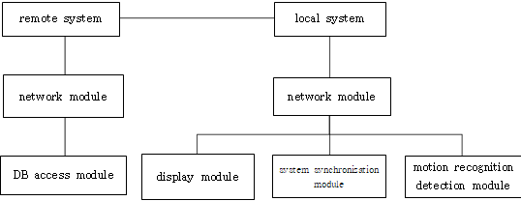
(Figure 3-1) Software system reference model for providing realistic interactive fitness contents

  - Software system module

Realistic interactive fitness content is divided into 'remote system' and 'local system'. The remote system consists of the ‘exercise program DB’ with various exercise programs and the ‘user DB’ where the user’s personal information is managed. The user DB has various information about the user, and in particular, it is possible to present a 'customized exercise' to the user by using the 'user exercise history DB'.
The local system uses the 'wired/wireless interface module' to provide the user with the contents recommended by the 'user-customized exercise DB' provided by the 'remote system'. The 'exercise interface providing module' is synchronized with the 'motion recognition detection module' and 'display module' so that users can utilize interactive fitness content.

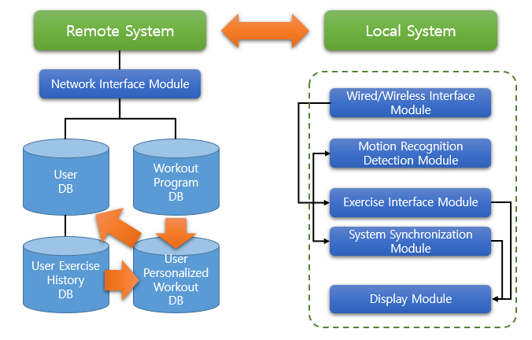
(Figure 3-2) Software system configuration module for providing realistic interactive fitness contents

Accordingly, realistic interactive fitness contents are composed of the following software system modules.

    - Remote System

The remote system consists of a network interface module and DB group to communicate with the local system. The network interface module consists of a module in charge of the network and a DB access module that accesses the DB, stores information in the DB, and extracts information for transmission to the local system.

      - Network Interface Module

The network interface module is a module in which the remote system performs the role of storing or extracting DB information and TCP/IP network communication with the local system.

      - User DB

The user DB is a database in which user information is stored.

      - User workout history DB

The user exercise history DB is a database in which exercise performance information of the user is stored.

      - Workout program DB

The exercise program DB is a database in which various exercise program information is stored.

      - Custom workouts DB

The user-customized exercise DB is a database that provides exercise optimized for each individual.

    - Local system

The local system consists of each independent module and an interface between the modules. The wired/wireless interface module, the exercise interface providing module, and the system synchronization module are composed of one system. The motion recognition detection module and display module are each composed of different systems. Therefore, in the interface between systems, the flow of data is defined as input/output.

      - Wired/Wireless Interface Module

The wired/wireless interface module of the local system enables smooth TCP/IP network communication with the remote system like the network interface module of the remote system.

      - Motion Recognition Detection Module

The motion recognition detection module interworks the skeleton information and skin information collected through the depth camera with the exercise interface providing module and the system synchronization module.

      - Exercise Interface Module

The exercise interface providing module is a module that provides an interface so that a user can exercise.

      - System Synchronization Module

The system synchronization module enables all modules operating in the local system to be synchronized and to transmit data organically.

      - Display Module

The display module is a module that outputs graphic image data transmitted from the system synchronization module to the hardware projection unit and the monitor unit, respectively.

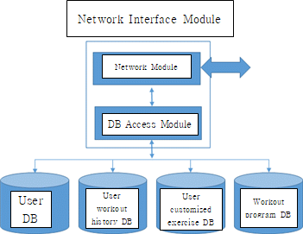
(Figure 3-3) Mutual roles and execution process of remote system configuration modules

  - Software module role and performance system

Each module of the remote system and local system constituting the software system for providing realistic interactive fitness content has a role and performance system, respectively. In this regard, the roles and execution system for each component module are as follows.

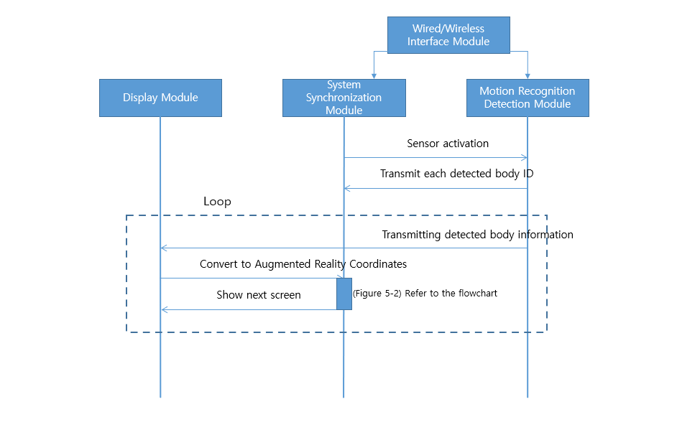
(Figure 3-4) Mutual Roles and Execution Process of Local System Configuration Modules

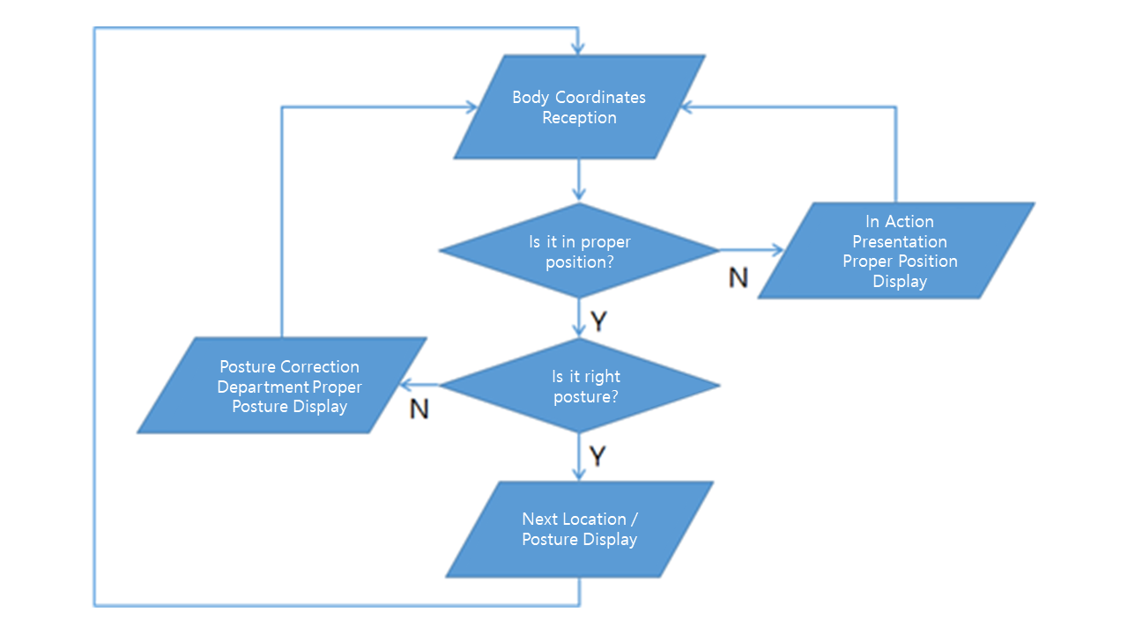
(Figure 3-5) System logic of work module in Loop of software sequence diagram

    - Remote System

It manages exercise information that can provide optimal exercise to the user by transmitting and receiving user information of the exercise system based on realistic interactive content and the local system.

      - Network Interface Module

The network interface module allows the remote system to communicate with the local system over TCP/IP networks, through this, it acts as a gateway to transmit the contents of the user DB, exercise program DB, user exercise history DB, and user-customized exercise DB of the remote system as needed.

      - User DB

The user DB includes information such as the user's name, gender, age, payment history, and membership subscription period, and is particularly equipped with a security module for personal information.

      - User workout history DB

The user exercise history DB is the history of past and recent exercise by the use, this is basic information that can recommend an accurate exercise program for the user. This information is stored 1:1 subordinate to the user DB.

      - Workout program DB

The exercise program DB contains various exercise contents, an exercise program is combined by combining about 10 to 15 types of content. Each exercise content is composed of a set unit, and the exercise program consists of 'Warm Up', 'Main Exercise', and 'Cool Down'.

      - User customized exercise DB

The exercise program consists of a combination of exercise contents in the exercise program DB according to a certain rule, unlike general configuration programs, there are also exercise programs that are created according to the user. In this case, the program is created only for a specific user. A corresponding program is a cyclic process that is created based on the exercise history DB of the user and is stored again as the user exercise history DB through the user DB.

    - Local system

An exercise system based on realistic interactive content recognizes a user in real time through a motion recognition sensing module. It also transmits and receives the user's exercise information and spatial information, where the user locates, to and from the remote management system. And the user's exercise information is managed by the remote management system.
The display module provides the user a workout space and includes the projection step that guides the motion according to the exercise interface module. In addition, this projection step includes the motion recognition step of sensing the user’s movement in the exercise space provided by the projector through the motion recognition sensor and the motion control step of providing an exercise program by controlling the projector and the motion recognition sensor through the motion control device.
Also, the motion control stage consists of three main stages. First, there is the 'exercise interface provision step' that provides an exercise interface that guides the user's motions for the exercise program through the projector. Second, there is a 'motion recognition step' of detecting the user's movement according to guidance from at least one or more motion recognition sensors, and finally a 'system synchronization step' of synchronizing the user's movement with the exercise interface.
The exercise program is characterized in that it is a realistic interactive content that allows the user's movement and the exercise interface to feel mutually homogeneous.
This ‘Method of providing exercise system’ may include a function of allowing the interface to accelerate or decelerate in real time according to the user’s motion and automatically adjust the pace according to the user’s physical strength.
It further includes the display step, where the user can check exercise intensity according to his/her movement, exercise evaluation and result, calories burned, personal health, exercise history, and user information or a combination of these.
In addition, it includes a wired/wireless communication step of managing each individual’s exercise information through the ‘remote management system’ or of providing/receiving an exercise program.
It also recognizes the user in real time, and manages the user’s exercise information in real time from the remote management system by communicating the user’s motion and coordinate information with the remote management system.

      - Wired/Wireless Interface Module

The wired/wireless interface module of the local system enables smooth TCP/IP network communication with the remote system like the network interface module of the remote system. Through this, it acts as a gateway to receive the contents of the user DB, exercise program DB, user exercise history DB, and user-customized exercise DB of the remote system as needed.

      - Motion Recognition Detection Module

The motion recognition detection module links the skeleton and skin information, collected through the depth camera, with the exercise interface providing module and the system synchronization module.

      - Exercise Interface Providing Module

The exercise interface providing module is a module that provides an interface so that a user can exercise. This module is synchronized with the motion recognition detection module to perform functions such as matching speed of user motion and exercise interface and progress speed adjustment in parallel.

      - System Synchronization Module

The system synchronization module enables all modules operating in the local system to be synchronized and to transmit data organically. This is the most important part of the entire system, and the motion interface providing module and the display module are operated by analyzing and processing the data received from the motion recognition detection module.

      - Display Module

The display module is a module that outputs graphic image data transmitted from the system synchronization module to a projection unit and a monitor unit, which are hardware. This module consists of various software including a 3D engine for expressing augmented reality.

