Project | Human Factor for Immersive Content Working Group  <http://sites.ieee.org/sagroups-3079/ >
Title | Description Scheme of Facial Image for Personal Recognition of Mixed Reality
DCN | 3079-21-0053-00-0002
Date Submitted | July 15, 2021
Source(s) | Yoon, Kyoungro yoonk@konkuk.ac.kr (Konkuk Univ.)  Bae, Hyo Chul th1q@nate.com (Konkuk Univ.)  Jeong, Sangkwon Peter ceo@joyfun.kr (JoyFun Inc.,)
Re:
Abstract | This document specifies the description scheme of human face region images, which is used for personal recognition of physical world users in mixed reality applications. This description scheme includes a description of face region size and key shape descriptors in the image.
Purpose | This document defines the description method and format of facial images for personal recognition of physical world users in mixed reality. The description method of facial images includes information on the size of the face region and a description of the face shape interface in the image.
Notice | This document is offered as a basis for discussion and is not binding on the contributing individual(s) or organization(s). The material in this document is subject to change in form and content after further study. The contributor(s) reserve(s) the right to add, amend or withdraw material contained herein.
Release | The contributor grants a free, irrevocable license to the IEEE to incorporate material contained in this contribution, and any modifications thereof, in the creation of an IEEE Standards publication; to copyright in the IEEE’s name any IEEE Standards publication even though it may include portions of this contribution; and at the IEEE’s sole discretion to permit others to reproduce in whole or in part the resulting IEEE Standards publication. The contributor also acknowledges and accepts that IEEE 3079 may make this contribution public.
Patent Policy | The contributor is familiar with IEEE patent policy, as stated in Section 6 of the IEEE-SA Standards Board bylaws <http://standards.ieee.org/guides/bylaws/sect6-7.html#6> and in Understanding Patent Issues During IEEE Standards Development http://standards.ieee.org/board/pat/faq.pdf

Description Scheme of Facial image for personal recognition

- Coverage

Various facial recognition programs used in mixed reality receive different facial images as input. At this time, by defining the standard of the facial image required by the program, or by describing the standard of the already acquired facial image, Makes face images used in different face recognition programs compatible.

- Description Scheme of Facial image

  - Introduction

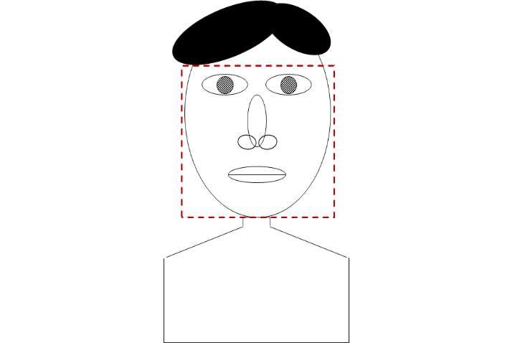

(Figure 2-1) Bounding box for facial region description

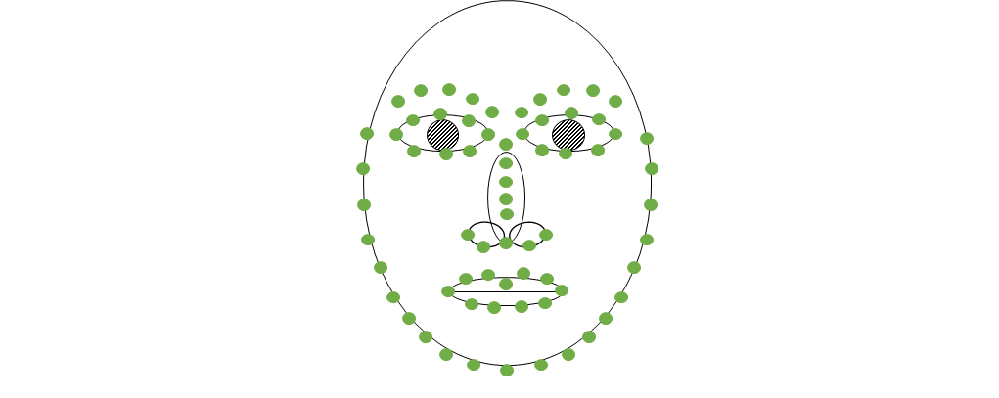
(Figure 2-2) Marking of morphemes for describing facial shapes

The description of the facial image is divided into the description of the face region and the description of the shape of the face. The face region descriptor defines the facial region within a given image as a bounding box like the red dotted rectangle in (Figure 2-1). The facial shape descriptor specifies the location of a specific area within the face that determines the shape of the face as indicated by the green dot in (Figure 2-2). and the number of points used to identify a part may vary depending on each part in face and the technique used.

  - face region descriptor

The face region defines the size of the image as the pixel value of the bounding box as shown in <Table 2-1>. The descriptor defined in <Table 2-1> can be represented as (Figure 2-3). The face region descriptor is arranged in the order of a 4-byte field code and a 2-byte field value, or only field values can be listed in the order of the fields given in <Table 5-1> without field names. The field value is a 2-byte integer value, and it is specified that the lower byte comes first. In the case of text-based descriptions such as XML or JSON, English field names are used as element names.

TopLeftX | x Value | y Value | TopLeftY | x Value | y Value
0x746C6678 | 2-Byte  coordinate | 2-Byte  coordinate | 0x746C6679 | 2-Byte  coordinate | 2-Byte  coordinate
Width | x Value | y Value | Height | x Value | y Value
0x78647468 | 2-Byte  coordinate | 2-Byte  coordinate | 0x68676874 | 2-Byte  coordinate | 2-Byte  coordinate
(Figure 2-3) Transmission format of face region descriptor

<Table 2-1> Detailed description of the face region descriptor
Filed Name | Filed Code | Filed Length | Description
TopLeftX | tlfx | 2byte integer | The x-coordinate of the top-left pixel where the facial region starts in the entire image
TopLeftY | tlfy | 2byte integer | The y-coordinate of the upper-left pixel where the facial region begins in the entire image
Width | wdth | 2byte integer | Width of face region (unit: number of pixels)
Height | hght | 2byte integer | Height of face region (unit: number of pixels)

  - face shape descriptor

The positions of the morphemes given below are arranged in a list form with the top left point as the origin within a specified face region. The descriptor defined in <Table 2-2> can be represented as (Figure 2-4). The face shape descriptor is listed in the order of a 4-byte field code, a 1 byte the number of points, and a 4-byte coordinate value that is repeated as many as the number of points. And if the fields used by the transmitter and the receiver are predefined, only the coordinate values can be listed in a pre-agreed order without field names. The field value is a 2-byte integer value, and it is specified that the lower byte comes first. In the case of text-based descriptions such as XML or JSON, English field names are used as element names.

Filed Code | Number of points | x position of 1st | y position of 1st | x position of 2nd | y position of 2nd | …… | …… | x position of n | y position of n
4 Byte | 1 Byte | 4 Byte | 4 Byte | 4 Byte | 4 Byte | 4 Byte | 4 Byte | 4 Byte | 4 Byte
(Figure 2-4) Transmission format of face shape descriptor

<Table 2-2> Detailed description of the face shape descriptor
Filed Name | Filed Code | Filed Length | Description
LeftJawLine | ljaw | (2 byte integer x 2) x n | List of n equally spaced (x, y) coordinates of the outline of the face from the outline point of the face on the horizontal extension line of the outer endpoint of the left eye to the center point of the lower chin (Excluding the center point of the lower chin)
RightJawLine | rjaw | (2 byte integer x 2) x n | List of n equally spaced (x, y) coordinates of the outline of the face from the outline point of the face on the horizontal extension line of the outer endpoint of the right eye to the center point of the lower chin (Excluding the center point of the lower chin)
Chin | chin | 2 byte integer x 2 | (x, y) coordinates of the center point of the lower chin
LeftEyeBrow | lebr | (2 byte integer x 2) x n | List of (x, y) coordinates expressed as n points equally spaced along the center of the left eyebrow from left to right
RightEyeBrow | rebr | (2 byte integer x 2) x n | List of (x, y) coordinates expressed by n points equally spaced along the center of the right eyebrow from left to right
NoseLine | nsln | (2 byte integer x 2) x n | A list of (x, y) coordinates expressed by n equally spaced points starting from the center point between the two eyes and ending with the nose
NoseBottom | nsbm | (2 byte integer x 2) x n | List of (x, y) coordinates represented by n equally spaced points from the left end to the right end of the lower nose line.
LeftEye | leye | (2 byte integer x 2) x n | List of (x, y) coordinates expressed as n equally spaced points starting from the left end of the left eye and clockwise along the outline
RightEye | reye | (2 byte integer x 2) x n | List of (x, y) coordinates expressed as n equally spaced points starting from the left end of the right eye and clockwise along the outline
OuterLip | olip | (2 byte integer x 2) x n | List of (x, y) coordinates expressed as n equally spaced points starting from the left end of the lip and clockwise along the outer edge of the lips
InnerLip | ilip | (2 byte integer x 2) x n | List of (x, y) coordinates expressed as n equally spaced points starting from the left end of the lip and clockwise along the inner periphery of the lips

- Summary

Many systems use facial images for personal recognition. However, various facial recognition methods have a different specification of images used. Therefore, when using facial recognition, different image specifications should be used according to the facial recognition method. This document defines the description method and format of facial images for personal recognition of physical world users in mixed reality. The description method of facial images includes information on the size of the face region and a description of the face shape interface in the image.

