Project | Cybersickness Reduction Working Group  < https://sagroups.ieee.org/3079/ >
Title | Proposal of New PAR for ‘Basic Framework of Motion Training’
DCN | 3079-21-0044-02-0000
Date Submitted | July 22, 2021
Source(s) | Sangkwon Peter Jeong ceo@joyfun.kr (JoyFun Inc.)  HyeonWoo Nam hwnam@dongduk.ac.kr (Dongduk Women’s University)
Re:
Abstract | This document is about description of PAR to propose motion recognition-based unmanned motion learning standard framework standard.
Purpose | This contribution document’s goal is to get approval by PAR to propose a standard framework standard for unmanned motion learning based on motion recognition.
Notice | This document is offered as a basis for discussion and is not binding on the contributing individual(s) or organization(s). The material in this document is subject to change in form and content after further study. The contributor(s) reserve(s) the right to add, amend or withdraw material contained herein.
Release | The contributor grants a free, irrevocable license to the IEEE to incorporate material contained in this contribution, and any modifications thereof, in the creation of an IEEE Standards publication; to copyright in the IEEE’s name any IEEE Standards publication even though it may include portions of this contribution; and at the IEEE’s sole discretion to permit others to reproduce in whole or in part the resulting IEEE Standards publication. The contributor also acknowledges and accepts that IEEE 3079 may make this contribution public.
Patent Policy | The contributor is familiar with IEEE patent policy, as stated in Section 6 of the IEEE-SA Standards Board bylaws <http://standards.ieee.org/guides/bylaws/sect6-7.html#6> and in Understanding Patent Issues During IEEE Standards Development http://standards.ieee.org/board/pat/faq.pdf

PAR for a New IEEE Standard

Section 1
  - Assigned Project Number:
P3079.2.1
  - Type of Document: Standard, Recommended Practice, or Guide
Standard
  - Life Cycle: Full Use or Trial Use
Full Use.

Section 2
2.1 Project Title:

Basic Framework for Motion Training

Section 3

3.1 Working Group: Cybersickness Reduction Working Group (C/SAB/3079_WG)
3.1.1 Contact Information for Working Group Cahir:
Name: Beom-Ryeol Lee
Email Address: lbr@etri.re.kr
3.1.2 Contact Information for Working Group Vice Cahir:
Name: Wookho Son
Email Address: whson@etri.re.kr
3.2 Society and Committee: C/SAB
3.2.1 Contact Information for Standards Committee Cahir:
Name: Robby Robson
Email Address: robby@computer.org
3.2.2 Contact Information for Standards Committee Vice Cahir:
None
3.2.3 Contact Information for Standards Representative:
None

3.3 Joint Sponsor: (chosen from drop down menu)
If you are not adding a joint sponsor to this project, you may leave this field blank.

Section 4

4.1 Sponsor Balloting Information: Individual or Entity
Individual

4.2 Expected Date of Submission of Draft to the IEEE-SA for Initial Standards Committee Ballot:

Month: Oct. Year: 2024

4.3 Projected Completion Date for Submittal to RevCom

Month: Jun. Year: 2025

Section 5

5.1 Approximate number of people expected to be actively involved in the development of this project:
30

5.2 Scope of the proposed standard:
This standard defines basic framework within the overall architectural framework for motion training system. This standard includes definitions for the functions and input/output interfaces of each component module, and the related data components and formats. By utilizing this standard basic framework, various application-specific UI/UX and service frameworks can be suggested.
5.3 Is the completion of this standard contingent upon the completion of another standard? Yes

5.4 Will this document contain a Purpose clause?
This document will not include a purpose clause.

5.5 Need for the project:
This standard defines the basic framework that can be used in common when developing content for providing various motion training services. The purpose of this is to avoid redundant development work that is involved in developing application-specific UI/UX-driven motion training systems for various service types.
Accordingly, if a basic framework is defined that can be used in common independent of service types, many application-specific UI/UX standard frameworks must be devised. Therefore, this standard for providing a separate common basic framework for motion training lends itself to efficient development of various services for motion training and to developing non-redundant standard framework for various application-dependent UI/UX and services as well.
5.6 Stakeholders for the standard:
Content Providers, Manufacturers, Local Governments, Constructors

Section 6
6.1 Intellectual Property:
A. Is the Sponsor aware of any copyright permissions needed for this project? No
B. Is the Sponsor aware of possible registration activity related to this project? No

Section 7

7.1 Are there other standards or projects with a similar scope? No

7.2 Joint Development - Is it the intent to develop this document jointly with another organization? No

7.3 International Standards Activities
A. Adoptions - Is there potential for this standard to be adopted by another organization?: No
B. Harmonization - Are you aware of another organization that may be interested in portions of this document in their standardization development efforts? No
7.4 Does the sponsor foresee a longer term need for testing and/or certification services to assure conformity to the standard? Yes
Additionally, is it anticipated that testing methodologies will be specified in the standard to assure consistency in evaluating conformance to the criteria specified in the standard? No

Section 8

8.1 Additional Explanatory Notes:
IEEE 3079.2.1 tries to define the standard for Basic Framework as shown in the figure below.
The reason why IEEE 3079.2 wants to separate Basic Framework, UI/UX Framework, and Service Framework is very simple. This is because each item has meaning as an independent standard from the point of view of a content developer for the purpose of actual service.

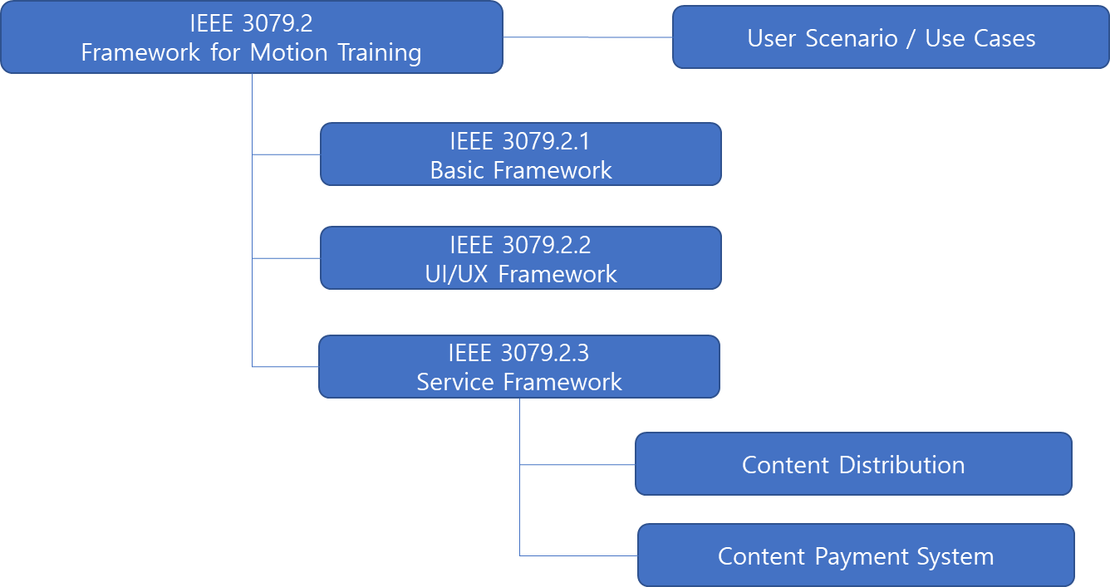

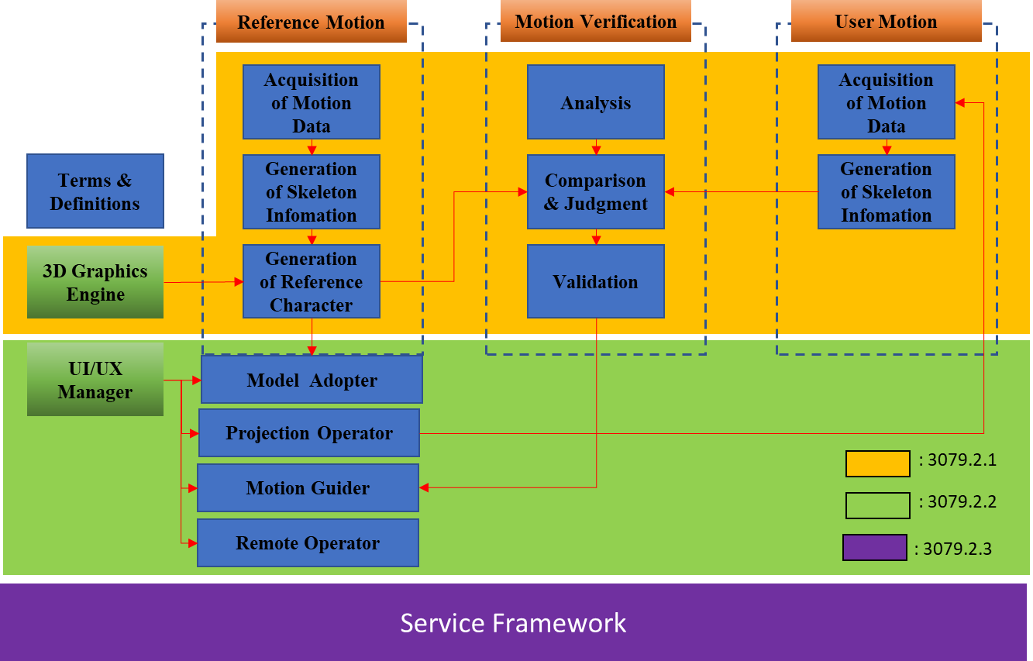

8.2 IEEE Code of Ethics

I acknowledge that I have read and I understand the IEEE Code of Ethics
I agree to conduct myself in a manner that adheres to the IEEE Code of Ethics when engaged in official IEEE business.

