Project | Human Factor for Immersive Content Working Group  <http://sites.ieee.org/sagroups-3079/ >
Title | RGB User Image-based User Motion Correction Instruction Providing System
DCN | 3079-21-0039-00-0002
Date Submitted | July 12, 2021
Source(s) | Sangkwon Peter Jeong ceo@joyfun.kr (JoyFun Inc.)  Gookhwan Lee ghlee@joyfun.kr (JoyFun Inc.)  Jimmy Jaeyoung Jang jimmyjanggg@joyfun.kr (JoyFun Inc.)  HyeonWoo Nam hwnam@dongduk.ac.kr (Dongduk Women’s University)
Re:
Abstract | This contribution document defines input/output interface to interact and guide movement of user effectively when depth camera with gesture recognition function and beam project are synchronized, and content guiding and controlling user's movement is serviced through data exchange between depth camera and beam project.
Purpose | This contribution document is to define input/output interface interaction to develop and service content utilizing projection display and sensor based on gesture recognition using depth camera.
Notice | This document is offered as a basis for discussion and is not binding on the contributing individual(s) or organization(s). The material in this document is subject to change in form and content after further study. The contributor(s) reserve(s) the right to add, amend or withdraw material contained herein.
Release | The contributor grants a free, irrevocable license to the IEEE to incorporate material contained in this contribution, and any modifications thereof, in the creation of an IEEE Standards publication; to copyright in the IEEE’s name any IEEE Standards publication even though it may include portions of this contribution; and at the IEEE’s sole discretion to permit others to reproduce in whole or in part the resulting IEEE Standards publication. The contributor also acknowledges and accepts that IEEE 3079 may make this contribution public.
Patent Policy | The contributor is familiar with IEEE patent policy, as stated in Section 6 of the IEEE-SA Standards Board bylaws <http://standards.ieee.org/guides/bylaws/sect6-7.html#6> and in Understanding Patent Issues During IEEE Standards Development http://standards.ieee.org/board/pat/faq.pdf

RGB User Image-based User Motion Correction Instruction Providing System

1 Coverage

When this technology provides a motion-responsive mixed reality service, there are cases where the user needs to express the image obtained from the RGB camera on the screen. In this case, if the user makes an incorrect motion compared to the 3D character while using the motion-responsive mixed reality service, the coordinates of the part to be corrected are mapped to the RGB user image on the screen. The augmentation mark for posture correction is expressed as the arrow visual symbol.

2 RGB user image-based user behavior calibration instructions system

2.1 Compare 3-D characters to user postures

In order to compare the 3D character and the user's posture, first, the user's 3D character is generated by receiving the user's skeleton information from the motion recognition sensor. Next, the 3D reference character created as a reference for comparing the user's posture with the user's 3D character generated by receiving the user's skeletal information, etc. is compared. For each separation action of the in-progress motion learning, we will continue to compare the coordinates of the body parts of the 3D reference character and the user's 3D character to the correct behavior.

2.2 Mapping user image coordinates obtained with 3-dimensionaluser coordinates and 2-dimensional RGB cameras

When the user proceeds with the classification action, there should be feedback on whether the action was correct or not. Therefore, as you can see in (Figure 1), there should be an indication of whether the motion was correct for the user image acquired with the RGB camera displayed on the screen, and which part was incorrect if it did not match. For this, there must be a mapping between the three-dimensional user coordinates and the user image coordinates acquired by the RGB camera displayed on the screen.
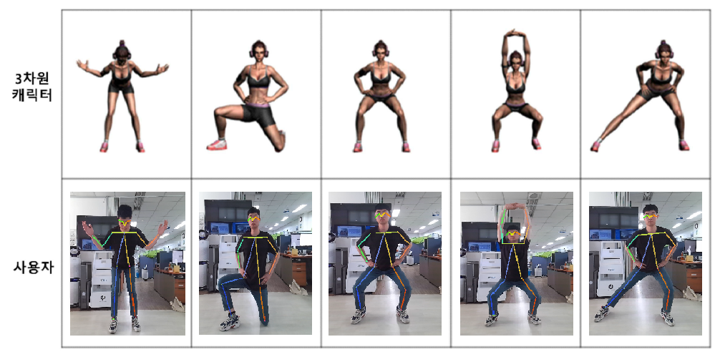
(Figure 1) User images acquired with RGB cameras and 3D character

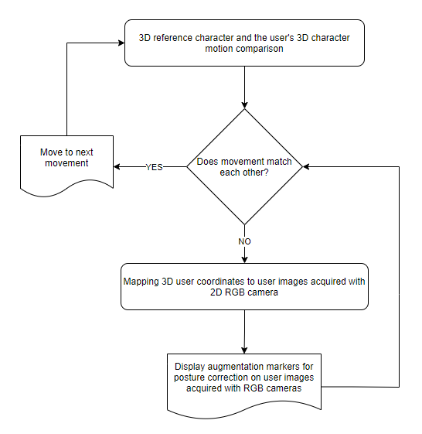
(Figure 2) System flow chart providing user behavior calibration instructions

2.2.1 Mapping detailing

The flowchart (Figure 2) shows the detailed process from whether the above motions match each other and displaying the augmented mark for posture correction on the user image acquired with the RGB camera.
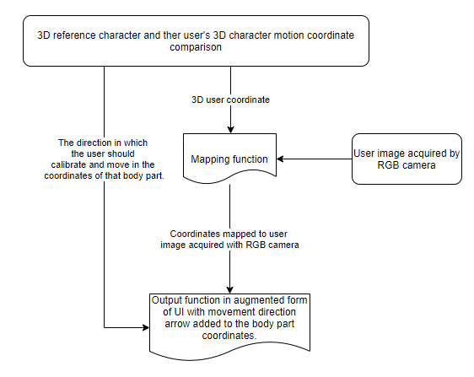
(Figure 4-3) Mapping Detail Flow Chart

The result obtained from the motion recognition sensor in real time will proceed as shown in the chart above (Figure 3).

2.3 Display of augmented markers for posture correction over user images acquired with RGB cameras

The augmented mark for posture correction should be displayed on the user image acquired with the RGB camera with the mapped coordinates (Figure 4). If the body parts being compared with each other have correct movements, a mark indicating that they are correct should be displayed. If incorrect, augmented markers for correcting posture for that body part should be displayed. The mark indicating that the motion was correct is indicated by a blue circled mark on the compared body part. When the movement is incorrect, a red correction instruction mark indicating the direction in which the user should move is displayed for the wrong part of the body part being compared, and a blue circle mark is displayed for the correct part.

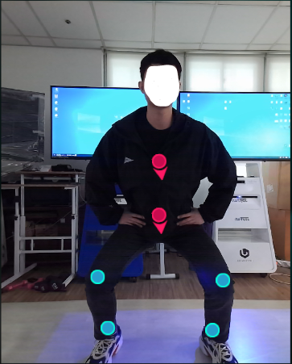

(Figure 4) Display augmented markers for posture correction on top of user images acquired with RGB cameras

3 Complementation of expression methods

The limitation of this technology is that by mapping the 3D user coordinates to the user image acquired with the 2D RGB camera, the user can recognize only the up, down, left and right among the directions in which the user should move by looking at the augmented mark for posture correction, while the depth value is Forward and backward information cannot be recognized. Therefore, it is possible to supplement the motion correction instruction in the forward and backward directions additionally through text or voice.

