Project | Human Factor for Immersive Content Working Group  <http://sites.ieee.org/sagroups-3079/ >
Title | Human Body Keypoint Data Format for Mixed Reality Motion Recognition
DCN | 3079-21-0008-01-0002
Date Submitted | July 15, 2021
Source(s) | Yoon, Kyoungro yoonk@konkuk.ac.kr (Konkuk Univ.)  Bae, Hyo Chul th1q@nate.com (Konkuk Univ.)  Jeong, Sangkwon Peter ceo@joyfun.kr (JoyFun Inc.,)
Re:
Abstract | This standard defines an interface that the basis for the transfer of human body keypoint information between applications in virtual reality and users in the physical world.
Purpose | The purpose of this standard is a body keypoint data format for transferring user body keypoint information from the physical world to the virtual world.
Notice | This document is offered as a basis for discussion and is not binding on the contributing individual(s) or organization(s). The material in this document is subject to change in form and content after further study. The contributor(s) reserve(s) the right to add, amend or withdraw material contained herein.
Release | The contributor grants a free, irrevocable license to the IEEE to incorporate material contained in this contribution, and any modifications thereof, in the creation of an IEEE Standards publication; to copyright in the IEEE’s name any IEEE Standards publication even though it may include portions of this contribution; and at the IEEE’s sole discretion to permit others to reproduce in whole or in part the resulting IEEE Standards publication. The contributor also acknowledges and accepts that IEEE 3079 may make this contribution public.
Patent Policy | The contributor is familiar with IEEE patent policy, as stated in Section 6 of the IEEE-SA Standards Board bylaws <http://standards.ieee.org/guides/bylaws/sect6-7.html#6> and in Understanding Patent Issues During IEEE Standards Development http://standards.ieee.org/board/pat/faq.pdf
Human body key point data format for Mixed Reality Motion Recognition

- Coverage

This standard is applied to a system using human body key point. Human body key point format is composed of environmental information' and 'key point information'.

- Human body key point data format

  - Introduction

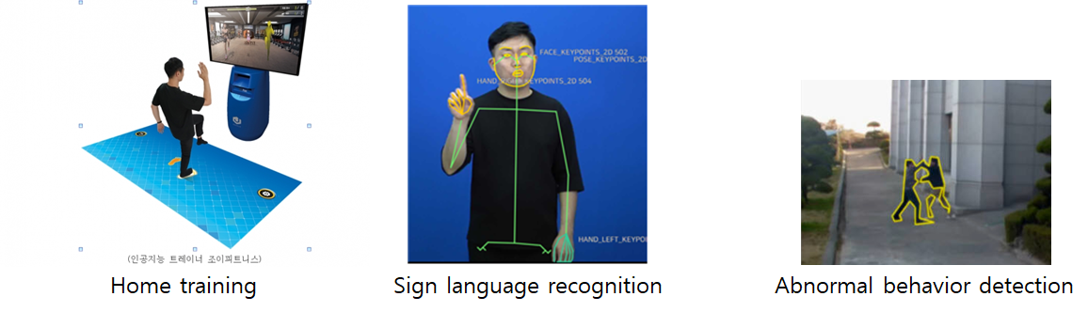
(Figure 2-1) Various systems using human body key point

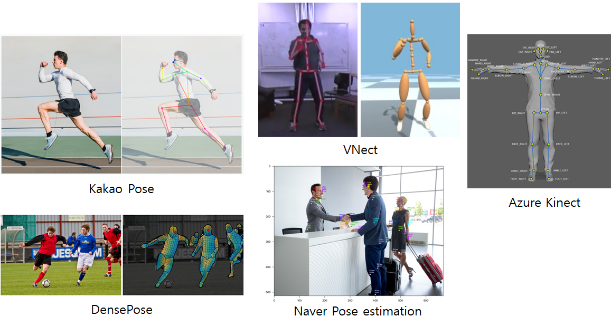
(Figure 2-2) Human pose estimation

Human body key point is used in various systems that recognize human motion, such as sign language recognition, home training, and abnormal behavior detection, as shown in (Figure 2-1). Human body key point generally extracts human body key point information through various methods through RGB camera or depth camera sensor, as shown in (Figure 2-2). However, each of these pose estimation methods differ in the image size, coordinate system, and number of body key points. (Table 2-1) shows the number of body key points according to each human pose estimation method.

(Table 2-1) Number of body key points in human pose estimation method
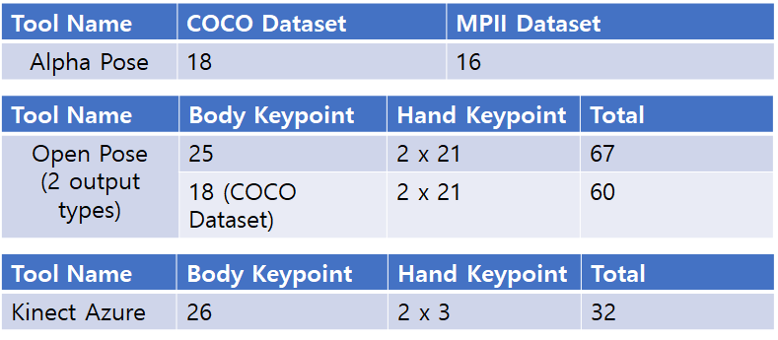

If a standard for the format of human body key point data extracted through various human pose estimation techniques is established, human body key point data required in mixed reality applications can be utilized in various application software regardless of the extraction tool.
This proposal intends to establish a standard for the representation of human body key point information extracted through various posture estimation techniques for systems using human body key points.

  - Structure of Human body key point data format

The human body key point data format consists of an 'environmental information' and a 'key point information' as shown in (Figure 2-3).
The 'environmental information' consists of image size, coordinate system (world coordinate system, camera coordinate system, pixel coordinate system, normalized coordinate system) and camera calibration information such as extrinsic parameter and intrinsic parameters as follow <Table 2-1>.
The 'key point information' consists of the location of the user's key points, connection information between key points, and the type of key points as follow <Table 2-2>. Among them, the location of the key point may be composed of all or part of the lists in <Table 2-3>. The position of each keypoint consists of integer values of x, y, and z.

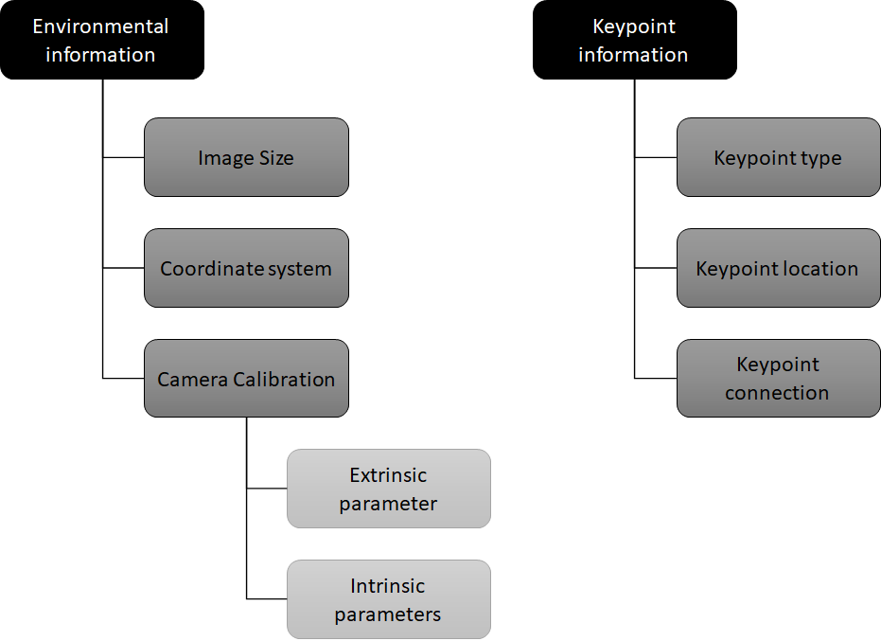
(Figure 2-3) Human body key point data format structure

    - Environmental information
<Table 2-1> Struct of environmental information
Name | Definition | Unit | Value Type
Image Size | Describe the width and height of the image size used for human pose estimation. | Pixel | Integer
Coordinate system | Describe the four coordinate systems.  Select one of the world coordinate system, camera coordinate system, normal coordinate system, and pixel coordinate system. | - | String
Camera Calibration | Describes the transformation relationship between 3D spatial coordinates and 2D image coordinates, or a parameter describing the transformation relationship | - | -
Extrinsic parameter | Describes the transformation relationship between the camera coordinate system and the world coordinate system. | - | -
Rotation | Describes the rotation between the camera coordinate system and the world coordinate system. |  | Matrix (float)
Translation | Describes the origin of the world coordinate system expressed in the coordinates of the camera-centered coordinate system. |  | Matrix (float)
Intrinsic parameters | Parameter for obtaining the projected position on the image or restoring the 3D spatial coordinate from the image coordinate | - | -
Focal length (fx, fy) | Describe the distance between the center of the lens and the image sensor (CCD, CMOS, etc.). | Pixel | Float
Principal point (cx, cy) | Describe the position of the center(pinhole) of the camera lens. | Pixel | Float
Skew coefficient | Describe the distortion coefficient between the x-axis and y-axis of the image sensor. | Degree | Float

    - Key point information
<Table 2-2> Struct of key point information
Name | Definition | Unit | Value Type
Key point type | Describe a list of names and numbers of available key points. |  | Array (String)
Key point location | Describe the location of key points.  For 2D key points, X, Y are described, and for 3D key points, X, Y, Z are described. | pixel | Array (Integer)
Key point connection | Describes connection information between key points. |  | Array (Integer)

<Table 2-3> List of key point location
Name | Definition | Unit | Value Type
CervicalVertebra1 | 1st cervical vertebra that supports the skull | pixel | Integer
CervicalVertebra2 | 2nd cervical vertebra (neck) | pixel | Integer
CervicalVertebra3 | 3rd cervical vertebra (neck) | pixel | Integer
CervicalVertebra4 | 4th cervical vertebra (neck) | pixel | Integer
CervicalVertebra5 | 5th cervical vertebra (neck) | pixel | Integer
CervicalVertebra6 | 6th cervical vertebra (neck) | pixel | Integer
CervicalVertebra7 | 7th cervical vertebra, lowest cervical vertebra | pixel | Integer
LeftEye | Left eye (center of pupil) | pixel | Integer
RightEye | Right eye (center of pupil) | pixel | Integer
LeftEyeBrow | the rightmost tip of the left eyebrow | pixel | Integer
RightEyeBrow | the leftmost tip of the right eyebrow | pixel | Integer
LeftEar | left ear canal | pixel | Integer
RightEar | right ear canal | pixel | Integer
Nose | the highest part of the nose | pixel | Integer
LeftClavicle | The part of the left clavicle that connects | pixel | Integer
LeftShoulder | The part where the left shoulder blade connects to the arm bone | pixel | Integer
LeftElbow | upper and lower joints of the left arm | pixel | Integer
LeftWrist | The joint where the left arm and hand connect | pixel | Integer
LeftHand | center of left hand | pixel | Integer
RightClavicle | The part of the right clavicle that connects to the sternum | pixel | Integer
RightShoulder | The part where the right shoulder blade connects to the arm bone | pixel | Integer
RightElbow | The upper and lower joints of the right arm | pixel | Integer
RightWrist | The joint where the right arm and hand connect | pixel | Integer
RightHand | right palm center | pixel | Integer
ThoracicVertebra | spine, roughly in the middle of the stomach | pixel | Integer
ThoracicVertebra1 | 1st thoracic vertebrae, connecting to the cervical vertebrae | pixel | Integer
ThoracicVertebra2 | 2nd thoracic vertebrae (spine) | pixel | Integer
ThoracicVertebra3 | 3rd thoracic vertebrae (spine) | pixel | Integer
ThoracicVertebra4 | 4th thoracic vertebra (spine) | pixel | Integer
ThoracicVertebra5 | 5th thoracic vertebrae (spine) | pixel | Integer
ThoracicVertebra6 | 6th thoracic vertebrae (spine) | pixel | Integer
ThoracicVertebra7 | 7th thoracic vertebrae (spine) | pixel | Integer
ThoracicVertebra8 | 8th thoracic vertebrae (spine) | pixel | Integer
ThoracicVertebra9 | 9th thoracic vertebrae (spine) | pixel | Integer
ThoracicVertebra10 | 10th thoracic vertebra (spine) | pixel | Integer
ThoracicVertebra11 | 11th thoracic vertebra (spine) | pixel | Integer
ThoracicVertebra12 | 12th thoracic vertebrae (spine), connected to the lumbar vertebrae | pixel | Integer
LumbarBertebra | The lumbar spine, roughly in the area of ​​the navel | pixel | Integer
LumbarBertebra1 | 1st lumbar vertebrae, connected to the thoracic vertebrae | pixel | Integer
LumbarBertebra2 | 2nd lumbar vertebra | pixel | Integer
LumbarBertebra3 | 3rd lumbar vertebra | pixel | Integer
LumbarBertebra4 | 4th lumbar vertebra | pixel | Integer
LumbarBertebra5 | 5th lumbar vertebrae, connected to the lumbar vertebrae | pixel | Integer
Sacrum | sacrum, tailbone | pixel | Integer
Pelvis | part of the hip and tailbone that connects to the thigh | pixel | Integer
LeftPelvis | left middle part of the hipbone | pixel | Integer
RightPelvis | right middle part of the hipbone | pixel | Integer
LeftHip | The joint between the left thigh and hip bone | pixel | Integer
RightHip | The joint between the right thigh and hip | pixel | Integer
LeftKnee | left leg knee | pixel | Integer
LeftAnkle | left leg ankle | pixel | Integer
LeftHeel | heel of left foot | pixel | Integer
LeftFoot | center of left foot | pixel | Integer
RightKnee | right leg knee | pixel | Integer
RightAnkle | right leg ankle | pixel | Integer
RightHeel | heel of the right foot | pixel | Integer
RightFoot | center of right foot | pixel | Integer

- summary

Human body key point data format is used in various systems that recognize human motion, such as sign language recognition, home training, and abnormal behavior detection. Human body key point generally extracts human body key point information through various methods through RGB camera or depth camera sensor. However, each of these pose estimation methods differ in the image size, coordinate system, and number of body key points. This proposal intends to establish a standard for the representation of human body key point information extracted through various posture estimation techniques for systems using human body key points.

