Project | Human Factor for Immersive Content Working Group  <http://sites.ieee.org/sagroups-3079/ >
Title | I/O Interactive Guideline of Content & User
DCN | 3079-21-0006-00-0002
Date Submitted | January 31, 2021
Source(s) | Jeong, Sangkwon Peter ceo@joyfun.kr (JoyFun Inc.)  Lee, GookHwan ghlee@joyfun.kr (JoyFun Inc.)  Choi, Soojin soojin_choi@joyfun.kr (JoyFun Inc.)  Nam, HyeonWoo hwnam@dongduk.ac.kr (Dongduk Women’s University)
Re:
Abstract | This contribution document defines input/output interface to interact and guide movement of user effectively when depth camera with gesture recognition function and beam project are synchronized, and content guiding and controlling user's movement is serviced through data exchange between depth camera and beam project.
Purpose | This contribution document is to define input/output interface interaction to develop and service content utilizing projection display and sensor based on gesture recognition using depth camera.
Notice | This document is offered as a basis for discussion and is not binding on the contributing individual(s) or organization(s). The material in this document is subject to change in form and content after further study. The contributor(s) reserve(s) the right to add, amend or withdraw material contained herein.
Release | The contributor grants a free, irrevocable license to the IEEE to incorporate material contained in this contribution, and any modifications thereof, in the creation of an IEEE Standards publication; to copyright in the IEEE’s name any IEEE Standards publication even though it may include portions of this contribution; and at the IEEE’s sole discretion to permit others to reproduce in whole or in part the resulting IEEE Standards publication. The contributor also acknowledges and accepts that IEEE 3079 may make this contribution public.
Patent Policy | The contributor is familiar with IEEE patent policy, as stated in Section 6 of the IEEE-SA Standards Board bylaws <http://standards.ieee.org/guides/bylaws/sect6-7.html#6> and in Understanding Patent Issues During IEEE Standards Development http://standards.ieee.org/board/pat/faq.pdf

I/O Interactive Guideline of Content & User

1. A general outline

As depth cameras spread widely, contents that recognize the user's behavior and induce interaction by allowing the users to sense and perceive based on the recognized data are being provided in various ways. Users used to rely on the front display when they follow the motion according to the scenario as what the display guides. However, as motion recognition technology progresses and displays are applied in various ways, the interface for users and contents that interact with users is expanding boundlessly. In particular, the number of contents that guide users' behavior by using beam projects is rapidly increasing.
Thus, this standard provides guidelines for interactions corresponding to I/O when using a beam projection display as a user interaction interface for motion-aware content using a depth camera, providing a smoother service and an effective interface.

2. Context of the standard

This standard defines multiple interaction interface guidelines for interaction in developing contents based on recognized users' information using depth cameras which recognize users' motion. In order to facilitate a content service, users must accurately interact with the virtual objects or menus being projected, the standard includes guidelines for optimizing the placement of virtual objects, checking commands for user's input, and optimization of user's display representations.

3. Interface interaction between contents and users

3.1. Arrangement optimization of the virtual object

Moves without stepping on the human shadow
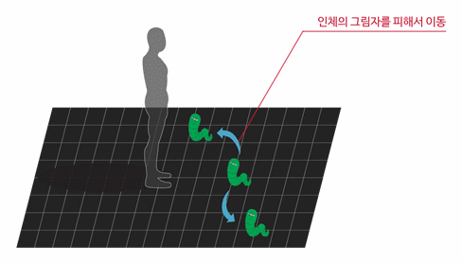

(Figure 3-1) Conceptual diagram of display representation optimization
through the placement of virtual objects

Users use contents by responding to projected images, and the interaction between contents and users in this process has a significant impact on the user's usability.
In situations where a user intentionally tries to enter information into a specific virtual object of a projection image, if the user can't see the intended virtual object shadow because of their shadow, the users would face an embarrassing situation.
Therefore, it is necessary to review the user scenario of the contents and optimize the display representation through the placement of virtual objects which fit the users' interface. so that the user's shadow does not interfere with the interaction control.
In other words, virtual objects should be placed in front of the user to ensure that they are visually recognizable and not covered by shadows generated by projections.

3.2 Command verification for user input
Step and hold for 3 seconds
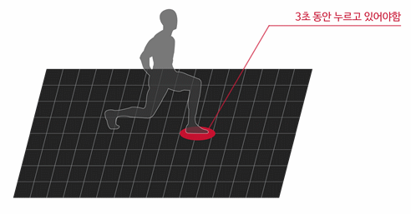
(Figure 3-2) Conceptual diagram of the decision-making guidelines by user motion

The users generate continuous interactions within a programmed area scope. Thus, users' behavioral patterns in a wide scope can be likely to be different from the intention planned content.
In such a case, if the content responds immediately to the user's unintended behavior, it may be right for the intention of the planning, but since the input of commands do not correspond to the user's intention, so it can cause serious errors.
Therefore, the content needs to identify the user's exact intention and reflect it.
For this process, when a user is required to enter a command, the user needs to be clearly communicated by allowing them to take the action continouly for some time.
in other words, if the user wants to enter a command into action, allow them to secure enough time (more than two seconds) to meet their intentions, and avoid from taking to much time considering the user's convenience.

3. 3. User Display optimization
1.5 times bigger than the size of your feet.
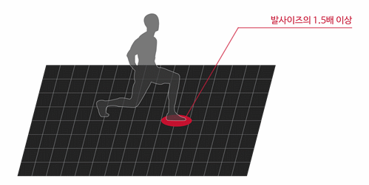
(Figure 3-3) User display representation optimization technology conceptual diagram

In order to allow interactions between users and virtual images augmented by a projection, the reflection area for user's motion should be specified. the shaped image at this point not only plays a role as inducing users' movement, but also plays a role as the range of sensors' perception for the user's movement.
Therefore, this point can cause users' movement contraction and act as a distraction factor if there is no adequate error margins for the users' movement response area.
To avoid this error, the size of the features drawn on the floor should be 1.5 times bigger the size of the original input area.
The size of the input area is based on the average body size of people in their 30s, which is announced by the Ministry of Health and Welfare every year.

4. The application of the interactive interface

(A) The size of the interface may be changed at convenience, but must comply with the requirements set out in 5-1.
(B) It is recommended that instructions be compiled in accordance with the basic operational recognition or action recognition methods, etc. for anything not prescribed or insufficient in this standard.

