Project | Human Factor for Immersive Content Working Group  <http://sites.ieee.org/sagroups-3079/ >
Title | Reference Model of the Software System for Immersive Fitness Content
DCN | 3079-21-0004-00-0002
Date Submitted | January 31, 2021
Source(s) | Jeong, Sangkwon Peter ceo@joyfun.kr (JoyFun Inc.)  Lee, GookHwan ghlee@joyfun.kr (JoyFun Inc.)  Choi, Soojin soojin_choi@joyfun.kr (JoyFun Inc.)  Seo, Dong Il Dillon mailto::dillon.seo@dtcp.capital (DTCP)
Re:
Abstract | In this document, the input/output interface is defined so that the depth camera with motion recognition function and the projector can interact by synchronizing with each other.  In a situation where synchronized data is linked to direct and control the user's movements, it effectively guides and interacts with the user's movements.
Purpose | This contribution document defines the interaction of the input/output interface for developing and serving content using a motion recognition-based sensor using a depth camera and a projection display.
Notice | This document is offered as a basis for discussion and is not binding on the contributing individual(s) or organization(s). The material in this document is subject to change in form and content after further study. The contributor(s) reserve(s) the right to add, amend or withdraw material contained herein.
Release | The contributor grants a free, irrevocable license to the IEEE to incorporate material contained in this contribution, and any modifications thereof, in the creation of an IEEE Standards publication; to copyright in the IEEE’s name any IEEE Standards publication even though it may include portions of this contribution; and at the IEEE’s sole discretion to permit others to reproduce in whole or in part the resulting IEEE Standards publication. The contributor also acknowledges and accepts that IEEE 3079 may make this contribution public.
Patent Policy | The contributor is familiar with IEEE patent policy, as stated in Section 6 of the IEEE-SA Standards Board bylaws <http://standards.ieee.org/guides/bylaws/sect6-7.html#6> and in Understanding Patent Issues During IEEE Standards Development http://standards.ieee.org/board/pat/faq.pdf

Reference Model of Software System for Immersive Fitness Content

1. A general outline

Existing motion recognition contents only needed depth cameras and front displays for interaction between users and contents, but it is essential for fitness content to present sophisticated movements. Fitness content should provide more sensory and cognitive information data because it requires more sophisticated measurement and correction of the user's posture. To this end, technologies such as multi-display techniques, projection techniques, and real-time synchronization of mutual data should be optimized.
This standard presents a reference model for software systems configuration so that realistic interactive fitness content can be seamlessly serviced.

2. Context of the standard

This standard presents a reference model for software system which provides realistic interactive fitness content. The composition of this standard is as follows: The software system reference model is presented by clearly defining the characteristics of the technology, presenting reference steps such as motion recognition detectors that make up the system, posture correction by front screen, and data transfer by bottom screen. This document details the software system configuration module, the role of each module and performance system by its function.

3. The outline of realistic Interactive Fitness Content
By inducing human senses and cognition in augmented virtual spaces, it creates a realistic interactive content with similar experiences and sensibilities with the real fitness training, allow the users to experience the interaction between them and objects.
A software system reference model, which consists of remote and local systems (Figure 5-1) to provide exercise systems and methods for anytime, anywhere exercise. it automatically recognizes users and their spaces, without having to install additional sensors in the user's body to recognize user motion.

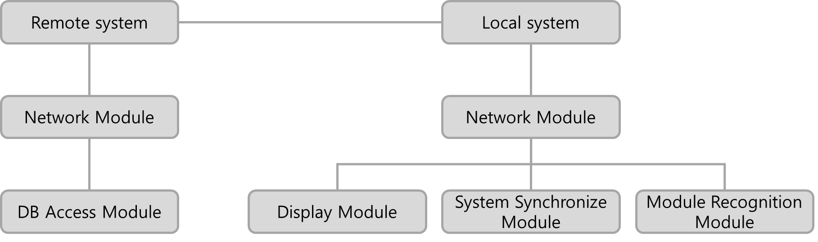
(Figure 5-1) Software system reference model for realistic interactive fitness content.

5.1. Software system module

Realistic interactive fitness contents are divided into 'remote system' and 'local system'.
The remote system consists of "Exercise Program DB" with various exercise programs and "User DB" where users' personal information is managed. User DB has a variety of information about users, and in particular, user exercise history DB can be used to present "customized exercise" to users.
The local system is designed to provide users with content recommended by the "customized exercise DB" provided by the "remote system" using the "wire and wireless interface module." The "exercise interface provision module" is synchronized with the "action recognition detection module" and "display module" to allow users to utilize interactive fitness content.
(Figure 5-2) Software system configuration module for realistic and interactive fitness content.

Thus, realistic interactive fitness content consists of the following software system modules:

5.1.1. Remote system

The remote system consists of a network interface module and a DB group to communicate with the local system. The network interface module consists of a module responsible for the network and a DB access module that accesses the DB and extracts the information for storing and transmitting the information to the local system.

5.1.1.1. Network interface module

A network interface module is a module in which stores or extracts a local system and TCP/IP network communication and DB information.

5.1.1.2. User DB

User DB is a database that stores user information.

5.1.1.3. User exercise history DB

The user exercise history DB is a database that holds information of the user's exercise performance.

5.1.1.4. Exercise program DB

The Exercise Program DB is a database that holds various exercise program information.

5.1.1.5. User customized exercise DB

Customized exercise DB is a database that provides exercise optimized for each individual.

5.1.2. Local system

The local system consists of each independent module and an interface of each relevant interface for each module. The wired and wireless interface module, the exercise interface module, and the system synchronization module are composed of one system, the motion recognition module and the display module are composed of different systems separately. Thus, inter-system interfaces are defined as input and output of data.

5.1.2.1. Wire and wireless interface module

The wired and wireless interface module of the local system facilitates TCP/IP network communication with the remote system, such as the network interface module.

5.1.2.2. Motion recognition Module

The motion recognition module links skeleton information and skin information collected through the depth camera with the exercise interface providing module and system synchronization module.

5.1.2.3. Exercise interface module

An exercise interface module provides an interface for users to exercise.

5.1.2.4. System synchronization module

The system synchronization module allows any module operating within the local system to synchronize and transmit data organically.

5.1.2.5. Display module

A display module outputs graphical image data from a system synchronization module to a hardware projection unit and a monitor unit respectively.

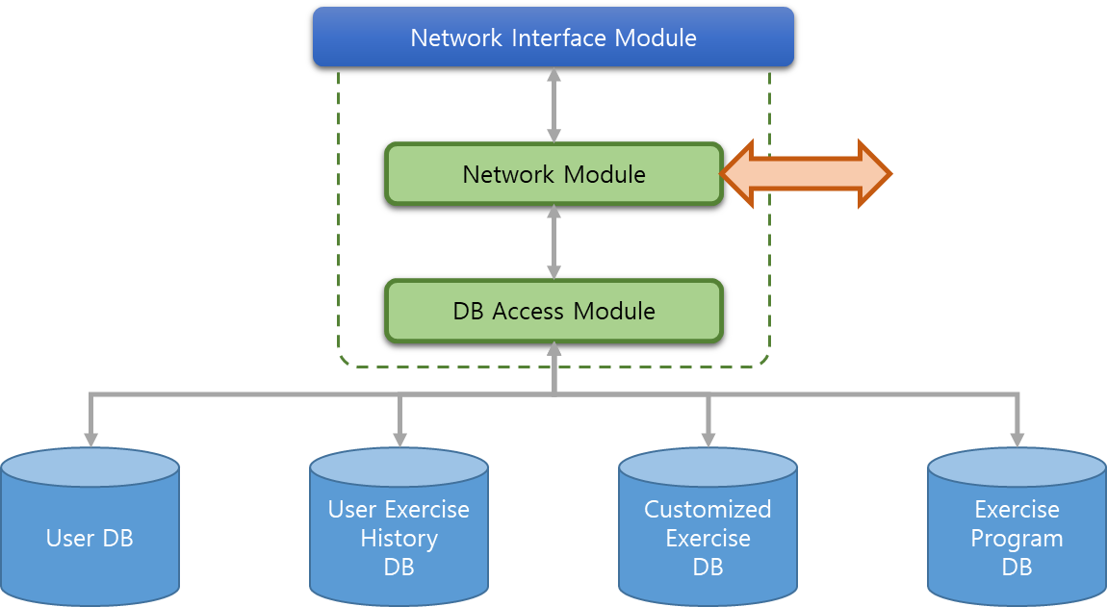
(Figure 5-3) role and process of the remote computer configuration module

5.2. The role and performance system of the software module

Each module of the remote system and the local system, which constitutes a software system for realistic interactive fitness content, has its own role and performance system, respectively. In this regard, the role and performance systems for each configuration module are as follows:
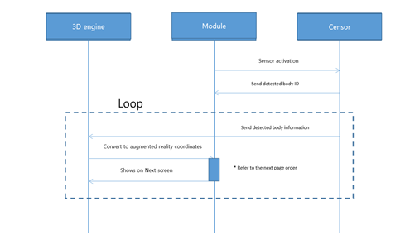
(Figure 5-4) The role and process of performance of the local system module
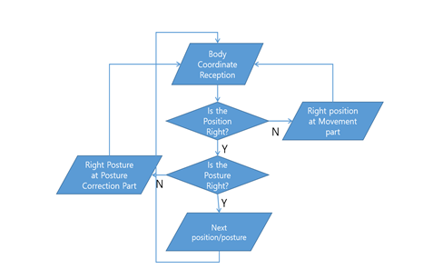
(Figure 5-5) System logic of the operation module in the Loop of the software sequence diagram

5.2.1. Remote system

We manage the information of the user of the exercise system based on realistic interactive content and the exercise information that can provide the optimal exercise to the user by sending and receiving it with the local system.

5.2.1.1. Network interface module

The network interface module facilitates TCP/IP network communication with the local system, which serves as a gateway for transmitting the contents of the remote system's user DB, exercise program DB, user exercise history DB, and custom exercise DB.

5.2.1.2. User DB

The user DB contains information such as the user's name, gender, age, payment history, and membership period, especially a security module for personal information.

5.2.1.3. User exercise history DB

The user exercise history DB is the history of past and recent exercise, and this is the basic information that allows users to recommend accurate exercise programs. This information is kept 1:1 dependent on the user DB.

5.2.1.4. Exercise program DB

The exercise program DB contains a myriad of different exercise contents, and it combines about 10 to 15 kinds of content to combine exercise programs. Exercise content consists of each set, and exercise programs consist of Warm Up, Main Exercise, and Cool Down.

5.2.1.5. User customized exercise DB

An exercise program consists of a combination of exercise content in the exercise program DB according to certain rules, and unlike a typical configuration program, there are also exercise programs which are created according to users. Since this is a program created only for a specific user, the appropriate program is a circular process created based on the user's exercise history DB and stored back into the user movement history DB through the user DB.

5.2.2. Local system

An exercise system based on realistic interactive content recognizes users in real time through a motion recognition detection module, sends and receives information and spatial information of the users with the remote management system, and manages the users' exercise information seamlessly.
It includes a projection step that provides exercise space to users through the display module and guides them through the motion interface module. It features a motion recognition sensor that detects the user's movement in the exercise space provided by the above projector and a motion control stage that provides exercise programs by controlling the projector and the motion recognition sensor through the exercise control device.
The exercise control phase also includes a movement interface that guides the user's movement through the projector, a motion recognition phase that detects the user's movement from at least one motion recognition sensor, and a system synchronization phase that synchronizes the user's movement and movement interfaces.
The method of providing an exercise system based on realistic interactive content features an adaptive acceleration or deceleration of the exercise interface as the user moves, allowing the user to automatically adjust the pace according to his or her physical strength.
The method of providing an exercise system based on realistic interactive content includes additional display steps that users can check during or after exercise by displaying exercise information, user information, exercise evaluation and results, calorie information consumed, individual fitness information, or combination of these.
Methods for providing exercise systems based on realistic interactive content include more wired and wireless communication steps that allow individuals to manage their exercise information, provide or receive exercise programs through remote management systems.
The method of providing an exercise system based on realistic interactive content recognizes users in real time through the above wired and wireless communication steps, and transmits and receives information and spatial information of users with the above remote management system.

5.2.2.1. Wire and Wireless interface module

The wired and wireless interface module of the local system facilitates TCP/IP network communication with the remote system, such as the remote computer's network interface module, which provides a gateway to receive the contents of the user DB, exercise program DB, user exercise history DB, etc.

5.2.2.2. Motion recognition module

The motion recognition detection module links skeleton information and skin information collected through the depth camera with the exercise interface module and system synchronization module.

5.2.2.3. Exercise interface module

An exercise interface module receives an exercise program provided by a remote system and provides an interface for the user to exercise. The module is synchronized with the motion recognition detection module to perform control functions, such as matching the speed of user motion and exercise interfaces, and adjusting the speed of progress.

5.2.2.4. System synchronization module

An exercise interface module receives an exercise program provided by a remote system and provides an interface for the user to exercise. The module is synchronized with the motion recognition detection module to perform control functions, such as matching the speed of user motion and exercise interfaces, and adjusting the speed of progress.

5.2.2.5. Display module

A display module outputs graphical image data from a system synchronization module to a hardware projection unit and a monitor unit respectively. The module features a variety of software, including a 3D engine to represent augmented reality.

